how to install Zotero:

this is its download link:
https://www.zotero.org/download/

after installing it, we need to get some plugins for this software:
https://zotero-chinese.com/plugins/

get theses plugins:
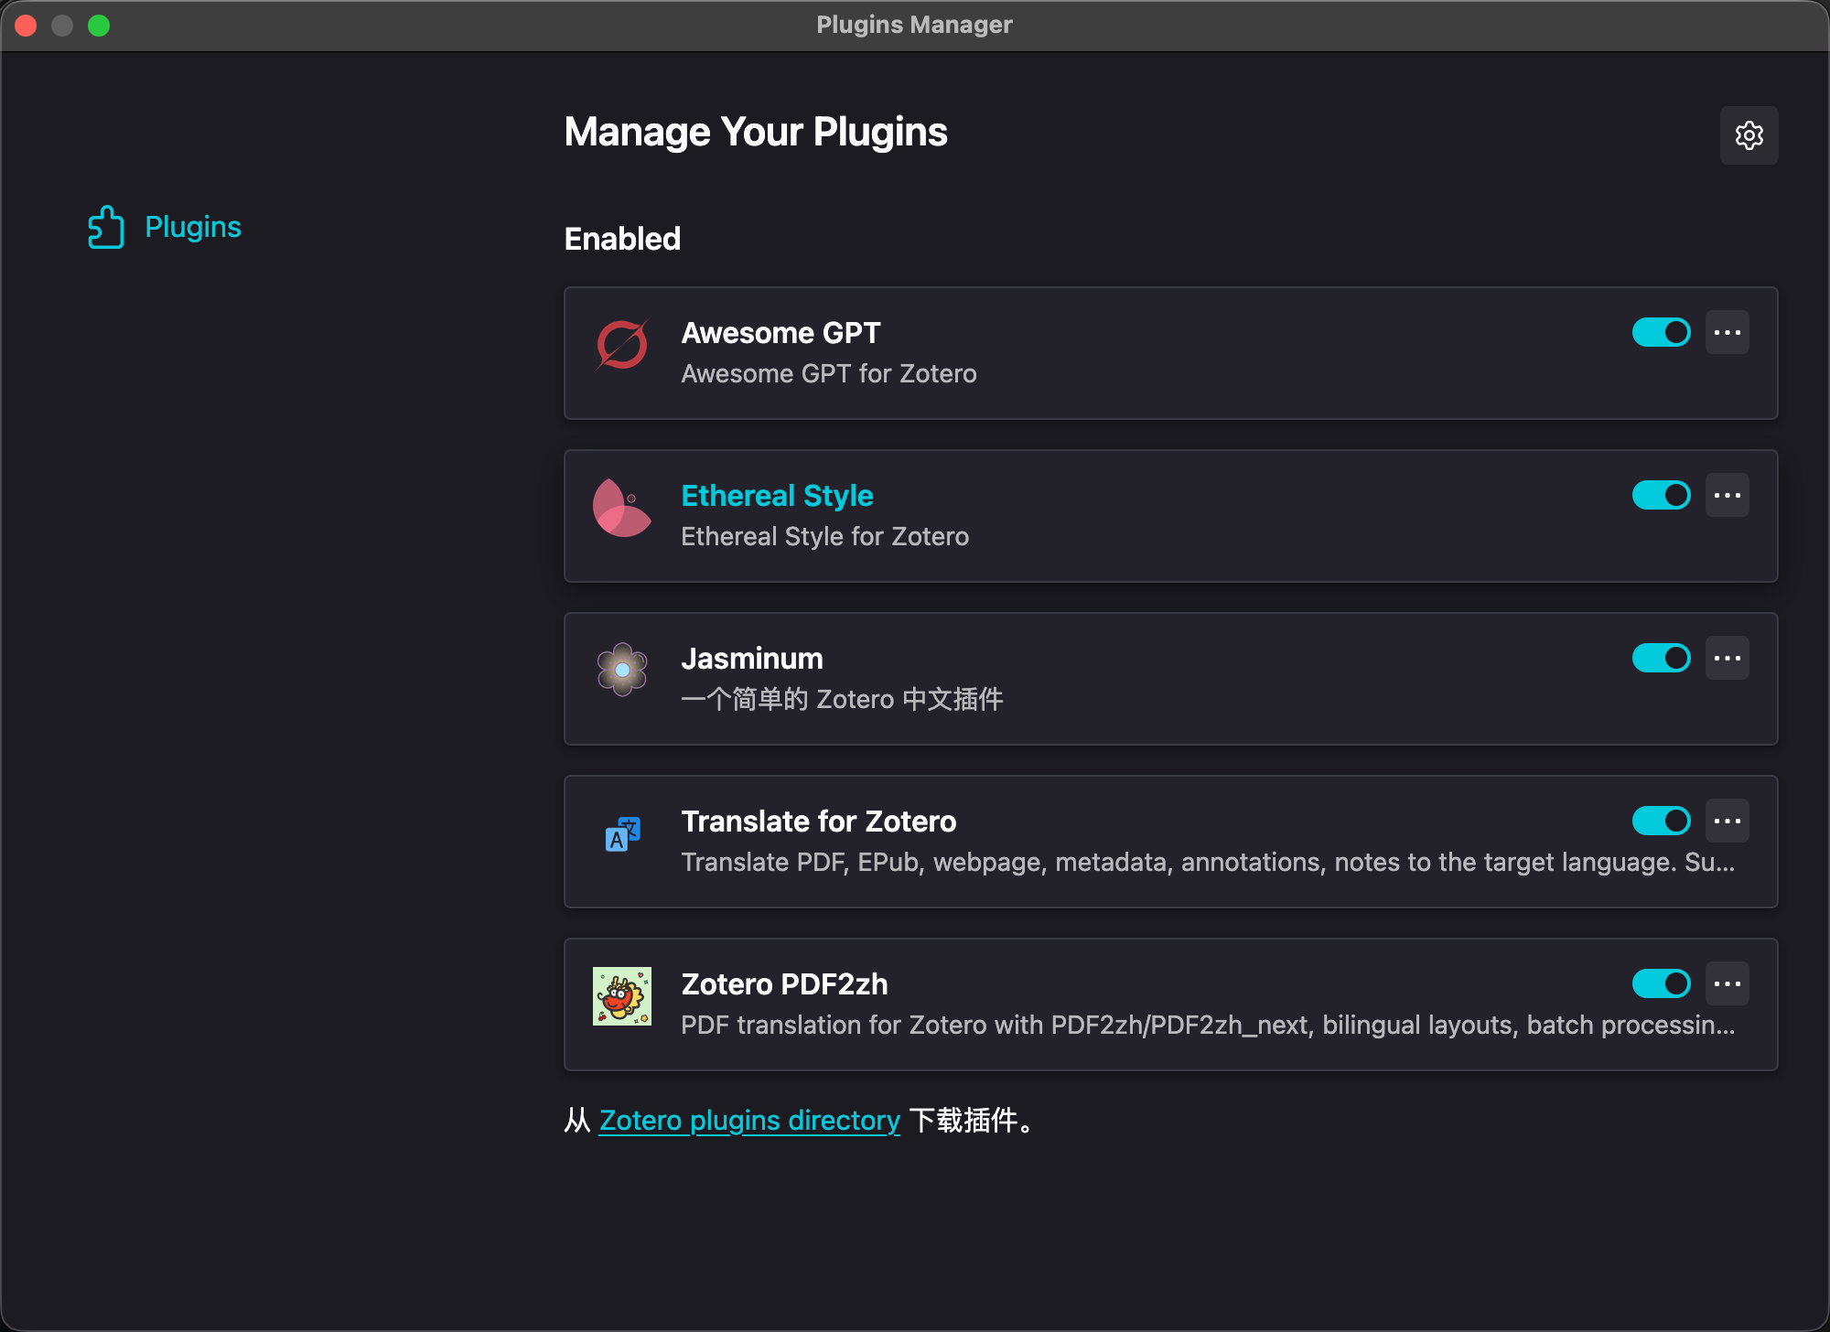
At the same time, they are easy to use;

