2) Tustin Integrator
Model: ‘integrator_12B.mdl’
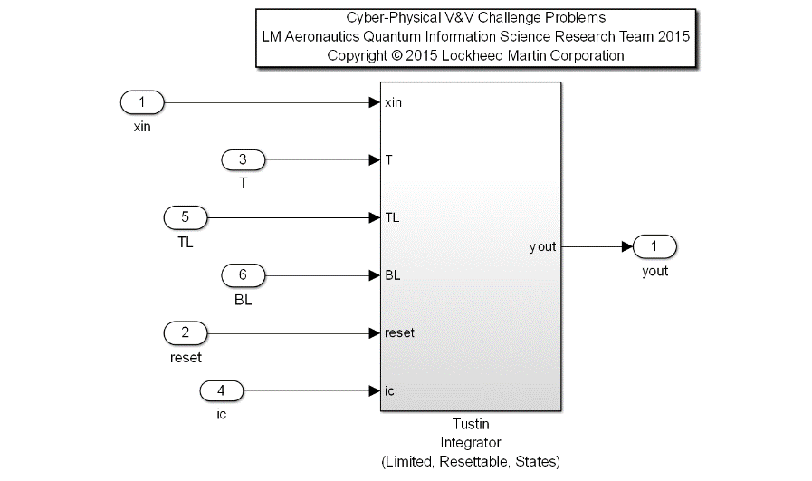
Description: A common flight control utility for computing the Tustin Integration of a signal yout = T/2*(xin + xinpv)+ ypv. The algorithm bounds the allowable integration range with a position limiter, with TL as the Top Limit, and BL as the Bottom Limit. Other inputs are the signal to be integrated (xin), the time step (dt), a Boolean reset flag (reset), and the initial condition upon a reset condition (ic). A provision has been implemented for the limiter functionality in the algorithm. If the user plumbs a TL value that is less than BL, the algorithm will swap these numerical values to correctly bound the signal.
Input Scope | Name | # | Type | Description
Global | xin | 1 | Double | Input Signal to be integrated with the Tustin method
Global | T | 2 | Double | Time step quantified by rate of execution
Global | TL | 3 | Double | Top Limit bounding the output, yout.
Global | BL | 4 | Double | Bottom Limit bounding the output, yout.
Global | reset | 5 | Boolean | Reset control, initializes output to ic value.
Global | ic | 6 | Double | Initial Condition for yout when in reset mode.

Output Scope | Name | # | Type | Description
Global | yout | 1 | Double | Output Signal result of Tustin integration method on xin

Definitions:
- Normal operation: the integrator is not in reset mode, and the output is within the specified limits (TL and BL).
- ypv: prior yout value
- xinpv: prior xin input value
- SP: Saturation Point

Requirements:
- When Reset is True and the Initial Condition (ic) is bounded by the provided Top and Bottom Limits (BL <= ic <= TL), the Output (yout) shall equal the Initial Condition (ic).
- The Output (yout) shall be bounded by the provided Top and Bottom limits (TL and BL)
- When in normal operation, the output shall be the result of the equation, yout = T/2*(xin + xinpv)+ ypv

Test config:
- xin is parameterized as a PCHIP-interpolated smooth signal, defined by three control points c1,c2,c3, --1<=xin<=1
- -10<=TL<=10
- -10<=BL<=10
- t = 20 (t is simulation time)
- -10<=ic<=10
- T = 0.1

