Fisher Bachman-Rhodes

Doctor Gao

CS466

5 February 2025

Week 3 Project Report

**Approach and Effort**

During this week working on the project, I have completed the tasks in chapter 5 and chapter 7 of our textbook. In chapter 5 we built a very simple card-based memory game. I followed the textbook’s instructions and was very satisfied with the results. This week’s work was probably the most fun for me so far. I was successful in building this game and I will display my script and output in the **Achievements** section of this document.

For the Chapter 7 section of this section of the project, I followed the textbook’s instructions on how to add UI elements to our work from week 2 of this project. This work included adding a settings button, a popup settings menu, and a score counter. The development process was very straightforward as my work didn’t vary much at all from the textbook

**Achievements**

I will include two screenshots of the output from each of these chapter’s code alongside the demo video.

Chapter 5 Output:

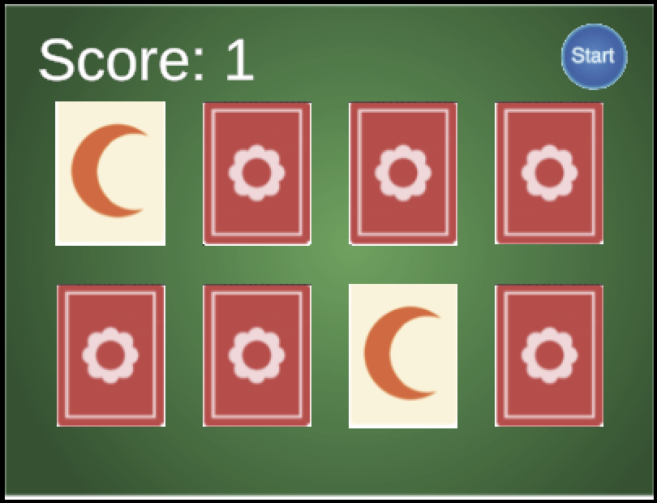

Chapter 7 Output:

