1. ***AutoSar***

***About AUTomotive Open System ARchitecture (AUTOSAR)***

AUTOSAR is an effort at standardization that is intended to address a variety of issues associated with automotive software, including ballooning code size and the increasing complexity of the development process. The AUTOSAR consortium was established in July 2003 by a core group of European car manufacturers and automotive electrical part suppliers to start standardization of in-vehicle electronic control unit (ECU) software interfaces and software modules. Currently, over 100 companies such as car manufacturers, automotive electrical part suppliers, chip manufacturers, and software manufacturers, are members of the AUTOSAR consortium.

***Three Key AUTOSAR Features***

AUTOSAR is a development process that increases automotive software reusability, enables stable quality and reliability, and reins in software-related costs. AUTOSAR has three key features.

**Layered Architecture**

In AUTOSAR, software is componentized and application software reusability is improved.

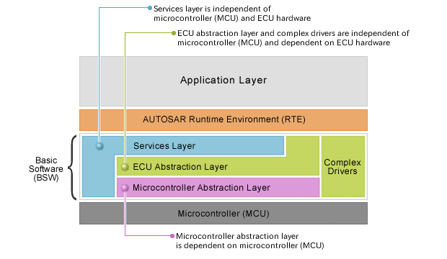

**AUTOSAR Methodology**

In AUTOSAR, the entire sequence from upstream design to detailed design and mounting is standardized, and communication network, ECU, and microcontroller (MCU) settings are laid out and performed in order.

### Design Sequence Using AUTOSAR Methodology

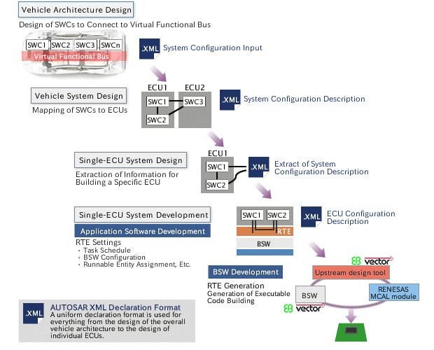

**Application Interface**

In AUTOSAR, the interface between the SWCs (software components) of the functions making up application software is standardized, and what data types can be exchanged at what values for a given application are determined.

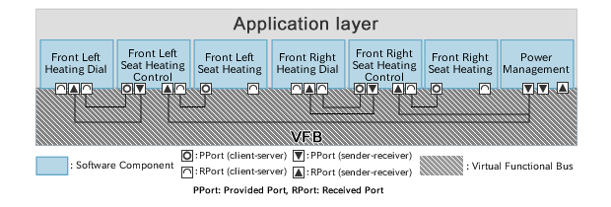

## Renesas' Activities

Renesas has been a Premium Partner of the [AUTOSAR Consortium](http://www.autosar.org/) since July 2004, and has been deeply involved in standardization activities. Renesas has been concentrating on a device driver compatible with AUTOSAR software, Microcontroller Abstraction Layer (MCAL), and started releasing MCAL products for Renesas automotive microcontrollers from 2007. Renesas also works together with partner vendors to provide our customers AUTOSAR solutions integrated with Renesas MCAL and OS.

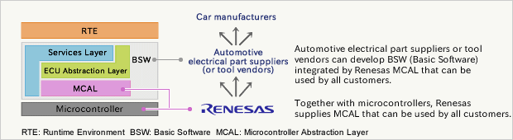

1. ***MCAL***

### *MCAL (Microcontroller Abstraction Layer)*

MCAL is a software module that directly accesses on-chip MCU peripheral modules and external devices that are mapped to memory, and makes the upper software layer independent of the MCU.

Details of the MCAL software module are shown below.

#### **RENESAS MCAL Block Diagram**

1. ***MCAL Testing***