实验三

1.

# include <iostream>

using namespace std;

void fun()

{

int n, count=0;

cout<<"输入n: ";

cin>>n;

for (int i = 0; i <= n/5; i++)

{

for (int j = 0; j <= (n-(5*i))/2; j++)

{

count++;

int k = n - (5*i) - (2*j);

cout<<i<<" * 5 + "<<j<<" * 2 + "<<k<<" = "<<n<<endl;

}

}

cout<<"一共有 "<<count<<" 种兑换方法"<<endl;

}

int main(int argc, char const *argv[])

{

fun();

return 0;

}

运行结果：

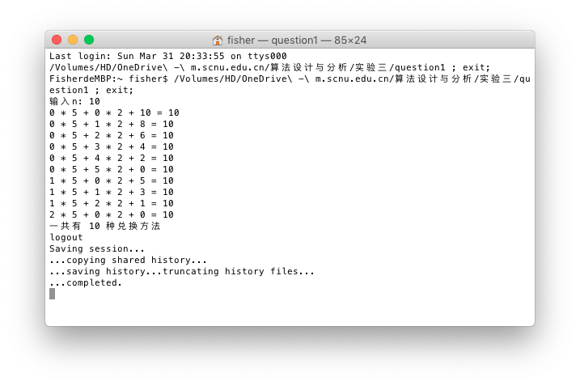

2.

# include <iostream>

# include <vector>

using namespace std;

void fun2()

{

int minSize, maxSize, n, fishSize[51], min, max;

cout<<"fish's minSize and maxSize: ";

cin>>minSize>>maxSize;

cout<<"fish number n: ";

cin>>n;

cout<<"fish's size: ";

for (int i = 0; i < n; i++) {

cin>>fishSize[i];

}

if (n>0) {

min = fishSize[0]*2;

max = fishSize[0]*10;

}

for (int i = 1; i < n; i++) {

if (fishSize[i]*2 < min) {

min = fishSize[i]*2;

}

if (fishSize[i]*10 > max) {

max = fishSize[i]*10;

}

}

cout<<"有这么多种: "<<maxSize-minSize-(max-min)<<endl;

}

int main(int argc, char const *argv[])

{

fun2();

return 0;

}

运行结果：



3.

# include <iostream>

using namespace std;

void fun3()

{

int n, a[1001], maxArea=0;

cout<<"输入n: ";

cin>>n;

cout<<"输入高度: ";

for (int i = 0; i < n; i++) {

cin>>a[i];

}

for (int i = 0; i < n; i++)

{

int area = a[i];

// 向前找矩形，直到找到的矩形比当前矩形小

for (int j = i-1; j >= 0; j--)

{

if (a[j] >= a[i]) {

area += a[i];

} else {

break;

}

}

// 向后找矩形，直到找到的矩形比当前矩形小

for (int j = i+1; j < n; j++)

{

if (a[j] >= a[i]) {

area += a[i];

} else {

break;

}

}

if (area > maxArea)

{

maxArea = area;

}

}

cout<<"maxArea: "<<maxArea<<endl;

}

int main(int argc, char const *argv[])

{

fun3();

return 0;

}

运行结果：

