Seeking the Optimal Database Join Operation

Sean Koppenhafer
Portland State University
Portland, OR
Koppen2@pdx.edu
Luis Santiago
Portland State University
Portland, OR
lsantiag@pdx.edu

Databases are an extremely popular solution to storing large amounts of data. Database systems offer many operations that can be ran on the included data. In this project, we exclusively look at optimizing the database join operation. The join operation finds common elements in two or more databases and produces a database with only the common elements. Because the join operation can be a computationally expensive operation, this paper focuses on finding the optimal parallel algorithm for implementing the join operation.

Introduction
A database join operation finds common elements in two or more databases that match based on a data relationship and produces a new “joined” database containing those common elements. An easy way to think about the join operation is to think of it as a bitwise AND. In a bitwise AND, only bits that are ‘1’ in both numbers will be '1' in the resulting number. In the join operations, the join keys represent bits. Only join keys that exist in both databases will be included in the resulting joined database.
Database join operations can be computationally expensive. Each database needs to be traversed in its entirety to find common elements. Early implementations of the join operation used sort algorithms that were computationally expensive and difficult to parallelize. Those sort algorithms were used due to the strict memory constraints available in computers of the time.
Modern computers are able to leverage the large amounts of main memory available to employ more advanced join algorithms for increased performance. One benefit of the increased memory is the ability to use hash based algorithms. Hash based algorithms are less computationally expensive with the added benefit that they are embarrassingly parallel algorithms. For this reason, hash based join algorithms are standard in modern database systems.
The goal of this project was to create the largest runtime speedup between a serial and a parallel implementation of the join operation. Input data was comprised of two databases: one database which held information about employees at a company. The other database contained information related to trips the employees in the first database had taken. Expected results of the join operation were a sorted list of trips that each employee took.
Many algorithms for performing a database join operation exist. Because many of the papers on this topic were written in the 1980s and 1990s, not all of the principles discussed were relevant when implementing a modern join algorithm. Multiple join algorithms were tested to ensure that the algorithm with the highest performance was selected.
Our join algorithm was implemented in C using pthreads. An MPI based join program was briefly considered but the added complexity of programming a MPI program turned us back to pthreads.

Prior work
Research and discussion of the best join operation algorithm has taken on many forms throughout history. Topics such as the size of the input databases to join and the underlying architecture of the machine which will run the operation has been discussed almost as much as the join algorithm. In this project the input data size was small enough that it could fit into main memory in its entirety. For this reason, more complex join operations which operate on partitions of the database due to memory constraints were not considered.
A typical hash join algorithm has three distinct phases: partition, build and probe. The partition phase divides data into sets using a hash function on the join key element and is optional. The build phase creates a hash table based on the join key element in-memory. This stage is used when the size of the databases are large and was skipped in our program due to a small enough data size. Finally, the probe phase scans the input databases for matches on the join key. Matches are then placed into the resulting joined database.
Fast hash functions were another field explored by our team. Hash functions are a popular research field of their own and go outside of the scope of this project. Ultimately, a simple hash function was chosen over a fast hash function, but the research done was valuable in estimating how much impact the hash function would have on overall performance.

Input Database Generation
As stated in the introduction, inputs to the join program are comprised of two databases. One database is an employee information database with 20,000 elements. Each element holds the first and last name of the employee, and their own unique employee ID. The second database is a trip information database with 100,000 elements. Each element holds the timestamp of the trip, the employee ID that went on the trip corresponding to one of the employee IDs generated in the employee information database, and a trip destination.
To generate the databases, a Python script was written. Both the employee information and the trip information databases were output as individual comma separated value (CSV) files for easy parsing by the join program. Standardized filenames were also chosen for easy loading by the join program.
To generate a first and a last name for each employee, a database of first and last names was found online. Luckily, the database was a plain text file, which made parsing the files very easy. Non-unique names are acceptable since each employee will have a unique employee ID. Employee ID generation was handled by choosing a unique number between 0 and 200,000. A number larger than 200,000 could have been chosen as an upper boundary, but that seemed sufficiently large to test the join program.
Trip generation was handled similarly to employee information generation. First, a date for the trip was randomly generated in the format of dd/mm/yyyy. Second, an employee ID from the employee information database was chosen randomly to go on the trip. Finally, a different online database was leveraged to provide the ability to randomly choose a US city as the trip destination. The key to this stage was ensuring that the employee ID for the trip always matched an employee ID in the employee information database.

Join operation algorithms
After reading through many papers, we initially created a simple serial algorithm to test our understanding of the join operation concepts. In this test, input data was simplified. Employee IDs were numbered 0 to 19,999 sequentially. All other aspects about the two input databases were the same as described above.
The serial algorithm was implemented using an array of linked lists. Each node in the linked list held a pointer to a trip element in the trip database. The “join array” is an array of linked lists containing 20,000 elements, where each element in the join array contained a head pointer to a linked list. Because employee IDs were numbered sequentially from 0 to 19,999 in the initial implementation, the employee ID could be used to index into the join array.
The serial algorithm iterates through the trips in the trip database using the employee ID from the trip as an index into the join array. A new node is allocated each trip and is pushed to the head of the linked list indexed by the employee ID. Adding to the head of the linked list was important to ensure maximum performance by eliminating the need to traverse an entire linked list each time a node was added.
To print results, all linked lists in the join array were iterated over sequentially. Because the employee IDs were sequential, no checking or synchronization was required to ensure that the trips being printed belonged to the current employee.
With the serial algorithm working, a parallel version of the algorithm was attempted. The most straight forward way to parallelize the serial program was to split the trips array into N number of threads and have each thread run through the same algorithm used in the serial version. Because only one join array existed, a mutex was needed to ensure that threads were synchronized correctly when writing results to the join array.
With the added overhead of the mutex, this solution was actually slower than the serial solution. Even with 16 threads, the parallel version was just barely faster than the serial version. It was clear that the mutex needed to be removed. After researching additional papers, the solution became clear.
On the second attempt at a parallel solution, each thread allocated its own join array instead of using one global join array. Because each thread is now writing its results to its own join array, no synchronization was needed between threads, allowing us to remove the mutex. These changes allowed the parallel solution to finally surpass the speed of the serial solution. A visual representation of the algorithm showing the process of creating linked lists for each employee in each join array is shown below.
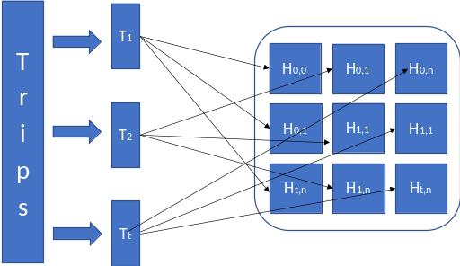
Parallel Join Algorithm (t = thread, n = employee ID)
With the added speed of the parallel solution came added complexity. In the serial solution and the first parallel solution, printing the results of the join array was simple. Since an element in the join array contained a linked list of all trips an employee took, it was simple to print the results.
With the improved parallel solution, printing results was more complicated due to the fact that the global join array had been replaced by individual join arrays for each thread. That meant instead of having one linked list per employee containing all of their trips, each employee had N (where N = Number of threads) linked lists potentially containing their trips. Because it was possible for 0 through N linked lists to exist per employee, all join arrays had to be checked for an employees trips.
Even with a working parallel solution, there was still one open issue: all of the solutions so far have assumed that the employee IDs will be sequentially numbered from 0 to 19,999, allowing us to leverage the employee ID as a direct index into the join arrays. A more general solution was needed that could handle employee IDs that were not sequentially number. After more research, a hash function provided the solution.
The hash function selected was simple modulo 20,000 on the employee ID. The result of the hash function was then used to index into the join arrays instead of the employee ID. This ensured that we could still use a 20,000 element join array for each thread. Two potential downsides with hash function include:
- Modulo operations are slow relative to bitwise operations.
- Uniform distribution is not guaranteed. It is possible for multiple employees to map to the same linked list within the join arrays.
Because collisions in the join array between employee IDs were now possible, the results printing function cannot blindly print all trips contained in the linked lists pointed to by the hash index. Instead, each node in the linked lists would need to have its employee ID compared to the current employee ID that the results were being printed for. If the IDs matched, then the trip could be printed. If the IDs did not match, then the trip was skipped until the employee that trip was reached later.
Adding the hash function did not change the underlying join algorithm. Which is why this was an attractive solution to handling non-sequential employee IDs. Beyond the changes described above to the print function, nothing else had to change in the program. Which ensured that we did not accidentally break anything when enabling the final solution.

Simulation Methodology
Leveraged from the homework, the runtime calculation was used as the performance indicator for the project. The time was stored before the join operation ran and again immediately after the operation finished (before the results were printed). The resulting time delta of the operation was printed to stdout for our automation scripts to scrape the runtime data.
First, a serial runtime baseline was established, and then multiple parallel join program were ran with increasing number of threads between 2 and 32. After join programs were finished running, the data was pulled together to calculate the speedup of the run versus the serial baseline.
Automation of this process was handled by creating a Perl script that would run the join program N number of times (where N = the number of threads to use). The script would extract the runtime of the join program, calculate the speedup versus the serial baseline, and print all of this information to a text file in the same format that was used in the homework.
A second Pearl script was created to calculate the average runtime for each thread count over multiple runs. The join program was run one hundred times for each number of threads. Then the one hundred runs were averaged to give us the average runtime for the join program at N number of threads. Performance comparison was then done on the average runtimes of the join program.
Simulations were ran on the Portland State University ECE Linux Servers. The hardware specifications for those machines are listed below.
- 2X Intel® Xeon® CPU E5-26700 @ 2.60GHz
- 32 total cores.
  - 8 physical cores per processor for 16 physical cores total.
  - 8 virtual cores per processor (hyperthreading) for 16 virtual cores total.
- 32KB L1 cache per core
- 256KB L2 cache per core
- 20MB L3 unified cache per slot

Results
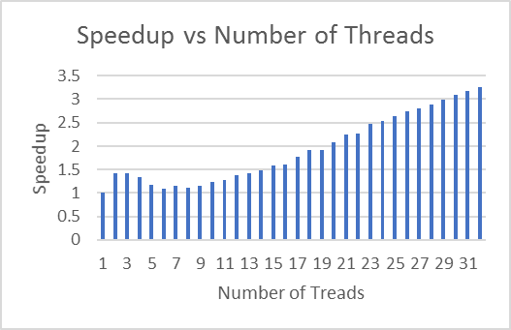

Overall, we reached the speedup goals we were aiming for. Peak performance was obtained by running with 32 threads which provided almost a 3.25x speedup over the serial implementation. Aside from outlier data between between 4 and 8 threads, an almost linear speedup curve can be observed.
Various theories were discussed on the dip in performance between 4 and 8 cores. The most likely one is that caching is impacted when using 4 to 8 cores. It is possible that false sharing is worst with these number of threads. It is also possible these number of threads are being split evenly among the two physical CPU chips on the ECE Linux machines in a way that causes the caches to fill slowly.
We felt that the least likely reason was due to the overhead of pthreads. Overhead of allocation, creation, and running of the threads are unlikely to cause this issue because we continue to see speedups past 9 threads. If this were the cause, we would expect performance to get worse as the number of threads increase.

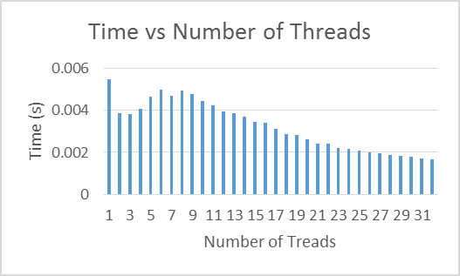

From the runtime graph above, an observed 3x improvement between the serial implementation and 32 threads translates only to a 3ms difference. Between 3 threads and 32 threads, only a 1.5ms performance delta can be observed. It is likely that this speedup delta is small due to the small input data size used in this project. With a larger input data size, we would expect the runtime delta to be larger than observed above.

Conclusion
Aside from minor dips in performance on certain thread configurations, we were able to complete what we set out to do with this project: find the fastest parallel join algorithm possible. While there were some setbacks along the way, academic papers were able to steer us in the right direction for a better solution. Modern hash join algorithms were essential inspirations for the algorithm that we implemented. Without the prior work done by researchers over the last few decades this project would not have been successful as it was.

References
Parallel Database Systems: The Future of High Performance Database System. David Dewitt and Jim Gray. Communications of the ACM. June 1992.
Join Processing in Relational Databases. Priti Mishra and Margaret H. Eich. ACM Computing Surveys. March 1992.
Join Processing in Database System with Large Main Memories. Leonard D. Shapiro. ACM Transactions on Database Systems. September 1986.
Sort vs. Hash Join Revisited for Near-Memory Execution. Nooshin S. Mirzadeh, Onur Kocberber, Babak Falsafi, and Boris Grot. EcoCloud, EPFL. University of Edinburgh.
Design and Evaluation of Main Memory Hash Join Algorithms for Multi0core CPUs. Spyros Blanas, Yinan Li, and Jignesh M. Patel. University of Wisconsin-Madison.
A Parallel Sort Merge Join Algorithm for Managing Data Skew. Joel L. Wolf, Daniel M. Dias, Philip S. Yu. IEEE Transactions on parallel and distrubuted system, Vol 4, NO.1, January 1993.
Main-Memory Hash Joins on Multicore CPU: Tuning to the Underlying Hardware. Cagri Balkesen, Jens Teubner, Gustavo Alonzo and M. Tamer Özsu. University of Waterloo Canada.

