OEM Burnoff Module Specification
By: Sean Koppenhafer

Interface Connections
Black box testing was used on a known-good OEM burnoff module to create this operation specification. Measurements for input signals were taken from a 1985 Corvette. Output measurements were taken both in the car and on a testbench.
Connector Pin | Wire Color | Name | Type | Description
A | Red | Battery+ | Input | Voltage varies depending on battery+ voltage. ~11.8V→14.7V
B | Yellow | Ignition | Input | 12V when ignition on, 0V (GND) when ignition off.
C | Green | Serial | Input | ~5V when car turns off in open loop. ~2.5V when car turns off in closed loop.
D | White | Burnoff Signal | Output | Supplies battery+ to burnoff input of MAF.
E | Black | Ground (GND) | Input | Engine ground for the burnoff module.
F | Blue | MAF Power | Output | Supplies battery+ to MAF.
Table 1-1: Burnoff Module Connector

OEM Burnoff Module Waveforms
Driving the input wires on the testbench in accordance with the measurements defined above in Table 1-1, these waveforms were captured using an oscilloscope. All waveforms were captured using 5V per vertical division and 1 second per horizontal division. The top (yellow) signal is tracing the ignition input, the middle (blue) signal is tracing the MAF Power output, and the bottom (purple) signal is tracing the burnoff signal output. The serial input is not shown in the waveform but is being manipulated on the testbench to create open/closed loop scenarios.
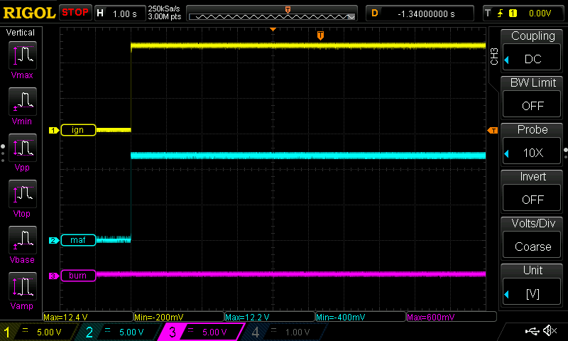
Fig 1-1: OEM Burnoff Module When Ignition Turns On
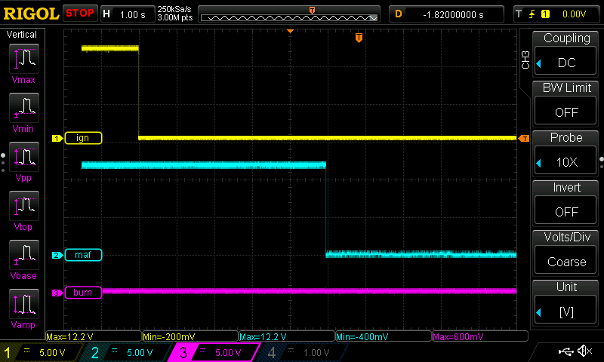
Fig 1-2: OEM Burnoff Module When Ignition Turns Off In Open Loop (No Burnoff)

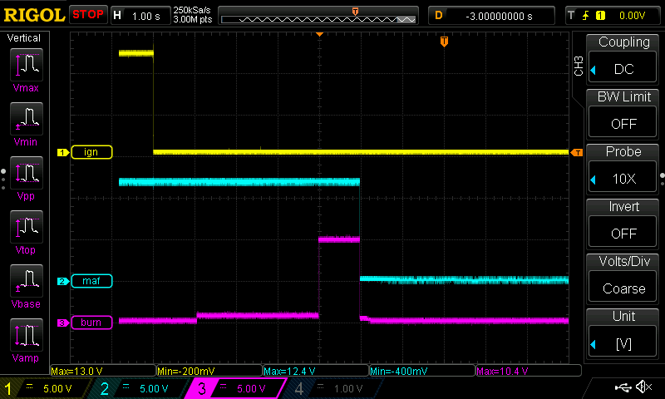
Fig 1-3: OEM Burnoff Module When Ignition Turns Off In Closed Loop (Burnoff)

Operation Specification
- When ignition (Pin B) is on (+12V), supply battery+ (Pin A) to MAF Power (Pin F). Burnoff Signal (Pin D) is off.
- When ignition (Pin B) transitions from +12V to GND (AKA the car is turned off), a few things can occur.
  - Battery+ (Pin A) always continues to be supplied to MAF Power (Pin F) for five seconds before turning off regardless if the car was in open or closed loop.
  - If the car was in open loop when turned off, the Serial (Pin C) input will go to 5V. Keep the Burnoff signal (Pin D) off.
  - If the car was in closed loop when turned off, the Serial (Pin C) input will go to 2.5V. Wait four seconds, then supply battery+ (Pin A) to the Burnoff Signal (Pin D) for one second. The burnoff signal (Pin D) should go high while MAF Power (Pin F) is still high.

In either open or closed loop, the burnoff module should pull zero current five seconds after ignition goes low.

