Replacement Burnoff Module Design
By: Sean Koppenhafer

General Information
This circuit was designed for input supply voltages on Battery+ up to 15V. All parts have at least a -40C to 105C temperature rating.
The ignition and serial input pins are protected by standard diodes. The MAF PWR and Burnoff Signal output pins are protected by schottky diodes. Battery+ is protected by the pmos high side switch. Ground is the only pin not protected by a diode or transistor.
All input pins, aside from ground, have a 0.1uF bypass capacitor. All ICs have the same 0.1uF bypass capacitors next to their supplies.
The unused second circuit on the AND gate has all of its inputs tied to ground and its output unconnected.

PIN F – MAF Power Control
From the OEM spec we know this pin needs to be on whenever the ignition is on, and for roughly five seconds after the ignition is turned off. At a high level this breaks down into a high side switch to control PIN F through a timer circuit. The switch is controlled both by the ignition being being on and some sort of timer that holds the switch on after ignition drops. For the timer circuit a classic IC, the 555 timer, was used.

High-Side Switching
A high side switch using a pmos and a nmos transistor in combination with a pullup resistor on the pmos gate was used. The circuit controls the gate of the nmos transistor to turn the pmos on/off. The pmos can then supply battery+ (Pin A) to MAF PWR (Pin F) and also provide a switched supply for the rest of the circuit. Using a switched voltage source not just for MAF PWR (Pin F), but for the entire circuit, this design achieves a current draw of 19uA when off according to LTSpice simulation.
The nmos gate is controlled both by ignition (Pin B) and the output of the five second 555 timer. Because the switched supply powers the rest of the circuit, we cannot have a glitch between when ignition (Pin B) goes low and the 555 timer output goes high. To solve this, the 555 timer output and ignition (Pin B) are on at the same time. When ignition (Pin B) goes high, the 555 timer output also goes high. When ignition (Pin B) goes low, the 555 timer keeps the switch on for five seconds before turning the switch off.

Five Second Timer
After ignition (Pin B) goes from high to low (12V → 0V), we need MAF PWR (Pin F) to stay high for five seconds. A 555 timer is a simple, well-known IC that implements a timer. In the monostable configuration we can achieve a five second delay using a 47k resistor and a 100uF capacitor. Unfortunately, the delay begins on the negative edge of the trigger signal in the standard monostable 555 configuration, which is a problem. I needed to find a way to move the delay to the positive edge of the trigger signal so that I could pull trigger low the entire time ignition was on to ensure there would be no glitches on the switched supply.
Thanks to user bunky_bunk on Reddit, I was able to find a solution. Tying the threshold and trigger signals together to the RC network, then adding a nmos controlled by ignition (Pin B), which bypassed the 100uF capacitor, solved the problem. When ignition (Pin B) is on, the nmos is on, which bypasses the 100uF capacitor and pulls trigger/threshold to ground. This turns the 555 timer on. When ignition (Pin B) turns off, the nmos turns off, connecting the 100uF capacitor to trigger/threshold. As the capacitor charges, the voltage rises above the off threshold of the 555 timer after roughly 5.17 seconds, turning the 555 timer off.

PIN D – Burnoff Signal Control
Controlling the burnoff signal is more difficult than MAF PWR. The same high side switch circuit could be reused, as could a 555 timer to control the delay. More control logic to control the switch was required though, which lead to much of the circuits complexity detailed below.

Timer Control Logic
A two circuit comparator IC was used to determine when ignition (Pin B) was low and when we were in closed vs open loop. To create a constant reference voltage, a 5v linear regulator is used. If ignition is less than 5v, then the output of the comparator is high. A voltage divider off of the 5v supply was used to create a 3.2V reference voltage for the serial (Pin C) comparator. If the Serial pin is below 3.2v, the comparator output is high.
An AND gate is used to create a ‘do a burnoff cycle’ signal. If both outputs of the comparator are high (ignition is off and we are in closed loop), then we should do a burnoff cycle.

On-After Four Second Delay Timer
LearnElectronics from YouTube gave me the base “on-after delay” circuit. A 39k resistor with a 100uF capacitor creates roughly a four second delay. For a while I struggled with how to enable the delayed timer and also how to turn the timer off since the base circuit never turns the timer off. Using the same principle from the five second timer, bypassing the capacitor in the RC network and holding the trigger pin high would allow me to not start the delay until a burnoff was requested by the AND gate. A pmos was used to bypass the capacitor, which works perfectly, since the pmos would be on (bypassing the capacitor) when the AND gate is low, and the pmos would be off when the AND gate is high (allow the delay to start).
Because the 555 timer is on the same switched supply as the rest of the circuit, the other 555 timer actually turns this timer off. Relying on the other timer to switch things off after five seconds created the staggered burnoff signal: off for four seconds, on for one second, and then off when the other 555 timer shuts off.

Waveforms
Waveforms were captured and compared for the same scenarios captured in the OEM specification document to ensure design correctness. All waveforms were captured using 5V per vertical division and 1 second per horizontal division. The top (yellow) signal is tracing the ignition input, the middle (blue) signal is tracing the MAF Power output, and the bottom (purple) signal is tracing the burnoff signal output. The serial input is not shown in the waveform but is being manipulated on the testbench to create open/closed loop scenarios.
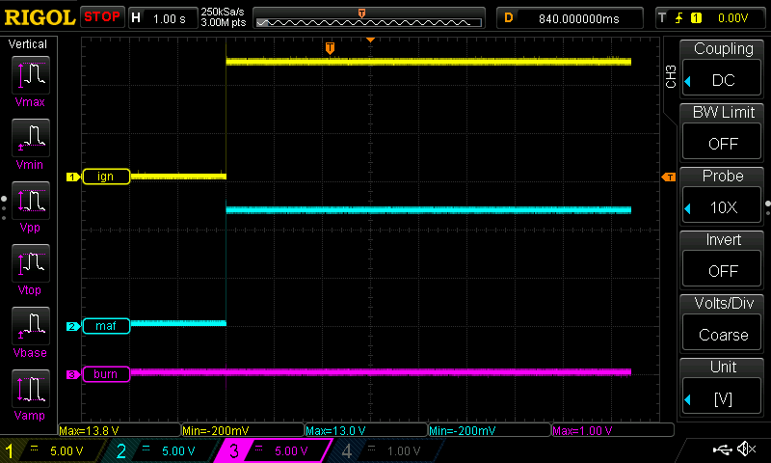
Fig 1-1: My Burnoff Module When Ignition Turns On
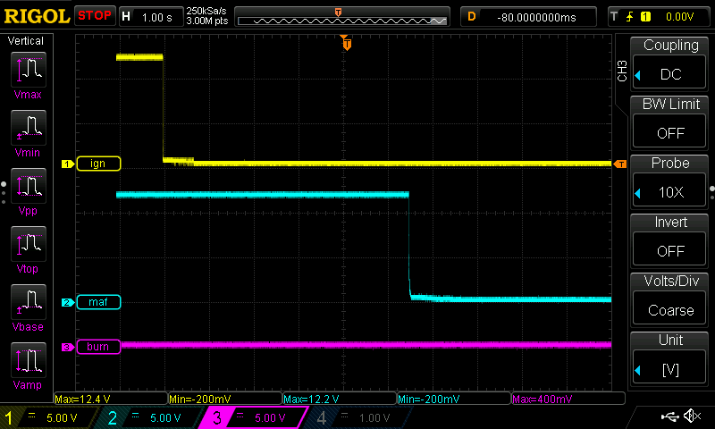
Fig 1-2: My Burnoff Module When Ignition Turns Off In Open Loop (No Burnoff)
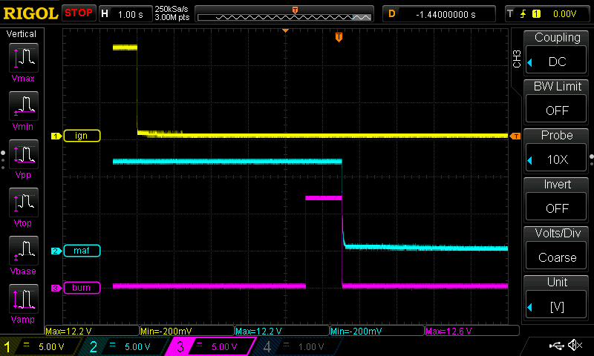
Fig 1-3: My Burnoff Module When Ignition Turns Off In Closed Loop (Burnoff)

Results
My design keeps MAF PWR high for roughly 5.5 seconds versus 5 seconds in the OEM part. My design keeps a 1 second burnoff time by starting at 4.5 seconds instead of 4 seconds in the OEM part. Otherwise, my designs waveforms mimic the OEM design exactly with the exception of the extra half second time shift.

