How To Build The Circuit
By: Sean Koppenhafer

Ordering the PCB
I recommend ordering the PCB through OshPark. They are a great PCB manufacturer based in the USA. You can use other services (which are truthfully significantly cheaper) but they are all based in China. Its up to you, but I like to support a USA business.
On the OshPark website, choose ‘browse for files’ and select the Kicad project file named ‘burnoff_pcb.kicad_pcb’ in the ‘burnoff_pcb’ folder. Follow OshParks instructions to order the PCBs. Three is the minimum number of boards available to order through OshPark– which means you’ll have extras in case you mess up!
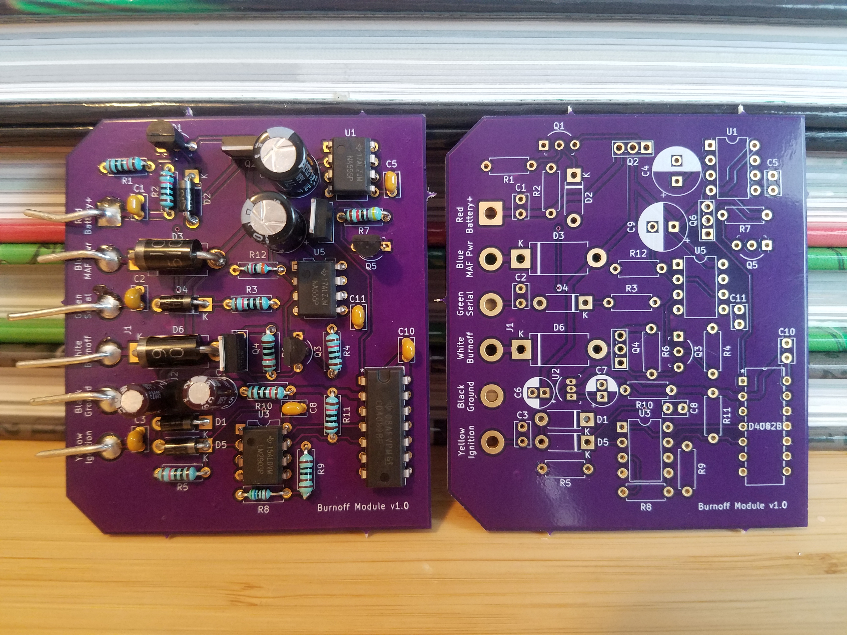

Ordering Components
I recommend ordering components through Digikey. Go into the shopping cart and select ‘Upload a File’ towards the bottom of the page. Upload ‘parts_cart.xlsx’ from this repository. It should auto fill your cart with all of the parts needed. Walk through the rest of the checkout steps to get your parts.
If you choose another component supplier or Digikeys website changes, you can always use the BOM to manually order components.

Additional Items
- Soldering Iron – I suggest a soldering station like the Hakko FX888D-23BY if you can afford it. Soldering stations work so much better than standalone irons and will last you for life. I also recommend you pickup a tip pack that includes screwdriver tips. It makes contact with IC legs easier to maintain.
- Solder – I recommend leaded solder with a rosin core. Its much easier to work with.
- Desoldering wick – If you make a mistake, and you will, you’ll want to have some of this on hand to remove solder. I recommend paying a little extra and getting some of the good stuff like Chemtronics.
- Diagonal cutters – Allows you to cut leads off after soldering.
- Good lighting – I used a headlamp.

Reading The BOM
The Bill Of Materials (BOM) is the spreadsheet that describes every component in the circuit. On the PCB each component has a reference identifier printed on the board. If you look at the top right corner of the circuit board you’ll see U1 and C5 printed on the PCB. These are component identifiers that match the ‘Reference’ column of the BOM. According to the BOM, U1 is a NA555P (‘Value’ column) IC chip, and C5 is a 0.1uF (‘Value’ column) capacitor. Using the BOM you can determine what component every reference on the PCB corresponds to. C = capacitor, U = IC chip, R = Resistor, Q = transistor, D = diode. Resistor values are always in Ohms.

Building The Circuit
I won’t go into detail how to solder or desolder parts here. There are many great tutorials on YouTube available. A few quick pieces of advice:
- Pay close attention to part orientation. Heavily use the reference pictures to double check. ICs have a small circle on them towards pin 1, which should face the same direction as the small U shape in the top of the image on the PCB. Diodes have a stripe that match the stripe on the PCB. Larger cylinder capacitors have a – and a + lead that match with the image on the PCB. Transistors are direction dependent as well. Resistors and ceramic capacitors (0.1uF) are directionless and can be installed in any way.
- Heat the pad for about a second before adding solder.
- Bend two opposite corner legs on ICs to hold them down as you solder the first leg. The rest of the legs do not need to be bent.
- Bend leads on resistors, capacitors, diodes, and transistor to hold them in place as you solder.
- Cut leads on resistors, capacitors, diodes, and transistors after soldered.

Final Assembly
The PCB is designed to fit in the OEM metal housing of the burnoff module. It also reuses the OEM connector. Cut the connector wires (large colored wires to the left of the PCB below) of the OEM burnoff module as close to the PCB as possible.
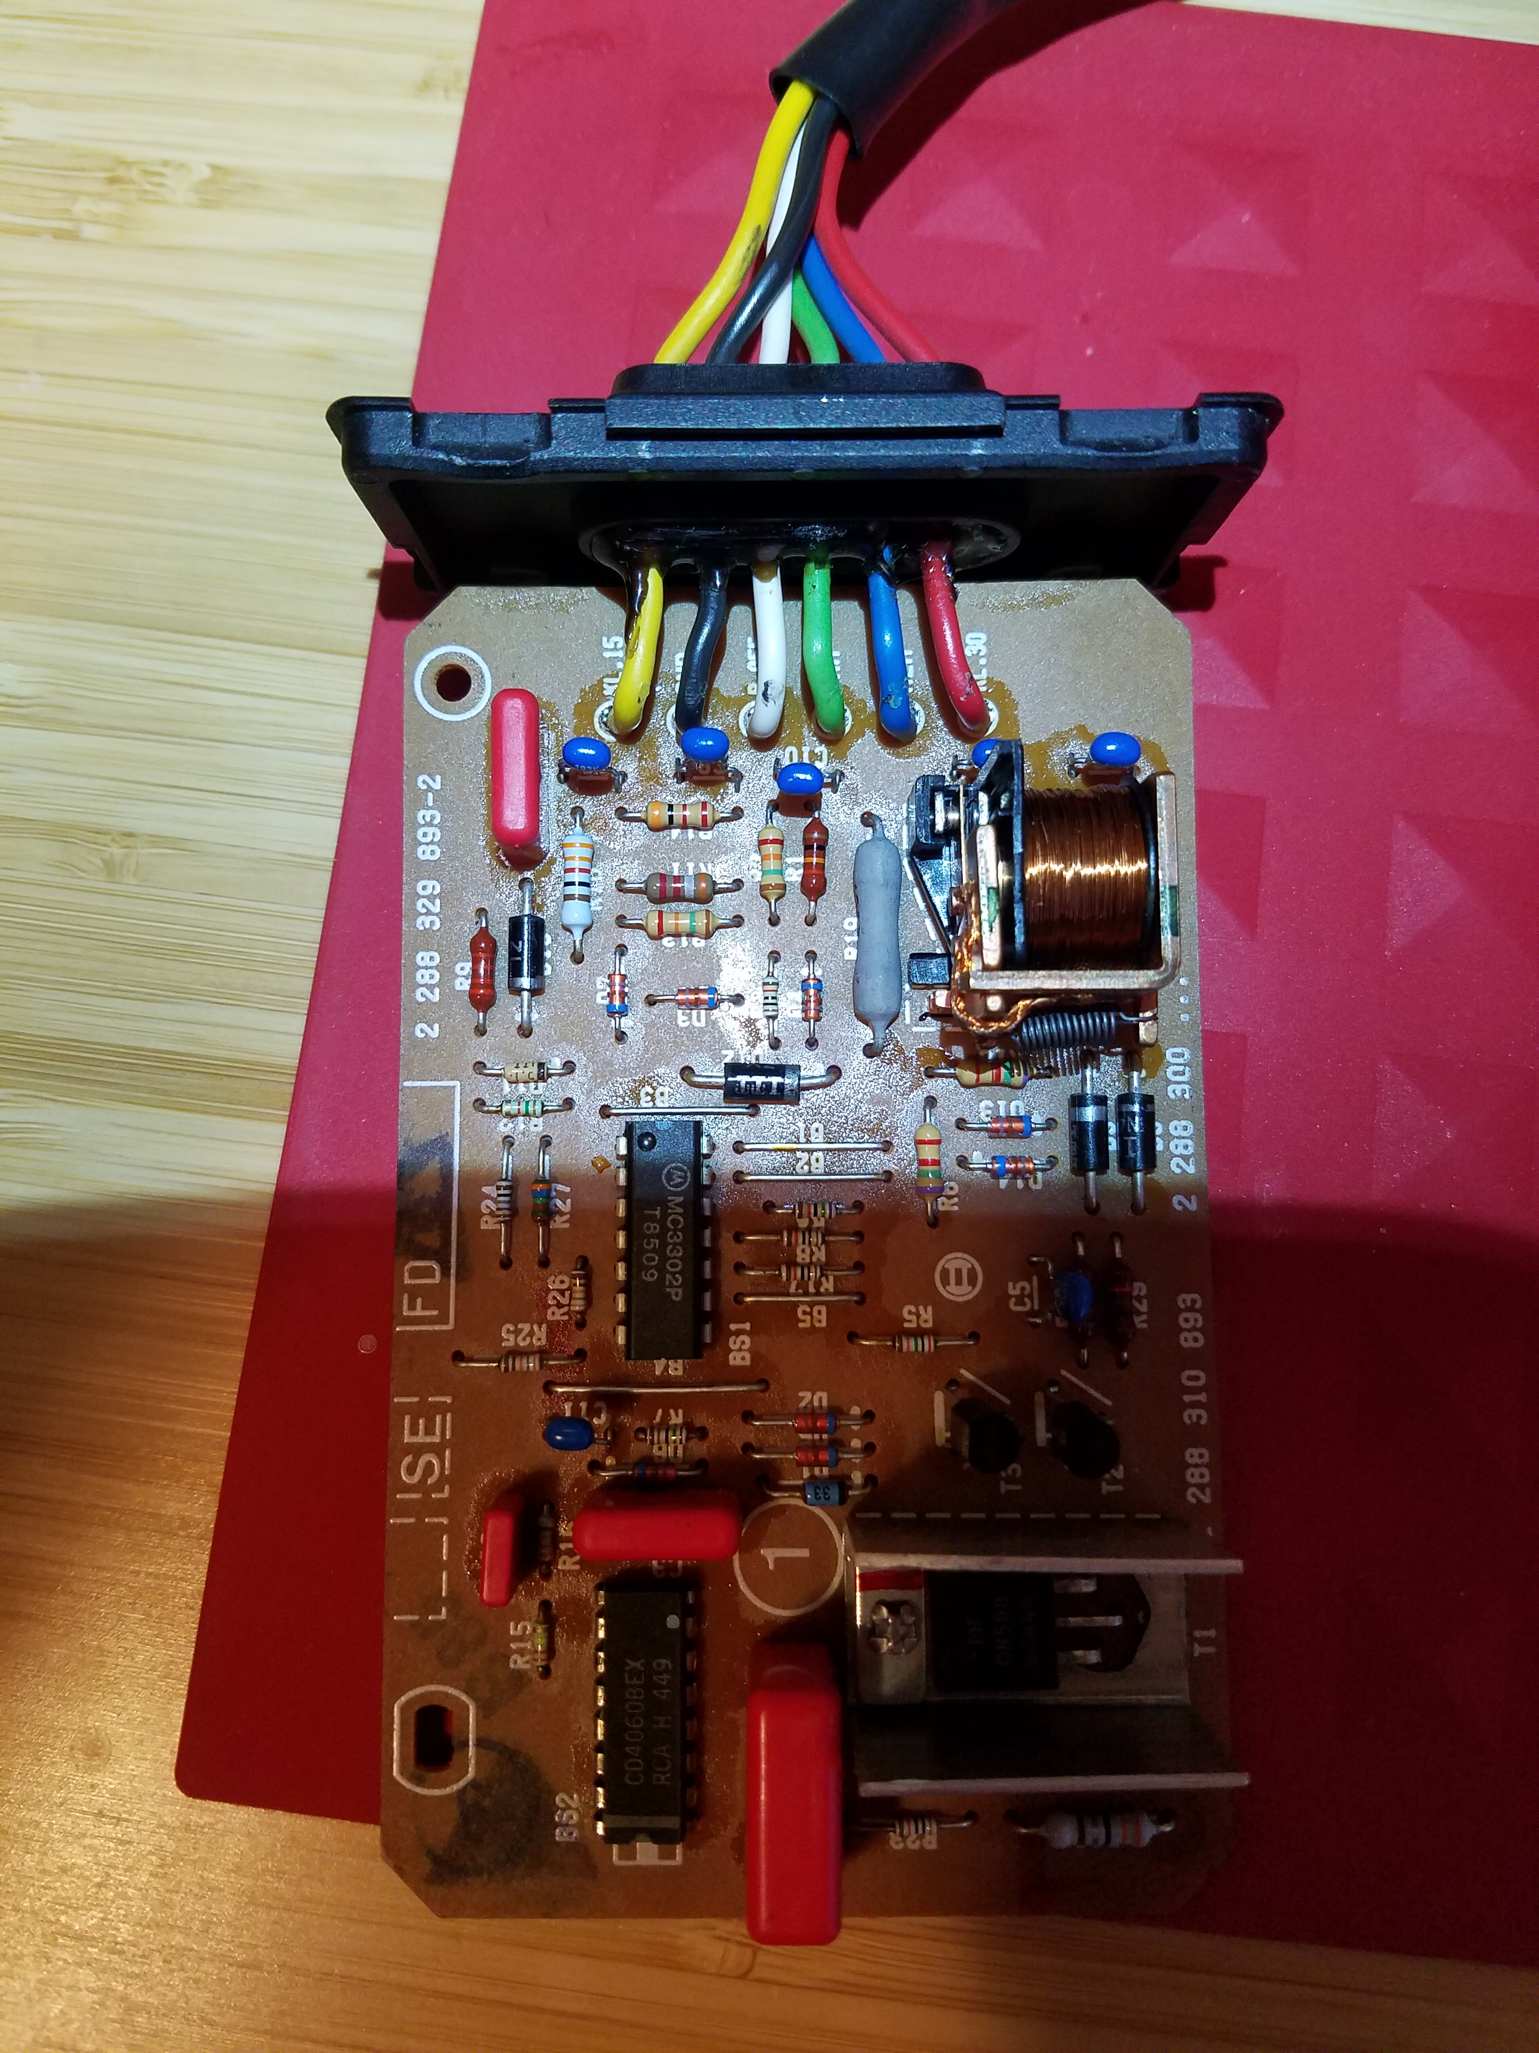

Then strip the wires and solder them onto your new PCB. The wire colors are printed on the PCB. The final result will look like this.
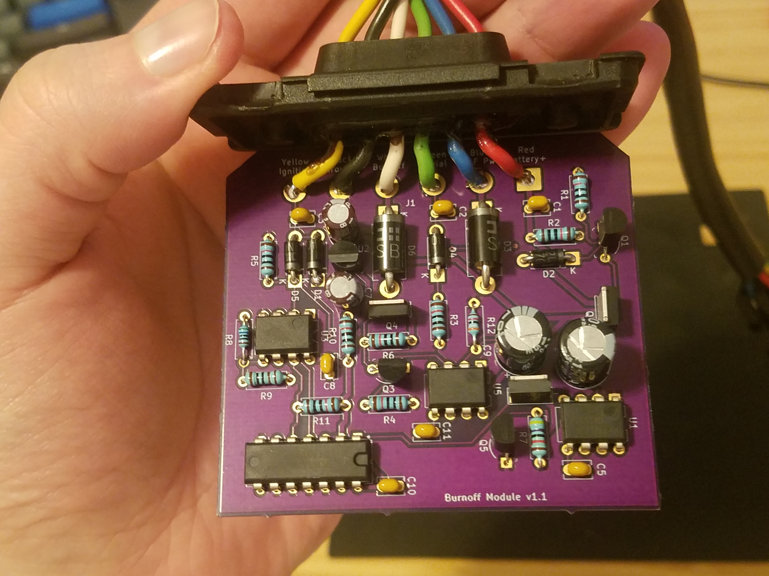
To slide the PCB into the OEM metal housing you’ll likely need to trim or grind the small bumps left from the manufacturing process that held the boards together. You’ll also need to find something non-flammable and non-conductive to backfill the empty portion of the housing as the new PCB is smaller than the OEM part. I used some thin metal with the original rubber isolation stopper to backfill.

