User Story

As a customer, I would like a shopping cart website that allows me to filter items by name, price, or their type. This makes it significantly easier to navigate the site.  
It is also helpful to be able to add items to my shopping cart, and see what I have previously added to my cart. This is helpful to keep track of what I am purchasing.  
  
As a student, I would like to create a shopping cart website which allows users to sort items, add items to a shopping cart, and see their current shopping cart using  
PhP, HTML, and SQL to get a better sense of how these pieces fit together. It is helpful to me to have the practice involved in creating tables and writing the SQL,  
practicing my HTML structure, and integrating PHP into the HTML to make a functional site.

Database Schema

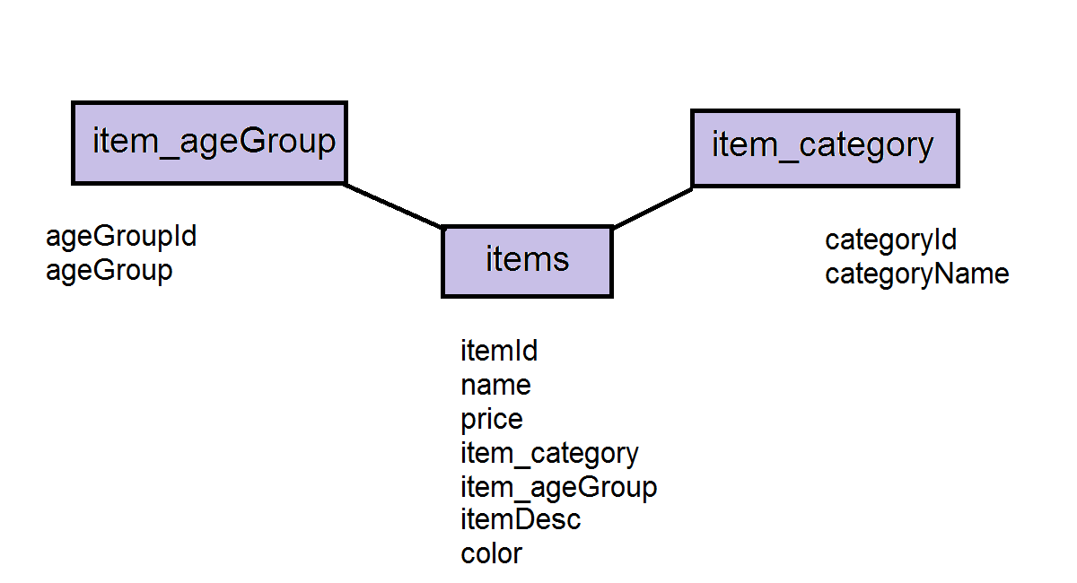

Mock Up

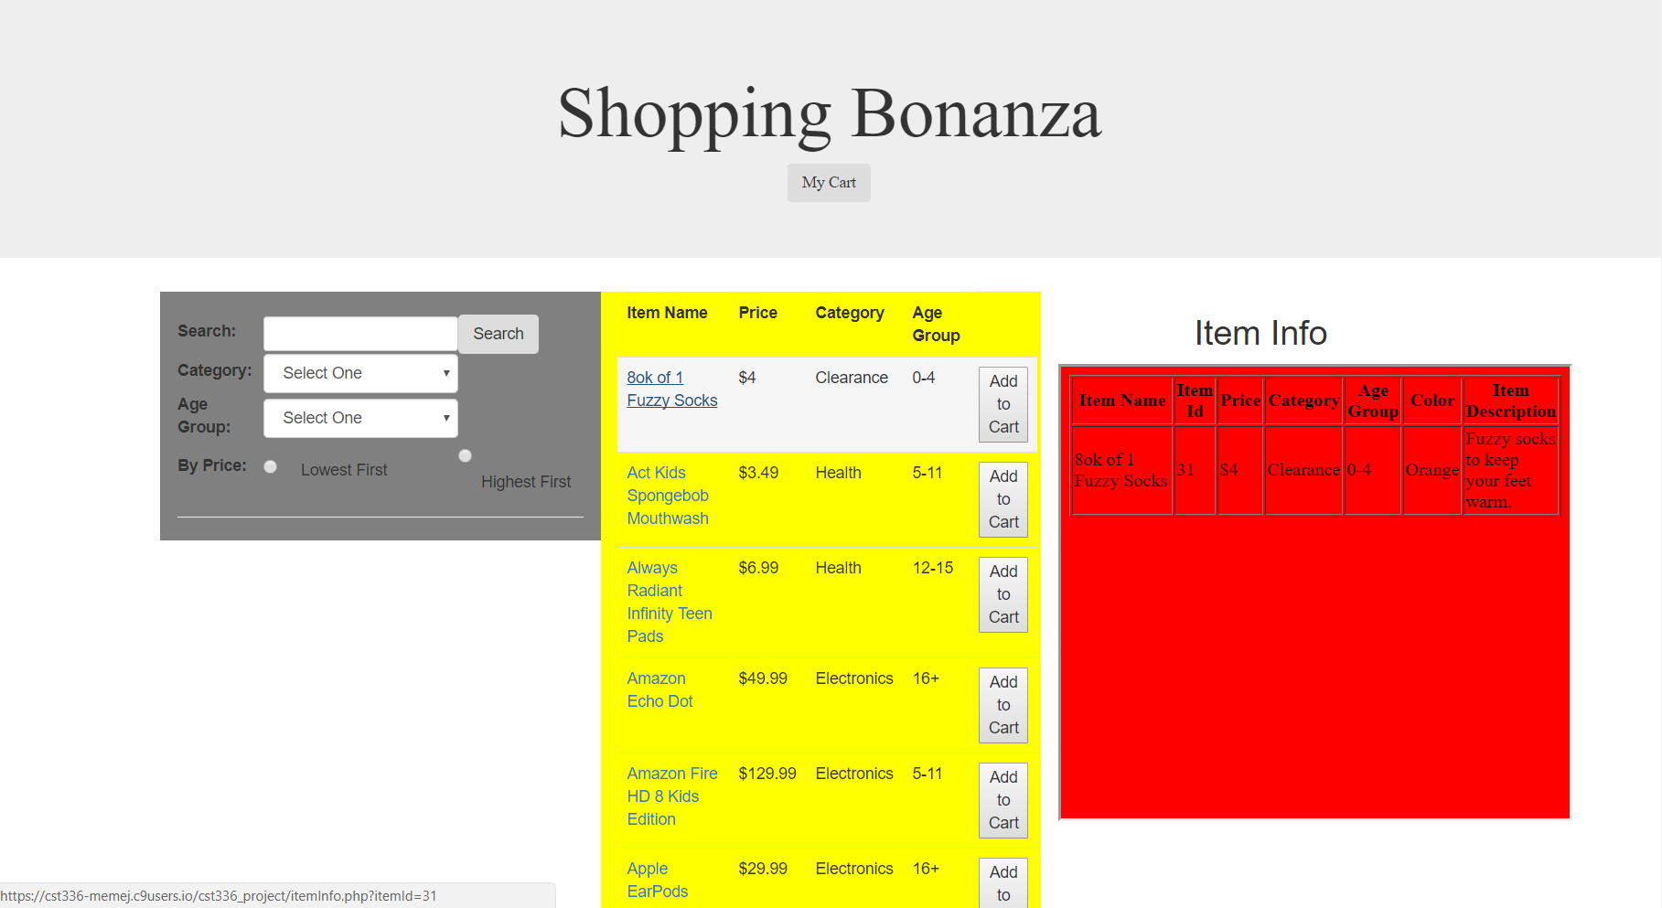

GitHub

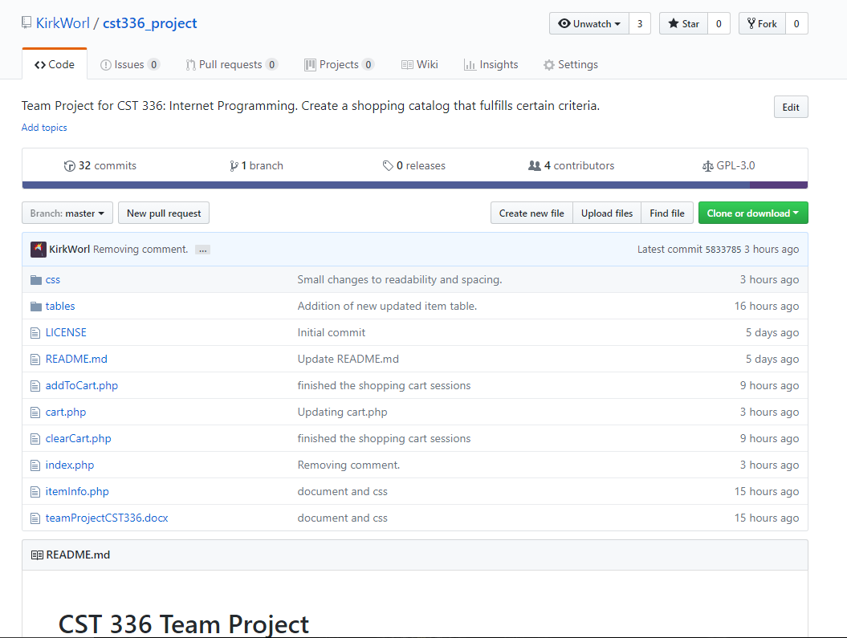

Trello

