JSSMAHAVIDYAPEETHA

Mini Project/Internship Assessment
on
THE HOSTEL YARD: HOSTEL / PG / PROPERTY MANAGEMENT SYSTEM

Subject Name: Mini project/Internship Assessment
Subject Code: BCS-752
COURSE: B.Tech. SEMESTER: VII
by
Akhand Raj Singh (2300910100024)
Rtik Chauhan (2300910100153)
Aksh Bhagat (2300910100025)
Under the guidance of
Mentor: Ajay Sir
Department of Computer Science and Engineering
JSS ACADEMY OF TECHNICAL EDUCATION
C-20/1, SECTOR-62, NOIDA
30 October 2026

VISION AND MISSION
VISION OF THE INSTITUTE
JSS Academy of Technical Education Noida aims to become an Institution of excellence in imparting quality Outcome Based Education that empowers the young generation with Knowledge, Skills, Research, Aptitude and Ethical values to solve Contemporary Challenging Problems.
MISSION OF THE INSTITUTE
- Develop a platform for achieving globally acceptable level of intellectual acumen and technological competence.
- Create an inspiring ambience that raises the motivation level for conducting quality research.
- Provide an environment for acquiring ethical values and positive attitude.
VISION OF THE DEPARTMENT
“To spark the imagination of the Computer Science Engineers with values, skills and creativity to solve the real-world problems.”
MISSION OF THE DEPARTMENT
- To inculcate creative thinking and problem-solving skills through effective teaching, learning and research.
- To empower professionals with core competency in the field of Computer Science and Engineering.
- To foster independent and lifelong learning with ethical and social responsibilities.

PROGRAM OUTCOMES (POs)
Engineering Graduates will be able to:
PO1: Engineering knowledge: Apply the knowledge of mathematics, science, engineering fundamentals, and an engineering specialization to the solution of complex engineering problems.
PO2: Problem analysis: Identify, formulate, review research literature, and analyze complex engineering problems reaching substantiated conclusions using first principles of mathematics, natural sciences, and engineering sciences.
PO3: Design/development of solutions: Design solutions for complex engineering problems and design system components or processes that meet the specified needs with appropriate consideration for the public health and safety, and the cultural, societal, and environmental considerations.
PO4: Conduct investigations of complex problems: Use research-based knowledge and research methods including design of experiments, analysis and interpretation of data, and synthesis of the information to provide valid conclusions.
PO5: Modern tool usage: Create, select, and apply appropriate techniques, resources, and modern engineering and IT tools including prediction and modeling to complex engineering activities with an understanding of the limitations.
PO6: The engineer and society: Apply reasoning informed by the contextual knowledge to assess societal, health, safety, legal and cultural issues and the consequent responsibilities relevant to the professional engineering practice.
PO7: Environment and sustainability: Understand the impact of the professional engineering solutions in societal and environmental contexts, and demonstrate the knowledge of, and need for sustainable development.
PO8: Ethics: Apply ethical principles and commit to professional ethics and responsibilities and norms of the engineering practice.
PO9: Individual and teamwork: Function effectively as an individual, and as a member or leader in diverse teams, and in multidisciplinary settings.
PO10: Communication: Communicate effectively on complex engineering activities with the engineering community and with society at large, such as, being able to comprehend and write effective reports and design documentation, make effective presentations, and give and receive clear instructions.
PO11: Project management and finance: Demonstrate knowledge and understanding of the engineering and management principles and apply these to one’s own work, as a member and leader in a team, to manage projects and in multidisciplinary environments.
PO12: Life-long learning: Recognize the need for, and have the preparation and ability to engage in independent and life-long learning in the broadest context of technological change.
PROGRAM EDUCATIONAL OUTCOMES (PEOs)
PEO1: To apply computational skills necessary to analyze, formulate and solve engineering problems.
PEO2: To establish as entrepreneurs, and work in interdisciplinary research and development organizations as an individual or in a team.
PEO3: To inculcate ethical values and leadership qualities in students to have a successful career.
PEO4: To develop analytical thinking that helps them to comprehend and solve real-world problems and inherit the attitude of lifelong learning for pursuing higher education.
PROGRAM SPECIFIC OUTCOMES (PSOs)
PSO1: Acquiring in depth knowledge of theoretical foundations and issues in Computer Science to induce learning abilities for developing computational skills.
PSO2: Ability to analyse, design, develop, test and manage complex software system and applications using advanced tools and techniques.

COURSE OUTCOMES (COs)
CO | Course Outcome
C340.1 | Developing a technical artifact requiring new technical skills and effectively utilizing a new software tool to complete a task.
C340.2 | Writing requirements documentation, selecting appropriate technologies, identifying and creating appropriate test cases for systems.
C340.3 | Demonstrating understanding of professional customs & practices and working with professional standards.
C340.4 | Improving problem-solving, critical thinking skills and report writing.
C340.5 | Learning professional skills like exercising leadership, behaving professionally, behaving ethically, listening effectively, participating as a member of a team, developing appropriate workplace attitudes.
CO-PO-PSO MAPPING
 | PO1 | PO2 | PO3 | PO4 | PO5 | PO6 | PO7 | PO8 | PO9 | PO10 | PO11 | PO12 | PSO1 | PSO2
C340.1 | 3 | 3 | 3 | 3 | 2 | 3 | 3 | 3 | 3 | 3 | 2 | 3 | 3 | 3
C340.2 | 3 | 3 | 3 | 3 | 3 | 3 | 3 | 3 | 3 | 2 | 3 | 3 | 3 | 3
C340.3 | 2 | 2 | 3 | 3 | 3 | 2 | 3 | 3 | 3 | 1 | 2 | 3 | 3 | 3
C340.4 | 2 | 2 | 2 | 2 | 2 | 2 | 2 | 2 | 2 | 3 | 2 | 3 | 2 | 2
C340.5 | 2 | 2 | 2 | 2 | 2 | 2 | 2 | 2 | 2 | 3 | 2 | 3 | 2 | 2
C340 | 2.40 | 2.40 | 2.60 | 2.60 | 2.40 | 2.40 | 2.60 | 2.60 | 2.60 | 2.40 | 2.20 | 3.00 | 2.60 | 2.60

CERTIFICATE BY COMPANY/INDUSTRY/INSTITUTE

This is to certify that Akhand Raj Singh (2300910100024), Rtik Chauhan (2300910100153), Aksh Bhagat (2300910100025), students of B.Tech. (Computer Science and Engineering), JSS Academy of Technical Education, Noida, have successfully carried out the mini project / internship entitled “The Hostel Yard: Hostel / PG / Property Management System” at [Company / Industry / Institute Name], [City], from [Start Date] to [End Date].
During this period the students worked sincerely and displayed good technical skills and professional conduct. The work was found satisfactory.

Signature of Authorized Signatory with Seal
Name & Designation: [__________]
Date: [__________]
(Photocopy of the original training certificate to be attached here.)

DECLARATION

We hereby declare that this submission is our own work and that, to the best of our knowledge and belief, it contains no material previously published or written by another person nor material which to a substantial extent has been accepted for the award of any other degree or diploma of the university or other institute of higher learning, except where due acknowledgment has been made in the text.

Signature:
Name: Akhand Raj Singh Roll No.: 2300910100024
Name: Rtik Chauhan Roll No.: 2300910100153
Name: Aksh Bhagat Roll No.: 2300910100025
Date: 30 October 2026

CERTIFICATE

This is to certify that Mini Project/Internship Assessment Report entitled “The Hostel Yard: Hostel / PG / Property Management System” which is submitted by Akhand Raj Singh, Rtik Chauhan, Aksh Bhagat (Roll Nos. 2300910100024, 2300910100153, 2300910100025) in partial fulfillment of the requirement for the award of degree B. Tech. in Department of Computer Science and Engineering of Dr. APJ Abdul Kalam Technical University, Uttar Pradesh, Lucknow is a record of the candidate’s own work carried out by them under my supervision. The matter embodied in this report is original and has not been submitted for the award of any other degree.

Supervisor: Ajay Sir Date: 30 October 2026

ACKNOWLEDGEMENT

We would like to express our sincere gratitude to everyone who supported us in completing this mini project and its report. First, we thank our mentor, Ajay Sir, Department of Computer Science and Engineering, JSS Academy of Technical Education, Noida, for the guidance, regular feedback and encouragement given throughout the work.
We are grateful to the head of the department and the faculty members for their support and for the knowledge that formed the base of this project.
We also thank our friends, who tested the application and gave useful suggestions, and our families, whose constant motivation made this work possible. Finally, we acknowledge the open-source communities behind Node.js, Express, MongoDB, React, Vite and Tailwind CSS, whose documentation and tools were essential to this project.

Akhand Raj Singh (2300910100024)
Rtik Chauhan (2300910100153)
Aksh Bhagat (2300910100025)
30 October 2026

ABSTRACT

Small and medium hostel and paying-guest businesses in India still depend on paper registers, spreadsheets and messaging applications to manage rooms, tenants and rent. This causes double bookings, missed payments, unresolved complaints and a lack of visibility for owners. This report presents The Hostel Yard, a web-based property management system developed to digitize these operations.
The system is built as a full-stack JavaScript application. The backend uses Node.js, Express 5, MongoDB with Mongoose and Zod validation; authentication relies on OTP verification, bcrypt hashing and JWT cookies; authorization is role-based with fine-grained permissions for the Business Owner, Landlord, Property Manager, Staff and Tenant. The frontend uses React 19, Vite, React Router, TanStack Query, Zustand, Tailwind CSS and Recharts. The product is deployed on Vercel as two services behind one domain.
The application provides modules for organizations, properties, rooms, beds, tenants, bed allocation, bookings, rent plans and dues, payments with a verification workflow, expenses, complaints, announcements, notifications, staff and managers, dashboards and reports, together with a tenant self-service portal. More than one hundred REST endpoints and about 31,500 lines of code were produced.
The report describes the tools and technologies and compares them with alternatives, discusses their history, features and the paradigm shift they represent, and documents the work done through architecture, use case and data flow diagrams, module information and annotated screens. It concludes with the industrial and societal relevance of the project and its future scope.
Keywords: Property management, hostel, PG, MERN, Node.js, Express, MongoDB, React, RBAC, JWT.

TABLE OF CONTENTS
CERTIFICATE BY COMPANY/INDUSTRY/INSTITUTE
DECLARATION
CERTIFICATE
ACKNOWLEDGEMENT
ABSTRACT
TABLE OF CONTENTS
LIST OF TABLES
LIST OF FIGURES
ABBREVIATIONS AND NOMENCLATURE
CHAPTER 1 INTRODUCTION
1.1 Overview of the Project
1.2 Summary of the Work Done
1.3 Role in the Project
1.4 Project Background
1.5 Problem Statement
1.6 Project Goals and Objectives
1.7 Scope of the System
1.8 Users of the System
1.9 Methodology Followed
1.10 Organization of the Report
CHAPTER 2 TOOLS & TECHNOLOGY USED
2.1 Technology Stack at a Glance
2.2 Backend Technologies
2.3 Frontend Technologies
2.4 Deployment and Tooling
2.5 Alternative Technologies
2.6 Why the Chosen Technologies Were Preferred
2.7 Comparative Study of Technologies
2.8 Development Environment
CHAPTER 3 HISTORY AND FEATURES OF THE TECHNOLOGY
3.1 History of the Technologies Used
3.2 Features of the Technologies
3.3 Paradigm Shift: Need and Added Features
CHAPTER 4 WORK DONE
4.1 Diagrammatic Representation of the Project
4.2 Use Case Diagram
4.3 Data Flow Diagrams
4.4 Module Information
4.5 Screenshots and Discussion of the Work Done
CHAPTER 5 CONCLUSIONS AND FUTURE SCOPE
5.1 Conclusion
5.2 Use of the Learned Technology in the Final-Year Major Project
5.3 Industrial Relevance of the Technology Used
5.4 Societal Relevance and Impact of the Project
5.5 Future Scope
REFERENCES
APPENDICES

LIST OF TABLES
Table 1.1: Roles and responsibilities
Table 2.1: Technologies used in the project
Table 2.2: Comparison of backend frameworks
Table 2.3: Comparison of databases
Table 2.4: Comparison of frontend libraries
Table 3.1: Timeline of key technologies
Table 3.2: Need and added features of the new approach
Table 4.1: Module summary

LIST OF FIGURES
Figure 4.1: System architecture of The Hostel Yard
Figure 4.2: Entity-relationship diagram (principal entities)
Figure 4.3: Use case diagram
Figure 4.4: Level 0 data flow diagram
Figure 4.5: Level 1 data flow diagram
Figure 4.6: Level 2 data flow diagram of the rent and payments process
Figure 4.7: Login and password recovery screen
Figure 4.8: Business owner setup and OTP verification screen
Figure 4.9: Owner and business dashboard screen
Figure 4.10: Property list and property form screen
Figure 4.11: Rooms and beds inventory screen
Figure 4.12: Tenants and bed allocation screen
Figure 4.13: Rent plans and rent dues screen
Figure 4.14: Payments and verification screen
Figure 4.15: Expenses screen
Figure 4.16: Complaints and announcements screen
Figure 4.17: Reports screen
Figure 4.18: Tenant portal screen

ABBREVIATIONS AND NOMENCLATURE
Abbreviation | Full form
API | Application Programming Interface
BSON | Binary JSON
CORS | Cross-Origin Resource Sharing
CRUD | Create, Read, Update, Delete
DFD | Data Flow Diagram
ER | Entity Relationship
HTTP(S) | Hypertext Transfer Protocol (Secure)
JSON | JavaScript Object Notation
JWT | JSON Web Token
MERN | MongoDB, Express, React, Node.js
ODM | Object Document Mapper
OTP | One-Time Password
PG | Paying Guest
RBAC | Role-Based Access Control
REST | Representational State Transfer
SPA | Single-Page Application
UPI | Unified Payments Interface
UTR | Unique Transaction Reference

CHAPTER 1
INTRODUCTION

1.1 Overview of the Project
The Hostel Yard is a web-based property management platform designed for hostels, paying-guest (PG) accommodations, rooms, hotels and flats. It replaces the registers, spreadsheets, phone calls and chat groups that most small and medium accommodation operators still use to run their business. The platform brings the complete life cycle of a residential property onto one system: creating properties, defining floors, rooms and beds, onboarding tenants, allocating beds, generating monthly rent, collecting and verifying payments, tracking expenses, handling complaints, broadcasting announcements and finally producing dashboards and reports for the owner.
The project was built as a full-stack JavaScript application. The server side is a REST API written with Node.js and Express 5 that stores data in MongoDB through the Mongoose object-document mapper. The client side is a single-page application written with React 19, bundled with Vite and styled with Tailwind CSS. The two halves communicate only through JSON over HTTPS, and both are deployed together on Vercel as two services behind one domain. The repository contains roughly 31,500 lines of JavaScript spread over about 125 backend files and 40 frontend source files, and exposes more than 100 API endpoints.
The system is multi-tenant in the software sense: every business that signs up is stored as an Organization, and every record in the database carries an organization key and, where relevant, a property key. This guarantees that one business can never read the data of another, and it allows a single deployment to serve many hostel businesses at the same time.

1.2 Summary of the Work Done
During the project period the following deliverables were designed, implemented and tested:
- A secure onboarding flow in which a business owner registers, receives a one-time password (OTP), verifies it and sets up the organization; managers, staff and tenants join later through invitation links.
- A role-based access control (RBAC) layer with five roles (Business Owner, Landlord, Property Manager, Staff and Tenant) and fine-grained permission constants such as VIEW_TENANTS, ADD_ROOMS or VIEW_DUES.
- A property hierarchy of Organization, Property, Room and Bed, together with bed allocation, bookings and tenant records.
- A financial engine consisting of rent plans, monthly rent dues, tenant payments (cash or UPI), manager verification or rejection of payments, expense tracking and payment settings.
- Operational modules for complaints, announcements, notifications and staff assignments.
- Owner, business and tenant dashboards plus a reporting module with charts built using Recharts.
- A tenant self-service portal in which a tenant can view the allotted bed, pay rent, download history, raise complaints and read announcements.
- Deployment configuration for Vercel, request validation with Zod and automated tests that run with the built-in Node.js test runner.

1.3 Role in the Project
The project was developed by a team of three students (Akhand Raj Singh, Rtik Chauhan and Aksh Bhagat) under the guidance of Ajay Sir. The team worked as full-stack developers and covered the whole development cycle: requirement gathering from the planning document, database design, API development, front-end development, integration, testing and deployment. The repository history begins on 31 August 2026. The work was divided into the following responsibilities:
- Requirement analysis and preparation of the project plan (THE-HOSTEL-YARD-PLAN.md), which defines roles, permissions, property hierarchy, modules and the build order.
- Backend development: models, validators, services, controllers, routes, middleware and security.
- Frontend development: routing with guards, state stores, API clients, layouts, pages and dashboard components.
- Testing, debugging and deployment configuration on Vercel.

1.4 Project Background
India has a very large floating population of students and working professionals who live in hostels and PGs. Most of these properties are run by individual owners or small companies with one to ten buildings. Interviews and observation of such operators reveal a common set of problems. Rent is recorded in notebooks, so nobody can say quickly who has paid and who has not. Bed availability is tracked on whiteboards or in memory, which leads to double allotment or empty beds that were never advertised. Tenants pay through UPI screenshots sent on messaging applications, and the owner must match each screenshot against a bank statement by hand. Complaints about water, electricity or Wi-Fi are made verbally and are forgotten. Owners with several properties have no consolidated view of income, expenses and occupancy, and they depend completely on their managers.
Generic accounting software does not solve these problems because it does not understand beds, rooms, floors or monthly rent cycles, while large hotel management systems are expensive and too complex for a small PG. This gap motivated the development of The Hostel Yard: a focused, affordable and easy-to-use product that models the domain exactly as a hostel owner thinks about it.

1.5 Problem Statement
To design and develop a secure, role-based, web-based system that digitizes the daily operations of multi-property hostels and PGs, including inventory (rooms and beds), tenant management, rent and payment collection with verification, expense tracking, complaint handling, communication and reporting, while keeping the data of every organization isolated and giving each type of user only the access that their role requires.

1.6 Project Goals and Objectives
- To maintain an accurate, real-time inventory of properties, rooms and beds and prevent double allotment of a bed.
- To automate generation of monthly rent dues and track their status through PENDING, PARTIAL, PAID, OVERDUE and CANCELLED states.
- To allow tenants to submit payments themselves and allow managers to verify or reject them, leaving a complete audit trail.
- To provide owners with dashboards and reports of collections, dues, expenses and occupancy across all their properties.
- To enforce least-privilege access through roles and permissions and to protect accounts with OTP verification and hashed credentials.
- To provide a modern, responsive user interface that works on mobile phones, since most managers and tenants use phones.
- To build the platform on a scalable, low-cost, serverless deployment model.

1.7 Scope of the System
The system covers hostels, PGs, hotels, rooms and flats. In scope are authentication, organization setup, properties, rooms, beds, tenants, allocations, bookings, rent plans, rent dues, payments, payment settings, expenses, complaints, announcements, notifications, staff, managers, dashboards and reports. Out of scope for the present release are online payment-gateway settlement, automatic SMS or e-mail delivery in production (OTPs are printed to the server console in development mode), a mobile native application and food-menu management, which are listed under future scope.

1.8 Users of the System
Table 1.1: Roles and responsibilities
Role | Responsibilities
Business Owner | Owns the organization, manages multiple properties, appoints managers, views consolidated collections, dues, expenses, occupancy and reports.
Landlord / Owner | Manages and monitors a single property: financial dashboard, tenants, occupancy, complaints and announcements.
Property Manager | Runs day-to-day operations: adds tenants, manages rooms and beds, allocates beds, collects and verifies rent, records expenses, resolves complaints.
Staff | Assigned to a property for limited tasks such as handling complaints or viewing allocations, according to staff permissions.
Tenant | Views own room and bed, pays rent, sees dues and payment history, raises complaints and reads announcements.

1.9 Methodology Followed
An iterative, module-by-module approach was followed. A planning document was prepared first, listing the roles, permissions, hierarchy and the modules. Development then proceeded in layers: database models first, then validators, services, controllers and routes for each module, followed by the front-end pages that consume them. Each module was tested manually through the user interface and, for critical logic, through automated tests. Version control with Git was used throughout, and every meaningful change was committed with a descriptive message.

1.10 Organization of the Report
Chapter 1 introduces the project. Chapter 2 explains the tools and technologies used, alternatives and a comparative study. Chapter 3 discusses the history and features of the technologies and the paradigm shift they represent. Chapter 4 documents the work done: architecture, use case diagram, data flow diagrams, module information and annotated screenshots. Chapter 5 concludes the report with the use of the learning in the final-year major project, industrial and societal relevance and future scope. References and appendices follow.

CHAPTER 2
TOOLS & TECHNOLOGY USED

2.1 Technology Stack at a Glance
The Hostel Yard follows the MERN-style architecture (MongoDB, Express, React, Node.js) with several modern additions. The table below lists every major tool, its version as declared in the project, and the role it plays.
Table 2.1: Technologies used in the project
Layer | Tool / Library | Purpose
Runtime | Node.js >= 20.19 | Executes JavaScript on the server
Web framework | Express 5.2 | Routing, middleware and REST API
Database | MongoDB with Mongoose 9 | Document storage and schema modelling
Validation | Zod 4 | Request body and parameter validation
Authentication | jsonwebtoken, bcryptjs, cookie-parser | JWT sessions in cookies, password and OTP hashing
File upload | Multer, Cloudinary | Multipart handling and cloud image storage
UI library | React 19 | Component-based user interface
Build tool | Vite 7 | Dev server and production bundling
Routing | React Router 7 | Client-side navigation and guards
Server state | TanStack Query 5 | Fetching, caching and refetching API data
Client state | Zustand 5 | Authentication, property selection and toast stores
Styling | Tailwind CSS 4 | Utility-first responsive design
Charts / icons | Recharts, lucide-react | Dashboards and iconography
HTTP client | Axios | API calls with interceptors
Deployment | Vercel | Hosting of frontend and backend services
Version control | Git | Source management

2.2 Backend Technologies

2.2.1 Node.js
Node.js is a JavaScript runtime built on Chrome’s V8 engine. It uses a single-threaded, event-driven, non-blocking input/output model, which makes it very efficient for applications that spend most of their time waiting for the database or network, as a property management API does. Using Node.js allowed the same language to be used on the client and the server, which reduced context switching and let validation rules and helper functions follow a consistent style. The project uses native ES modules ("type": "module") and the built-in node:test runner.

2.2.2 Express
Express is a minimal web framework for Node.js. In this project it provides the application object, the routers for each module, the JSON and URL-encoded body parsers, CORS configuration and the central error handler. Express 5 was chosen because it natively understands rejected promises in async handlers, so an error thrown inside an async controller reaches the error middleware without extra wrappers. The application mounts eighteen routers under /api, for example /api/auth, /api/properties, /api/rooms, /api/beds, /api/allocations, /api/rent, /api/payments, /api/expenses, /api/complaints, /api/announcements, /api/dashboard and /api/reports.

2.2.3 MongoDB and Mongoose
MongoDB is a document database that stores data as flexible, JSON-like documents. Mongoose adds schemas, validation, indexes, population of references and middleware on top of it. The domain of a hostel is naturally hierarchical and reference-heavy, and different property types (hostel, PG, flat) need slightly different attributes, so a flexible document model is a good fit. The project defines 24 Mongoose models. Every business model has an indexed organization reference and most have a property reference, which makes tenant-scoped queries fast and safe.

2.2.4 Zod
Zod is a TypeScript-first schema validation library that works equally well in plain JavaScript. Each module has a validator file (for example tenantValidator.js, paymentValidator.js) and a generic validate middleware parses req.body, req.query or req.params before the controller runs. Invalid input is therefore rejected with a clear message at the edge of the system, and controllers can assume clean data.

2.2.5 JSON Web Tokens, bcrypt and cookies
After a successful login the server signs a JSON Web Token (JWT) that contains the user id and sends it to the browser as a cookie named accessToken. The protect middleware reads the cookie, verifies the signature using the JWT_SECRET environment variable, loads the user and rejects the request if the account is missing or is not ACTIVE. Passwords and one-time passwords are never stored in plain text; they are hashed with bcryptjs before being saved. A role middleware then checks whether the authenticated user’s role and permissions allow the requested action.

2.2.6 Multer and Cloudinary
Multer parses multipart/form-data requests so that images and documents such as logos can be uploaded. The files are then pushed to Cloudinary, a cloud media service, and only the resulting URL is stored in MongoDB. This keeps the database small and avoids storing files on the serverless file system, which is ephemeral on Vercel.

2.3 Frontend Technologies

2.3.1 React and Vite
React is a declarative, component-based library for building user interfaces. The application is composed of reusable components (Modal, DataTable, toast viewport, dashboard cards) and page components grouped by feature (auth, dashboard, properties, inventory, people, finance, ops, team, reports and tenant). Vite serves the application during development with instant hot-module replacement and produces an optimized static bundle for production. It was preferred over Create React App because it starts almost instantly and the older tool is no longer maintained.

2.3.2 React Router with route guards
React Router provides client-side navigation. The file routes.jsx declares three layouts (AuthLayout, DashboardLayout and TenantLayout) and wraps pages in guard components such as ProtectedRoute, PublicOnly, RoleRoute, StaffAppGate and TenantAppGate. These guards read the logged-in user from the store and redirect to the correct place, so that a tenant can never open the owner dashboard and an anonymous visitor is sent to the login page.

2.3.3 TanStack Query and Zustand
Server state (lists of tenants, rent dues, payments and so on) is handled by TanStack Query, which provides caching, background refetching and loading and error states without hand-written effects. Small pieces of client state, namely the authenticated user, the currently selected property and the toast messages, are kept in three Zustand stores (authStore, propertyStore, toastStore). Zustand has almost no boilerplate compared with Redux.

2.3.4 Tailwind CSS, Recharts and Lucide
Tailwind CSS 4 is a utility-first CSS framework integrated through its Vite plugin. It makes it quick to build a consistent, mobile-first, responsive interface. Recharts renders the bar, line and pie charts used on dashboards and reports, and lucide-react supplies a consistent icon set.

2.4 Deployment and Tooling
The repository is a monorepo with a root package.json whose scripts delegate to the frontend and backend packages. A vercel.json file defines two Vercel services, a Vite frontend rooted at frontend/ and an Express backend rooted at backend/ with src/server.js as entry point. Rewrite rules send every request that begins with /api/ to the backend service and every other request to the frontend, so the browser sees a single origin and cookies work without cross-site problems. Environment variables (database URI, JWT secret, Cloudinary keys and the front-end URL) are provided through the hosting dashboard and documented in .env.example files.

2.5 Alternative Technologies
Each layer of the stack could have been implemented with other technologies. The most realistic alternatives are described below.
- Backend runtime and framework: Django (Python), Spring Boot (Java), Laravel (PHP), ASP.NET Core and NestJS (TypeScript on Node.js).
- Database: PostgreSQL or MySQL (relational) and Firebase Firestore (managed document store).
- Frontend: Angular, Vue.js, Svelte and Next.js.
- State management: Redux Toolkit, MobX, React Context and Recoil.
- Styling: Bootstrap, Material UI, Chakra UI and plain CSS modules.
- Authentication: Session cookies with server-side storage, OAuth providers, Firebase Authentication or Auth0.
- Deployment: AWS (EC2 or Elastic Beanstalk), Render, Railway, Heroku and Docker on a virtual private server.

2.6 Why the Chosen Technologies Were Preferred
- One language end to end. JavaScript on browser and server reduces learning cost for a single developer and allows quick movement between layers.
- Fit of the data model. Hostel data is hierarchical and reference-based, with property-specific optional fields. MongoDB’s flexible schema, combined with Mongoose validation, handles this well.
- Speed of development. Express, React and Tailwind have large ecosystems and abundant documentation.
- Performance and scale. Node.js handles many concurrent I/O-bound requests, and serverless hosting scales on demand.
- Cost. Every tool used is open source, and Vercel and the MongoDB and Cloudinary free tiers are sufficient for a pilot.
- Industry demand. MERN skills are widely requested, which makes the project directly relevant to placements.

2.7 Comparative Study of Technologies
Table 2.2: Comparison of backend frameworks
Criterion | Node.js + Express | Django | Spring Boot
Language | JavaScript | Python | Java
Learning curve | Low | Low to medium | High
Built-in features | Minimal, add libraries | Admin, ORM, auth included | Very rich, enterprise features
Concurrency model | Event loop, non-blocking | Threads / async (ASGI) | Multi-threaded
Code sharing with frontend | High | None | None
Best suited for | APIs, real-time apps | Content and admin heavy apps | Large enterprise systems

Table 2.3: Comparison of databases
Criterion | MongoDB | PostgreSQL / MySQL
Data model | Documents (JSON-like) | Tables with rows and columns
Schema | Flexible, enforced in Mongoose | Strict, enforced in database
Joins | Reference and populate or aggregation | Native SQL joins
Transactions | Supported (replica sets) | Mature, strong ACID
Horizontal scaling | Built-in sharding | Possible, more complex
Fit here | Good: nested, evolving data | Good: strongly relational reports

Table 2.4: Comparison of frontend libraries
Criterion | React | Angular | Vue.js
Type | Library | Full framework | Progressive framework
Language | JavaScript / JSX | TypeScript | JavaScript / SFC
Learning curve | Medium | High | Low
Ecosystem | Largest | Large, opinionated | Medium
Job market | Very high | High | Moderate

The study shows that no technology is universally best. For a small team building an API-centred, data-rich application with a rich user interface, the combination of Node.js, Express, MongoDB and React gives the best balance of productivity, flexibility and cost. A relational database such as PostgreSQL remains a strong alternative if future reporting becomes heavily transactional, and the layered service architecture used in the project would make such a migration manageable.

2.8 Development Environment
The project was developed on macOS using Node.js 20, npm, Git and a code editor. MongoDB was accessed through a connection string, the browser developer tools were used for debugging, and ESLint was configured for the front end. The pinned .nvmrc and .node-version files make sure every environment uses the same Node.js version.

CHAPTER 3
HISTORY AND FEATURES OF THE TECHNOLOGY

3.1 History of the Technologies Used
Understanding where each technology came from explains why it looks the way it does and why it was a sensible choice for this project.

3.1.1 JavaScript and Node.js
JavaScript was created by Brendan Eich at Netscape in 1995 in only ten days, to add small interactive behaviours to web pages. For more than a decade it was confined to the browser. In 2009 Ryan Dahl released Node.js, which took Google’s V8 engine out of the browser and wrapped it with file, network and process APIs. The idea of a single-threaded event loop with non-blocking I/O made it possible to serve thousands of concurrent connections using very little memory. The package manager npm, released the following year, grew into the largest software registry in the world. The standardization of ES6 (ECMAScript 2015) added classes, modules, arrow functions, promises and later async/await, which made JavaScript a mature language for large applications. The project relies on ES modules and async/await throughout.

3.1.2 Express
Express was started by TJ Holowaychuk in 2010, inspired by the Ruby framework Sinatra. It quickly became the standard way to write web servers in Node.js and is now maintained under the OpenJS Foundation. Version 5, released after a long development period, adds first-class handling of promises, stricter path-matching rules and removal of deprecated APIs, and is the version used here.

3.1.3 MongoDB and Mongoose
MongoDB was created by the company 10gen (later MongoDB Inc.) and released in 2009 as part of the NoSQL movement, which appeared because web-scale companies found rigid relational schemas and vertical scaling limiting. The name comes from “humongous”. It stores BSON documents and offers indexing, aggregation pipelines, replication and sharding. Mongoose, first released in 2010, gave Node.js developers a schema layer, validation, middleware and population on top of MongoDB’s flexible documents. Mongoose 9, used in this project, continues to modernize the API around promises.

3.1.4 React
React was developed at Facebook, first used in its news feed in 2011 and open-sourced in 2013. Its central idea, describing the interface as a function of state and letting a virtual DOM compute the minimal updates, replaced the earlier practice of manually manipulating the document. Hooks, introduced in React 16.8 in 2019, allowed state and effects in function components. React 19 adds further improvements such as actions, better asynchronous handling and improved ref and metadata support.

3.1.5 Vite, Tailwind CSS and supporting libraries
Vite was created by Evan You, the author of Vue.js, in 2020. It uses native ES modules in the browser during development and Rollup for production builds, making start-up nearly instant. Tailwind CSS, released by Adam Wathan and colleagues in 2017, popularized the utility-first approach to styling, and version 4 integrates directly with Vite and uses a faster engine. TanStack Query (originally React Query, 2019) solved the problem of server state, and Zustand (2019) offered a minimal alternative to Redux. JSON Web Tokens were standardized in 2015 as RFC 7519, and bcrypt, designed in 1999 by Niels Provos and David Mazières, remains a standard for password hashing because its cost factor can be raised as hardware improves.
Table 3.1: Timeline of key technologies
Year | Event
1995 | JavaScript created at Netscape
2009 | Node.js and MongoDB released
2010 | Express, npm and Mongoose appear
2013 | React open-sourced by Facebook
2015 | ES6 standard; JWT standardized (RFC 7519)
2017 | Tailwind CSS released
2019 | React Hooks, TanStack Query and Zustand
2020 | Vite released
2024 onwards | React 19, Express 5, Tailwind 4 reach stable releases

3.2 Features of the Technologies

3.2.1 Features of Node.js and Express
- Event-driven, non-blocking I/O suitable for API servers.
- Cross-platform and lightweight; the same code runs on a laptop and on serverless platforms.
- Huge package ecosystem through npm.
- Express offers routing, middleware chains, error-handling middleware and simple integration with template engines or APIs.
- Middleware composability: authentication, validation, uploads and logging are added as small functions.

3.2.2 Features of MongoDB and Mongoose
- Flexible document schema and nested data structures.
- Rich indexing including unique, sparse and compound indexes. The project uses unique and sparse indexes on phone and e-mail so that optional fields do not collide.
- Aggregation framework used for dashboard and report calculations.
- Mongoose schemas with enums, min and max constraints, defaults, references and timestamps.
- Replication and sharding for availability and scale.

3.2.3 Features of React and the frontend toolchain
- Reusable components, one-way data flow and a virtual DOM.
- Hooks for state and side effects.
- Vite offers instant start, hot module replacement and optimized builds.
- Tailwind offers design tokens, responsive variants and dark-mode support through utility classes.
- TanStack Query offers caching, deduplication of requests, background refetching and optimistic updates.
- React Router offers nested routes, layouts, redirects and route-level guards.

3.3 Paradigm Shift: Need and Added Features
The technologies used reflect several major shifts in how software is built, and each shift is visible in this project.

3.3.1 From server-rendered pages to API-first single-page applications
Earlier web applications generated a full HTML page on the server for every click. Modern applications separate concerns: the server exposes a JSON API and the browser renders the interface. This allows the same API to later serve a mobile application, and it gives users a faster, app-like experience. In The Hostel Yard, all business logic lives behind /api routes, and the React client only presents data.

3.3.2 From relational-only to flexible document stores
Rigid schemas made evolving products slow, since every change required a migration. Document databases allow models to evolve with the product. Fields such as invitation states or optional tenant details can be added to a schema without running a migration script, while Mongoose still enforces validation inside the application.

3.3.3 From monoliths on servers to serverless deployment
Traditionally an owner had to buy or rent a server, install software and keep it patched. Serverless platforms such as Vercel deploy directly from a Git repository, scale automatically and charge for usage. The vercel.json in this project defines the front-end and back-end services in a few lines. A consequence is that the backend must be stateless, which is why uploaded files go to Cloudinary and sessions are carried by a signed token rather than by server memory.

3.3.4 From manual permission checks to declarative RBAC
Rather than scattering if-statements around the code, access is described declaratively. The backend has permission constants files for owners, managers and staff, and the frontend mirrors them in config/permissions.js and config/authz.js, so menus, routes and API endpoints agree about who can do what.

3.3.5 From paper registers to a digital system of record
The most important shift is in the domain itself. A digital system of record gives owners accurate, instant answers: how many beds are vacant, which tenants are overdue, what was collected this month, which complaints are unresolved. It also gives an audit trail, because every payment, verification and status change is stored with who did it and when.
Table 3.2: Need and added features of the new approach
Traditional practice | Need | Feature added by the system
Notebook of tenants | Reliable records | Tenant, allocation and booking modules
Cash and screenshot payments | Verifiable collections | Payment submission with PENDING, VERIFIED, REJECTED flow
Monthly manual calculation | Automation | Rent plans and generated rent dues
Verbal complaints | Accountability | Complaint tickets with category, priority and status
Group messages | Reach | Announcements and in-app notifications
No consolidated view | Decision support | Dashboards and reports

CHAPTER 4
WORK DONE

4.1 Diagrammatic Representation of the Project
The system follows a three-tier, layered architecture, shown in Figure 4.1. Users interact with a React single-page application. The application calls the Express REST API over HTTPS. Inside the API a request passes through the router, then the validation middleware (Zod), then the authentication and authorization middleware, then a controller, which delegates business rules to a service. The service reads and writes MongoDB through Mongoose models and, where needed, calls Cloudinary.
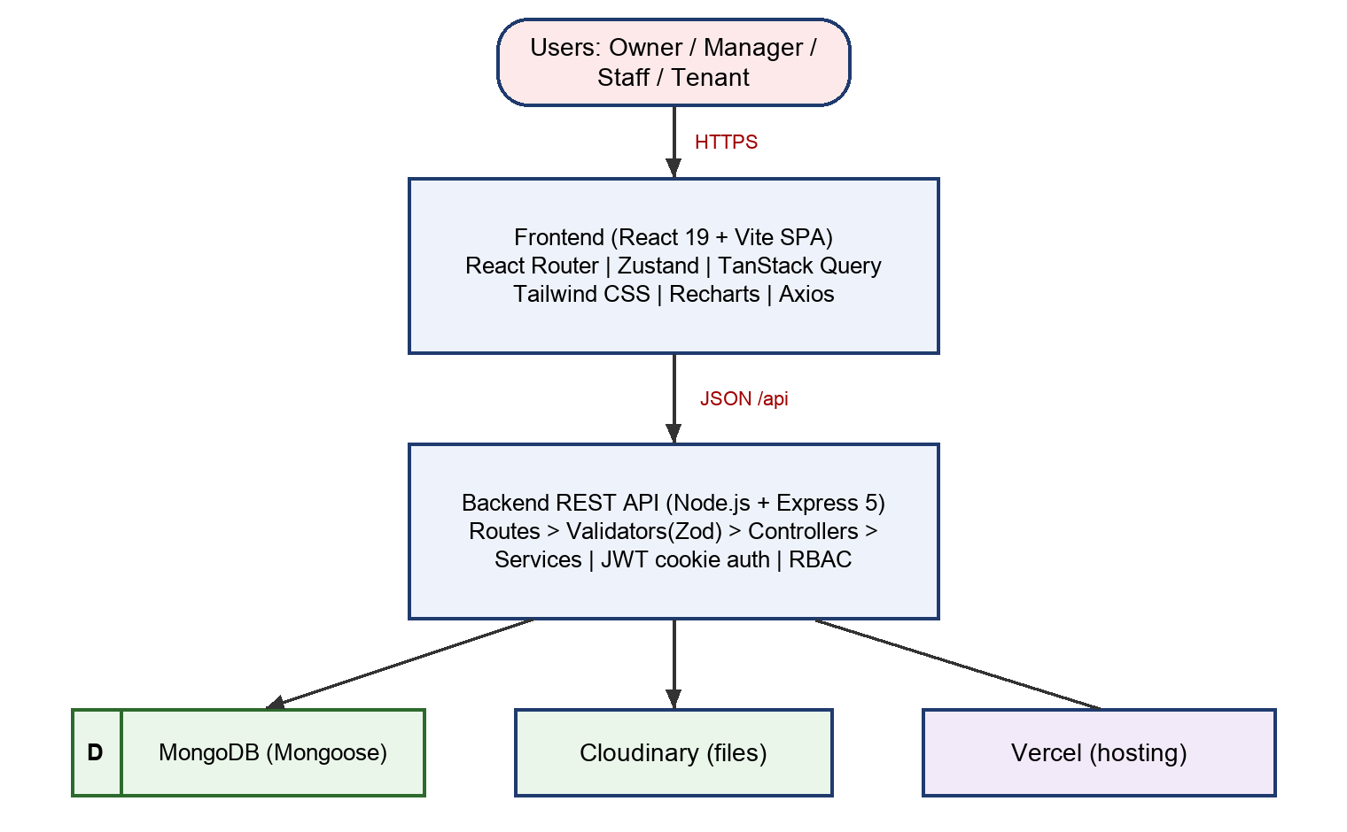
Figure 4.1: System architecture of The Hostel Yard
The separation between controllers and services is deliberate. Controllers only translate HTTP into function calls and back, while services contain the business rules such as preventing a bed from being allocated twice or computing the remaining balance on a rent due. This makes the rules testable without an HTTP server and reusable between modules, for example when the dashboard service needs the same dues logic as the rent service.
Figure 4.2 shows the entity-relationship view of the principal collections. An Organization owns Properties and Users. A Property contains Rooms, each Room contains Beds, and a Bed is occupied through an Allocation that links it to a Tenant. A RentDue belongs to an allocation and a tenant and receives one or more Payments. Complaints, Expenses, Announcements and Notifications are attached to a property and, where appropriate, to a tenant.
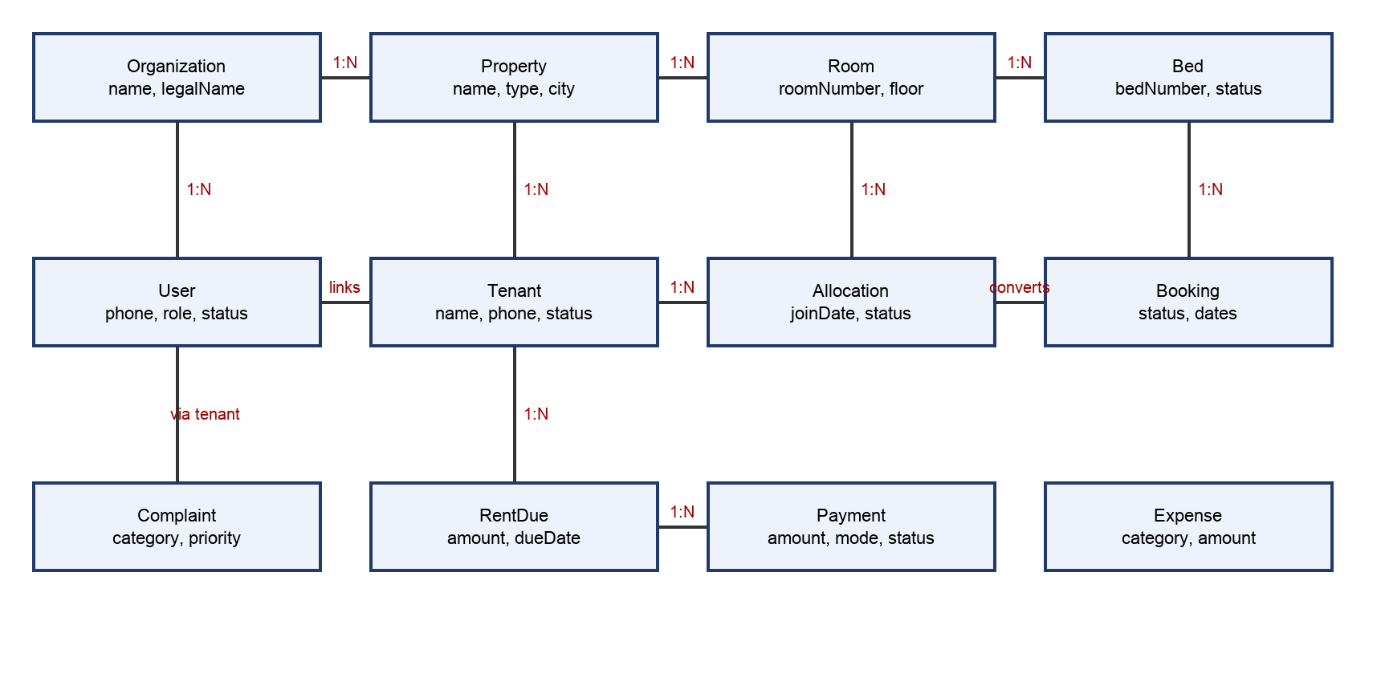
Figure 4.2: Entity-relationship diagram (principal entities)

4.2 Use Case Diagram
Figure 4.3 shows the use cases and the actors. The Business Owner and Landlord concentrate on oversight: properties, managers, expenses and reports. The Property Manager performs most operational use cases. Staff handle a limited subset such as complaints. The Tenant is a self-service actor who logs in, pays rent, raises complaints and reads announcements.
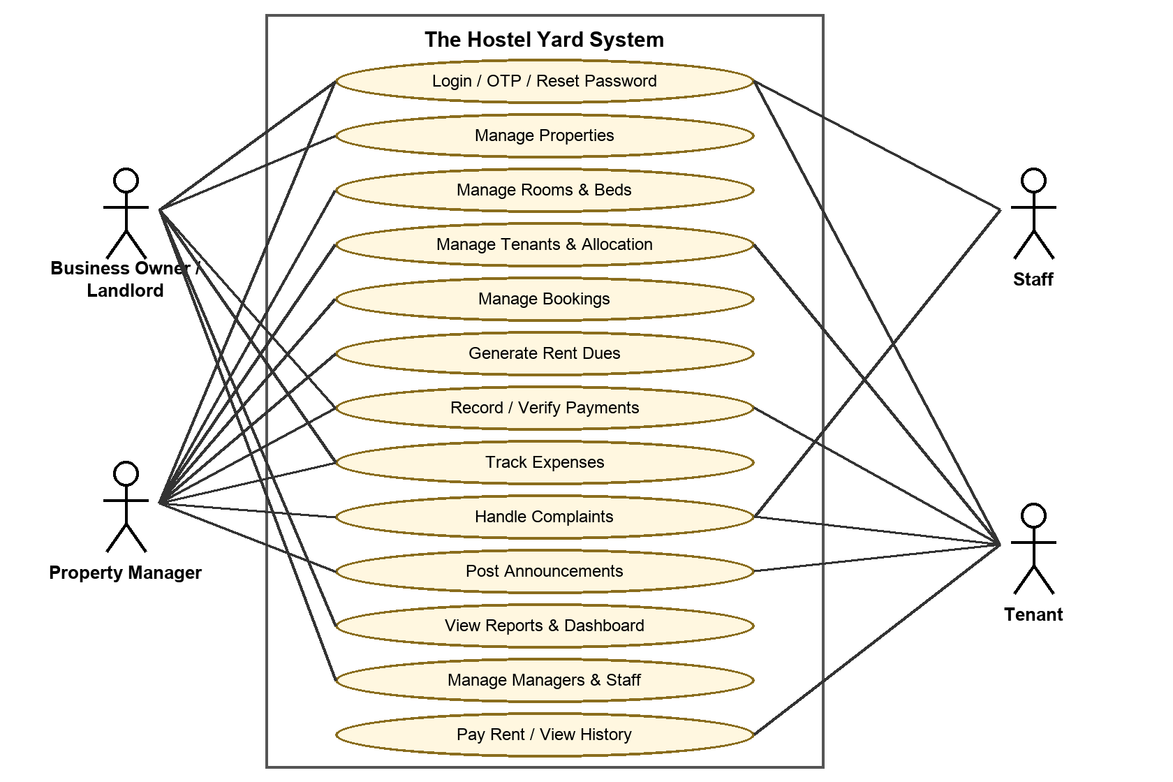
Figure 4.3: Use case diagram

4.3 Data Flow Diagrams

4.3.1 Level 0 DFD (context diagram)
The context diagram treats the entire system as a single process. Staff-side users (owners, managers and staff) send property, tenant, rent and expense data and receive reports and dashboards. Tenants send payments and complaints and receive dues and notices. The system stores and retrieves data from MongoDB and from Cloudinary for files.
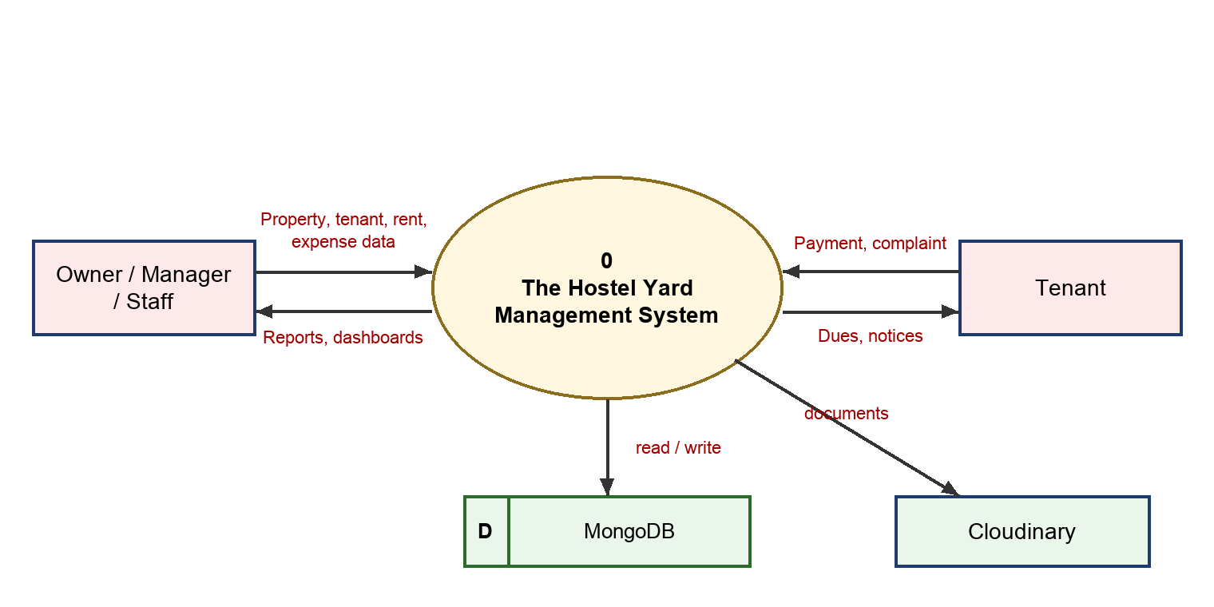
Figure 4.4: Level 0 data flow diagram

4.3.2 Level 1 DFD
At Level 1 the system is decomposed into six processes: authentication and access control, property/room/bed management, tenant and allocation management, rent and payments, complaints and announcements, and reports and dashboards. Each process reads or writes its own data stores.
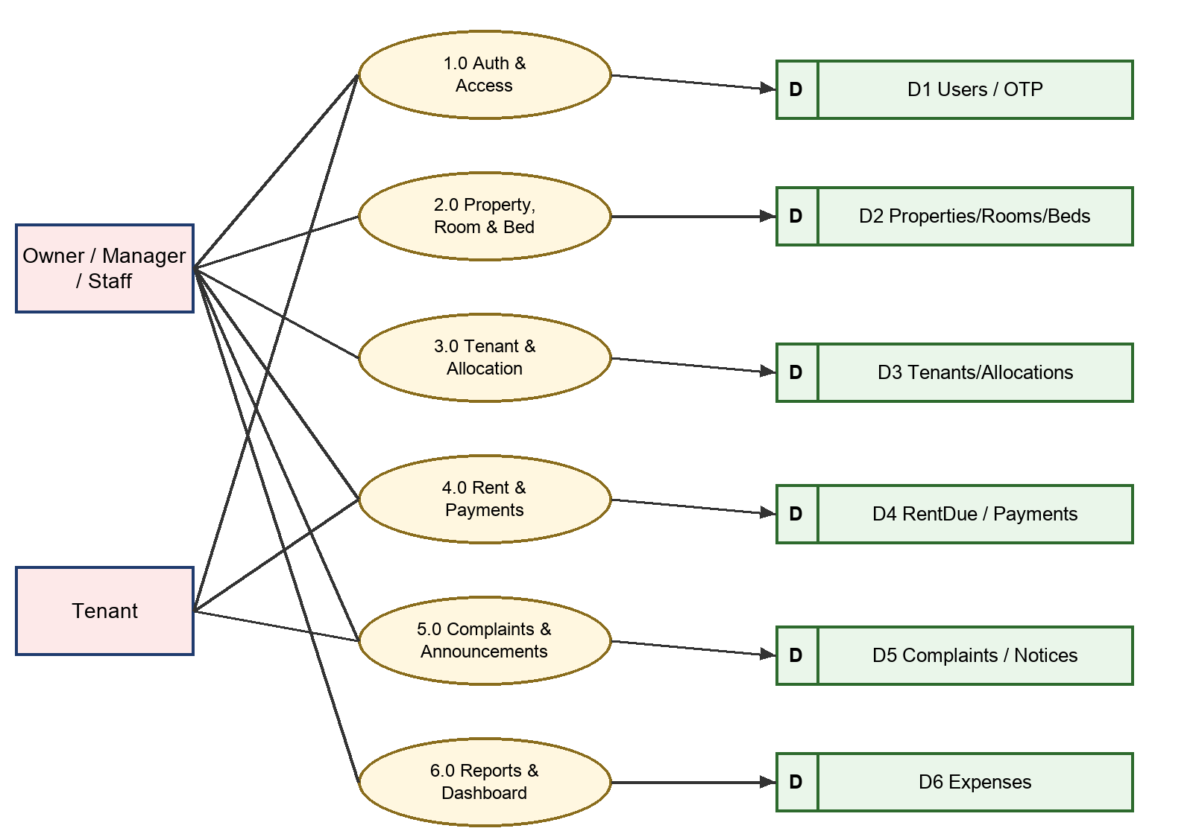
Figure 4.5: Level 1 data flow diagram

4.3.3 Level 2 DFD (Rent and Payments process)
The rent and payments process is the most important financial flow and is exploded at Level 2. A rent plan creates a rent due. The tenant submits a payment against the due with the mode (UPI or cash) and reference. The payment is stored as PENDING. A manager verifies or rejects it; on verification the due’s paid amount and status (PARTIAL or PAID) are updated, and the tenant is notified.
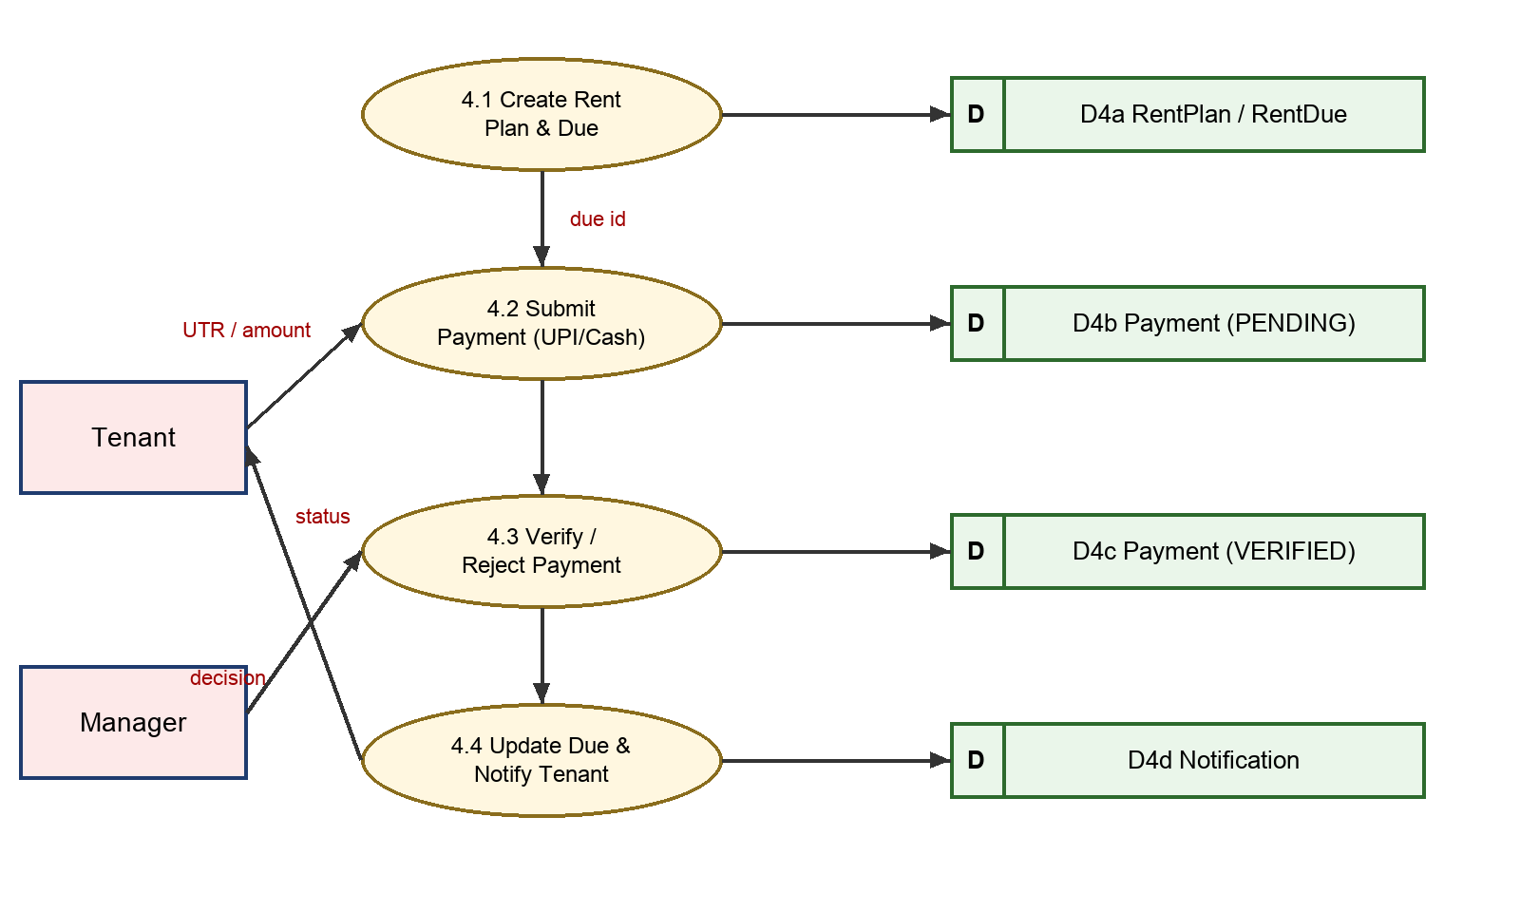
Figure 4.6: Level 2 data flow diagram of the rent and payments process

4.4 Module Information
The backend is organized by feature. Each module contains a model, a Zod validator, a service, a controller and a router. The table below summarizes the modules and their principal endpoints and rules.
Table 4.1: Module summary
Module | Responsibility and key rules
Authentication | Owner setup with OTP verification (6 digits, 5-minute expiry, maximum 5 attempts, 60-second resend cooldown, hashed in storage); login; forgot and reset password; JWT cookie session; account status check (ACTIVE required).
Organization and Property | Organization profile; properties with name, type, address and city; property selection on the client.
Managers and Staff | Invitation tokens; activation pages; property-manager assignment; staff assignments with limited permissions.
Rooms and Beds | Rooms with number, floor and type; beds with number and status such as AVAILABLE; availability queries.
Tenants | Tenant profile linked to organization and property; invitation and acceptance creating a user account; validation of phone numbers.
Allocations and Bookings | Assigns a tenant to a bed, marks the bed occupied, records join date and status; bookings reserve a bed before move-in.
Rent Plans and Dues | Plan defines amount and cycle; due generated per period with status PENDING, PARTIAL, PAID, OVERDUE or CANCELLED.
Payments and Payment Settings | Payments by CASH or UPI with PENDING, VERIFIED or REJECTED status; settings hold UPI details shown to tenants; verification updates the due.
Expenses | Expenses by category, amount and payment method per property.
Complaints | Categories (electrical, plumbing, cleaning, furniture, Wi-Fi, security, maintenance, other); priorities up to URGENT; status OPEN, ASSIGNED, IN_PROGRESS, RESOLVED, CLOSED or CANCELLED.
Announcements and Notifications | Property-wide notices; per-user notifications created by events such as payment verification.
Dashboard and Reports | Aggregation of collections, dues, expenses and occupancy for owner, business and tenant dashboards; report endpoints with validated filters.

4.4.1 Security design
- Every protected route first passes through protect, which verifies the JWT and requires an ACTIVE account.
- Authorization uses role and permission checks (roleMiddleware and the permission constants files).
- Passwords, OTPs and reset tokens are stored hashed; sensitive fields such as passwordHash use select: false so they are never returned by accident.
- CORS accepts only an allow-list of origins (the configured front-end URL, the Vercel URLs and the local development ports), with credentials enabled for cookie-based sessions.
- Zod validation protects every input; a central error middleware returns consistent JSON errors.

4.4.2 Testing
Automated tests are run with node --test. They cover the tenant update validator and an HTTP-level test of tenant update behaviour, and they guard against regressions in a module with many optional fields. Other modules were verified through manual end-to-end testing in the browser, following each role through its main flows.

4.5 Screenshots and Discussion of the Work Done
This section presents the principal screens of the application. For each screen, the feature or technology involved, its application in the project, its integration with other modules and its inputs and outputs are discussed, as required by the report guidelines.

4.5.1 Login and password recovery
[Insert screenshot here]
Source page: AuthPages.jsx
Figure 4.7: Login and password recovery screen
The login page authenticates every role through one form. Forgot-password and reset-password pages complete the recovery flow with an OTP.
- Feature of the technology/tool: Application of React forms, Zod-validated endpoints /api/auth/login and /api/auth/forgot-password, bcrypt comparison and a JWT cookie.
- Application in the project and integration: On success the authStore saves the user and the guards redirect to the correct dashboard: owners and managers to the staff application, tenants to the tenant portal.
- Inputs and outputs: Input: phone or e-mail and password (OTP and new password for recovery). Output: authenticated session, or a validation or account-status error message.

4.5.2 Business owner setup and OTP verification
[Insert screenshot here]
Source page: SetupOwnerPage and VerifyOwnerPage
Figure 4.8: Business owner setup and OTP verification screen
A new business owner enters name, contact details and organization name, receives a six-digit OTP and verifies it to activate the account.
- Feature of the technology/tool: Uses the SetupVerification and OTPVerification models, otpService (hashing, expiry, attempt limit and resend cooldown) and the setup token utility.
- Application in the project and integration: After verification an Organization and the owner User are created, which unlocks all other modules.
- Inputs and outputs: Input: owner and organization details, then the OTP. Output: ACTIVE owner account and a signed-in session. In development mode the OTP is printed on the server console.

4.5.3 Owner and business dashboard
[Insert screenshot here]
Source page: BusinessDashboard.jsx, OwnerDashboard.jsx
Figure 4.9: Owner and business dashboard screen
The dashboard summarizes occupancy, dues, recent collections and quick actions with charts rendered by Recharts.
- Feature of the technology/tool: TanStack Query fetches /api/dashboard data computed by dashboardService through MongoDB aggregation; components such as OccupancyCard, DuesOverview, RecentCollections and QuickActions present it.
- Application in the project and integration: It depends on the data created by the rent, payment, allocation and bed modules and links back to them through quick actions.
- Inputs and outputs: Input: selected property and period. Output: KPI cards, charts and shortcuts to pending work.

4.5.4 Property list and property form
[Insert screenshot here]
Source page: PropertyPages.jsx
Figure 4.10: Property list and property form screen
Owners create and edit properties of type hostel, PG, flat or hotel and switch between them.
- Feature of the technology/tool: Property model and propertyService with validation; propertyStore remembers the active property on the client.
- Application in the project and integration: The selected property scopes the rooms, beds, tenants, dues and reports shown in every other page.
- Inputs and outputs: Input: property name, type, address and city. Output: a property record and an updated property selector.

4.5.5 Rooms and beds inventory
[Insert screenshot here]
Source page: InventoryPages.jsx
Figure 4.11: Rooms and beds inventory screen
Rooms are created floor-wise with a type, and beds are created inside rooms. List and detail pages show occupancy status at a glance.
- Feature of the technology/tool: Room and Bed models, roomService and bedService, DataTable and Modal components.
- Application in the project and integration: Bed status is changed automatically when an allocation is created or ended.
- Inputs and outputs: Input: room number, floor, type, bed numbers. Output: inventory lists and status badges such as AVAILABLE.

4.5.6 Tenants and bed allocation
[Insert screenshot here]
Source page: TenantPages.jsx (people)
Figure 4.12: Tenants and bed allocation screen
Managers add tenants, invite them to create accounts and allocate an available bed to each tenant.
- Feature of the technology/tool: Tenant, TenantInvitation and Allocation models; allocationService prevents double allotment; invitation tokens make onboarding secure.
- Application in the project and integration: An allocation connects the tenant, bed and room, and later drives rent-due generation and tenant-portal content.
- Inputs and outputs: Input: tenant details, selected bed, join date. Output: tenant profile, allocation record and invitation link.

4.5.7 Rent plans and rent dues
[Insert screenshot here]
Source page: FinancePages.jsx (RentPage, RentPlanCreatePage)
Figure 4.13: Rent plans and rent dues screen
A rent plan fixes the amount and cycle for an allocation; the system generates dues for each period and shows their status.
- Feature of the technology/tool: RentPlan and RentDue models and rentService.generateRentDue; status moves between PENDING, PARTIAL, PAID and OVERDUE.
- Application in the project and integration: Dues feed the payment module, the dashboards and the tenant portal.
- Inputs and outputs: Input: rent amount, cycle, due date. Output: list of dues with balances and colour-coded statuses.

4.5.8 Payments and verification
[Insert screenshot here]
Source page: FinancePages.jsx (PaymentListPage, PaymentDetailPage, PaymentSettingsPage)
Figure 4.14: Payments and verification screen
Tenants submit a payment against a due using UPI or cash; managers verify or reject it. Payment settings hold the UPI details shown to tenants.
- Feature of the technology/tool: paymentService (createTenantPayment, verifyPayment, rejectPayment), PaymentSettings model, enumerated status PENDING, VERIFIED, REJECTED.
- Application in the project and integration: Verification updates the related rent due and creates a notification for the tenant; verified payments appear in collections on the dashboards.
- Inputs and outputs: Input: amount, mode, reference and a manager decision. Output: payment status, updated due balance and a notification.

4.5.9 Expenses
[Insert screenshot here]
Source page: ExpenseListPage, ExpenseFormPage
Figure 4.15: Expenses screen
Owners and managers record expenses such as maintenance, salaries and utilities.
- Feature of the technology/tool: Expense model with category, amount and payment method; expenseService and validators.
- Application in the project and integration: Expenses are combined with collections in reports to show net performance per property.
- Inputs and outputs: Input: category, amount, date, method. Output: expense list and totals.

4.5.10 Complaints and announcements
[Insert screenshot here]
Source page: OpsPages.jsx
Figure 4.16: Complaints and announcements screen
Tenants raise complaints with category and priority; managers assign and resolve them. Managers publish announcements to a property.
- Feature of the technology/tool: Complaint and Announcement models; complaintService tracks the OPEN to CLOSED life cycle; notificationService informs users.
- Application in the project and integration: Complaints link to a tenant, room and bed; announcements and notifications appear in the tenant portal.
- Inputs and outputs: Input: complaint description, category, priority; announcement title and body. Output: tickets with status history and notices.

4.5.11 Reports
[Insert screenshot here]
Source page: ReportsPage.jsx
Figure 4.17: Reports screen
Owners analyse collections, dues, expenses and occupancy over time.
- Feature of the technology/tool: reportService aggregates data with validated filters; Recharts draws the visualizations.
- Application in the project and integration: Consumes data from the payments, dues, expenses and allocations modules.
- Inputs and outputs: Input: date range and property filters. Output: charts and tables.

4.5.12 Tenant portal
[Insert screenshot here]
Source page: tenant/TenantPages.jsx, TenantDashboard.jsx
Figure 4.18: Tenant portal screen
A mobile-friendly area where a tenant sees the bed, pays rent, reviews history, raises complaints and reads announcements.
- Feature of the technology/tool: TenantLayout and TenantAppGate restrict access; tenantAccountService and getTenantPaymentInformation supply data.
- Application in the project and integration: It reuses the payment, complaint and announcement APIs with tenant-scoped permissions.
- Inputs and outputs: Input: payment details or a complaint. Output: confirmations and live status of dues and tickets.

CHAPTER 5
CONCLUSIONS AND FUTURE SCOPE

5.1 Conclusion
The Hostel Yard demonstrates that a complete, secure and practical property management system can be built by a single developer with a modern JavaScript stack. The project achieved its objectives: it models the hierarchy of organization, property, room and bed; automates rent dues; introduces a verifiable payment workflow; handles complaints and announcements; and presents owners with dashboards and reports. Role-based access control, OTP verification, hashed secrets and request validation provide a sound security baseline, and the Vercel configuration allows the whole system to be deployed from one repository.
The project also provided practical learning in requirement analysis, database design, API design, layered architecture, state management, authentication, deployment and debugging. Particular lessons were the importance of validating input at the boundary, keeping business rules in services rather than controllers, scoping every query by organization, and designing statuses as explicit state machines.

5.2 Use of the Learned Technology in the Final-Year Major Project
- The layered backend template (routes, validators, controllers, services, models) can be reused directly as the skeleton of the major project.
- The authentication and RBAC modules, including OTP, invitations and permission constants, can be copied and extended for any multi-role application.
- The React structure with feature-based pages, guards, Zustand stores and TanStack Query hooks will speed up the front end.
- Cloudinary uploads, Zod validation, central error handling and the Vercel monorepo setup are reusable infrastructure.
- Learning from this work will be extended with TypeScript, containerization with Docker and a continuous-integration pipeline.

5.3 Industrial Relevance of the Technology Used
The MERN family is among the most widely used stacks in start-ups and product companies. Node.js is used by organizations such as Netflix, PayPal and LinkedIn for API layers; React is the most popular front-end library; MongoDB is widely used for content, catalogue and operational data; and serverless platforms such as Vercel are common for deployment. The practices followed here, namely REST design, JWT authentication, RBAC, schema validation, multi-tenancy, Git-based workflows and CI-friendly testing, are the same as those expected in industry. Property technology (PropTech) and co-living are also fast-growing sectors in India, so the domain itself is commercially relevant.

5.4 Societal Relevance and Impact of the Project
- Transparency: tenants see exactly what they owe and what they have paid, reducing disputes between tenants and owners.
- Safety and accountability: complaint tracking and announcements make living conditions better and issues visible.
- Formalization of small businesses: small owners get affordable digital tools, records and reports that help them access credit and comply with taxation.
- Student and worker welfare: better-managed accommodation directly improves the living experience of millions of students and migrants.
- Reduced paper use: replacing registers and receipts with digital records is environmentally beneficial.
- Data protection: the system stores personal details, so privacy by design (hashing, access control and tenant isolation) is an ethical responsibility that the project takes seriously.

5.5 Future Scope
- Integration with a payment gateway (UPI intent, cards and auto-reconciliation) with automatic receipts.
- Production SMS, WhatsApp and e-mail delivery for OTPs, reminders and notices.
- Automatic overdue reminders and late-fee calculation using scheduled jobs.
- Food menu, mess attendance, visitor and gate-pass modules, as listed in the project plan.
- Digital agreements with e-signature, and KYC document verification.
- Native mobile applications (React Native) and push notifications.
- Advanced analytics: occupancy forecasting and pricing suggestions using machine learning.
- IoT integration for smart locks and electricity metering.
- Wider automated test coverage, TypeScript migration and CI/CD with monitoring and audit logs.
- Multi-language support for regional users.

REFERENCES
- Node.js Foundation, “Node.js Documentation,” https://nodejs.org/docs.
- Express.js, “Express 5.x API Reference,” https://expressjs.com.
- MongoDB Inc., “MongoDB Manual,” https://www.mongodb.com/docs/manual/.
- Mongoose, “Mongoose Documentation,” https://mongoosejs.com/docs/.
- Meta Open Source, “React Documentation,” https://react.dev.
- Vite, “Vite Guide,” https://vite.dev/guide/.
- TanStack, “TanStack Query Documentation,” https://tanstack.com/query/latest.
- Tailwind Labs, “Tailwind CSS Documentation,” https://tailwindcss.com/docs.
- Colin McDonnell, “Zod Documentation,” https://zod.dev.
- M. Jones, J. Bradley and N. Sakimura, “JSON Web Token (JWT),” RFC 7519, IETF, 2015.
- N. Provos and D. Mazières, “A Future-Adaptable Password Scheme,” USENIX Annual Technical Conference, 1999.
- Vercel, “Vercel Documentation,” https://vercel.com/docs.
- Cloudinary, “Cloudinary Documentation,” https://cloudinary.com/documentation.
- I. Sommerville, Software Engineering, 10th ed., Pearson, 2015.
- The Hostel Yard project repository and planning document (THE-HOSTEL-YARD-PLAN.md).

APPENDICES
Appendix A: Repository structure
Path | Contents
backend/src/models | 24 Mongoose models
backend/src/routes | Route definitions per module (18 routers)
backend/src/controllers and services | HTTP handlers and business rules
backend/src/validators | Zod schemas
backend/src/middlewares | Auth, role, upload, validation and error middleware
backend/src/modules | Dashboard and reports modules
backend/tests | Automated tests (node --test)
frontend/src/pages and features | React pages and dashboard components
frontend/src/store and services | Zustand stores and API clients
vercel.json | Vercel services and rewrites
Appendix B: Environment variables
The backend requires MONGODB_URI, JWT_SECRET, FRONTEND_URL and Cloudinary credentials, as documented in the .env.example files. Secrets must never be committed to the repository.

