 Client : M. TOGBE

Fitness Buddy

*Functional Specifications*

Groupe Tripaloski :

Filips BARAKATS

Loïc de La Tullaye

# Project Overview

Create a Fitness buddy that allows users to set, monitor, and analyze their fitness habits and daily routines. The app could help users build exercises, fitness routines, track progress, and visualize growth over time using customizable features and detailed insights.

# Key Features

1. **Exercises Creation and Customization:**
   * Users can create an exercise by setting a name, image, description and instruction.
   * Browse through the exercises provided.
2. **Routines Creation and Customization:**
   * Users can create fitness routines by setting a name, color, icon, and time reminder.
   * They can set a goal for each routine: How many times a week or day must it be completed.
   * The app can also provide custom routines.
3. **Progress Tracking and Streaks:**
   * Display visual streaks and completion history, motivating users to maintain their fitness routines.
   * A calendar view shows how consistently users have completed a habit, highlighting any missed days. (Implement with google calendar)
   * Achievement system that rewards the user for completed routines and exercises.
4. **Statistics and Insights:**
   * Generate insights into fitness trends, completion rates, and streak length.
   * Create a dashboard with weekly and monthly habit statistics using Jetpack Compose charts.
5. **Notifications and Reminders:**
   * Send reminders for each routine based on a user’s preferred schedule.
   * Implement push notifications or local notifications to alert users.
6. **Dark Mode and Custom Themes:**
   * Jetpack Compose theming to support light and dark modes, with options for custom colors.
7. **Data Persistence:**
   * Room database for storing user data locally, and spring boot for cloud storage
8. **Required features:**
   * Registration and login with email and password, google and GitHub.
   * View the user’s profile (profile picture, name, email, join date, routine streak).
   * Share an exercise, routine or achievement via Gmail, SMS, any other social media.
   * Admin can see the evolution of connections to the app.
   * A user can see the graphic of screentime of the application.
   * French, English and Russian languages.
   * Unit tests.

# User use cases

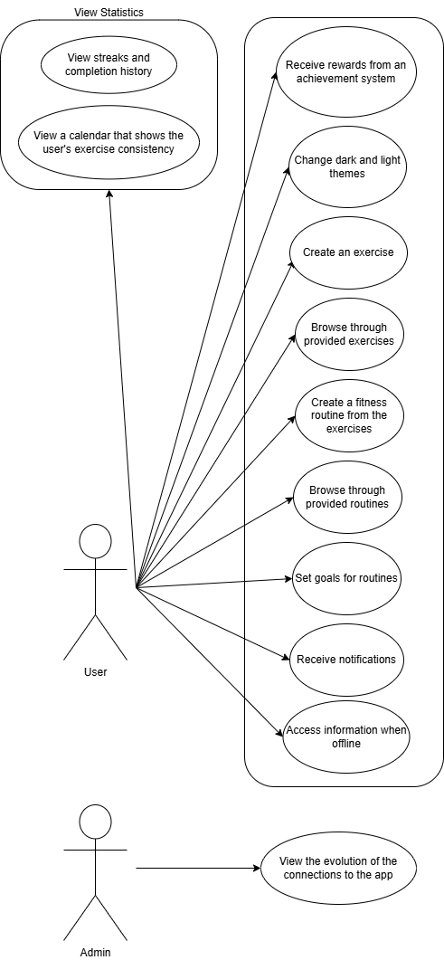

# Technical Specifications

* **Jetpack Compose:** For the UI, which will be modern, reactive, and responsive:
  + Speeds up testing and uses a single code base to write code.
* **Room:** For local data storage of habits, streaks, and user settings:
  + It’s a lightweight local database compatible with Kotlin that allows simple data storage.
* **Spring boot:** Remote data sync, user authentication, and cloud backup:
  + We have a lot of experience on this back-end platform.
* **Minio:** Document saving platform:
  + Service to store and retrieve heavy files, easy to host and free.
* **PostgreSQL:** Database:
  + Relational database that we use regularly and easy to synchronize with spring.
* **Charts and Graphs:** Compose libraries like MPAndroidChart or others to display progress visually:
  + The library provided by Jetpack Compose provides everything to implement graphs quickly and easily.