**J. Cent. South Univ.** (2013) 20: 3437−3444



**DOI:** 10.1007/s11771­013­1868­1

Bending stress of rolling element in elastic composite cylindrical roller bearing

YAO Qi­shui(姚齐水)1, 2 , YANG Wen(杨文)2, YU De­jie(于德介)1, YU Jiang­hong(余江鸿)2

1. College of Mechanical and Vehicle Engineering, Hunan University, Changsha 410082, China;
2. College of Mechanical Engineering, Hunan University of Technology, Zhuzhou 412007, China

© Central South University Press and Springer­Verlag Berlin Heidelberg 2013

**Abstract:** A new structure design method of elastic composite cylindrical roller bearing is proposed, in which PTFE is embedded into a hollow cylindrical rolling element, according to the principle of creative combinations and through innovation research on cylindrical roller bearing structure. In order to systematically investigate the inner wall bending stress of the rolling element in elastic composite cylindrical roller bearing, finite element analysis on different elastic composite cylindrical rolling elements was conducted. The results show that, the bending stress of the elastic composite cylindrical rolling increases along with the increase of hollowness with the same filling material. The bending stress of the elastic composite cylindrical rolling element decreases along with the increase of the elasticity modulus of the material under the same physical dimension. Under the same load, on hollow cylindrical rolling element, the maximum bending−tensile stress values of the elastic composite cylindrical rolling element after material filling at 0° and 180° are 8.2% and 9.5%, respectively, lower than those of the deep cavity hollow cylindrical rolling element. In addition, the maximum bending­compressive stress value at 90° is decreased by 6.1%.

**Key words:** elastic composite cylindrical roller bearing; hollowness (degree of filling); finite element analysis; bending stress; rolling element

# Introduction

As a kind of important mechanical element, the cylindrical roller bearing directly affects the working performance of the whole machine. It is found that the solid cylindrical roller bearing has defects including low load bearing precision, high vibration noise, and being easily damaged under high speed or heavy load conditions. In order to overcome these disadvantages, hollow cylindrical roller bearings [1−3] have been designed and thoroughly investigated. The structural characteristic of the hollow cylindrical roller bearing is that the rolling element is hollow, which is classified into two types: with preload and without preload [4]. Because the hollow cylindrical rolling element possesses higher elasticity compared to the solid one, contact area between the hollow cylindrical roller bearing and ring increases in the case of load, therefore, service life is prolonged due to reduction of contact stress [5−7]. Because the hollow cylindrical roller bearing has lighter weight, smaller centrifugal inertial force and higher adaptive rotation speed [8], it has been paid wide attention in high­speed bearing. Various kinds of new types of hollow cylindrical roller bearings are

continuously designed, in addition, large quantity of work has been done regarding structural design, and theoretical analysis as well as application [9−11].

It is shown in theoretical and experimental research that hollow cylindrical roller bearing has advantages in many aspects, however, there are also some problems, especially the bending fatigue fracture is apt to occur with the hollow cylindrical rolling element under periodical alternative deformation state [12−13].

Some defects in traditional (both in solid and hollow) cylindrical roller bearings make them hard to satisfy some special mechanical requirements. Through innovative research on the structure of the cylindrical roller bearing, the design method of new structure in elastic composite cylindrical rolling element is put forward in which PTFE (Polytetrafluoroethylene) is embedded into the deep cavity hollow cylindrical rolling element, to maintain the advantages of hollow cylindrical roller bearing. The cylindrical roller bearing designed is named as elastic composite cylindrical roller bearing [14−15]. The structures of the three kinds of elements are as shown in Fig. 1. The detailed structure of the elastic composite cylindrical roller bearing is shown in Fig. 2. Because the rolling element of the elastic composite cylindrical roller bearing is easier to be deformed than

**Foundation item:** Project(51175168) supported by the National Natural Science Foundation of China; Projects(2011GK3148, 2012GK3092) supported by Science and Technology Program of Hunan Province, China

**Received date:** 2013−01−12; **Accepted date:** 2013−04−10

**Corresponding author:** YAO Qi­shui, Professor, PhD Candidate; Tel: +86−731−22183978; E­mail: [yaoqishui@126.com](mailto:yaoqishui@126.com)

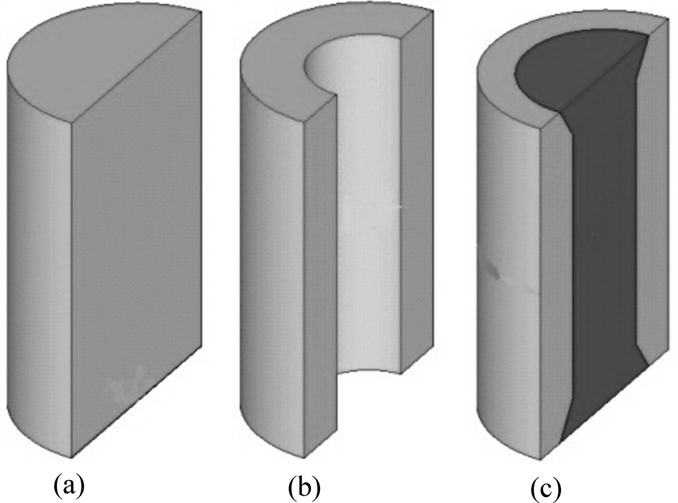

**Fig. 1** Three kinds of rolling elements: (a) Solid rolling element;

(b) Hollow rolling element; (c) Elastic composite cylindrical rolling element

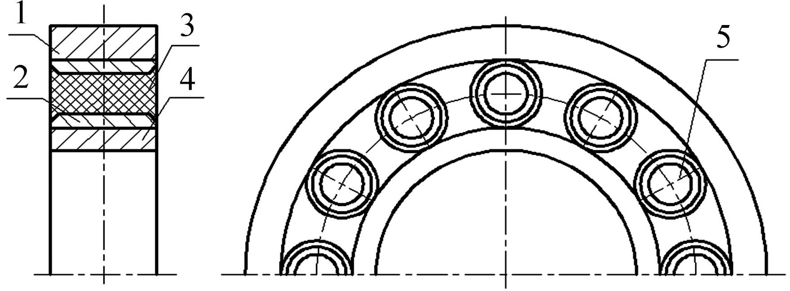

**Fig. 2** Structural drawing of elastic composite cylindrical roller bearing: 1—Bearing outer ring; 2—Deep cavity hollow rolling element; 3—Bearing inner ring; 4—Inner ring of bearing; 5—

Elastic composite cylindrical rolling element

the solid one, its anti­fatigue damage ability increases and safe service life is prolonged. In addition to lighter weight, higher precision and higher rotational speed, the PTFE in the hollow rolling element possesses extra good

basically the same; the load attached to the elastic composite cylindrical roller bearing can be transmitted to the outer ring and vice versa. Here, we will discuss the load distribution inside the elastic composite cylindrical roller bearing and general cylindrical roller bearing and the stress of elastic composite cylindrical rolling element under radial load.

## Load distribution inside cylindrical roller bearing under static load

In most rolling bearing applications, inner ring and outer ring operate stably, rotate usually at relatively low speed, there is not big inertia force to affect load distribution between the rolling elements, and friction force and moment acting on the rolling element do not generate remarkable influence on the load distribution. So, a roller­race (linear) contact is given by [20]

*Q*=*K*1*δn* (1)

where *Q* is the normal load of roller­race (N), *K*1 is the load−displacement coefficient (N/mm), *δ* is the displacement or contact deformation (mm), and *n* is the load−displacement index (for ball bearings, *n*=3/2; for roller bearings, *n*=10/9).

Under the load, the approached value in normal direction between the two races separated by the rolling element equals the sum of approached value between rolling element and every race:

*δ*n=*δ*i+*δ*o (2)

Then

*n*

physical characteristics, so the new type of bearing also   

  1  

(3)

behaves remarkable vibration absorption effect.

The researches on structural design and bearing

*K* n     1 1  

   

capacity of the elastic composite cylindrical roller bearing [16−17] show that bending fatigue fracture,

caused by heavy bending stress, has become one of

And

☹ (1 / *K*i ) *n* ＋ (1 / *K*o ) *n* ☺

*n*

failure forms of hollow cylindrical roller bearing. In order to explore the effect of bending stress on the elastic

*Q*=*K*n*δ*

For contact between steel roller and race, there is

4

(4)

composite cylindrical roller bearing, bending stress of the elastic composite roller is taken as the research object

*K*1   8.06  10

*I* 8 / 9

(5)

and mechanical analysis is carried out under static load

where *I* is the roller length.

state of the elastic composite cylindrical roller bearing. In addition, numerical computations are related with non­linear finite element [18−19] software, ABAQUS, to

*F*   *ZK* (    1 *P* )*n*

r n r 2 d

*J* r ( )

(6)

understand stress distribution of the inner wall and influence of PTFE on the stress of the inner wall.

# Static stress analysis of elastic composite

where *F*r is the applied load (N), *Z* is number of the

rolling elements, *P*d is the radial internal clearance (mm), and *J*r(*ε*) is integral of the radial load distribution.

1

*Q*   *K*  *n*

  *K* (  

*P* )*n*

(7)

# cylindrical roller bearing

max

n   0

n r 2 d

Loads on the elastic composite cylindrical roller bearing and the general cylindrical roller bearing are

where *φ* is the directional angle (°).

*F*r=*ZQ*max*J*r(*ε*) (8)

10 / 9

1

  

*Q*   *Q*max  1   2 (1   cos  ) 

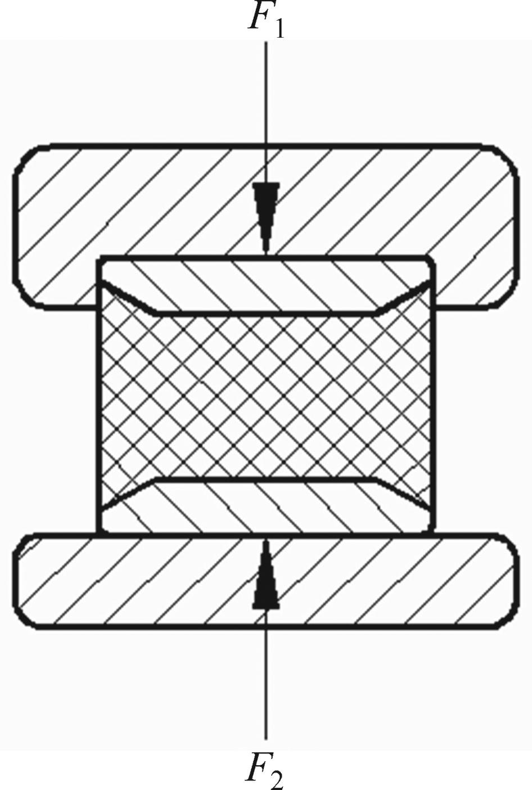

(9)

☹ ☺

According to the above equation, the load distribution inside the cylindrical roller bearing can be calculated if *Z*, *P*d and *I* are known.

In order to investigate the load distribution inside the elastic composite cylindrical roller bearing, model NU318E of cylindrical roller bearing is taken to calculate according to the above equation. And the loads inside elastic composite cylindrical roller bearings, with the same dimension as NU318E and with different degrees of filling, are also calculated with finite element analysis. The results show that the load distribution in the elastic composite cylindrical roller bearing with the degree of filling below 65% is not remarkably different from that of the traditional cylindrical roller bearing under the same clearance. The simple and effective theoretical calculation method of load distribution inside elastic composite cylindrical roller bearing has provided essential data for the finite element analysis. The load distribution inside elastic composite cylindrical roller bearing is shown in Fig. 3.

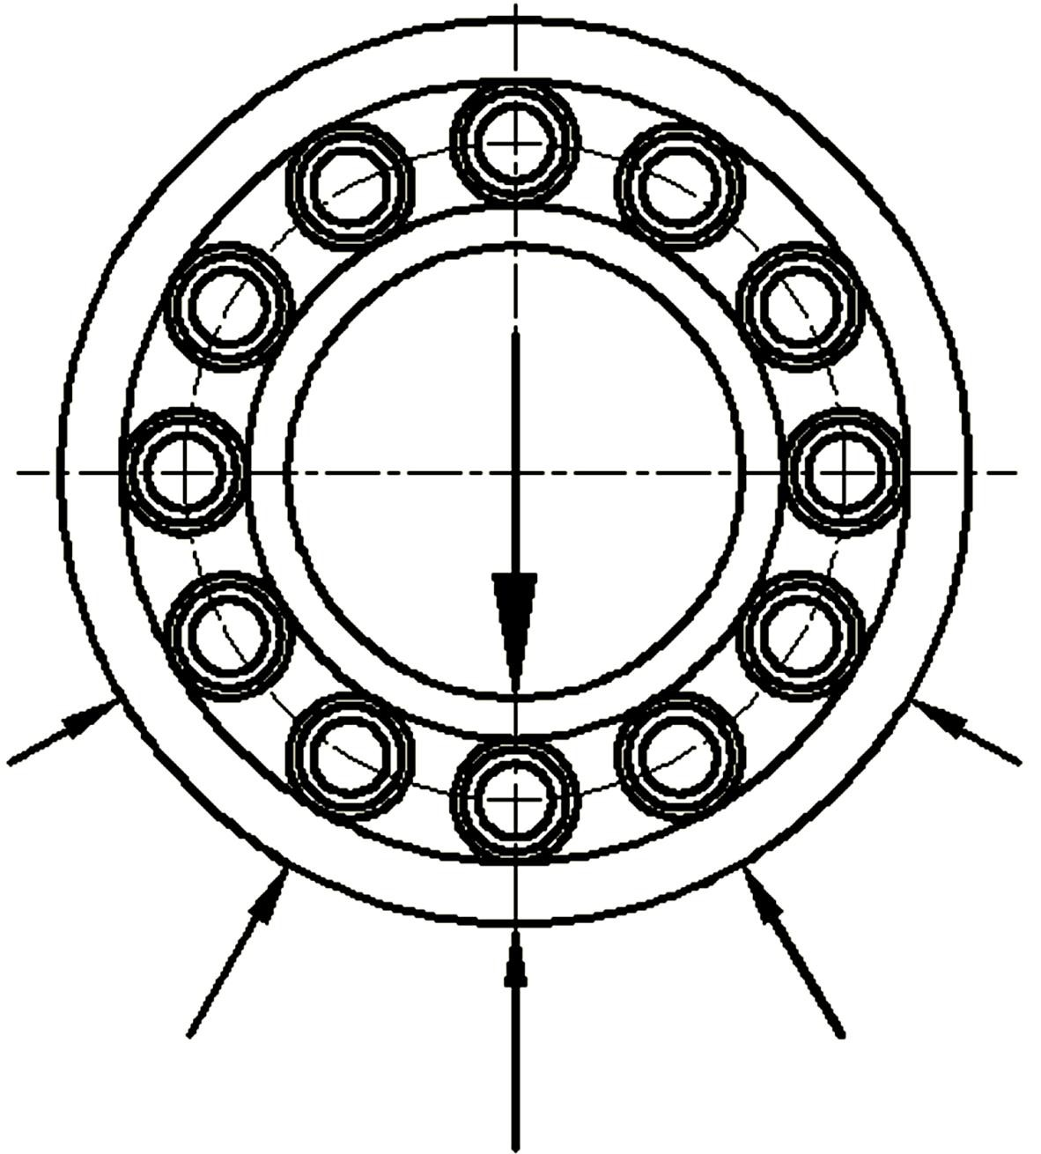

**Fig. 3** Load distribution inside elastic composite cylindrical roller bearing

## Stress analysis of elastic composite cylindrical roller bearing under static load

As shown in Fig. 4, the radial load borne by composite element at contact point of inner and outer races is the same under the action of single radial load, *F*1=*F*2=*F* [20]. The composite element contacts with inner and outer races and generates contact stress under radial load. The element is bent and deformed under the stress; pulling stress is generated at points *A* (0°) and *C* (180°) due to pulling strength; compressive stress is generated at points *B* (90°) and *D* (270°) due to compressive stress (Fig. 5). Because the embedded PTFE plays the role in load bearing and transmission, the bending stress of the inner wall is smaller than that of the hollow rolling element.

**Fig. 4** Finite element analysis on elastic composite cylinder rolling under action of load–race load

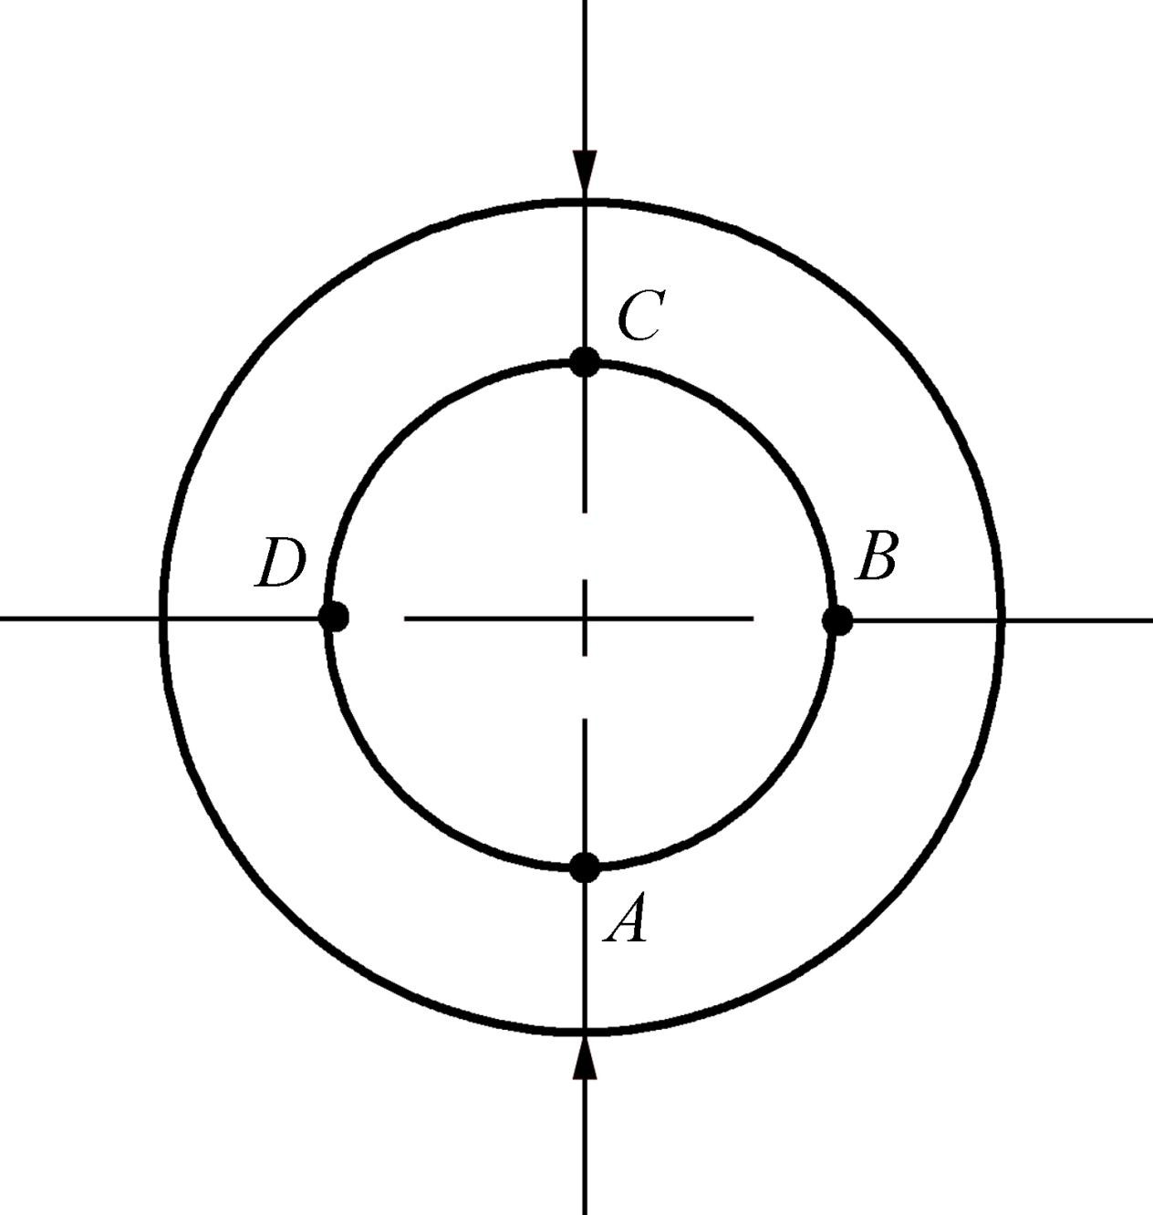

**Fig. 5** Sectional load of elastic composite cylinder rolling element

# Numerical analysis of bending stress at inner wall of elastic composite cylindrical rolling element

Bending stress is one of the factors affecting bearing performance of the elastic composite cylindrical roller bearing [21]. It is found that bending fatigue is not generated in the case that pulling stress of the inner wall is lower than 379 MPa, and the failure mode is contact fatigue and pocking mark peeling. If the pulling stress of the inner wall is higher than 490 MPa, then bending fatigue fracture will occur. In general bearing design, the pulling stress of the inner wall is below 345 MPa, therefore, the hollow cylindrical roller bearing can maintain relatively high working life.

To investigate the influence of physical dimension and filling material of the rolling element on bending stress of the elastic composite cylindrical roller bearing, comparative analysis is utilized in elastic composite cylindrical rolling elements with different physical dimensions and filling materials. In order to investigate the difference among elastic composite cylindrical roller

bearing and other cylindrical roller bearings regarding bending stress, the comparative analysis is used again, taking hollow cylindrical roller bearing, deep cavity hollow cylindrical roller bearing and elastic composite cylindrical roller bearing as three types. The performance of all the three kinds of bearings is related to physical dimension of the roller. In other words, under a certain load, the optimum structural dimension of roller in hollow cylindrical roller bearing, deep cavity roller bearing and deep cavity hollow roller bearing can be determined through optimization design. In addition, the optimum physical dimension of the roller is different depending on the different loads borne by the bearing [22]. Therefore, finite element analysis is taken on bending stress of the inner wall in the three types of bearing with different hollowness (degree of filling) under the same load and the same physical dimension.

## Confirmation of geometric dimension and material characteristics of model

The dimensions of NU318E bearing are taken as the physical dimensions of three types of bearings and the related parameters are listed in Table 1 after referring to

GB T 283—2007 and GB T 4661—2002. Considering

structural characteristics and load characteristics of the roller bearing, it takes only 1/2 of the rolling element, 1/4 of the inner ring and 1/16 of the outer ring as finite element analysis model to simplify the analysis, as shown in Fig. 6.

**Table 1** Physical dimension parameters of NU318E bearing

|  |  |
| --- | --- |
| Parameter | Value |
| Inner diameter of bearing/mm | 90 |
| Outer diameter of bearing/mm | 190 |
| Width of bearing/mm | 43 |
| Diameter of rolling element/mm | 28 |
| Length of rolling element/mm | 30 |
| Number of rolling elements | 13 |

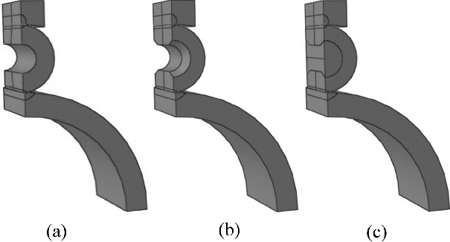

**Fig. 6** Finite element analysis model of three types of bearings:

(a) Hollow cylindrical rolling bearing; (b) Deep hole hollow cylindrical roller bearing; (c) Elastic composite cylindrical rolling bearing

The inner and outer rings are all made of GCr15 bearing steel with elastic modulus of 207 GPa and Poisson ratio of 0.3. The elastic modulus of PTFE is 280 MPa, and Poisson ratio is 0.4.

Regarding structural dimension of rolling element and influence of filling materials on the bending stress of the elastic composite cylindrical rolling element, the finite element model for elastic composite cylindrical roller bearing is built with 40%−70% degree of filling of the rolling element. The performance parameters of filling materials mainly include elastic modulus of the materials. Under certain inner dimensions of the rolling element, the high molecular materials are taken as the filling materials to carry out finite element analysis. The corresponding performances are listed in Table 2.

**Table 2** Corresponding performances of high molecular materials

|  |  |  |
| --- | --- | --- |
| Material | Elastic modulus/MPa | Poisson ratio |
| PE (Low density) | 172 | 0.439 |
| ABS plastics | 200 | 0.394 |
| PTFE | 280 | 0.4 |
| PP copolymer | 896 | 0.410 3 |
| PE (High density) | 1 070 | 0.410 1 |
| PTFE | 1 200 | — |
| Polyethylene (pp) | 1 649 | — |

PBT 1 930 0.390 2

## Definition of boundary and load

ABAQUS [23] provides various types of attachment constraint methods. Combined with objective conditions of the model, symmetry constraint is used because the model is highly symmetric. The constraint in U2 and U3 directions is used on inner ring bottom section and U1= UR2=UR3=0 for constraint of left section of inner and outer rings and rolling element. In addition, U3 constraint is taken on longitudinal center line of the left section.

Under the static load, the inside load distribution of cylindrical roller bearing is calculated according to Eqs. (1)−(9) and it is concluded that the load of the rolling element at 0° position is the maximum, and is 2.5×107 Pa according to load to surface area and load to the upper side of the outer ring.

## Contact establishment and meshing

There are connections between rings and rolling element of the model and between the two kinds of materials in the elastic composite cylindrical rolling element, which play the role in load bearing and transmission. Take contact surface of rings as the main surface and contact surface of the rolling element as the

auxiliary surface to establish contact pairs separately, and then take outer wall of the filling material as the auxiliary surface and inner surface of the rolling element as the main surface to establish contact pairs between filling materials and hollow rolling elements.

When considering factors including geometric shape, load condition and material combination etc. as the study objects, the whole axisymmetric model uses quadratic nonlinear three­dimensional space unit C3D15. Analysis precision and efficiency of finite element analysis have intimate relationship with unit density and geometric shape of the unit. Too dense mesh may cause too long calculation time and too loose mesh cannot precisely describe spatial change of the variables. Therefore, more and finer meshes should be subdivided at contact positions between the elastic composite cylindrical rolling element and the rings to improve calculation precision. On the other hand, other parts can be rougher to save calculation time in the case that there is no remarkable influence on the precision. The stress converged with coarse to fine meshes is shown in Fig. 7. The stress will increase with elements of model increasing. Finally, the model which contains 8 139 elements is reasonable. The mesh division is shown in Fig. 8.

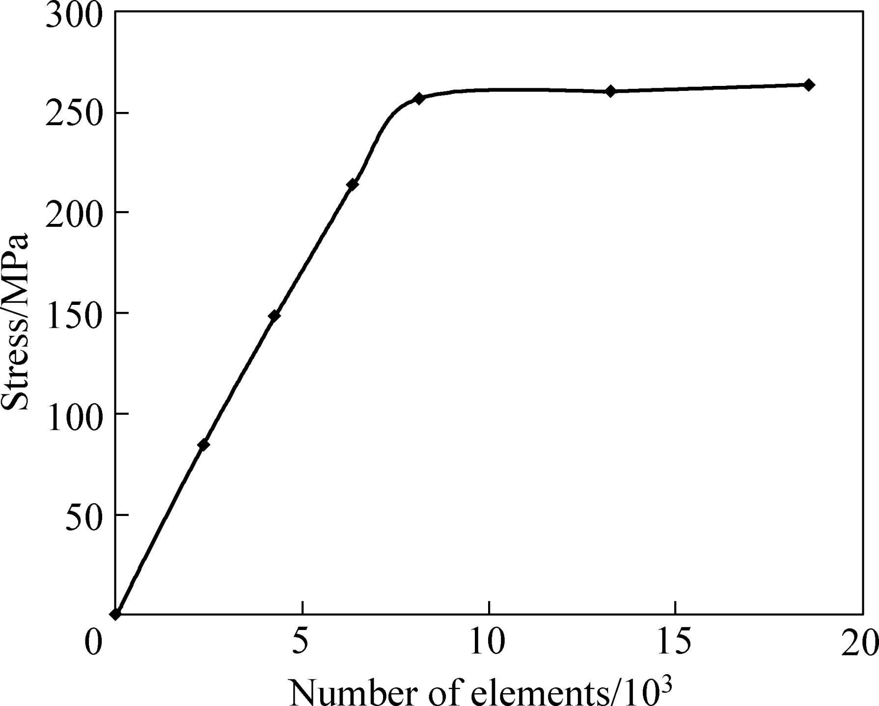

**Fig. 7** Stress vs number of elements

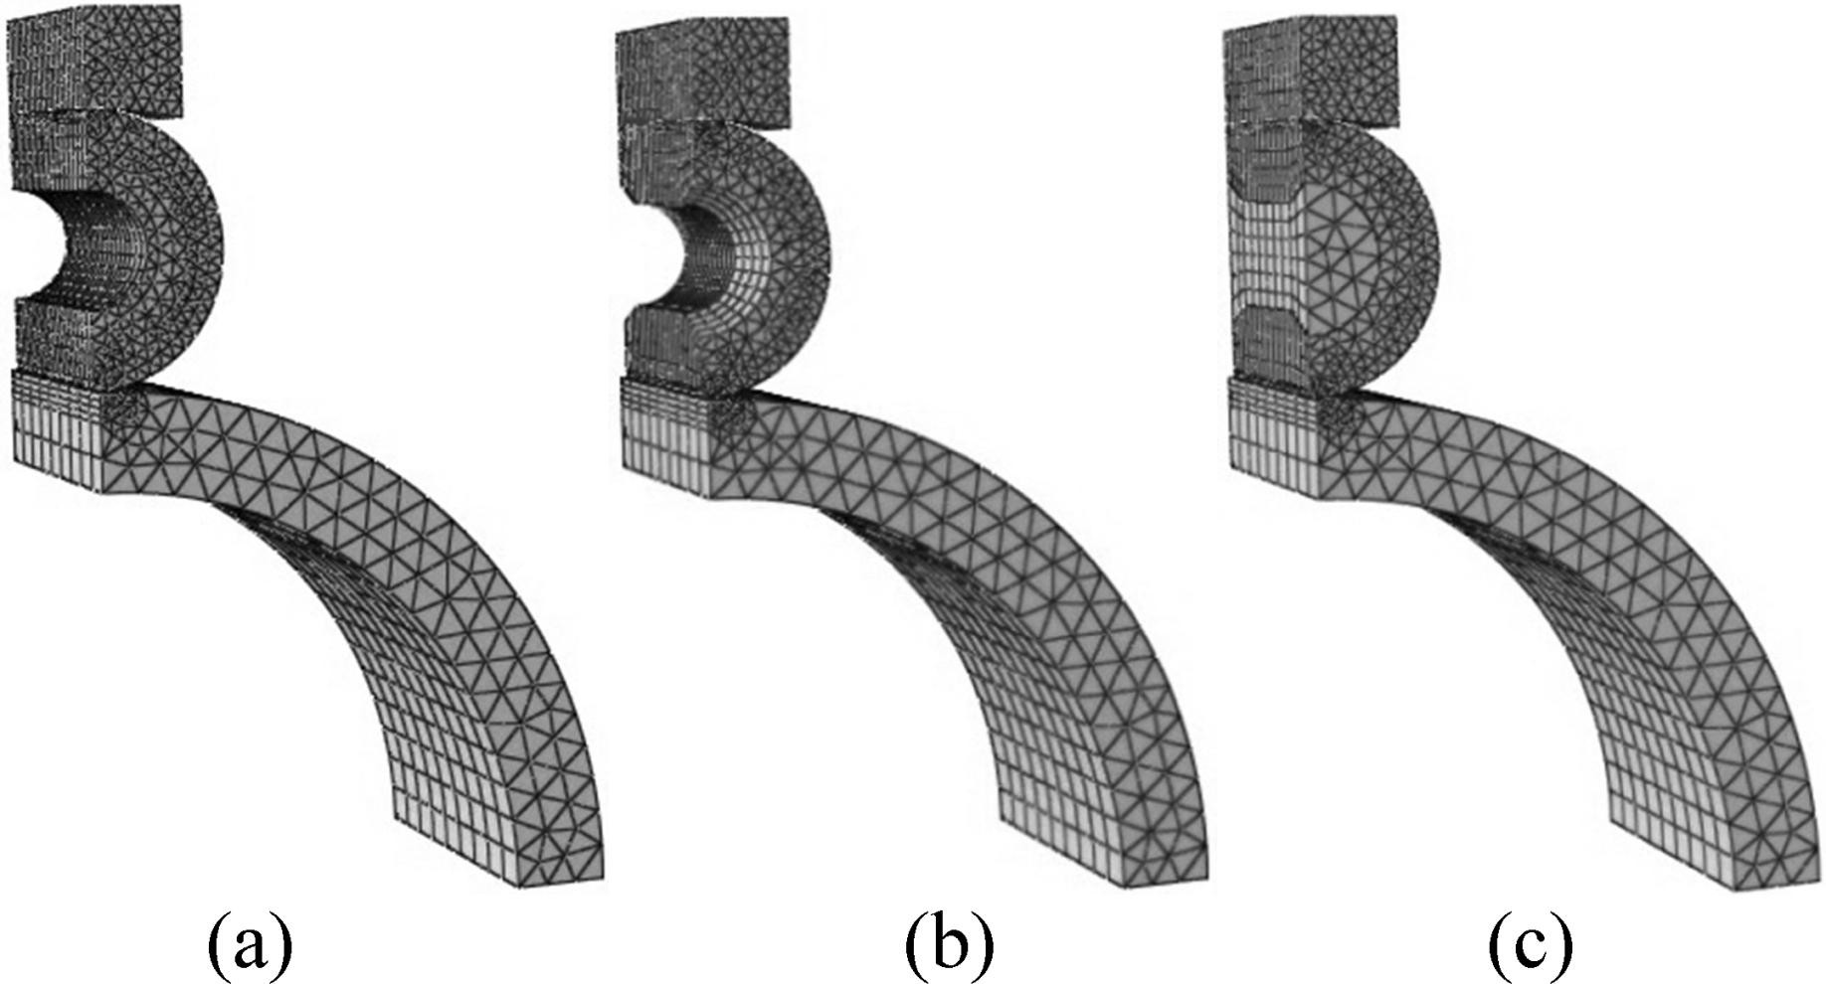

**Fig. 8** Finite element analysis of meshing model of three types of bearings: (a) Hollow cylindrical rolling bearing; (b) Deep hole hollow cylindrical roller bearings; (c) Elastic composite cylindrical rolling bearing

# Results and analysis

Bending stress of the inner wall is extracted and analyzed through finite element analysis and calculation. Figures 9−11 show the inner wall bending stress of hollow cylindrical rolling element, deep cavity hollow cylindrical rolling element and elastic composite cylindrical rolling element, respectively. In order to maintain high operating life in the three kinds of rolling elements, the critical value of pulling stress is limited to be 345 MPa in the inner wall. The inner wall bending stress in the three kinds of rolling elements changes periodically and alternately. The rolling elements in which the inner wall bending stress is below critical line includes hollow cylindrical rolling element with 40%−60% hollowness, deep cavity hollow cylindrical rolling element with 40%−55% hollowness and elastic composite cylindrical rolling element with 40%−55% degree of filling. The inner wall bending stress analysis

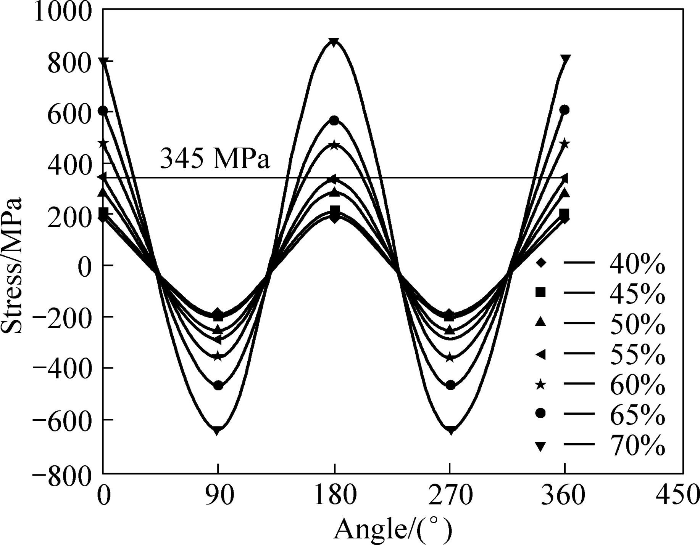

**Fig. 9** Inner wall bending stress of hollow cylindrical rolling element

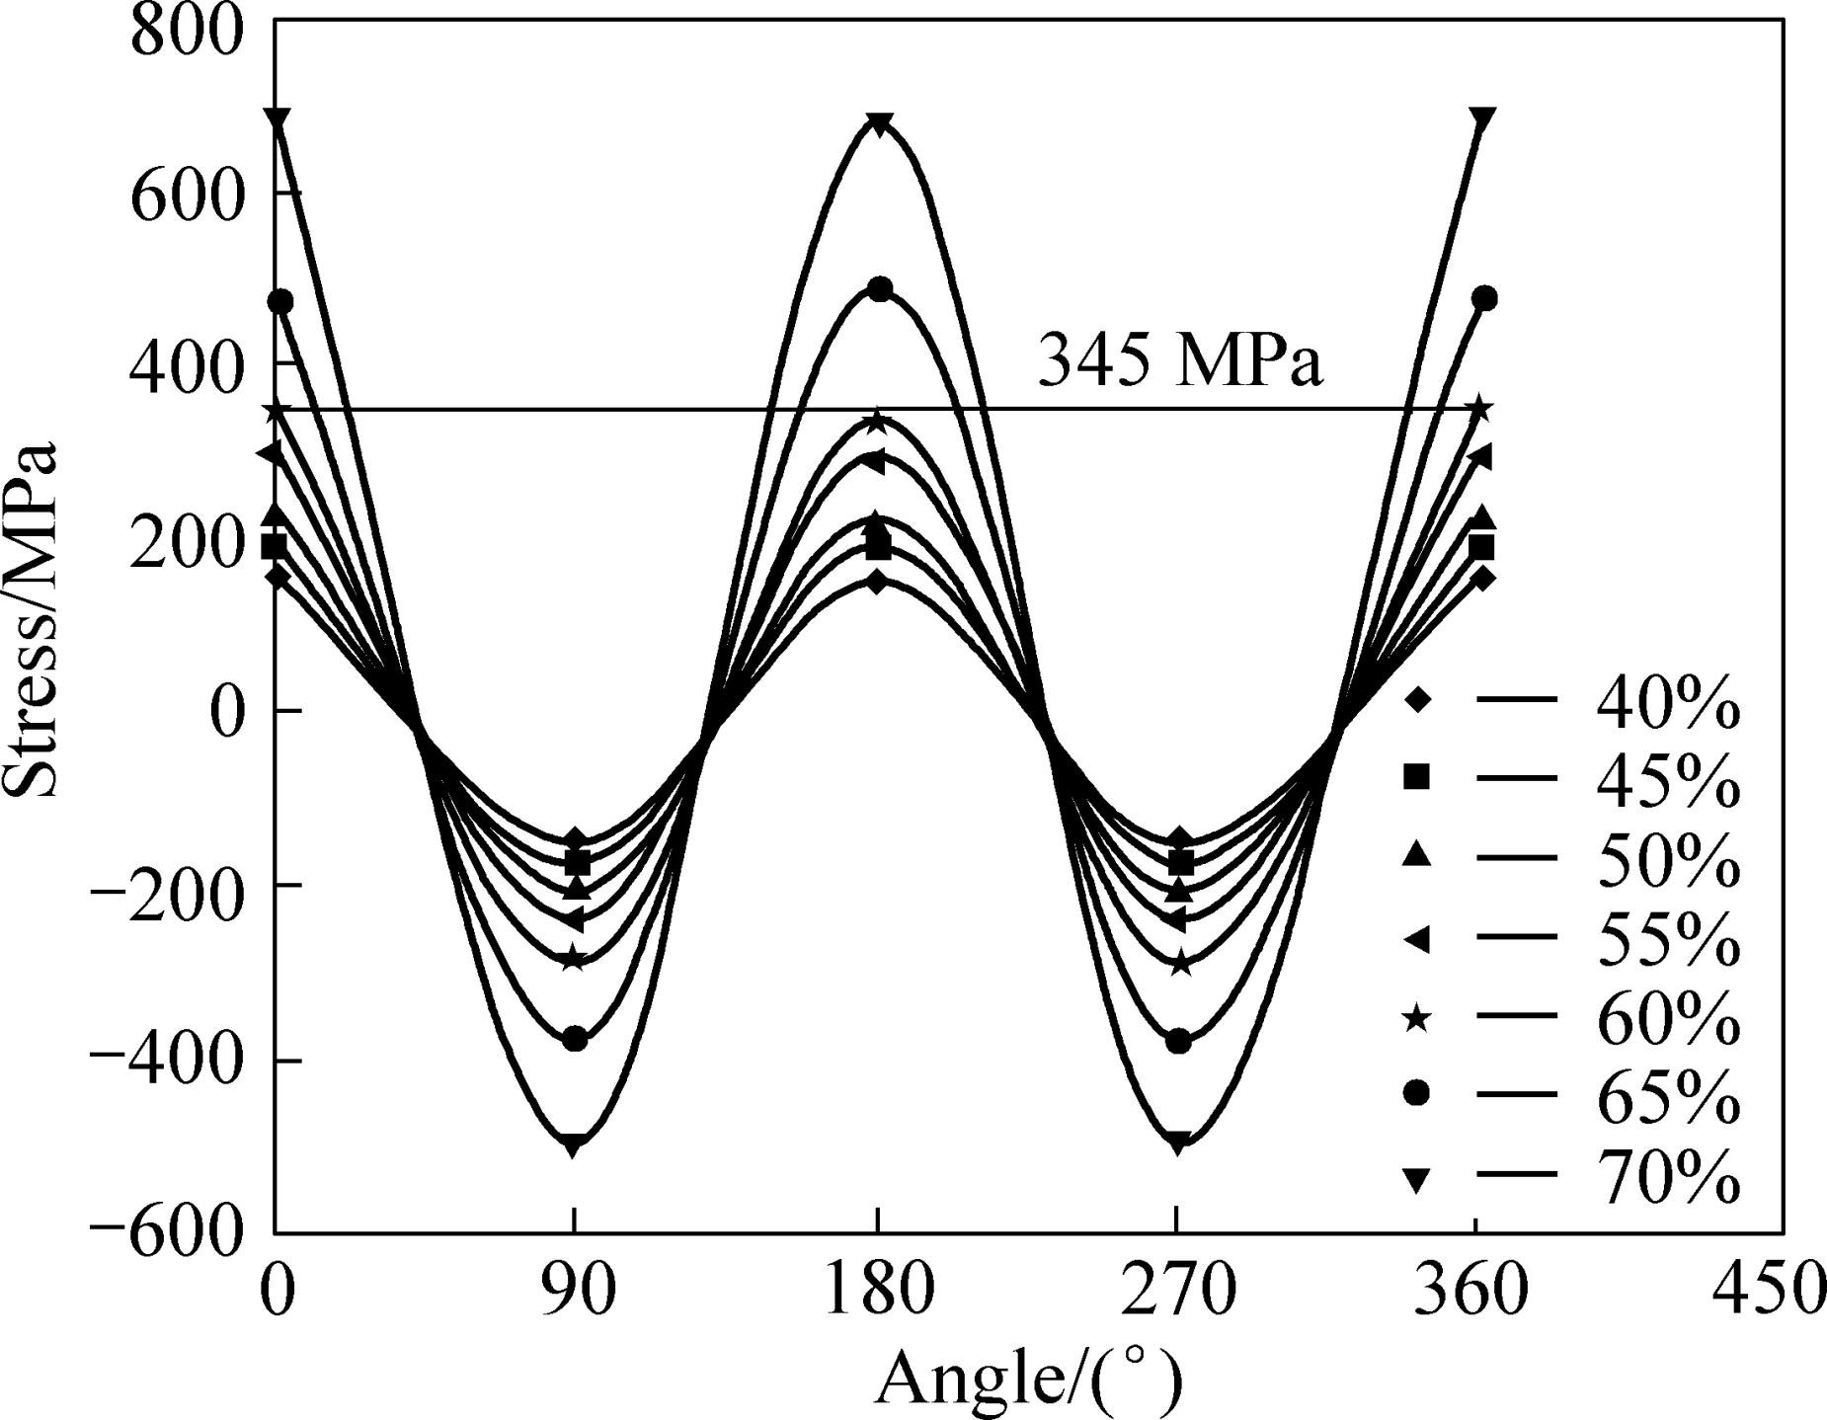

**Fig. 10** Inner wall bending stress of deep cavity hollow cylindrical rolling element

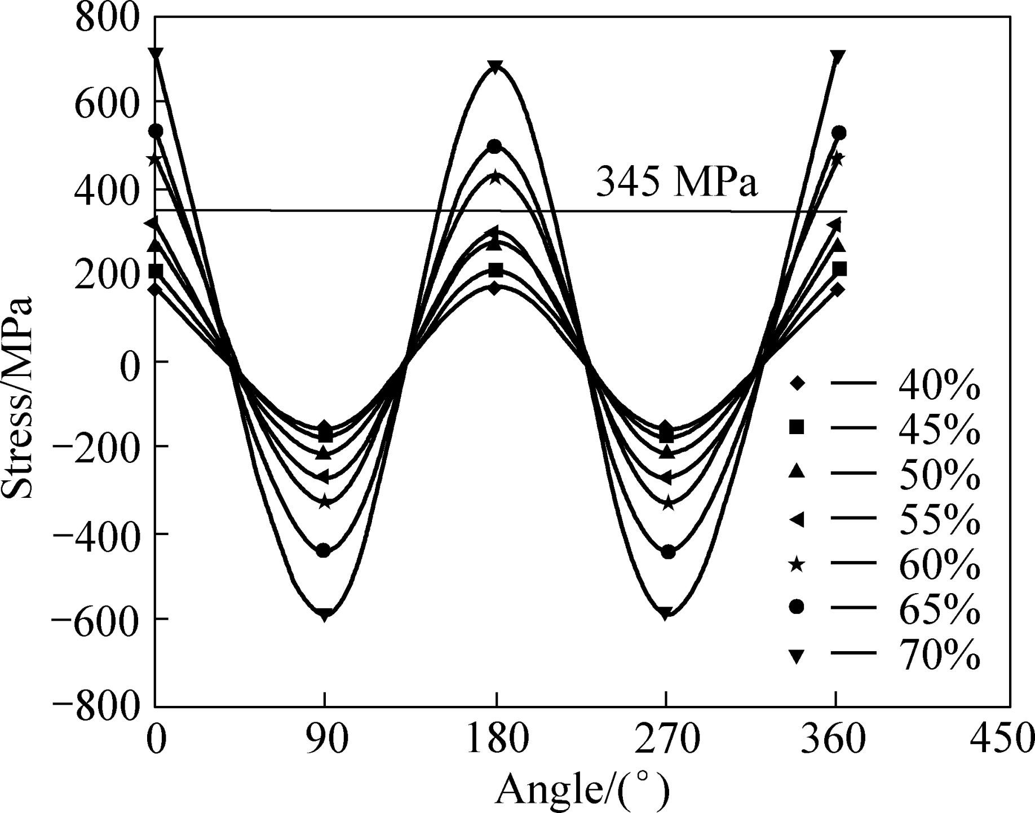

**Fig. 11** Inner wall bending stress of elastic composite cylindrical rolling element

of the all three kinds of rolling elements should be carried out under the premise of the above internal physical dimensions.

In order to carry out reasonable comparison, it is necessary to implement under the optimum structural dimension of the three kinds of bearings. After large quantity of finite element analysis, it is concluded that the optimum hollowness (degree of filling) values of hollow cylindrical rolling element, deep cavity hollow cylindrical rolling element and elastic composite cylindrical rolling element are 60%, 55% and 55%, respectively. Therefore, the three kinds of rolling elements with above optimum physical dimensions are taken to carry out comparison analysis for inner wall bending stress.

1. It is shown in Table 3 that hollow cylindrical rolling element and deep cavity hollow cylindrical rolling element with different inner physical dimensions have different inner wall bending stress values under the same load and construction appearance dimension. The maximum bending­tensile stress values of the deep cavity hollow cylindrical rolling element at 0° and 180° are 2.4% and 3.2%, respectively, lower than those of the hollow cylindrical rolling element. In addition, the maximum bending­compressive stress value at 90° is decreased by 1.3%.
2. It is shown in Table 3 that elastic composite cylindrical rolling element and hollow cylindrical rolling element with different inner physical structural dimensions have different inner wall bending stress values under the same load and construction appearance dimension. The maximum bending­tensile stress values of the elastic composite cylindrical rolling element at 0° and 180° are 10.8% and 13.1%, respectively, lower than those of the hollow cylindrical rolling element. In addition, the maximum bending­compressive stress value at 90° is decreased by 7.5%.
3. It is shown in Table 3 that the maximum bending­tensile stress values of the elastic composite cylindrical rolling element after material filling at 0° and 180° are 8.2% and 9.5%, respectively, lower than those of the deep cavity hollow cylindrical rolling element. In addition, the maximum bending­compressive stress value at 90° is decreased by 6.1%.

The corresponding results of self­comparison among elastic composite cylindrical rolling elements with different structural dimensions and filling materials are shown in Figs. 12−14.

It is shown in Fig. 12 that the bending stress of the elastic composite cylindrical rolling element changes regularly under different degrees of filling. The bending stress increases along with the increase of degree of filling.

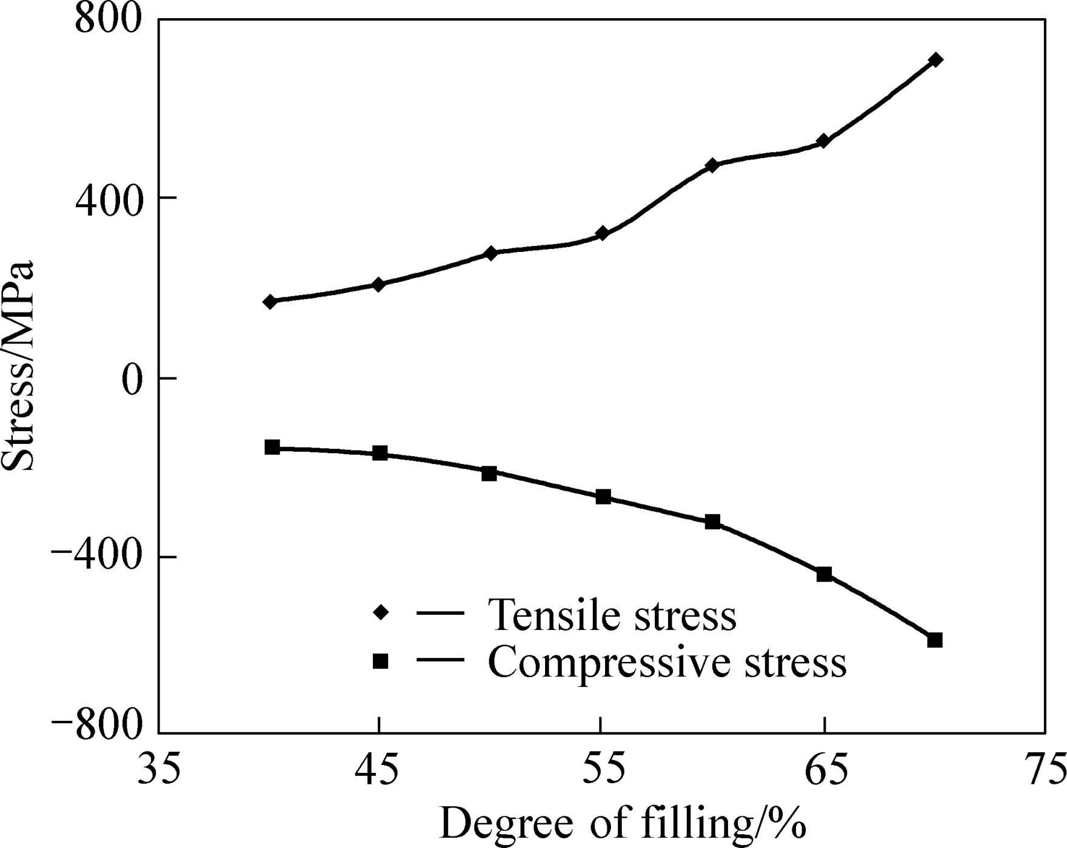

**Fig. 12** Relationship between inner wall bending stress and degree of filling in elastic composite cylindrical rolling element

**Table 3** Comparison of bending stress among three kinds of rolling elements

|  |  |  |  |  |  |  |
| --- | --- | --- | --- | --- | --- | --- |
| Type of |  | At 0° |  | At 90° |  | At 180° |
| rolling element | 1/MPa | Reducing rate/% | 2/MPa | Reducing rate/% | 3/MPa | Reducing rate/% |
| Hollow | 351.6 | — | 289.7 | — | 335.1 | — |
| Deep cavity | 343.4 | 2.4 | 285.9 | 1.3 | 324.7 | 3.2 |
| Elastic | 317.4 | 10.8 | 269.4 | 7.5 | 296.4 | 13.1 |

than hollow cylindrical rolling element and deep cavity cylindrical rolling element regarding inner wall fatigue life.

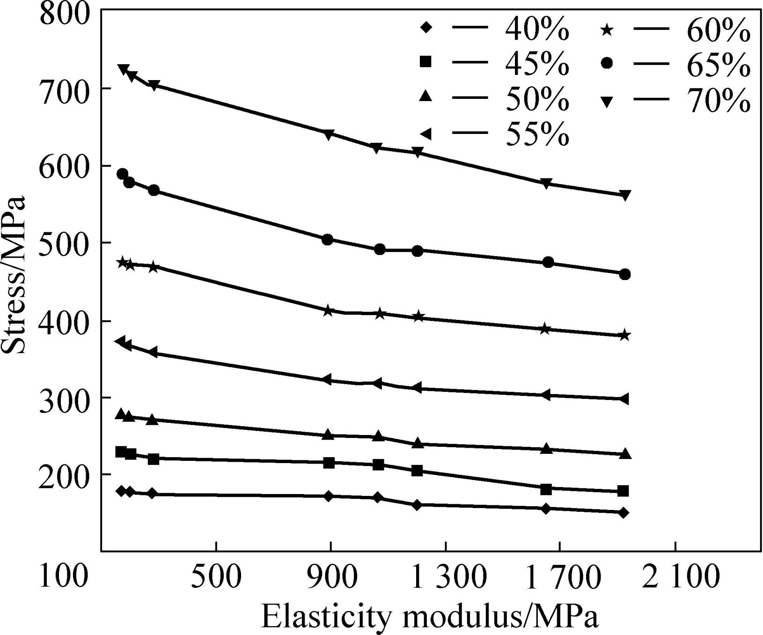

**Fig. 13** Relationship between inner wall bending stress (tensile stress) and elastic modulus of elastic composite cylindrical rolling elements with different degrees of filling

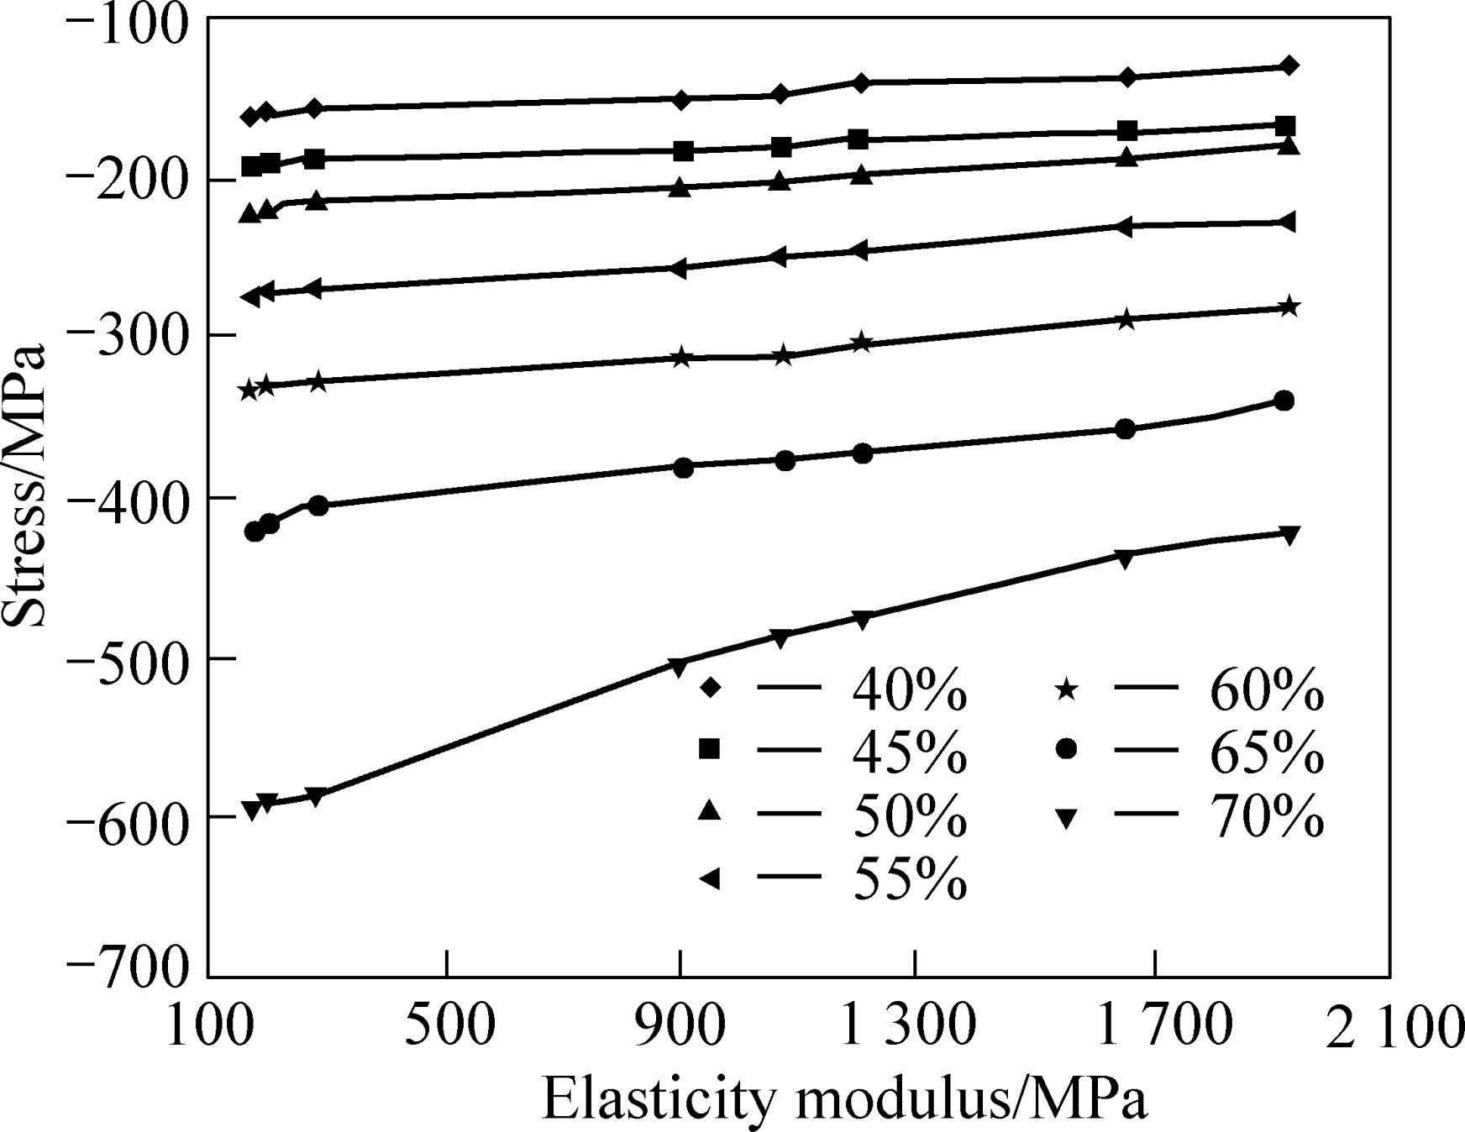

**Fig. 14** Relationship between inner wall bending stress (compressive stress) and elastic modulus of elastic composite cylindrical rolling elements with different degrees of filling

It is shown in Figs. 13−14 that the bending stress of the elastic composite cylindrical rolling element decreases with the increase of elastic modulus under the same degree of filling. The higher the degree of filling is, the bigger the amplitude of variation of the bending stress in elastic composite cylindrical rolling element will be. When the degree of filling is relatively low, the bending stress of the elastic composite cylindrical rolling element remains steady along with the increase of the elastic modulus.

# Conclusions

1. Under the same load and dimension, inner wall bending stress of the elastic composite cylindrical rolling element with different inner structural dimensions is decreased to different degrees compared with that of the hollow cylindrical rolling element and deep cavity hollow cylindrical rolling element. This shows that the elastic composite cylindrical rolling element is better
2. With the same filling material, the higher the filling degree is, the bigger the bending stress of the elastic composite cylindrical rolling element will be. With different filling materials, bending stress of the elastic composite cylindrical rolling element with the same degree of filling decreases with the increase of the elastic modulus. The larger the degree of filling of the elastic composite cylindrical rolling element is, the larger the amplitude of variation of bending stress will be.
3. Under the same load and physical structure, the maximum hollowness (degree of filling) values of hollow cylindrical rolling element, deep cavity hollow cylindrical rolling element and elastic composite cylindrical rolling element when the inner bending stress is below the critical value are 60%, 55% and 55%, respectively; hollow cylindrical rolling element and deep cavity hollow cylindrical rolling element with different inner structural dimensions have different inner wall bending stress values. This shows that design of deep cavity in the hollow cylindrical rolling element can change the inner stress distribution inside the rolling element.

# References

[1] ERWIN V Z. Palmgren revisited—A basis for bearing life prediction [J]. Journal of the Society of Tribologists and Lubrication Engineers, 1998(2): 18−23.

[2] JOHNS P M, GOHAR R. Roller bearing under radial and eccentric loads [J]. Tribology International, 1981, 14(6): 131−136.

[3] ABU JADAYIL W M, JABER N M. Numerical prediction of optimum hollowness and material of hollow rollers under combined loading [J]. Materials and Design Journal, 2010, 31: 1490−1496.

[4] LUO Hong, LIU Jia­jun. Analysis of contact problems on hollow cylindrical roller [J]. Tribology, 1997, 17(3): 253−259. (in Chinese)

[5] BOWEN W L, BHATEJA C P. The hollow roller bearing [J]. Journal of Lubrication Technology (ASME), 1980, 102(4): 222−234.

[6] TEUSNER H. The logarithmic roller profile—the hertzian elastic

contact problems [J]. Journal of Applied Mechanics (ASME), 1974, 41(2): 484−490.

[7] HATRNETT M J. The analysis of contact stresses in rolling element bearings [J]. Journal of Lubrication Technology (ASME), 1979, 101(1): 105−109.

[8] PIKOVOKII V A. Study of the working capacity of high­velocity radial bearing with hollow rollers [J]. Strength of Materials, 1982(10): 1178−1185.

[9] ABU J W M, FLUGRAD D R. Fatigue life investigation of solid and hollow rollers under pure normal loading [J]. Tribotest, 2007, 13(4): 165−181.

[10] PRASHAD H. Determination of stiffness of roller bearings—An alternative approach [J]. Journal of the Institution of Engineers (India): Mechanical Engineering Division, 2004, 81: 186−192.

[11] ZHANG Hong­wei, CHEN Jia­qing, ZHANG Xiang­dong. Numerical simulation on contact mechanics of hollow cylindrical roller bearings [J]. Bearing, 2011(8): 1−6. (in Chinese)

[12] DENG Song, HUA Lin, HAN Xing­hui, HUANG Song. Finite

element analysis of contact fatigue and bending fatigue of a theoretical assembling straight bevel gear pair [J]. Journal of Central South University, 2013, 20(2): 279−292.

[13] LUO Hong, LIU Jia­jun. The hollow cylindrical roller bearing and its wear problems [J]. Tribology, 1993, 13(3): 276−286. (in Chinese)

[14] YAO Qi­shui. Improve the cylindrical roller bearing fatigue method and elastic composite cylindrical roller bearing. China Patent, 201110061171.1[P]. 2011−07−27. (in Chinese)

[15] YAO Qi­shui. A kind of elastic composite cylindrical roller bearing.

China Patent, 201120066406. 1 [P]. 2011−11−23. (in Chinese)

[16] YAO Qi­shui, YANG Wen, YU Jiang­hong, ZHANG Ran. Research on structure design of elastic composite cylindrical roller bearing [J]. China Mechanical Engineering, 2012, 23(24): 2899−2902. (in Chinese)

[17] YAO Qi­shui, YANG Wen, YU Jiang­hong, ZHANG Ran. Research of carrying capacity of elastic composite cylindrical roller bearing [J]. Journal of Mechanical Transmission, 2013, 37(5): 6−9. (in Chinese)

[18] FENG Wei, HUA Lin, HAN Xing­hui. Finite element analysis and simulation for cold precision forging of a helical gear [J]. Journal of Central South University, 2012, 19(12): 3369−3377.

[19] LU Yan­jun, ZHANG Yong­fang, YU Yang­bing, YU Lie. Nonlinear dynamics of flexible rotor system supported on fixed­tilting pad combination journal bearing [J]. Journal of Central South University of Technology, 2011, 18(3): 610−617.

[20] HARRIS T A. Roller bearing analysis: Original version 5, volume 1, basic concepts of bearing technology [M]. LUO Ji­wei Tr. Beijing: China Machine Press, 2006, 133−148.

[21] HARRIS T A. Roller bearing analysis: Original version 5, volume 2, advanced concepts of bearing technology [M]. LUO Ji­wei Tr. Beijing: China Machine Press, 2009, 60−61.

[22] WEI Yan­gang. Research on the performances of a novel roller bearing­deep cavity hollow cylindrical roller bearing [J]. Chinese Journal of Mechanical Engineering, 2005, 41(2): 107−111. (in Chinese)

[23] SHI Yi­ping, ZHOU Yu­rong. Example explanation of finite element analysis [M]. Beijing: China Machine Press, 2006, 125−164. (in Chinese)

**(Edited by YANG Bing)**