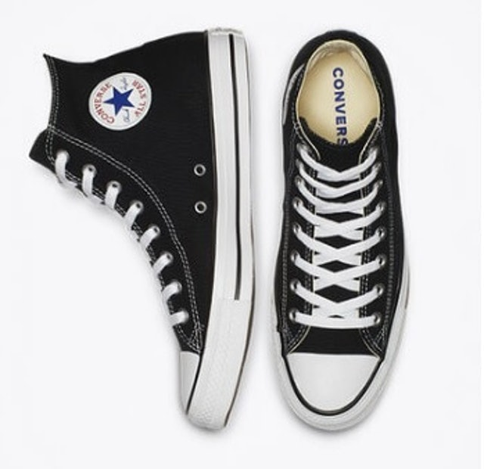

|  |  |
| --- | --- |
| **Seri** | Chuck Taylor All Star |
| **Tipe** | High cut |
| **Upper sole** | Canvas |
| **Insole** | OrthoLite |
| **Outsole** | Vulcanized rubber outsole |
| **Warna** | Black, pink, red, maroon, natural ivory, optical white, navy, charcoal |
|  |  |
|  |  |

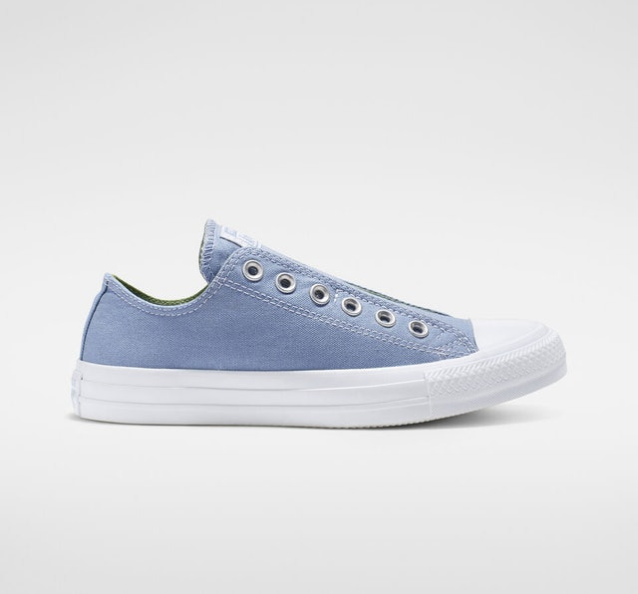

|  |  |
| --- | --- |
| **Seri** | Chuck Taylor All Star |
| **Tipe** | Low cut, slip on |
| **Upper sole** | Canvas |
| **Insole** | Tidak ada keterangan |
| **Outsole** | Vulcanized rubber sole |
| **Warna** | Indigo fog/peat moss/white, plum chalk/washed coral/white, turf orange/melon baller/white |