Nama : Fitri Cahyaniati(11)

Kelas : SIB1G

TUGAS :

1. Create a program with Stack implementation to insert a sentence and display the reversed version of the sentence as a result!

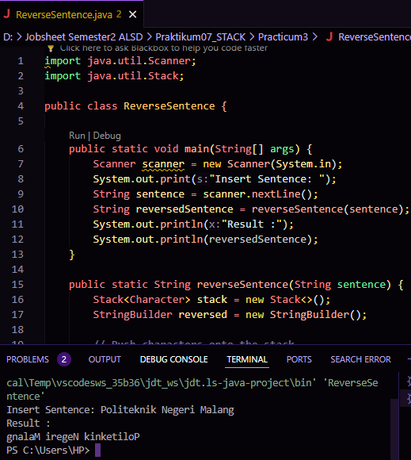

1. Every Sunday, Dewi shops to a supermarket that is in her residential area. Everytime she finishes, she keeps the receipt of what she has bought in a wardrobe. After 2 months, She had 8 receipts. She plans to trade her 5 receipts in exchange for a voucher. Create a program using stack implementation to store Dewi’s receipt. As well as the retrieving the receipts. The information that are included in a receipt are as follows:

• Transaction ID

• Date

• Quantity of items

• Total price

