**Procedures to allocate reservoirs on a CaMa-Flood river map (for CaMa-Flood v4.12)**

Dai Yamazaki

23Oct 2023

In this document, the procedures to allocate GRanD reservoirs on a CaMa-Flood river map is described. In addition, same scripts can be used to add reservoirs not included in GRanD database.

Note: The format of dam parameter list file is slightly modified in v4.12 (fldsto/uparea parameter was excluded). Please use a dam parameter list which is generated by the updated script.

1. **Input data (included in CaMa-Flood package)**

List of GRanD reservoirs is available in CaMa-Flood package.

$(CaMa-Flood)/map/data/GRanD_alloc.csv.

Some reservoirs have error or mismatch of the attribute data required for allocation (lat, lon, uparea) compared to the MERIT Hydro river map (hydrography basemap for CaMa-Flood). Thus, we corrected the errors or mismatches by allocation reservoirs on 1-min resolution MERIT Hydro data.

The original attribute data is (lat_ori, lon_ori, area_ori), and the corrected data is (lat_MERIT, lon_MERIT, area_MERIT). The corrected attribution data is used to allocate GRanD reservoirs on a CaMa-Flood river map.

Example of GRanD_alloc.csv file.

1. **Allocate reservoirs on a CaMa-Flood river map**

Please go to src_param/ directory in your map directory (e.g. map/glb_15min/src_param/). Then, edit s04-allocate_gauge.sh script, and execute it.

In default, the allocated reservoir list “GRanD_river.txt” and “GRanD_small.txt” are outputted. GRanD_river.txt is for large reservoirs allocated on the mainstem, while GRanD_small.txt represents small reservoirs which cannot be represented in CaMa-Flood unit-catchment.

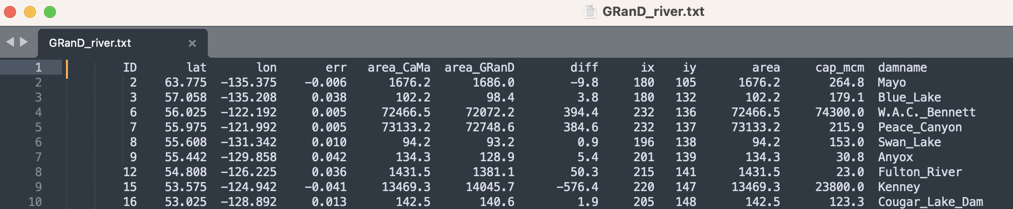

Example of GRanD_river.txt file.

1. **Prepare dam parameter list.**

**2.1 Working location**

Please go to the directory with sample reservoir operation scripts (etc/reservoir_operation/).

Note: you first need to execute “no reservoir” simulation in order to estimate 100-year return-period discharge.

The scripts to prepare reservoir parameter file is in dam_param/.

**2.2 Please edit the s00-link.sh script, and execute it**

Please specify the input files and directories. Note that you need to download Reservoir Geometry data (ReGeom) and Reservoir surface area timeseries (GRSAD). Explanation on how to locate this data is available in s00-link.sh comments.

**2.3 Please exit s01-calc_damparam.sh script, and execute it.**

You need to set project name (TAG), and SYEAR,EYEAR,DT of the naturalized simulation.

The Python scripts for (1) calculating annual mean and max discharge at each dam location, (2) calculating 100year discharge at each dam location, (3) estimating normal water storage from satellite data, (4) merging these information into one dam parameter list, (5) finalizing the dam parameter list for use in CaMa-Flood, are executed.

The dam parameter list file is saved (./${TAG}/damparam_${TAG}.csv). CaMa-Flood reservoir operation scheme can be used by specifying this file as CDAMFILE in namelist.

**Sample dam parameter list file (CSV)**

**2.4 If you want to manually modify dam parameters:**

Please edit the “dam_params_comp.csv" in $TAG directory, and then execute t02-finalize.sh.

1. **Add reservoirs not included in GRanD data**

Reservoirs not included in GRanD data can be added by adding their information in input reservoir list data. The sample file is prepared as:

$(CaMa-Flood)/map/data/GRanD_alloc+Mekong.csv

Please find the latitude, longitude and upstream area of the new reservoir, using MERIT Hydro river map (or CaMa-Flood 1min river map), and specify the data as lat_MERIT, lon_MERIT, area_MERIT), and provide reservoir capacity in million M3 (CAP_MCM). The other fields can set to undef value (-99). Then please follow the above procedures to allocate reservoirs in CaMa-Flood map, and estimate reservoir parameters.

Note that satellite data to estimate normal water volume is not available for non-GRanD reservoirs. Please set an appropriate value by yourself.

テーブル

**Example of adding new dams on input CSV data**