Automotive Body Fit Process Capability Study
High-Volume Automotive OEM | Hood-to-Fender Gap | Synthetic Educational Case Study
PORTFOLIO DISCLAIMER — This project uses a synthetic educational dataset created solely to demonstrate statistical process capability analysis. It does not contain proprietary or confidential manufacturing data from any company.
Samples | 100 | Mean | 3.500000 mm
Sample STDEV | 0.196000 mm | Specification | 3.000 to 4.000 mm
Cp | 0.850 | Cpk | 0.850
Observed rejects | 1 (10,000 ppm) | Expected rejects* | 10,741 ppm

1. Executive Summary
The study evaluates 100 synthetic hood-to-fender gap measurements. The mean is 3.500 mm against a 3.500 mm target, so the process is centered. The sample standard deviation is 0.196 mm. Cp and Cpk are both 0.850, below the illustrative 1.33 capability criterion. The process is aimed correctly, but variation is too large.
Conclusion: Not capable. The estimated natural process spread is wider than the available specification window.

2. Definitions and Equations
Cp = (USL - LSL) / (6 x s)
Cpk = min[(USL - mean) / (3 x s), (mean - LSL) / (3 x s)]
For this dataset, Cp = (4.000 - 3.000) / (6 x 0.196) = 0.850. Because the mean is centered, Cpu = Cpl = Cpk = 0.850. Calculations use the sample standard deviation (n - 1).

3. Visual Analysis
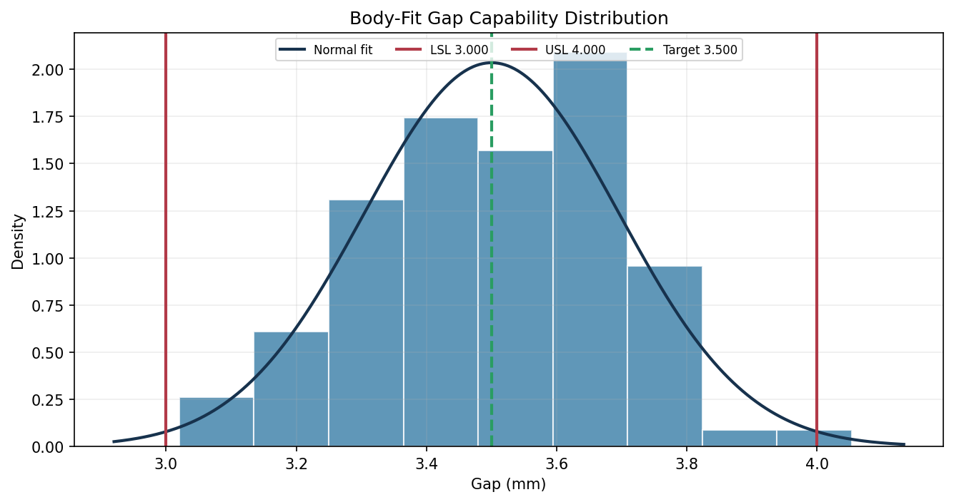
Figure 1. Capability histogram and fitted normal distribution.
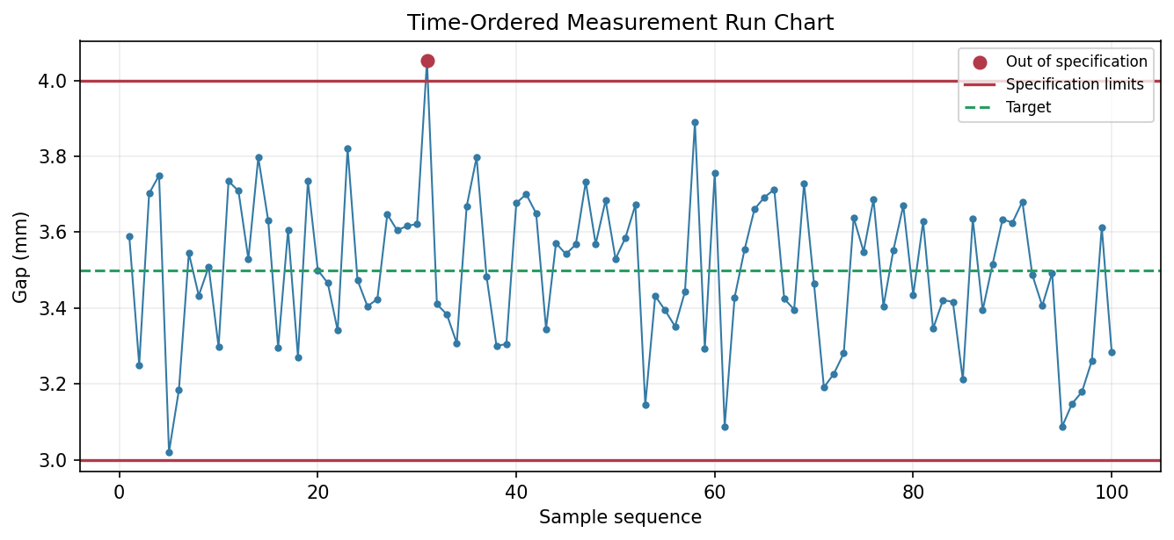
Figure 2. Time-ordered measurements; sample 31 exceeds the USL.

4. Engineering Interpretation
- Centering is not the primary problem: the mean matches the nominal target.
- Variation is the primary problem: six standard deviations equal 1.176 mm, wider than the 1.000 mm specification window.
- One observed measurement is out of specification, equivalent to 10,000 ppm in this small dataset.
- The normal-model expected PPM is an estimate, not a guarantee of future defect rate.
- Confirm statistical stability with an appropriate control chart and measurement adequacy with Gauge R&R before relying on capability indices.

5. Recommended Improvement Plan
Workstream | Recommended action
Measurement | Perform Gauge R&R and standardize gauge orientation and contact pressure.
Fixture | Inspect locators, clamps, hinge interfaces, and wear points; establish preventive-maintenance limits.
Method | Standardize adjustment sequence, torque method, and acceptance criteria in the work instruction.
Material/design | Review tolerance-stack contributors and supplier variation for closures, hinges, fenders, and mounts.
Control | Use rational subgroups and an X-bar/R chart, or an I-MR chart when subgrouping is not appropriate.
Verification | After corrective action, collect an independent time-ordered dataset and demonstrate the program-specific Cpk requirement.

6. Statistical Cautions
*Expected PPM assumes an independent, stable, approximately normal process. Cp/Cpk do not establish stability, normality, causal control, or measurement-system adequacy. Specification limits are engineering requirements, not control limits. Acceptance thresholds must follow applicable customer and program requirements.

7. References
- AIAG Statistical Process Control (SPC), 2nd Edition
- AIAG Measurement Systems Analysis (MSA), 4th Edition
- AIAG & VDA FMEA Handbook
- Douglas C. Montgomery, Introduction to Statistical Quality Control, 8th Edition
- ISO 22514 series — Statistical methods in process management

Appendix A — Raw Measurements
Sample | Value (mm) | Status
1 | 3.589583 | PASS
2 | 3.250239 | PASS
3 | 3.702068 | PASS
4 | 3.750044 | PASS
5 | 3.020328 | PASS
6 | 3.184072 | PASS
7 | 3.544947 | PASS
8 | 3.432880 | PASS
9 | 3.508446 | PASS
10 | 3.297414 | PASS
11 | 3.734608 | PASS
12 | 3.708967 | PASS
13 | 3.529349 | PASS
14 | 3.797153 | PASS
15 | 3.630665 | PASS
16 | 3.295837 | PASS
17 | 3.605743 | PASS
18 | 3.270705 | PASS
19 | 3.734369 | PASS
20 | 3.500087 | PASS
21 | 3.466035 | PASS
22 | 3.340848 | PASS
23 | 3.821203 | PASS
24 | 3.473689 | PASS
25 | 3.404594 | PASS
26 | 3.423822 | PASS
27 | 3.647018 | PASS
28 | 3.604908 | PASS
29 | 3.616842 | PASS
30 | 3.621407 | PASS
31 | 4.053146 | FAIL
32 | 3.410124 | PASS
33 | 3.383418 | PASS
34 | 3.307325 | PASS
35 | 3.668133 | PASS
36 | 3.797590 | PASS
37 | 3.483930 | PASS
38 | 3.300666 | PASS
39 | 3.304622 | PASS
40 | 3.676868 | PASS
41 | 3.700251 | PASS
42 | 3.649755 | PASS
43 | 3.344740 | PASS
44 | 3.571273 | PASS
45 | 3.542132 | PASS
46 | 3.567874 | PASS
47 | 3.732597 | PASS
48 | 3.569112 | PASS
49 | 3.684015 | PASS
50 | 3.529740 | PASS
51 | 3.585647 | PASS
52 | 3.671996 | PASS
53 | 3.144962 | PASS
54 | 3.432015 | PASS
55 | 3.393984 | PASS
56 | 3.351461 | PASS
57 | 3.443252 | PASS
58 | 3.889945 | PASS
59 | 3.294187 | PASS
60 | 3.757038 | PASS
61 | 3.088002 | PASS
62 | 3.428175 | PASS
63 | 3.553758 | PASS
64 | 3.660623 | PASS
65 | 3.692169 | PASS
66 | 3.712893 | PASS
67 | 3.424683 | PASS
68 | 3.396008 | PASS
69 | 3.729202 | PASS
70 | 3.464409 | PASS
71 | 3.190757 | PASS
72 | 3.226693 | PASS
73 | 3.280656 | PASS
74 | 3.638148 | PASS
75 | 3.548628 | PASS
76 | 3.686935 | PASS
77 | 3.404866 | PASS
78 | 3.552695 | PASS
79 | 3.670558 | PASS
80 | 3.434620 | PASS
81 | 3.627956 | PASS
82 | 3.345644 | PASS
83 | 3.421067 | PASS
84 | 3.416352 | PASS
85 | 3.210907 | PASS
86 | 3.635577 | PASS
87 | 3.394229 | PASS
88 | 3.515839 | PASS
89 | 3.634006 | PASS
90 | 3.625371 | PASS
91 | 3.680601 | PASS
92 | 3.487832 | PASS
93 | 3.405864 | PASS
94 | 3.492568 | PASS
95 | 3.086875 | PASS
96 | 3.147497 | PASS
97 | 3.178893 | PASS
98 | 3.261024 | PASS
99 | 3.613572 | PASS
100 | 3.284182 | PASS

