1. cd to the base folder using cd HILTM_demo
2. Install the python env for the system using hltm_env.yml, by the command:

conda env update -n my_env --file hltm_env.yml

1. download the glove.6B.300d embs from <https://nlp.stanford.edu/projects/glove/> and put it in the folder: ./QDTM/glove_embeddin
2. Run qe_server.py using the command:

python qe_server.py.

1. Run ./QDTM QDTM.jar using the command:

cd QDTM

jave -jar QDTM.jar

1. Open the system page ./Interface/firstpage.html

Note:

The folder *topic_labelling* contains modules for the topic labelling algorithm used by the system.

You can use your own dataset and stopwords by put the file in the dataset folder and replace the relevant codes in the qe_server.py:

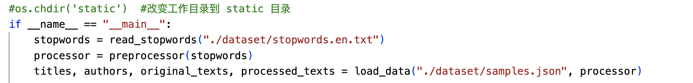

You may need to reformat your dataset and modify the function *load_date*.

You could also define your own preprocessor.

You also need to download the glove.6B.300d embs from <https://nlp.stanford.edu/projects/glove/> and put it in the folder: ./QDTM/glove_embedding

The ./QDTM/temp folder will store models you trained using the system.

Know issues:

OOV issue when trained too many models.

Important: You are not allowed to use the system or modify the system for any business purpose.