Catherine Fitzgerald

CS1008

Professor Krawtiz

November 26, 2021

Notes and Observations

* Due to my robot not functioning properly for the last exercise, I have to begin by adjusting the program from that exercise to ensure that the robot successfully completes the maze.
* My initial observation is that the robot completes each step of the maze correctly, it just is off proportionally to the maze I have drawn out.
* Part of the reason why the robot was slightly off from the path of the maze was because of the shapes not being completed correctly
  + After conducting some testing outside of the maze, I have determined that:
    - (-)100:(-)100 4:00s completes a full circle
    - (-)100:(-)100 1:00s completes one 90° turn
* Now that I have incorporated these conclusions into the maze, the robot runs the shapes correctly.
* It does not, however, do the last ‘zig zag’ motion of the maze correctly, I think this is due to the shape running in the opposite direction as the other parts.
  + To solve this problem, I created a new subroutine specifically for this leg of the maze
* The subroutine didn’t solve my issue and that is when I realized that I could simply change the order the ‘zig-zag’ is executed in and that solved the problem
* I ran the program and when something didn’t line up I stopped, adjusted that specific line of code, and re-ran it - adjusting when needed - until the maze was complete
* Now, I am going through the code and adding the lights
* For sounds after each section of the maze, I’ve included a diagram that highlights the various sections:

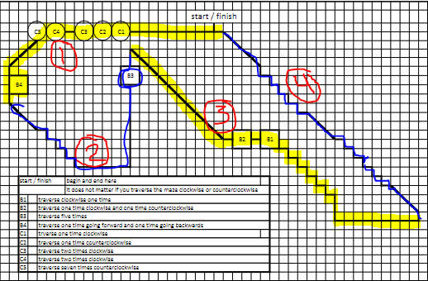

* For the completion dance, I created a new subroutine