CHAPTER 1: PROJECT PROPOSAL
  - Introduction
The Water, Sanitation and Hygiene (WASH) Commission of Liberia is mandated to coordinate water supply, sanitation infrastructure, and hygiene promotion activities across the country. For several years, the Commission has relied on manual and paper-based procedures to handle service requests, citizen complaints, and routine reporting. These traditional approaches have contributed to delays in response, frequent data loss, and weak coordination among departments. In response to these challenges, the Electronic Governance Library (EGovLib) is proposed as a digital e-governance platform designed to modernize WASH service processes and improve overall service delivery.​
1.2 Problem Statement
Despite its national mandate, the WASH Commission continues to experience significant operational inefficiencies arising from fragmented data handling practices and the absence of a centralized complaint management system. These limitations result in slow response times, limited transparency in service delivery, and low levels of citizen engagement. Conequently, public trust is weakened, accountability mechanisms are undermined, and the broader goals of improving public health outcomes through effective WASH services are negatively affected.​
1.3 Problem Statement
This project proposes the design and implementation of EGovLib, a web-based e-governance system that enables citizens to submit service requests and complaints online from any location with internet access. Through this platform, authorized WASH Commission staff can receive and track submitted requests, assign tasks to relevant departments, update service statuses, and generate periodic management reports. The system further provides real-time dashboards and summaries to support informed decision-making, enhance transparency, and strengthen coordination between departments involved in WASH service delivery.​

1.4 Aim and Objectives
The aim of this project is to design and implement an EGovLib system that improves WASH service delivery, coordination, and accountability within the WASH Commission of Liberia.​
Objectives
The specific objectives of the study are to:
Digitize the management of WASH service requests and complaints through a centralized online platform.​
Improve response time and institutional accountability in handling citizen service requests.​
Enhance citizen participation and transparency in WASH-related decision-making and feedback processes.​
Support data-driven planning, monitoring, and reporting using reliable and timely service request information.​

1.5 Project Scope
This project is limited to the operations of the WASH Commission of Liberia, with a focus on the management of service requests, complaint handling, reporting, and basic monitoring functions. The system is developed and evaluated within a four-month academic timeframe, concentrating on core functionalities such as user registration, request submission, request tracking, status updates, and report generation. Broader integrations with external government systems, nationwide deployment, and advanced analytics are acknowledged as future extensions beyond the current project scope.​

1.6 Ethical Considerations
All data collected during the course of this project, including information from interviews, surveys, and system logs, was handled with strict confidentiality. Participation in the study was voluntary, and respondents were informed of the purpose of the research and their right to withdraw at any time. No physical, psychological, or social harm was inflicted on participants, and all information obtained was used solely for academic and system development purposes, in line with institutional ethical guidelines.

CHAPTER 2: FIRST REVIEW
2.1 Literature Review
This section reviews existing literature on e-governance systems, public sector digitalization, and Water, Sanitation, and Hygiene (WASH) service delivery, with specific emphasis on how these systems are analyzed, modeled, and designed to support efficient service delivery in developing-country contexts. The review establishes the conceptual foundation for the system analysis and UML-based design choices presented in Chapter Three.
E-governance systems are widely defined as the use of information and communication technologies (ICT) to support government operations, service delivery, and citizen interaction through structured digital platforms. Scholars emphasize that effective e-governance systems require clear definition of system actors, services, and workflows at the design stage in order to ensure usability, reliability, and scalability. According to the United Nations, the success of digital government initiatives depends not only on technology availability but also on systematic planning and modeling of system components and interactions prior to implementation.
Existing studies on public sector digitalization highlight the importance of system analysis in identifying user requirements, functional processes, and information flows. Davis’ (1989) Technology Acceptance Model suggests that systems perceived as useful and easy to use are more likely to be adopted by end users. From a design perspective, this implies that system functionality must be clearly structured and aligned with user needs, a principle reflected in the use case modeling and functional decomposition adopted in Chapter Three of this study.
Transparency and accountability, which are core objectives of e-governance, are strongly influenced by how system processes are designed and represented. Rogers’ (2003) diffusion of innovation theory explains that the adoption of new technologies is facilitated when systems are intuitive and compatible with existing practices. UML-based design techniques, such as activity diagrams and class diagrams, support this by providing standardized visual representations of workflows, data relationships, and system behavior. These representations improve shared understanding among developers and stakeholders, thereby reducing ambiguity during system development.
In developing-country contexts, several authors emphasize that poorly designed digital systems often fail due to unclear requirements, fragmented workflows, and lack of maintainability. Literature suggests that early modeling of system architecture helps identify potential design issues before implementation, thereby reducing development risks and long-term maintenance challenges. This reinforces the decision in this study to employ UML diagrams as part of the EGovLib system design, as discussed in Chapter Three.
Within the WASH sector, digital governance platforms are increasingly designed to support complaint management, service monitoring, and data-driven decision-making. Studies indicate that effective WASH information systems rely on clearly defined processes for service request submission, validation, processing, and feedback. These processes naturally lend themselves to activity-based modeling, which is used in Chapter Three to illustrate the flow of service requests within the EGovLib system. By modeling these workflows, system designers can ensure consistency, traceability, and accountability in service delivery.
Furthermore, literature on WASH digital platforms highlights the importance of structured data management to support reporting and planning. Class-based modeling approaches are commonly recommended to define entities such as users, service requests, and resources, as well as their relationships. This approach informs the class diagram presented in Chapter Three, which captures the structural components of EGovLib and their interactions. Such modeling supports system extensibility, allowing new services or user roles to be integrated with minimal disruption.
Empirical studies also show that citizen engagement in digital governance is enhanced when systems provide clear feedback mechanisms and status tracking. From a design standpoint, this requires explicit modeling of system states and interactions, which is achieved through UML behavioral diagrams. By visualizing system behavior prior to implementation, designers can ensure that user interactions are logical, transparent, and aligned with service delivery objectives.
In summary, the reviewed literature demonstrates that successful e-governance and WASH digital platforms depend heavily on systematic system analysis and well-structured design. The use of UML as a standardized modeling language supports effective communication, early identification of design issues, and improved system maintainability. These insights directly inform the system analysis and UML design of the EGovLib system presented in Chapter Three, ensuring that the proposed architecture is grounded in established theory and empirical evidence.
2.2 Research Methodology
This study adopted a case study research design focusing on the WASH Commission of Liberia as the primary unit of analysis. Both qualitative and quantitative data were collected through interviews, surveys, document analysis, and system log reviews to understand existing processes and evaluate the EGovLib system. The System Development Life Cycle (SDLC) model was used to guide the phases of system analysis, design, implementation, and testing, ensuring a structured and iterative development approach.​

System Development Models Considered
This section presents a review of selected system development models relevant to the design and implementation of the Electronic Governance Library (EGovLib). The models reviewed include the Waterfall Model, Iterative Model, Agile Model, and the System Development Life Cycle (SDLC) Model. Each model is examined to determine its suitability for the development of a public-sector e-governance system within the operational context of the WASH Commission of Liberia.

Waterfall Model
The Waterfall Model is a traditional linear system development approach in which development activities progress sequentially through distinct phases: requirements analysis, system design, implementation, testing, deployment, and maintenance. Each phase must be completed and documented before moving to the next.
One major strength of the Waterfall Model is its structured nature, which promotes thorough documentation and clear milestones. This makes it easy to manage and suitable for projects where requirements are well understood and unlikely to change. However, its rigidity represents a significant limitation. Once a phase is completed, revisiting it to accommodate changes is difficult and costly. Additionally, user feedback is typically incorporated late in the development cycle, increasing the risk of developing a system that does not fully meet user needs.
In the context of EGovLib, the Waterfall Model is less suitable because WASH service processes involve evolving requirements, stakeholder feedback, and contextual challenges that require flexibility during development.

Iterative Model
The Iterative Model involves developing the system through repeated cycles, or iterations. Each iteration includes planning, design, implementation, and testing, resulting in a progressively refined system. User feedback obtained after each iteration is used to improve subsequent versions.
The Iterative Model supports early identification of design flaws and functional gaps, making it easier to adapt the system to user needs. This flexibility is particularly valuable for systems that evolve over time. However, the model requires careful management to prevent uncontrolled expansion of system scope. It may also demand more development time and continuous stakeholder involvement.
For EGovLib, the Iterative Model offers advantages in refining features such as service request tracking and reporting. Nonetheless, its resource demands and the project’s limited academic timeframe make it less optimal as the primary development approach.

Agile Model
The Agile Model emphasizes rapid development, continuous user collaboration, and frequent delivery of functional system components through short development cycles known as sprints. Agile prioritizes flexibility and responsiveness to change over extensive upfront documentation.
Agile’s strengths include rapid adaptation to changing requirements and high levels of stakeholder engagement. However, it places less emphasis on formal documentation and structured approvals, which can pose challenges in public-sector environments. Agile development also requires constant availability of stakeholders, which may not be feasible in institutional settings.
Given that EGovLib is intended for a government agency that requires formal documentation, accountability, and standardized procedures, the Agile Model is not the most appropriate choice for this project.

System Development Life Cycle (SDLC) Model
The System Development Life Cycle (SDLC) Model provides a comprehensive and structured framework for developing information systems. It consists of interconnected phases including planning, requirements analysis, system design, implementation, testing, deployment, and evaluation. While structured, SDLC allows feedback between phases, making it adaptable without sacrificing control.
SDLC is particularly suitable for institutional systems due to its emphasis on detailed analysis, documentation, and quality assurance. It supports the use of modeling techniques such as UML diagrams during the design phase, enabling clear representation of system structure and behavior. This contributes to better communication among developers, stakeholders, and end users.
For EGovLib, SDLC provides a disciplined approach that ensures system requirements are clearly defined, risks are minimized, and system quality is maintained throughout development.

Justification for the Selected Model
After careful evaluation of the reviewed system development models, the System Development Life Cycle (SDLC) Model was selected as the most suitable methodology for the EGovLib project.
First, EGovLib is a public-sector e-governance system intended to support transparency, accountability, and efficient service delivery within the WASH Commission of Liberia. SDLC aligns well with these objectives by promoting structured documentation, formal approval processes, and systematic development practices.
Second, the project relies extensively on UML-based system modeling, including use case, activity, class, sequence, communication, and state chart diagrams. SDLC naturally integrates these modeling activities during the analysis and design phases, ensuring consistency between system requirements and implementation.
Third, SDLC supports clear identification of functional and non-functional requirements, which is essential for a system that manages sensitive citizen data and institutional workflows. This reduces the likelihood of system failure and enhances maintainability.
Finally, given the four-month academic timeframe of the project, SDLC provides a controlled development approach that facilitates effective planning, implementation, testing, and evaluation within limited time and resources.

2.3 Resource Requirements
The successful development and deployment of EGovLib require both hardware and software resources. Hardware resources include desktop and laptop computers for staff, server or cloud hosting infrastructure for the application and database, and mobile devices for citizen access. Software resources include the EGovLib web application, a relational database management system, standard web browsers, and appropriate development tools and frameworks for coding, testing, and version control.​

Hardware Resources
Hardware resources provide the physical foundation on which the EGovLib system operates. For this project, desktop and laptop computers are required for WASH Commission staff to access the administrative and operational modules of the system. These devices support activities such as reviewing service requests, updating request status, generating reports, and managing user accounts.
A central server or cloud-based hosting infrastructure is also required to host the EGovLib web application and database. This server ensures centralized data storage, system availability, and secure access for both staff and citizens. In addition, citizens can access the system using personal devices such as smartphones, tablets, or computers, enabling remote submission and tracking of service requests.
Supporting hardware such as backup storage devices and power protection equipment is important to prevent data loss and ensure system continuity, particularly in environments where power fluctuations may occur.

Software Resources
Software resources are critical for the development and operation of EGovLib. The core software component is the EGovLib web application, which provides interfaces for citizens, staff, and administrators. A relational database management system is required to store and manage data related to users, service requests, departments, and system logs.
Development tools and frameworks are necessary for coding, testing, and maintaining the system. These include programming languages, integrated development environments, version control systems, and testing tools. Standard web browsers are also required to allow users to access the system without the need for specialized client software.
Security software components, such as authentication and authorization mechanisms, are essential to protect sensitive user data and restrict unauthorized access to the system. Together, these software resources ensure that EGovLib operates efficiently, securely, and reliably.

Human Resources
Human resources play a vital role in the successful execution of the EGovLib project. System developers are responsible for system analysis, design, implementation, and testing. Their technical expertise ensures that system requirements are correctly translated into functional software components.
Administrative staff and WASH Commission personnel contribute domain knowledge regarding existing service request processes and organizational workflows. Their involvement is crucial during requirements gathering, system validation, and user acceptance testing. In addition, system administrators are required to manage user accounts, system configurations, data backups, and routine maintenance after deployment.
End users, including citizens and staff members, also represent an important human resource. Their feedback during testing and evaluation phases supports system refinement and improves usability and acceptance.

Network and Infrastructure Resources
Reliable network and infrastructure resources are required to support online access to EGovLib. Internet connectivity enables citizens to submit service requests remotely and allows staff to process and monitor requests in real time. Adequate bandwidth and network stability are necessary to ensure acceptable system performance, particularly during peak usage periods.
Web hosting infrastructure, whether cloud-based or locally hosted, provides continuous system availability and scalability. Infrastructure resources must also support data backup, recovery, and system monitoring to ensure long-term sustainability.

Importance of Resource Planning

2.4 Functional Requirements
The functional requirements describe the core services that EGovLib must provide to its users. The system shall allow citizens to submit complaints and service requests through an online interface and receive feedback on their status. It shall also enable authorized staff members to view and update the status of assigned requests, while generating periodic management reports that summarize service performance, complaint trends, and response times.​
2.5 Non-Functional Requirements
Non-functional requirements specify the quality attributes and constraints under which EGovLib must operate. The system shall implement robust security and authentication mechanisms to protect user data and restrict unauthorized access. It is expected to provide high availability and acceptable performance levels under typical usage, while offering a user-friendly interface that supports intuitive navigation for both staff and citizens, including those with limited ICT experience.​

2.6 Modeling Diagrams
To clearly represent the behavior and structure of EGovLib, Unified Modeling Language (UML) diagrams were used during system analysis and design. These diagrams include a use case diagram that captures user interactions with the system and an activity diagram that illustrates the flow of activities in processing service requests. Together, they support better communication among stakeholders and provide a blueprint for implementation.​
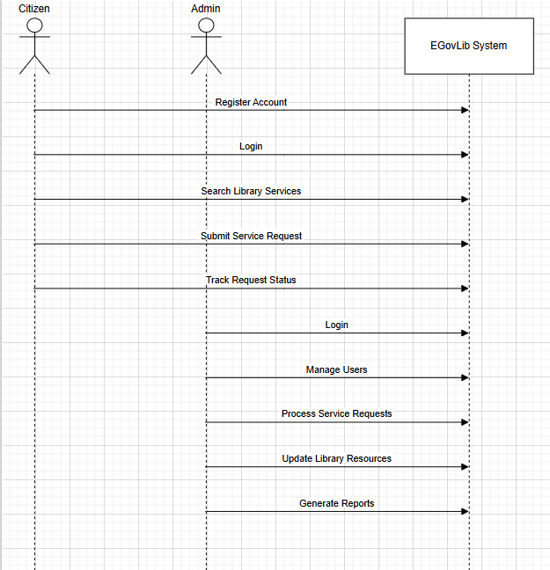
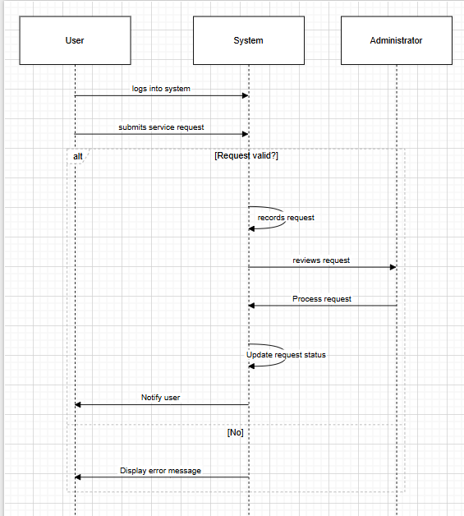
2.6.1 Use Case Diagram
Figure 2.1: Use Case Diagram of the EGovLib System
The use case diagram models the interactions between the main actors—Citizen, Staff, and Admin—and the core functionalities of EGovLib. Citizens can register, submit service requests, track the status of their requests, and provide feedback, while staff users can view assigned requests, update their status, and generate reports. Administrative users manage system configuration, including user accounts and departmental structures, ensuring that the platform reflects the organizational setup of the WASH Commission.​

Use the following PlantUML code to generate the use case diagram:
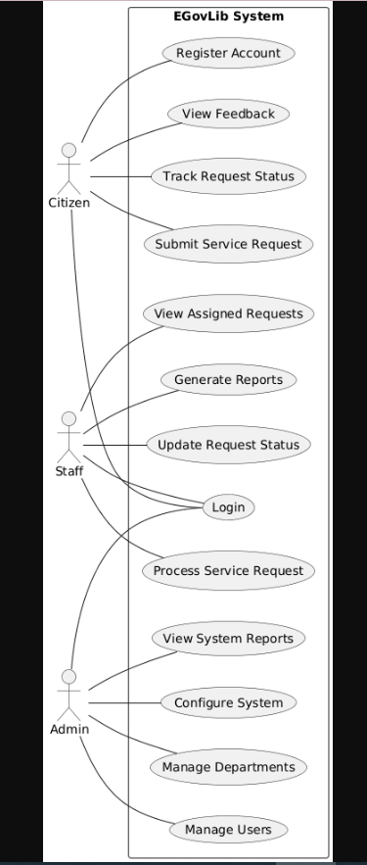
2.6.2 Activity Diagram
Figure 2.2: Activity Diagram for Service Request Processing in EGovLib
The activity diagram illustrates the sequence of actions involved in processing a citizen’s service request within EGovLib. The process begins when a citizen submits a request, after which the system validates the input and assigns the request to the appropriate department. Assigned staff then process the request, update its status in the system, and trigger a notification to inform the citizen of the outcome or any further required actions.​
Use the following PlantUML code to generate the activity diagram:
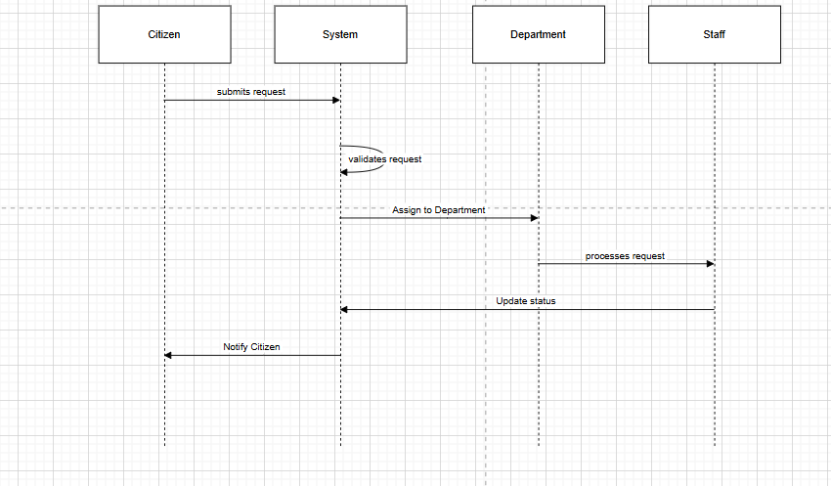
2.7 Project Plan
The project activities for the design and implementation of EGovLib were planned and scheduled over a four-month academic period. A Gantt chart was used to allocate timeframes to major tasks such as requirements analysis, system design, development, testing, documentation, and final evaluation. This structured planning approach facilitated effective time management, task coordination, and continuous monitoring of project progress.
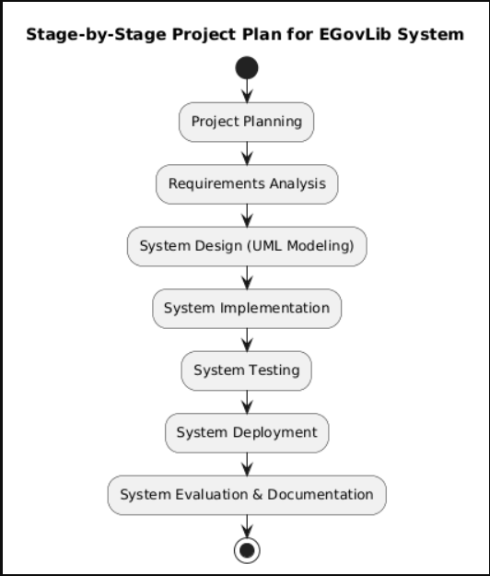

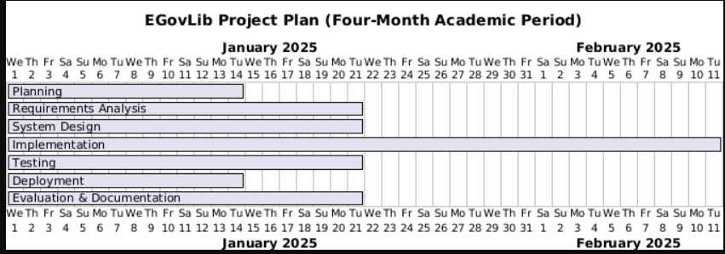

CHAPTER 3: SECOND REVIEW

3.1 UML Design Guidelines
Unified Modeling Language (UML) diagrams were employed to visualize both the structural and behavioral aspects of the EGovLib system. These diagrams provide a standardized way to document system components, interactions, and workflows, thereby improving communication among developers, stakeholders, and end users. By modeling the system before implementation, potential design issues can be identified early, and the resulting architecture becomes easier to maintain and extend.​
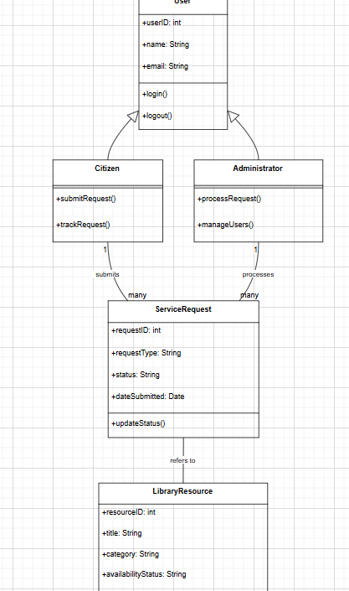
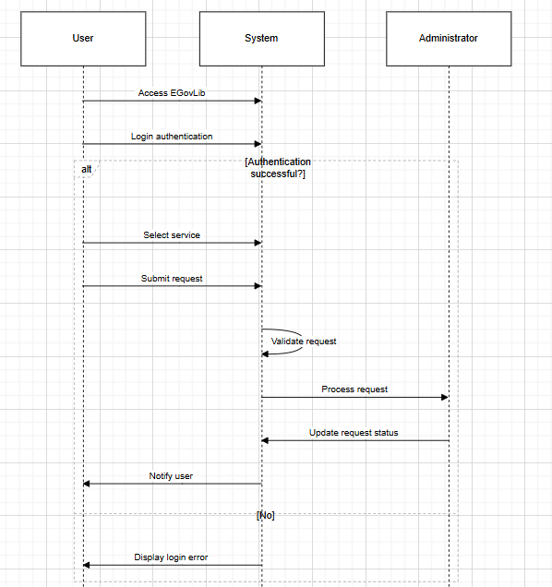
3.2 Class Diagram
Figure 3.1: Class Diagram of the EGovLib System
The class diagram represents the main classes, their attributes, and the relationships that define the static structure of EGovLib. The User class encapsulates common attributes such as userID, username, password, and role, and is specialized into Citizen, Staff, and Admin subclasses to reflect different access levels and responsibilities. The ServiceRequest class captures key information about each request, including requestID, description, status, and dateSubmitted, while the Department class maintains departmental identifiers and names, supporting the assignment and handling of requests across organizational units. Associations indicate that a citizen can submit multiple service requests, staff can process multiple requests, and each request is handled by a specific department.​
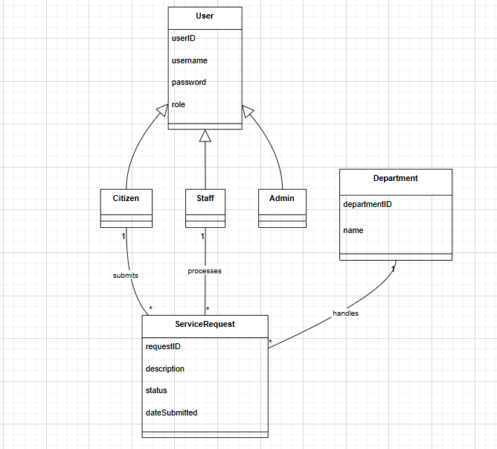
3.3 Object Diagram
Figure 3.2: Object Diagram Showing Runtime Interaction in EGovLib
The object diagram provides a snapshot of specific instances of classes and their links at a particular moment during system execution. In the context of EGovLib, instances such as citizen1 : Citizen, request1 : ServiceRequest, staff1 : Staff, and dept1 : Department illustrate how an individual citizen’s request is linked simultaneously to a responsible staff member and the relevant department. This runtime perspective helps to validate that the relationships defined in the class diagram correctly support the intended system behavior.​
Use the following PlantUML code to generate the object diagram:
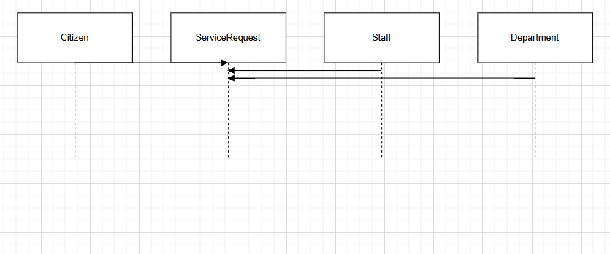
3.4 Sequence Diagram
Figure 3.3: Sequence Diagram for Citizen Service Request Submission
The sequence diagram models the chronological order of interactions between system components during the submission and processing of a citizen’s service request. The process begins when the Citizen sends a “Submit Request” message to the System, which then forwards an “Assign Request” message to the Department. The Department notifies the assigned Staff member, who updates the request status in the System, after which the System sends a “Notify Resolution” message back to the Citizen. This diagram highlights the flow of control and the messages exchanged among participants over time.​
Use the following PlantUML code to generate the sequence diagram:
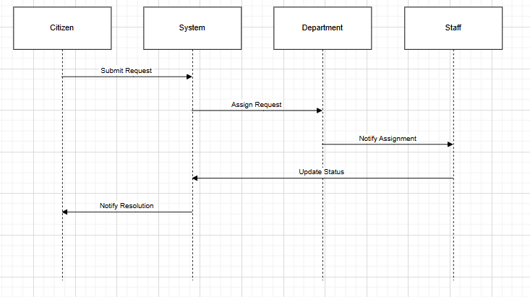
3.5 Communication Diagram
Figure 3.4: Communication Diagram Illustrating Message Flow in EGovLib
The communication diagram presents the same interaction scenario as the sequence diagram but emphasizes the structural links between objects and the numbering of messages. In this diagram, the Citizen sends message “1. Submit Request” to the System, which sends “1.1 Assign Request” to the Department. The Department then issues “1.2 Process Request” to Staff, followed by Staff sending “1.3 Update Status” to the System, and finally the System issuing “1.4 Notify” back to the Citizen. This representation helps to visualize how collaborating objects are interconnected while maintaining the order of messages.​
Use the following PlantUML code to generate the communication diagram:
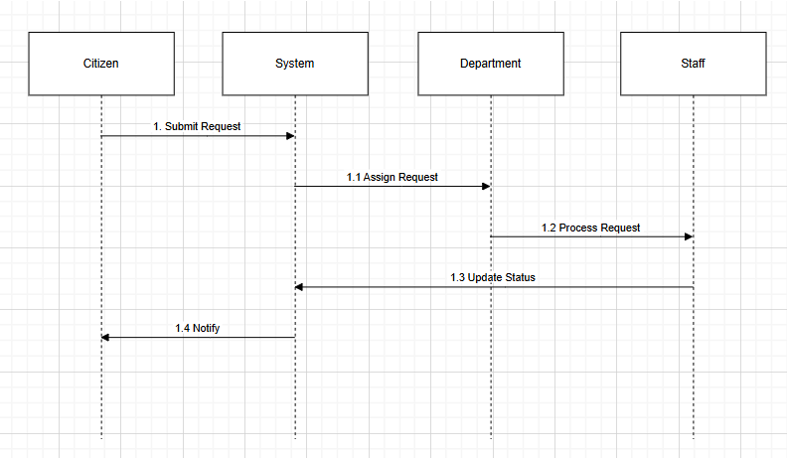

3.6 State Chart Diagram
Figure 3.5: State Chart Diagram of a Service Request Lifecycle
The state chart diagram describes the lifecycle of a service request as it transitions through various states within EGovLib. A request initially enters the Submitted state when created by a citizen and then moves to Assigned once it is allocated to a department. As staff begin work, the request enters the InProgress state, followed by Resolved when the issue has been addressed, and finally Closed after confirmation or completion of all follow-up actions.​
Use the following PlantUML code to generate the state chart diagram:
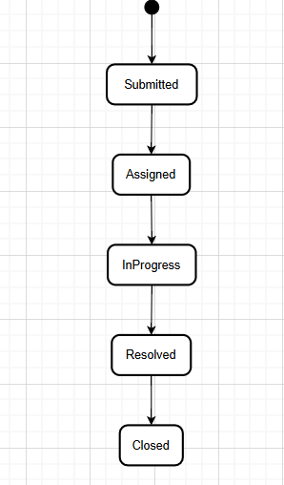
3.7 Process Design
The process design specifies the logical flow and conditions under which service requests are created and managed in EGovLib. A key pre-condition is that the citizen must be registered in the system before submitting a request, ensuring that all requests are associated with valid user accounts. The main post-condition for the process described in this chapter is that the service request is successfully logged in the system and assigned to an appropriate department or staff member for further action

CHAPTER 4: FINAL PROJECT
4.1 System Implementation
EGovLib was implemented as a web-based information system comprising a user-friendly frontend interface, application backend logic, and a secure database layer for persistent data storage. The frontend enables citizens and staff to access system features through standard web browsers, while the backend processes requests, enforces business rules, and manages interactions with the database. The database stores user profiles, service requests, departmental records, and transaction logs, ensuring that information can be retrieved, updated, and reported efficiently. System screenshots are used in the appendices to illustrate key functionalities such as user registration, request submission, request tracking, and administrative management of departments and users.​
4.2 Testing Techniques
A combination of black box and white box testing techniques was applied to ensure the reliability and correctness of EGovLib. Black box testing focused on validating functional requirements by checking whether features such as complaint submission, status updates, and report generation behaved as expected from the end user’s perspective. White box testing examined the internal logic, control structures, and database queries within the code to identify logical errors, unreachable paths, and performance bottlenecks, thereby improving overall system robustness.​
4.3 Project Evaluation
The evaluation of EGovLib indicates that the project largely achieved its objectives of improving efficiency, transparency, and service delivery within the WASH Commission’s service request processes. The system supports faster complaint handling, centralized data management, and better visibility of request status for both staff and citizens. However, implementation also revealed contextual challenges, particularly limited internet connectivity in some areas and varying levels of digital literacy among users, which may affect adoption and consistent use of the system. Addressing these challenges through capacity building, user training, and infrastructure improvements is essential for maximizing the long-term impact of EGovLib on WASH service delivery in Liberia.

References

Chapter One: Introduction to EGovLib& Background of the Study
(E-Government concepts, digital public services, global context)
United Nations. (2020). United Nations E-Government Survey 2020: Digital government in the decade of action for sustainable development. New York, NY: United Nations Department of Economic and Social Affairs.
United Nations. (2022). United Nations E-Government Survey 2022: The future of digital government. New York, NY: United Nations Department of Economic and Social Affairs.
World Bank. (2016). World development report 2016: Digital dividends. Washington, DC: World Bank.
World Bank. (2020). GovTech maturity index: The state of public sector digital transformation. Washington, DC: World Bank.
OECD. (2018). Digital government review: Building data-driven public sector. Paris: OECD Publishing.
Scholl, H. J. (2015). E-government: Information, technology, and transformation. New York, NY: Routledge.
Layne, K., & Lee, J. (2001). Developing fully functional e-government: A four-stage model. Government Information Quarterly, 18(2), 122–136.
Moon, M. J. (2002). The evolution of e-government among municipalities: Rhetoric or reality? Public Administration Review, 62(4), 424–433.

Chapter Two: Literature Review & Theoretical Framework
(Technology adoption, user acceptance, innovation diffusion)
Davis, F. D. (1989). Perceived usefulness, perceived ease of use, and user acceptance of information technology. MIS Quarterly, 13(3), 319–340.
Rogers, E. M. (2003). Diffusion of innovations (5th ed.). New York, NY: Free Press.
DeLone, W. H., & McLean, E. R. (2003). The DeLone and McLean model of information systems success: A ten-year update. Journal of Management Information Systems, 19(4), 9–30.
Zhang, P., & Li, N. (2005). The intellectual development of human-computer interaction research: A critical assessment of the MIS literature (1990–2002). Journal of the Association for Information Systems, 6(11), 227–292.
Kumar, V., Mukerji, B., Butt, I., &Persaud, A. (2007). Factors for successful e-government adoption: A conceptual framework. Electronic Journal of E-Government, 5(1), 63–76.
Alter, S. (2008). Defining information systems as work systems: Implications for the IS field. European Journal of Information Systems, 17(5), 448–469.

Chapter Three: System Analysis and Design (EGovLib UML Design)
(UML, system modeling, software architecture, workflows)
Dennis, A., Wixom, B. H., &Tegarden, D. (2015). Systems analysis and design: An object-oriented approach with UML (5th ed.). Hoboken, NJ: John Wiley & Sons.
Booch, G., Rumbaugh, J., & Jacobson, I. (2005). The unified modeling language user guide (2nd ed.). Boston, MA: Addison-Wesley.
Fowler, M. (2004). UML distilled: A brief guide to the standard object modeling language (3rd ed.). Boston, MA: Addison-Wesley.
Larman, C. (2005). Applying UML and patterns: An introduction to object-oriented analysis and design (3rd ed.). Upper Saddle River, NJ: Prentice Hall.
Curtis, B., Kellner, M. I., & Over, J. (1992). Process modeling. Communications of the ACM, 35(9), 75–90.
ISO/IEC. (2017). Systems and software engineering—Life cycle processes (ISO/IEC 12207:2017). Geneva: International Organization for Standardization.

Chapter Four: System Implementation & Development
(Software engineering practices, development models, maintainability)
Pressman, R. S., & Maxim, B. R. (2020). Software engineering: A practitioner’s approach (9th ed.). New York, NY: McGraw-Hill Education.
Sommerville, I. (2016). Software engineering (10th ed.). Boston, MA: Pearson Education.
McLeod, R., & Schell, G. (2007). Management information systems (10th ed.). Upper Saddle River, NJ: Pearson Education.
Laudon, K. C., &Laudon, J. P. (2020). Management information systems: Managing the digital firm (16th ed.). New York, NY: Pearson.

APPENDICES
Appendix A: UML Diagrams
This appendix contains the UML diagrams developed for EGovLib, including the use case diagram, activity diagram, class diagram, object diagram, sequence diagram, communication diagram, and state chart diagram used during system analysis and design.​
Appendix B: Survey Questionnaire
This appendix presents the survey questionnaire used to collect data from WASH Commission staff and, where applicable, citizens regarding existing service request processes and perceptions of the EGovLib system.​
Appendix C: System Screenshots
This appendix includes screenshots of the implemented EGovLib system interfaces, such as login pages, user dashboards, request submission forms, request tracking views, and administrative management screens.​
Figure c.1 shows the home page of the Egov sysem, services, department, and public information:
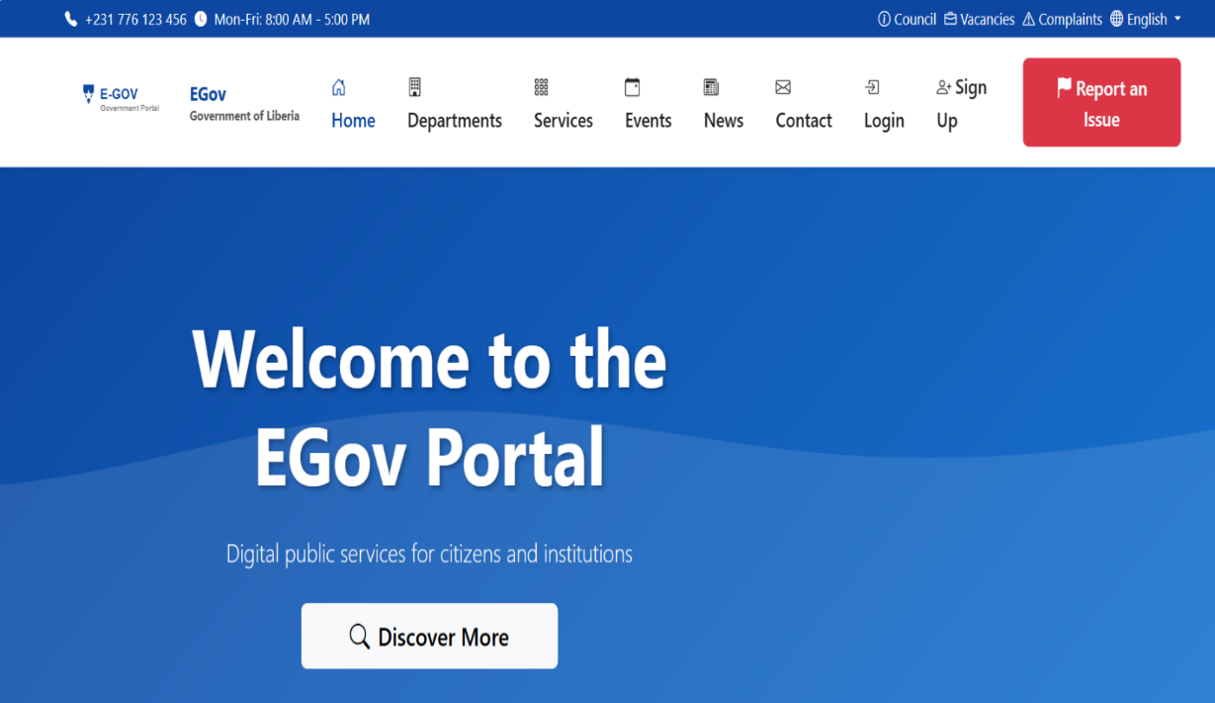

Figure c.2: User Login Page, this screen allows registered users to authenticate and access the system securely.
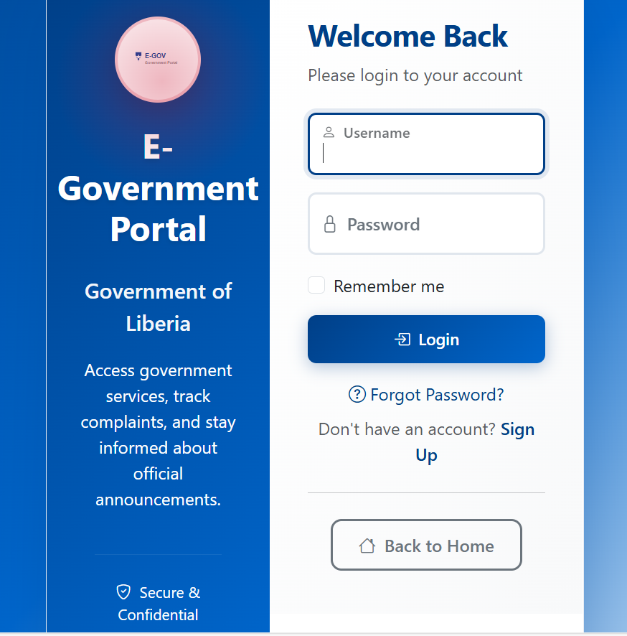

Figure c.3:sign-up page
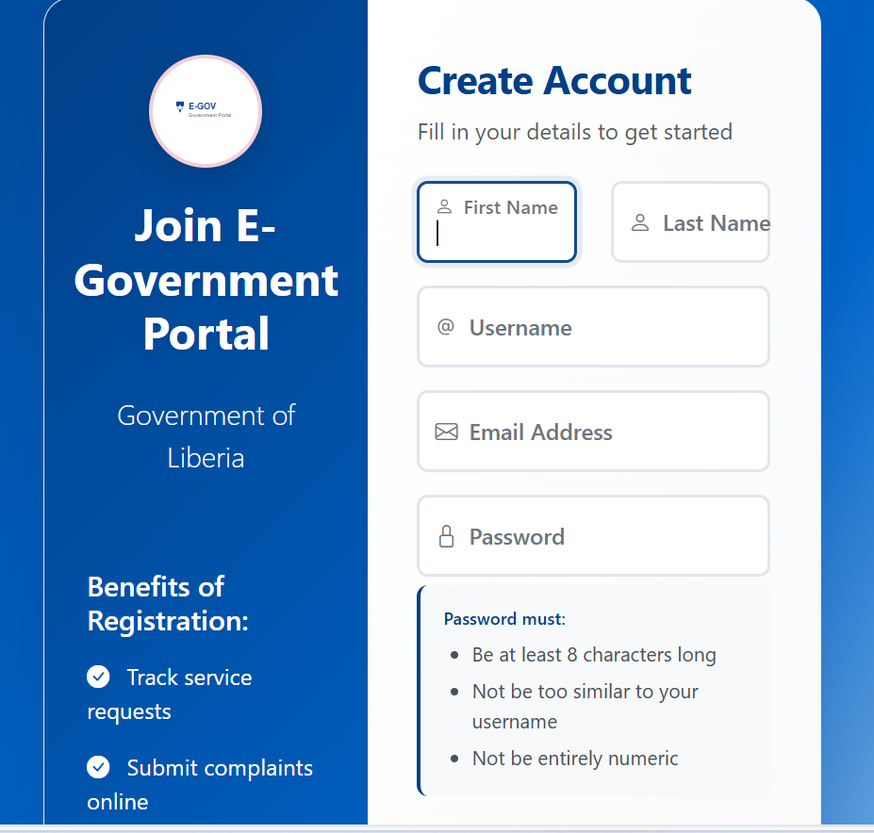

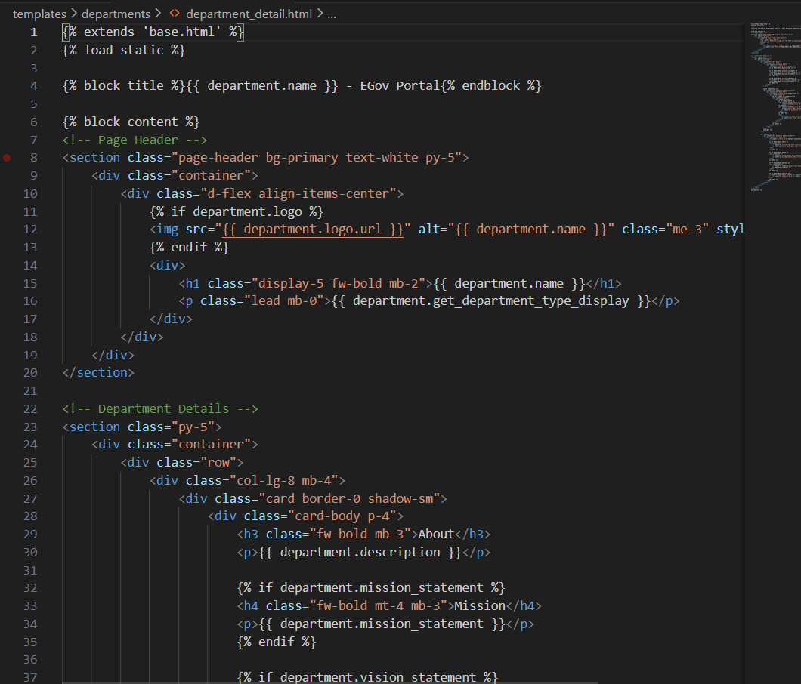
Figure c.4: codes

