# Assignment 1-Introduction to Agent Based Modeling

Author name: Chung-chien, An a1810681

Jiacheng Zhao a1783358,

Yifan Zhou a1776510,

Word count: 2289

Date of submission: 19/04/2020

# Part 1

## How to use the system

**The definitions of adjusting icons :**

* **population**

Population of birds can be adjusted by users, which control the quantity of prays. The range of adjustment can afford from 0 to 1000. However, the system will automatically inform users when the population is less than 1.

* **vision**

The range of vision for prays for detecting other companies or predators. The range of adjustment can afford from 0 to 10, which means the maximum capability is 10 blocks away.

* **minimum-separation**

The value of prays stay flocked, which can change the range of flocking distance. The width of the flocking group can be decided and influenced by changing value.

* **max-align-turn**

Value to adjust the willingness of being a group. In the maximum value, the group can be observed as a line toward a direction.

* **max-cohere-turn**

Value of adjusting group’s direction. This value provides a wider range for deciding the direction of a group randomly.

* **max-separate-turn**

Value of adjusting each prays’ distance. When two turtles are too close to each other, this value can separate them for remaining actual behaviour of real birds.

* **CheasingLine**

Create a line between predator and its target for visualisation and easier for evaluating the performance and behavior of the model.

* **escape-range**

The moving range when a prey detecte a predator is surrounding itselfs.

* **escape-turn**

The escape direction when a prey detecte a predator is surrounding itselfs.

**Recommended value:**

Minimum-separation: 0.25

Max-align-turn: 13.25

Max-cohere-turn: 12.25

Max-separate-turn: 9.00

Vision: 10

Escape-turn: 100

Escape-range: 100

**Setting Steps:**

1.Set up all variables

2. Press Setup button

3. Press Go button

4. Watch the modeling view

## Evidence and assessment

This system is creating a natural reaction that shows grouplise birds under attacks from predators. The major behavior is the movement of birds showing how to flock to each other and escape from predators.

When the system starts, birds and predators will be initiated on the view. Before each move, birds will check if there is any predator around them within the designated vision. For example, a prey will actively avoid any predator which is in the escape range. A successful escape includes two stages.

The first stage is direction alternation. An escaping bird must check the direction of predators to make sure the escaping direction is different. The difference between two directions shorter than 80 degrees will be seen as a risky situation for the prey. Thus, under this risky situation, the reaction is to change the direction to the predator’s heading direction with some deviation as escape.

The second stage is the speed of escape. A predator is in the danger zone of a prey. Therefore, it will fly away faster than before. Because in the real world, when a bird is chased by a predator, it will speed up for running away.

After the escape, the bird will try to find some flock mate to join the flock. The flocking part is based on the flocking model from Netlogo.

When a flock of birds meets a predator, birds nearest the predator will fly away to escape, but soon they will fly to find a flock again.

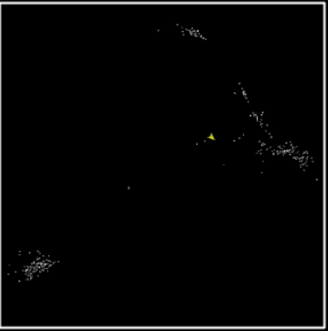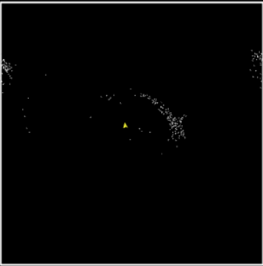

The predator of this system will find the weakest prey around them. Weakness in a group in most situations can be seen as an element for a predator to evaluate its target. In this model, we consider a prey stayed the outer rim of a group is considered as the weakest individual due to lacking the protection from its flock. Therefore, a predator will always choose the weakest individual for increasing hunting rate.

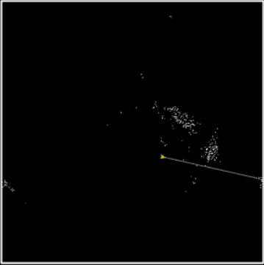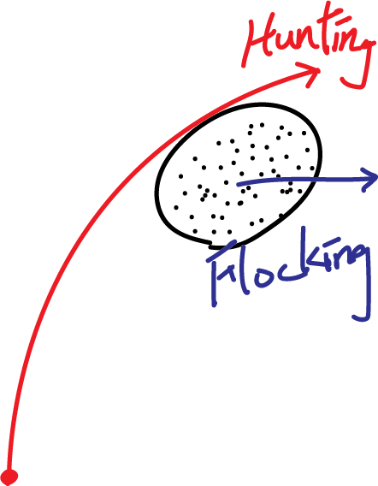

In this system, before every move of the prey, it will check the number of prey around this prey. If the number is small, it means this prey doesn’t have too many flocking mates, it will be considered as weak and easy to catch. The predator will find the weakest prey and create a link with it, then face the direction of the prey and move. In the real world, a predator always chases birds flying alone because they will be easier to be caught than a flock of birds.

The chasing link can be seen by choosing ‘on’ from the setting page.

# Part 2

## How to use the system

The definitions of adjusting icons **:**

**setup :** To distribute grass randomly across the farm. Initialize the shape and size of farmer A's and farmer B’s sheep initial energy and distribution area.

**go :** To run the program, it gives the sheep the ability to eat grass, fertility and die.

**setup-line :** To make it easier for the user to read the image, two lines were created to divide the farm into three equal areas.

**initial-number-sheep :** Initializes the initial sheep number for farmer A.

**initial-number-sheepTwo :** Initializes the initial sheep number for farmer B.

**sheep-gain-from-food :** The energy that sheep can get from each grazing activity.

**birth- energy :** Sheep breed when their energy reaches a specified value.

**grass-regrowth-time :** The rate at which grass grows.

**Run the program :** At first to set up the program and set up the line, to show the distribution area of the two farmers' sheep and the distribution area of the pasture on the farm. Then , touch the go button and run the program, the figure will show the change of sheep, sheepTwo and grass. Because grass has a large number, so the figure shows 1 / 4 of grass.

For example :

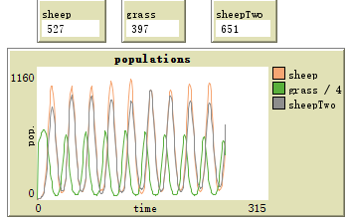

**Description of the system**

This system is a sheep-grass model. So in this system, it should have sheep and grass. The requirement of part 2 is two farmers have different and same areas to feed the sheep. So the operation of this system has three main components.

First is to set up the system. Initializing two farmers' sheep and using different colors to sign these two group sheep. Meanwhile, limit the initialization position of two groups of sheep, randomly initialize the sheep to the specified position as required. If this system wants to change the location of the sheep. Changing the code of ycor number can make the sheep in different areas. By initializing the sheep, these two groups of sheep have different colors and have initialized energy and location. After that, Initializes the distribution of grass and the rate of grass growth.

Second is to set the move, eat grass, reproduce and death function. There is a list to show every function.

Move : Move function can ask different groups of the sheep eating in their limited area and have a random movement.

Eat grass : In eat grass function, Every grass eaten by sheep turns brown. And sheep will gain energy by eating grass.

Reproduce : In reproduce function, If sheep have enough energy and it can breed. Every new sheep has the initial energy.

Death : If the energy of sheep is zero, sheep will die.

Third is to run the system. Set the initial values of the two groups of sheep, the ability of each group to acquire energy, the growth rate of the grassland and the reproductive energy of the sheep. Click the setup and setup-line button to initialize the system. Then to click the go button to run the system and the number of two group’s sheep and grass will show on the figure.

## Evidence and assessment

# The first situation of this system is both farmer A and farmer B's sheep can use the third part of the grassland. With the same initial number of these two groups. This system show the degree of variation in the number of sheep and grass.

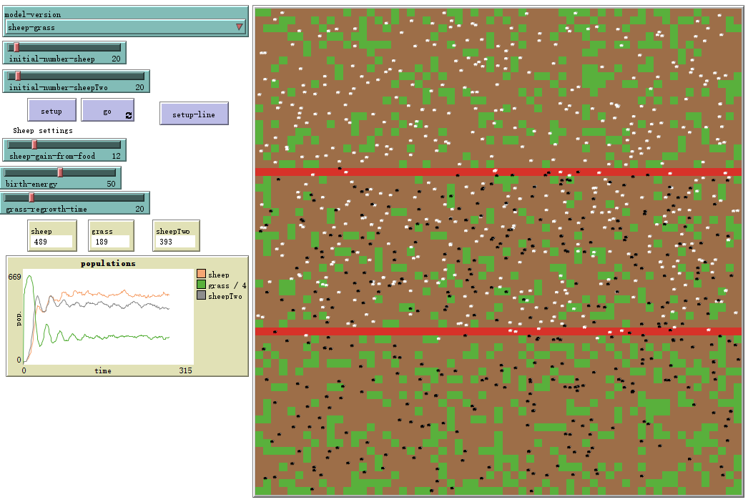

From the figure we can find that at first the amount of grass will rise briefly and then fall to a stable value. Meanwhile, the Numbers of the two sheep also came close to a plateau after rising to a peak and falling by a small fraction. It can be seen from the figure that the maximum number of sheep a farmer can raise is between 380 and 470. From the figure we can also find that the first and the second area have more grass than the third area.

The second situation is that both farmers are not allowed to use the third area. Therefore, the initialization area and activity area of the two groups of sheep were adjusted. Farmer A can only use the first area, farmer B can only use the second area.

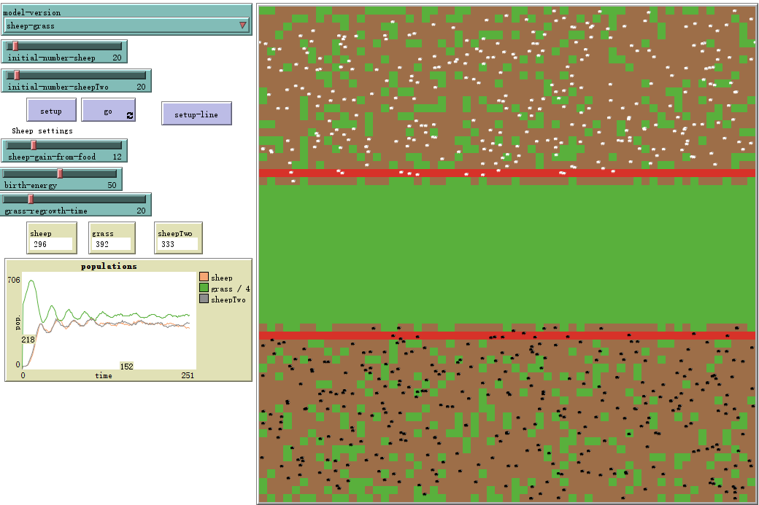

From this figure we can find that the first and second area have sheep and the third area do not have sheep. Therefore, the first and second area’s grass are changing and the third area is full of grass because both farmers are not allowed to use this area. Because farmers can use less area than the first situation. It can be seen from the figure that the maximum number of sheep a farmer can raise is between 280 and 340.

The third situation is that only one farmer is allowed to use the third area. Therefore, the initialization area and activity area of the two groups of sheep were adjusted. So let's say that only farmer A can use the third area.

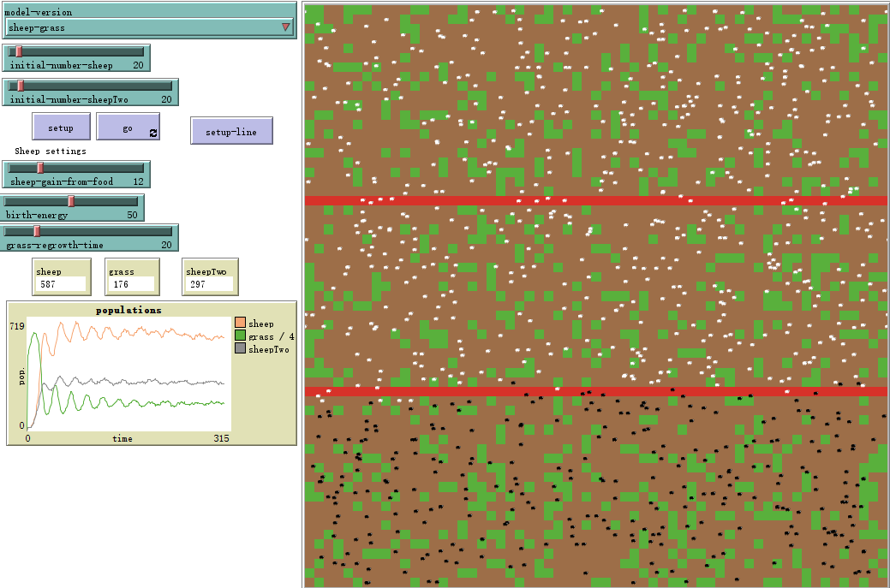

From the figure we can find that the first and third areas have more grass than the second. Because farmer A can use more area than farmer B. So farmer A can raise 450 to 670 sheep and farmer B can raise 260 to 340 sheep. The amount of grass is basically the same as in the first situation.

# 

# 

# 

# 

# 

# 

# Part 3

**Target Functionality :** In this system, the first situation is both farmer A and farmer B's sheep can use the third part of the grassland. At first both farmers have the same number of sheep

**The definitions of adjusting icons :**

* **GainSheep**

The weight value for aggressively increasing the population of sheep for the behinder.

* **AddSheepNumber**

The basic value for gaining the population of sheep for farmers.

* **sheep-gain-from-food**

This weight can adjust the birth rate from the value of food energy.

* **grass-regrowth-time**

This value is controlling the recovering time of grass. Higher values make grass recovering slower.

**Internal examining value:**

GainSheep: 2

AddSheepNumber: 10

Sheep-gain-from-food : 3

Grass-regrowth-time: 5

**Setting Steps:**

1. Set up all variables

2. Press Setup button

3. Press Go button

## Evidence and assessment

The key point in part 3 is how to remain balanced between sheeps and grass. Under this model, farmers in this system are designed as a sheep provider and quantity controller. The ultimate goal is to make sure the quantity of sheep can be maximum while the energy provided from grass can be used to keep sheep in a stable number. However, the viberate of sheep’s population is almost inevitable such as figure 3.1 and 3.2. Before a stable population, there must be a period of time that is unstable, which is considered as the period of adjustment. A successful and effective system should reduce the period of adjustment as short as possible.

The system shall adjust the increase rate by the upper bound and lower bound as figure 3.3, the farmer will evaluate current boundaries for increasing or decreasing the number put into the field.

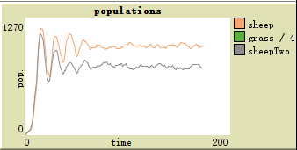

**figure 3.1 A stable number of sheep**

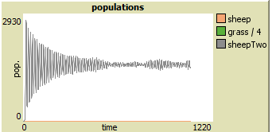

**figure 3.2 prospection**



**figure 3.3 The reference value for population control**

The first stage of the system is called “ raising period”. In the rising period, both framers will continuously increase their sheep in the field until the field cannot torrience a certain amount of sheep.



**figure 3.4 Rising Period**

The second stage is called “cooldown period”. In this stage, due to the field being out of the capability to torrience the population of sheep, the population of sheep will directly shrink back to the limitation of this field. This period is also usually showing the greatest shock of the population.



**Figure 3.5 Cooldown Period**

The third and last stage is called “ competition period”. When the system is under this stage, both farmers will become aggressive to put their sheep into the field to maximize their stocking rate. This system is designed when a farmer is behind than others, this farmer will take more aggressive operations to take advantages back. More sheeps will be put back to the field when the behind farmer found chances to raise the extra population of sheep.



**Figure 3.6 Competition Period**

## Behaviour and Affection

* **What are the stocking rates you get?**

This system with provided control values can provide around 250 +- 50 sheep for each farmer.

* **Are these the same as the manually derived values for part 2?**

No. This is because part 3 does not consider the situation of birth rate due to the modern stock farming normally farming their livestocks in the same gender. However, the data analysis shows a similar curve compared with part 2.

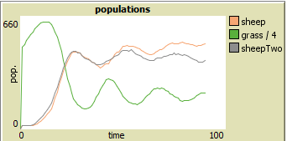

* **What happens if you get one farmer who is more prepared to put up with wild swings in population? Does she get to run more or less sheep over time?**

Basically both farmers will reach the similar result to show their sheep died out by starvation after the population was not under control. The behavior shall show the population rocket to an apex, which is the limitation of this field. Then, the population will dramatically drop back to the bottom until the grass grows back.

* **What is the effect of changing the growth rate of grass? Or changing the breeding rate of sheep?**

The meaning of the growth rate of grass in this system is representing the capability of torrienceness in a field. Higher regrowth rate of grass can make more population of sheep staying on the field. However, higher torrienceness is basically a buffer to contain a higher population. The massive starvation occured by over population still cannot be avoided by simply raising the value of the growth rate.