StudyBNB: Study between Breakfast and Bed

FiveGuys

U-seong Kim  
*Dept. of Information System*  
*Hanyang University*Seoul, South Korea  
jeneve1@hanyang.ac.krHankyu Park  
*Dept. of Information System*  
*Hanyang University*Seoul, South Korea  
official03x@hanyang.ac.krDongjin Lim  
*Dept. of Information System*  
*Hanyang University*Seoul, South Korea  
ehdwlsdudwo1@hanyang.ac.kr

Sangyun Chi  
*Dept. of Information System*  
*Hanyang University*Seoul, South Korea  
csy9604@hanyang.ac.kr

Michael Sklors  
*Dept. of Information System*  
*Hanyang University*Karlsruhe, Germany  
skmi1013@h-ka.de

*Abstract—This paper revolves around developing a study time checker service. Studying is inseparable with students. During the flow of learning they may want to check their study time and take a break accordingly. However, if students look at their smartphones to check their study time, it might cause them to lose their concentration. The question is how to study more efficiently and take a break that fits the study time. A proper solution would be to check the study time and recommend study methods through the SKT NUGU AI speaker.*

Keywords—studying, time, check, application, Android, SKT NUGU, AI speaker

1. Role Assignments

|  |  |  |
| --- | --- | --- |
| Roles | Name | Task description and etc. |
| User | Hankyu Park | User should provide appropriate feedback based on user experience and usability of the service. He will also Support development team with design choices, and NUGU SDK. |
| Customer | Michael Sklors | Customer should focus on requirements for the service and analysing costs and benefits. Also, he will support development team with design choices and critical feedback. |
| AI developer | Useong Kim | AI developer should decide which AI module to use, to solve problems we face. He will acquire skills to develop the service with AI modules in python and the NUGU SDK. |
| Application developer | Sangyun Chi | Application developer should think about the application part, especially deciding which platform and programming language to use. Also, he will looking for any appropriate open source libraries and datasets. |

|  |  |  |
| --- | --- | --- |
| Development manager | Dongjin Lim | Development manager should which requirement should be implemented, and which requirement shouldn’t be implemented, by taking the cost and expected satisfaction of users into account. Also, he should Manage the development team and focus on relevant requirements. |

# Introduction

## Motivation

Studying and reading is always present in our daily life, especially as a college student. When we study, it is easy to lose track of the hours spent and forgetting to take breaks. This results in being inefficient for the goal of studying for a class or an exam. Conversely, it is easy to lose concentration due to the temptation to use laptops and cell phones. From these cases, we thought that it would be good to students to provide a time-check application for studying. By using our application, students can see whether they should have rest at proper time, and they can focus on their study more. The ultimate question to answer is always "How can I be more efficient with my time for studying?"

This project is planning to provide a mobile app in combination with the SKT NUGU AI Speaker to communicate study times and share them with friends to motivate each other. By having an overview on the own study times and getting reminded to take breaks, the person will see an improvement in the learning progress. In addition, based on a dataset with studying times from other students we can train an AI model to predict required hours to study and the respective grade. Currently, we are thinking of setting the main target of AI analysis as a job seeker in his 20s. This is because they take common tests with a small number of subjects such as Computer Specialist, TOEIC, and Korean History Proficiency Test, and we thought that analysis on these tests is likely to be easier than other tests.

## Problem statement (client’s needs)

* There are many students who lose concentration easily, especially on electronic devices such as television, laptop, and cell phone.
* There are other students who focus too much on their study and forget about break time. It causes their brain to lose power. Scientifically, it has been found that proper rest increases brain efficiency.
* Time check applications like ‘Yeolpumta’ is sometimes inefficient because app itself is on cell phone, and it can disrupt concentration.
* Korean students tend to study by measuring their study time.

## Research on related software

Since the topic of studying is ubiquitous, a wide range of related software already exists. All the apps below have disadvantages that they are bound to the smartphone that they can lose concentration by it and can’t remind the learner of breaks. We plan to tackle these problems by combining it with SKT NUGU speaker.

### Yeolpumta(열품타)

It is a widely popular study timer application in South Korea [1]. Users can gather in study groups and see the rankings of each group member. It can prohibit its users not to run other apps while studying. It also allows users to focus by make white noise if they want. Users can use Cam study function, which users can see group members’ pictures, which are taken every 30 second. I think video seems better, but they provided picture every 30 second because of cost issue. Also, users can communicate each other in community.

### Forest

In Europe, the app Forest is being used [2]. While not using the phone, users can earn coins to exchange for planting a tree through a non-profit organization.

### Focus To-Do: Pomodoro Timer

It is a study time checker that has a rule that repeats 25 minutes study and 5 minutes break, for 4 times, and take 30 minutes break. This is a time management methodology proposed in 1980s. This application also provides white noise service and smartphone restriction mode.

### QandA

QandA is an application that provides appropriate answers to the question, using AI technique such as OCR. It also provides questions that are like the given question, so that users can study more about that type of problems. User can

### AI TOEIC – RIIID Tutor

RIIID Tutor is an application that helps users study TOEIC. RIIID Tutor is special that it uses AI techniques in analyzing users’ study data and recommend which parts to study. It enables personalized learning.

# Requirements

To identify the proper requirements of the users for the service, a stakeholder analysis needs to be carried out first [3]. Based on the results, important stakeholders are asked to provide input for the expected outcome through interviews or a survey.

The following requirements resulted from a brainstorming session of the authors. A survey for the user group will be conducted in the next phase of the project.

## Functional Requirements

Functional requirements define what the system is supposed to do to meet users’ expectations. <https://www.perforce.com/blog/alm/what-are-functional-requirements-examples>

### User Management

As a user, I want the application to have a basic account management system, so I can use it with friends. I should enter this application with ID and password.

### Creating a Study Group

As a user, I want to create a study group by by entering other users’ ID. I want to study with my friends, and I want to check my friends’ study time any time I want.

### Timer Function

As a user, I want to start the timer not only by touching the button on the app screen, but also by announcing it to the NUGU speaker.

### Information Sharing Function(about study time)

As a user, I want to check the study time of the group members, such as how much time they study, which subjects they study, and also whether the group member is studying now or not.

### Group Ranking

As a user, I want to see the group’s study time ranking, such as accumulated study time ranking over the past week. I can be motivated with this group ranking system.

### Feedback

As a user, I want to get feedback of my individual studying habits. I want to check whether balance of my subjects is fine, also I want to know the average study time of the successful applicants.

## Non-functional Requirements

Nonfunctional requirements define system attributes and ensure usability and effectiveness of the entire system. <https://www.scaledagileframework.com/nonfunctional-requirements/>

### Security

As a user, I don’t want to show my personal information to all people that are studying but only my study group to secure privacy.

### Reliability

As a user, I want the service to be working when I want to study, so from the morning until late night to cover all types of study personalities.

### Performance

As a user, I only need the service to perform quickly when I communicate with my study timer to not waste time.

### Maintainability

As a developer, I want the application to have clear services to fix them and easily add new separate functions.

### Scalability

As a user, I want the application to perform even during busy exam phases.

### Usability

As a user, it is important to me that the application is easy and fast to use so I can focus on studying and not being busy with setting up the environment.

# Development environment

## Choice of software development platform – App

The most suitable way to create a program that allows users to record and share their study time with other students is app development. Web development exists as an alternative, but it isn't considered because its accessibility of users was very low. So, this project will be based on an app. There are many options in the field of app development, including native apps, mobile apps, and hybrid apps.

1. Compare Native app, Hybrid app, and Web app

|  |  |  |  |
| --- | --- | --- | --- |
| Feature | Native app | Web app | Hybrid app |
| Development languages | Native only  (e. g. Kotlin,  Swift) | Web only | Native and Web  OR Web only |
| Code portability  and optimization | None | High | High |
| Access device-  specific features | High | Low | Medium |
| Leverage existing  knowledge | Low | High | High |
| Advanced graphics | High | Moderate | Moderate |
| Upgrade flexibility | Low | High | Moderate |
| Installation experience | High | Medium | High |

### App Development approach

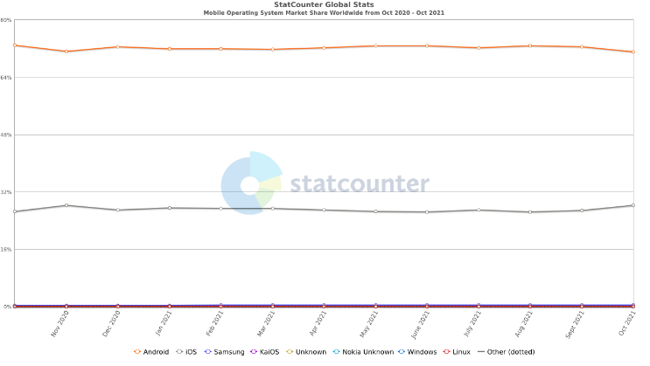

Native app: Native apps are apps developed in a language optimized for mobile devices. Currently, the market is divided into two platforms: Android and iOS. For Android development, the ability to handle Android SDK and Java-based Kotlin is necessary. For iOS development, the ability to handle Swift and a computer running Mac OS are necessary. The advantages of native app development are that it can maximize performance and that developers can take full advantage of the platform's features by calling and using the Native API. On the other hand, there are disadvantages in that you need to be familiar with handling the API of the platform and its low versatility due to it being platform-specific.

#### Web App: Web apps are a combination of mobile web and native apps, and have the advantages of native apps while having the characteristics of mobile web. Like mobile web, web apps are developed with general web technology and run on mobile browsers, but they are characterized by high speed by adopting a single page method rather than a full browser method. The advantages of web apps are that there is no need to install a separate app, can be accessed from any browser on any device, and is easy to maintain. On the other hand, the disadvantages are that developers have to use only the browser API, not the platform API, it is difficult to execute, and the operation is not smooth.

#### Hybrid App: A hybrid app is an app that blends the characteristics of a web app and a native app. The advantages of hybrid apps are that they can use both native APIs and browser APIs, so that various developments are possible, it is easy to develop because it is possible to develop an app with web development technology, and it can respond to multiple platforms with one development. On the other hand, the disadvantages are that you can use the native API only after learning native development knowledge, that you cannot increase the maximum performance because you run the app in the web view, and that the developer has to create the UI.

### We choose: Native App – Android

#### Native App: This project will be implemented as an app to check and compare study time with other students, and save unknown words or incorrect questions. There is no reason to use the Native API to implement these functions. This is a function that can be implemented with just the browser API. However, it is appropriate to develop as a Native App from the beginning because there is a possibility of using the Native API in the future, such as using the Screen Time API to record study time, or using the mobile phone use control API to restrict the use of mobile phones during study.텍스트, iPod이(가) 표시된 사진 자동 생성된 설명

#### Android: There are two reasons to choose Android as the project platform. First, Android can have far more control over the phone than iOS does. Android is more capable to use powerful features that control lock screens and bring information about cell phone usage that iPhone cannot do. Secondly, there are team members who have experienced Android development. If this project has a leisurely development period, there is no big problem to take lectures from the beginning because there is enough time to build the foundation. However, in a situation where a month or two months is given, such as the current project, it is most important to bring out the maximum results in a way that each person can do well.

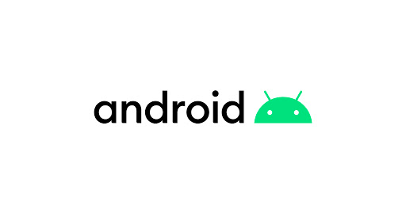

## Choice of software development platform – NUGU Play Builder



NUGU Speaker will not be utilized alone in this project. NUGU Speaker will be used as a sub-device concept such as Apple Watch used with iPhone and Samsung Galaxy Watch used with Samsung Galaxy series smartphones.

### Why using NUGU Speaker

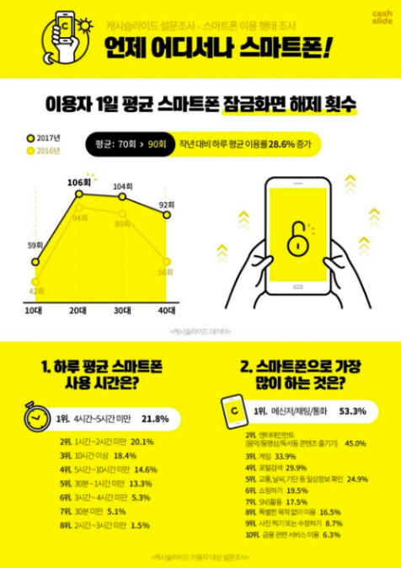

The biggest problem when using academic applications is that students must use a smart phone. According to the picture above, the top three items of the things that students do the most with your smartphone are things that interfere with their studies. The result tells that the more students use their phone, the more likely students are to do something other than study. Therefore, to use academic management applications such as Yeolpumta(열품타), students must be determined to never use content such as messengers, entertainment, and games. To overcome these shortcomings, it would be appropriate to use the NUGU speaker, which can minimize access to mobile phones, for learning recording.

### How to use NUGU Speaker

#### Recording Study Time: Detailed settings including existing learning ability, personal information such as age and gender, and goal score setting are registered in advance with the smartphone application, and learning time is recorded with NUGU Speaker. The command is:

* Aria, Start study today

(아리야, 오늘 공부 시작)

→ start timer

* Aria, breaktime

(아리야, 쉬는 시간)

→ pause timer

* Aria, Stop study today

(아리야, 오늘 공부 그만할래)

→ stop timer

#### Reading Wrong Answer Notes and Vocabulary: According to an article in Health Chosun, [4] there is a study result that people can memorize the most efficiently if they study memorization subjects right before going to bed at night. If users record the wrong answer note picture and vocabulary not memorized properly through the mobile phone application, NUGU Speaker will read the information from the database and read it. The command is:

* Aria, Read wrong answer note

(아리야, 오답노트 읽어줘)

→ start to read wrong answer note

* Aria, Read vocabulary lists

(아리야, 단어장 읽어줘)

start to read vocabulary lists

* Aria, Give me a vocabulary quiz

(아리야, 단어 퀴즈 내줘)

→ give a quiz from vocabulary lists randomly

## Choice of software development platform – Server

A server will be used for the NUGU AI speaker and Android app. The backend will be implemented with Firebase, and the database will be implemented with Firestore and Cloud Storage provided by Firebase. The server has a total of three roles. The first is the role of processing and storing user information recorded in the Android app. The second is the role of processing commands input from NUGU Speaker and return the result. Finally, it is the role of running commercial AI models on the server, such as an API that converts characters in an image into text, and an API that applies TTS to text

### Firebase



Firebase is chosen because of its many advantages.

* It is free to access if Google account exists
* The development speed is very fast because the backend work is standardized
* Almost everything needed for development is provided
* It is free to expand and contract server if paid option is chosen
* Real-time monitoring of errors enables immediate feedback

Since a limited number of people have to take charge of parts such as Android app development, NUGU Play Builder, server and backend, and Dataset processing, a simple backend construction is prefered. In addition, it is appropriate to use Firebase because Firestore and Cloud Storage provided by Firebase were needed to proceed with the project.

### Cloud Storage

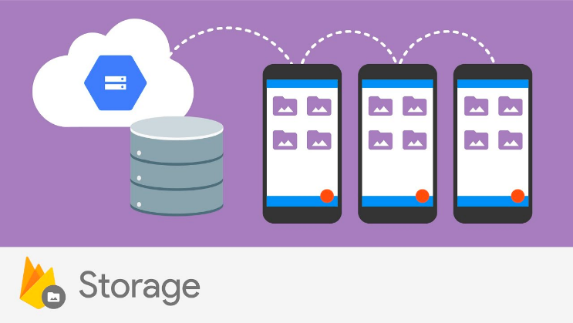

Cloud Storage is a database used to store large files such as images. It will serve to store the user's profile picture and a picture of the unknown word or incorrect question taken by the user with the smartphone.

### Firestore

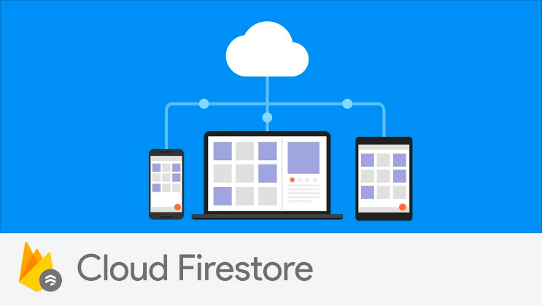

Firestore is a NoSQL Database for mobile app development. It will be used to store users' information and learning time. Like chatting, there is a feature that users can share data in real time, and it will be a necessary function to build a system that can encourage competition for learning by sharing each other's learning time in real time.

## Programming languages

### Kotlin

For the app development with Android Studio the language Kotlin is recommended. It's seamlessly integrated in the IDE and is the prefered language for developing Android apps according to Google. This makes it the clear choice for the app development.

### Python

For working on machine learning capabilities like recommendation functions the language Python is recommended. Due to its simplicity and consistency, development is faster than other languages. Especially for machine learning, many libraries, and frameworks like NumPy and scikit-learn exist in Python. One disadvantage is the performance of the language compared to C or C++. For the recommendation function of ‘StudyBNB’, speed is not a relevant characteristic though.

## Cost estimation

The cost estimation for the development is provided below:

1. Cost estimation

|  |  |  |
| --- | --- | --- |
| Resource | Description | Cost  (KRW) |
| Google Firebase | Development platform and backend | 0 |
| Notion | Documentation and collaboration page | 0 |
| Jupyter Notebook | Coding environment for Python | 0 |
| Android Studio | IDE | 0 |
| Github | Code version control | 0 |

## Development environment

For the development the following versions and resources are being used:

### Computer:

* CPU: AMD Ryzen 7 4700U with Radeon Graphics 2.00 GHz
* RAM: 16 GB
* OS: Windows 10 Education Version 21H1

### Android Studio:

* Version: Arctic Fox | 2020.3.1 Patch 3

### Jupyter Notebook:

* Version: 6.3.0

### Python:

* Version: 3.8.8

## Software in use

Since the topic of studying is ubiquitous, a wide range of related software already exists. Below, there is an overview on several apps that can be found on the Google Play Store.

### Yeolpumta(열품타)

**Overview**: 4.2 stars from 11,000 ratings and 1 Mio.+ downloads on Google Play Store

Yeolpumta is a widely popular study timer application in South Korea. Users can gather in study groups and see the rankings of each group member. It can prohibit its users running other apps while studying. It also allows users to focus by making a white noise if they want. Users can use the cam study function, where users can see the group members’ pictures, which are taken every 30 seconds. The video functions seem better, but they provide pictures only every 30 seconds because of cost issues. In addition, users can communicate with each other in a community.

### Forest

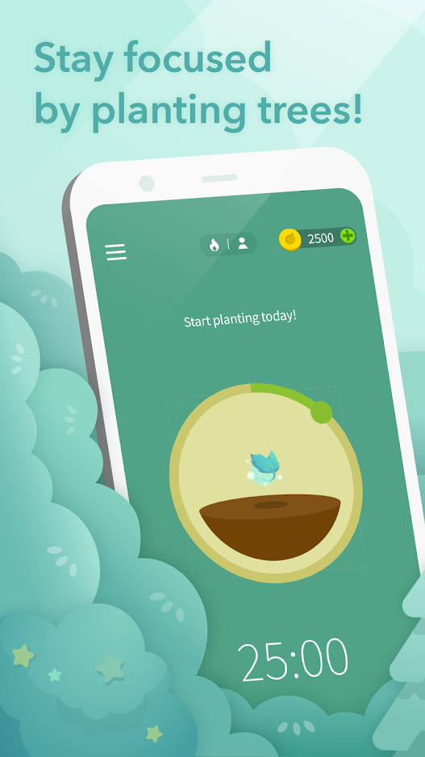

**Overview**: 4.8 stars from 403,000+ ratings and 10 Mio.+ downloads on Google Play Store

In Europe, the app Forest is popular to focus on studying. While not using the phone, users can earn coins to exchange for planting a tree through a non-profit organization. Forest makes use of Gamification aspects to reward the user for not using the phone. There is a premium version which provides statistics and collaboration functions to challenge friends.

### Focus To-Do: Pomodoro Timer

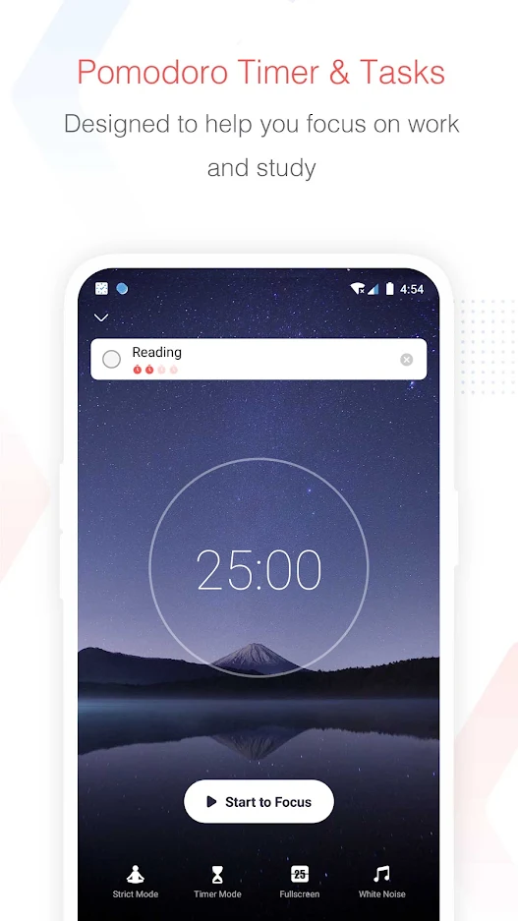

**Overview:** 4.7 stars from 157,000+ ratings and 1 Mio.+ downloads on Google Play Store

Focus To-Do: Pomodoro Timer is a study time checker that makes use of the pomodoro technique. Basically, the technique repeats a flow of 25 minutes of studying and 5 minutes of taking a break four times. After such a flow, the user takes a 30-minute break. This time management technique exists for many years since it has been proposed in the 1980s. This application also provides a white noise service and smartphone restriction mode.

### Quanda

**Overview:** 4.1 stars from 447,000+ ratings and 10 Mio.+ downloads on Google Play Store

QANDA is an application that makes use of AI techniques such as optical character recognition (OCR) to provide appropriate answers to math questions. In case of needing more explanation, the user can contact tutors. The app also searches the web regarding given question so that users can study more about that type of problem.

### AI TOEIC – RiiiD TUTOR

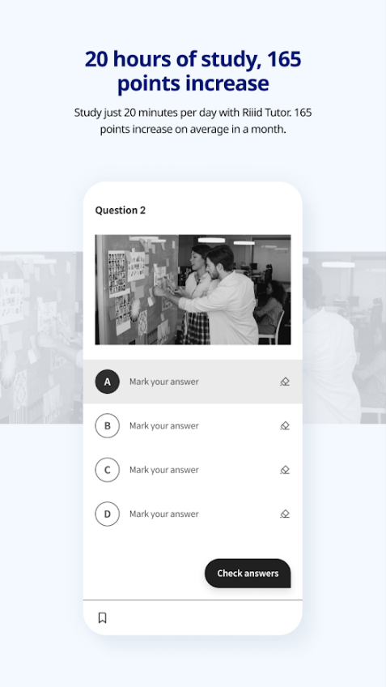

**Overview**: 4.6 stars from 8,000+ ratings and 1 Mio.+ downloads on Google Play Store

RiiiD Tutor is an application that helps users study the English test TOEIC. The app is special since it uses AI techniques in analyzing users’ study data and recommends which parts to study for the test. It also enables personalized learning.

### Conclusion

In conclusion, all the mentioned apps are widely popular as displayed in the amount of ratings and downloads. Nevertheless, they have disadvantages that they are bound to the smartphone. This causes the learner to lose concentration by picking up the phone. Some apps also don't remind the learner of proper breaks. Another problem is that the user can't start other apps like QANDA or RiiiD Tutor to support the studies since it contradicts with the idea of the study apps.

This proposal plans to tackle these problems by combining an application with the smart speaker SKT NUGU to minimize smartphone usage.

## Task Distribution

How we share our work is shown in the table below. Who will be in charge of what is determined by their experiences and abilities. However, if there are difficulties in each other's parts, we will help each other and proceed with the work.

1. Task Distribution

|  |  |
| --- | --- |
| Name | Task |
| U-seong Kim | - Play Builder  - Database  - Machine Learning  - Documentation |
| Hankyu Park | - Play Builder  - Database  - Machine Learning  - Documentation |
| Dongjin Lim | - Backend  - Project Management |
| Sangyun Chi | - UI Design  - Application  - Documentation |
| Michael Sklors | - UI Design  - Application  - Documentation |

# Specifications

## Splash Page

The splash screen is a graphic element consisting of a window containing an image, logo, and the current version of the software. It is displayed for about 0.5 second to avoid showing a blank screen during the loading time of the app's data. It also serves to express the brand identity of the 'StudyBNB'.

## Login Function

### Authentification : Firebase uses various authentication methods such as email/password, phone, Google, play games, Facebook, Twitter, and GitHub.

* Click "Google Login" and if the key value authenticated, "Login Success" message appears.
* If the key value is not established, pop-up message indicating that login failed.
* If the login is successful, the main page appears.

### Contact : If there is a problem with logging in, users contact the product manager and developer.

* Click "Contact" button, a little dialog will pop up that users can report the errors.
* Errors written by the user are sent to the developer's mail.

## Main Page

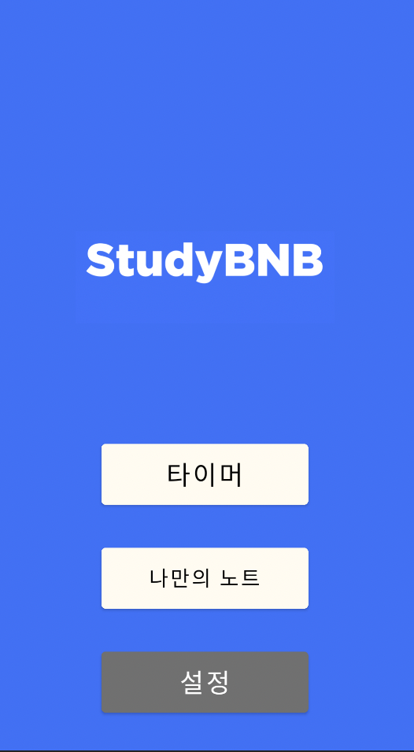

When the user logs in successfully, Main screen appears. Main screen is visible only when users logged in.

### Timer : When the users click 'timer' icon on the main screen, the main screen will change into timer page screen. It will be shown only when users are log-in state.

* A logged-in user can start a timer by requesting to NUGU speaker and measure the study time.
* When a user wants to take a break or finish studying, the timer can be stopped by requesting to the speaker.

### My Note : If the user click 'My note' icon on the main screen, the main screen will change into 'My note view page’.

* A logged-in user can note their own answer to memorize or words that they did not know before.

### Settings: When the users click 'settings' icon on the main screen, the main screen will change into 'Settings page'

* Users can delete one's account or log out in Settings page.

## My Note-taking Page

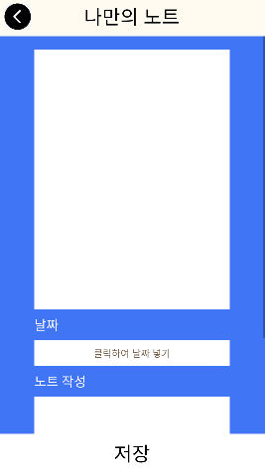

The 'My note-taking page' consists of box to insert a photo, a field for date and field for writing notes.

### Inserting a photo : When a user encounters an unknown problem or word, it can be recorded in the form of photo

### Recording the date : Users can record the date when the note was saved.

* Problems that were previously wrong or unknown can also be recorded from an earlier date.

##### References

1. H. Bae, “Review: How I study using a productivity app: Yeolpumta, September 2021, <https://highschool.latimes.com/la-canada-high-school/review-how-i-study-using-a-productivity-app-yeolpumta/>
2. Study International Staff, “Studying at home? Here are the best productivity apps to check out”, March 2020, <https://www.studyinternational.com/news/5-apps-focus-study-home/>
3. K. Udoagwu, “How to Carry Out a Requirements Analysis”, February 2021, <https://www.wrike.com/blog/how-carry-out-requirements-analysis/#What-is-the-requirements-analysis-process>
4. M. Jimin, “외워야 할 것 있다면 잠들기 전 집중하세요”, April 2019, <https://m.health.chosun.com/svc/news_view.html?contid=2019041801775>