

**SWP391 – Software development project**

### ARTIX

Version: 1.0



**ARTWORK SHARING PLATFORM**

– Ho Chi Minh, January 2024 –

|  |  |  |
| --- | --- | --- |
| **STT** | **Fullname** | **MSSV** |
| 1 | Nguyễn Dương Gia Bảo | SE171697 |
| 2 | Huỳnh Thiện Nhân | SE171117 |
| 3 | Trần Ánh Tuyết | SE170234 |
| 4 | Nguyễn Minh Thức | SE170592 |
| 5 | Phạm Minh Triều | SE172937 |

# Table of Contents

**Table of Contents.............................................................................................................................2**

1. Record of Changes...............................................................................................................................5
2. Software Requirement Specification...................................................................................................6

1. Product Overview......................................................................................................................... 6

* 1. Background..........................................................................................................................6
  2. Database.............................................................................................................................6

1.2.1 Database schema........................................................................................................6

1.2.2 Database tables..........................................................................................................7

1.2.2.1 Artwork…………………………………………………………………………………………………….7

1.2.2.2 Creators…………………………………………………………………………………………………….8

1.2.2.3 Account……………………………………………………………………………………………………..9

1.2.2.4 Roles……………………………………………………………………………………………………….…9

1.2.2.5 Tags……………………………………………………………………………………………………………9

1.2.2.6 Follow………………………………………………………………………………………………………10

1.2.2.7 PaypalAccount…………………………………………………………………………………………10

1.2.2.8 Comment…………………………………………………………………………………………………10

1.2.2.9 Report………………………………………………………………………………………………………11

1.2.2.10 Moderator……………………………………………………………………………………………11

1.2.2.11 Notification……………………………………………………………………………………………11

1.2.2.12 ViewReports…………………………………………………………………………………………12

1.2.2.13 Orders……………………………………………………………………………….…………………12

1.2.2.14 OrderDetail……………………………………………………………………………………………12

1.2.2.15 Commission……………………………………………………………………………………………13

1.2.2.16 CommissionForm……………………………………………………………………………………13

1.2.2.17 ArtworkTag……………………………………………………………………………………………13

1.2.2.18 RelyComments………………………………………………………………………………………14

1.3 Activity Diagram................................................................................................................ 15

1.3.1 Login…………………………......................................................................................15

1.3.2 Upload Artwork............................................................................................... 16

1.3.3 View Artwork....................................................................................................17

1.3.4 Artist Manage Artwork......................................................................................18

1.3.5 Receive and Update Commission..................................................................... 19

1.3.6 Manage User Report.........................................................................................20

1.3.7 Manage User.....................................................................................................21

1.3.8 View Dashboard................................................................................................22

1.3.9 Payment.............................................................................................................23

2. Audience Requirements....................................................................................................................24

* 1. Actors................................................................................................................................ 24
  2. Use Cases...........................................................................................................................24
     1. Use Case Diagram(s)................................................................................................ 24
     2. Descriptions............................................................................................................. 25
     3. Use Case Specification............................................................................................. 27

2.2.3.1: Register...........................................................................................................24

* + - 1. Login..............................................................................................................25
      2. Search Artworks........................................................................................... 26
      3. Upload Image............................................................................................... 27
      4. Like Image.....................................................................................................28
      5. Comment a Post of Image............................................................................ 29
      6. Follow............................................................................................................30
      7. Message........................................................................................................31
      8. Feedback and Report....................................................................................32
      9. Profile Settings..............................................................................................33
      10. Sharing artworks to other platforms............................................................ 34
      11. Purchase artworks.........................................................................................35
      12. View personal transaction history.................................................................36
      13. Export financial report files.......................................................................... 37
      14. View transaction history................................................................................38
      15. Add user....................................................................................................... 39
      16. Delete Artwork............................................................................................. 40
      17. View Report...................................................................................................41
      18. Approve Report............................................................................................ 42
      19. Purchase artwork service package............................................................... 43
      20. Rating........................................................................................................... 44
      21. Manage Paging............................................................................................. 45
      22. Manage Website Information.......................................................................46
      23. Manage Advertisement.................................................................................47
      24. Manage Package...........................................................................................48
      25. Request Pre-Order.........................................................................................49
      26. Cancel Pre-Order.......................................................................................... 32
      27. Forgot Password............................................................................................51
      28. Delete Artwork............................................................................................. 52
      29. Resell Artwork.............................................................................................. 53
      30. View Pre-Order Reported..............................................................................54

# I. Record of Changes

|  |  |  |  |
| --- | --- | --- | --- |
| **Date** | **A* M, D** | **In charge** | **Change Description** |
| 11/01/2024 | A | All Member | Create initial documents, add data about Use cases (Use case specification and Use Case Diagram), Context, Business Rules.  Initialization Format of SRS |
| 12/01/2024 | A | All Member | Add Functional Requirements and Non-functional Requirements |
| 13/01/2024 | M | Triều | Added 1 more actor to the system, Fix Use Case Diagram |
| 16/01/2024 | A | Bảo | Create Activity Diagram for View Artwork, Purchase and Propose Artistic Artwork |
| 17/01/2024 | A | Thức | Add more Use Case Specification |
| 17/01/2024 | D | Tuyết | Delete Use Case Daily Challenge and Point Exchange System |
| 17/01/2024 | M, A | Nhân | Modify Use Case Specification to fix with new Requirement and add more Use Case with Physic Image Requirement as same as part for Functional Requirement |
| 21/01/2024 | M | Nhân | Fixed Use Case Diagram with new Requirement after meeting Lecture |
| 21/01/2024 | M, D | Bảo | Fixed Activity Diagram and Delete some Activity Diagram to fit with the new Requirements after meeting Lecture |
| 21/01/2024 | A | Thức | Create Class Diagram |
| 28/01/2024 | M | Tuyết | Fix Class Diagram with editing from instructor |
| 28/01/2024 | M | Triều | Fix the Activity Diagram after Meeting Lecture to repair the logic |
| 29/01/2024 | A, M, D | All Member | Final review, consider adding, deleting, and editing the following: Class Diagram, Activity Diagram, Use Case Diagram. Add and remove Use Case Specifications after discussing Business Logic about the system in the same group. Edit SRS File presentation and create links for Table of Content |

*A - Added M - Modified D – Deleted

# 

# II. Software Requirement Specification

## 1. Product Overview

### 1.1 Background

Artwork Sharing Platform, a vibrant online community where artists from around the globe come together to showcase their creativity, discover inspiration, and connect with art enthusiasts. Our platform serves as a dynamic hub for the exchange of diverse artistic expressions, fostering a supportive environment for both established and emerging talents.

**1.2 Database:**

#### 1.2.1 Database schema

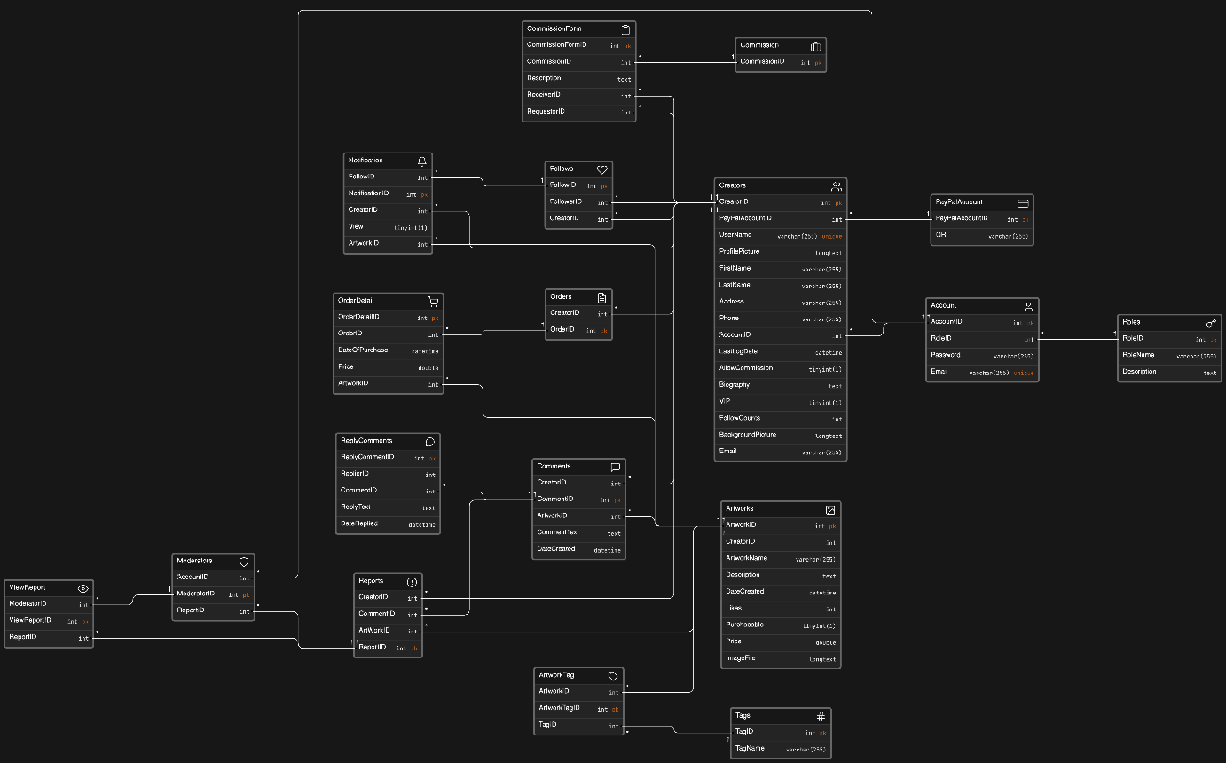

#### 1.2.2 Database tables

1. Artworks

|  |  |  |  |  |  |  |
| --- | --- | --- | --- | --- | --- | --- |
| **Field name** | **Type** | **Size** | **Unique** | **Not Null** | **PK/FK** | **Note** |
| ArtwordID | Integer | 32 | X | X | PK |  |
| CreatorID | Integer | 32 | X | X | FK |  |
| ArtworkName | Varchar | 255 |  |  |  |  |
| Description | Text | 255 |  |  |  | More detail of this Artwork |
| DateCreated | DateTime | 8 |  | X |  |  |
| Likes | Integer | 32 |  |  |  | Start from 0 |
| Purchasable | TinyInt | 1 |  |  |  |  |
| Price | Double | 32 |  |  |  | Price of the artworks if it is purchasable |
| ImageFile | Long Text | 255 | X | X |  | File image of Artwork |

2. Creators

|  |  |  |  |  |  |  |
| --- | --- | --- | --- | --- | --- | --- |
| **Field name** | **Type** | **Size** | **Unique** | **Not Null** | **PK/FK** | **Notes** |
| CreatorID | Integer | 32 | X | X | PK |  |
| AccountId | Integer | 32 | X | X | FK |  |
| PaypalAccountID | Integer | 32 |  | X | FK | Account for creators to receive money |
| UserName | Varchar | 255 | X | X |  |  |
| ProfilePicture | LongText | MAX |  |  |  | Creator's profile picture |
| FirstName | Varchar | 255 |  | X |  |  |
| LastName | Varchar | 255 |  | X |  |  |
| Address | Varchar | 255 |  |  |  |  |
| Phone | Varchar | 255 |  |  |  |  |
| LasrLogDate | DateTime | 8 |  | X |  | Last time logged in to the web of creator |
| AllowCommission | TinyInt | 1 |  |  |  |  |
| Biography | Text | MAX |  |  |  | More info about this Artis |
| FollowCounts | Integer | 32 |  |  |  | Number of Follower on this Artist |
| BackgroundPicture | LongText | MAX |  |  |  |  |
| Email | Varchar | 255 |  |  |  |  |
| VIP | TinyInt | 1 |  |  |  |  |

3. Account

|  |  |  |  |  |  |  |
| --- | --- | --- | --- | --- | --- | --- |
| **Field name** | **Type** | **Size** | **Unique** | **Not Null** | **PK/FK** | **Notes** |
| AccountID | Integer | 32 | X | X | PK |  |
| RoleID | Integer | 32 | X | X | FK |  |
| Password | Varchar | 255 |  | X |  |  |
| Email | Varchar | 255 |  | X |  |  |

4. Roles

|  |  |  |  |  |  |  |
| --- | --- | --- | --- | --- | --- | --- |
| **Field name** | **Type** | **Size** | **Unique** | **Not Null** | **PK/FK** | **Notes** |
| RoleID | Integer | 32 | X | X | PK |  |
| RoleName | Varchar | 255 |  | X | FK |  |
| Description | Text | MAX |  |  |  | More information about what the role can do |

1. Tags

|  |  |  |  |  |  |  |
| --- | --- | --- | --- | --- | --- | --- |
| **Field name** | **Type** | **Size** | **Unique** | **Not Null** | **PK/FK** | **Notes** |
| TagID | Integer | 32 | X | X | PK |  |
| TagName | Varchar | 255 |  | X | FK |  |

1. Follows

|  |  |  |  |  |  |  |
| --- | --- | --- | --- | --- | --- | --- |
| **Field name** | **Type** | **Size** | **Unique** | **Not Null** | **PK/FK** | **Notes** |
| FollowID | Integer | 32 | X | X | PK |  |
| FollowerID | Integer | 32 | X |  | FK |  |
| CreatorID | Integer | 32 | X |  | FK |  |

1. PaypalAccount

|  |  |  |  |  |  |  |
| --- | --- | --- | --- | --- | --- | --- |
| **Field name** | **Type** | **Size** | **Unique** | **Not Null** | **PK/FK** | **Notes** |
| PayPalAccount | Integer | 32 | X | X | PK |  |
| CreatorID | Integer | 32 |  | X | FK |  |
| QR | Varchar | 255 | X | X |  | Customer scan this QR to pay for creator |

1. Comment

|  |  |  |  |  |  |  |
| --- | --- | --- | --- | --- | --- | --- |
| **Field name** | **Type** | **Size** | **Unique** | **Not Null** | **PK/FK** | **Notes** |
| CommentID | Integer | 32 | X | X | PK |  |
| CreatorID | Integer | 32 | X | X | FK |  |
| ArtworkID | Integer | 32 | X | X | FK |  |
| CommentText | Text | MAX |  | X |  | Where user use to chat or comment on the artist's Artwork |
| DateCreated | Datetime | 8 |  | X |  | The date the user commented on Artwork |

1. Report

|  |  |  |  |  |  |  |
| --- | --- | --- | --- | --- | --- | --- |
| **Field name** | **Type** | **Size** | **Unique** | **Not Null** | **PK/FK** | **Notes** |
| ReportID | Integer | 32 | X | X | PK |  |
| CreatorID | Integer | 32 | X | X | FK |  |
| ArtworkID | Integer | 32 | X | X | FK |  |
| CommentID | Integer | 32 | X | X | FK |  |

1. Moderator

|  |  |  |  |  |  |  |
| --- | --- | --- | --- | --- | --- | --- |
| **Field name** | **Type** | **Size** | **Unique** | **Not Null** | **PK/FK** | **Notes** |
| ModeratorID | Integer | 32 | X | X | PK |  |
| ReportID | Integer | 32 | X | X | FK |  |
| AccountID | Integer | 32 | X | X | FK |  |

1. Notification

|  |  |  |  |  |  |  |
| --- | --- | --- | --- | --- | --- | --- |
| **Field name** | **Type** | **Size** | **Unique** | **Not Null** | **PK/FK** | **Notes** |
| NotificationID | Integer | 32 | X | X | PK |  |
| FollowID | Integer | 32 | X | X | FK |  |
| CreatorID | Integer | 32 | X | X | FK |  |
| ArtworkID | Integer | 32 | X | X | FK |  |
| View | TinyIny | 1 |  |  |  |  |

1. Viewreport

|  |  |  |  |  |  |  |
| --- | --- | --- | --- | --- | --- | --- |
| **Field name** | **Type** | **Size** | **Unique** | **Not Null** | **PK/FK** | **Notes** |
| ModeratorID | Integer | 32 | X | X | FK |  |
| ReportID | Integer | 32 | X | X | FK |  |
| ViewReportID | Integer | 32 | X | X | PK |  |

1. Orders

|  |  |  |  |  |  |  |
| --- | --- | --- | --- | --- | --- | --- |
| **Field name** | **Type** | **Size** | **Unique** | **Not Null** | **PK/FK** | **Notes** |
| OrderID | Integer | 32 | X | X | PK |  |
| CreatorID | Integer | 32 | X | X | FK |  |

1. OrderDetail

|  |  |  |  |  |  |  |
| --- | --- | --- | --- | --- | --- | --- |
| **Field name** | **Type** | **Size** | **Unique** | **Not Null** | **PK/FK** | **Notes** |
| OrderDetailID | Integer | 32 | X | X | PK |  |
| OrderID | Integer | 32 | X | X | FK |  |
| ArtworkID | Integer | 32 | X | X | FK |  |
| DateOfPurchase | Datetime | 8 |  | X |  | Date purchase the Artwork |
| Price | Double | 32 |  | X |  | Price of Artwork |

1. Commission

|  |  |  |  |  |  |  |
| --- | --- | --- | --- | --- | --- | --- |
| **Field name** | **Type** | **Size** | **Unique** | **Not Null** | **PK/FK** | **Notes** |
| CommissionID | Integer | 32 | X | X | PK |  |

1. CommissionForm

|  |  |  |  |  |  |  |
| --- | --- | --- | --- | --- | --- | --- |
| **Field name** | **Type** | **Size** | **Unique** | **Not Null** | **PK/FK** | **Notes** |
| CommissionFormID | Integer | 32 | X | X | PK |  |
| CommissionID | Integer | 32 | X | X | FK |  |
| ReceiverID | Integer | 32 | X | X | FK |  |
| RequestorID | Integer | 32 | X | X | FK |  |
| Description | TinyInt | 1 |  |  |  | The detail User want for Arkwork |
| Accept | TinyInt | 1 |  |  |  | The Artist accept the commission of User |

1. ArtworkTag

|  |  |  |  |  |  |  |
| --- | --- | --- | --- | --- | --- | --- |
| **Field name** | **Type** | **Size** | **Unique** | **Not Null** | **PK/FK** | **Notes** |
| ArtworkTagID | Integer | 32 | X | X | FK |  |
| ArtworkID | Integer | 32 | X | X | FK |  |
| TagID | Integer | 32 | X | X | PK |  |

1. ReplyComments

|  |  |  |  |  |  |  |
| --- | --- | --- | --- | --- | --- | --- |
| **Field name** | **Type** | **Size** | **Unique** | **Not Null** | **PK/FK** | **Notes** |
| ReplyCommentID | Integer | 32 | X | X | FK |  |
| ReplierID | Integer | 32 | X | X | FK |  |
| CommentID | Integer | 32 | X | X | PK |  |
| ReplyText | Text | MAX |  |  |  |  |
| DateReplied | DateTime | 8 |  |  |  |  |

**1.3 Activity Diagram**

1. Login

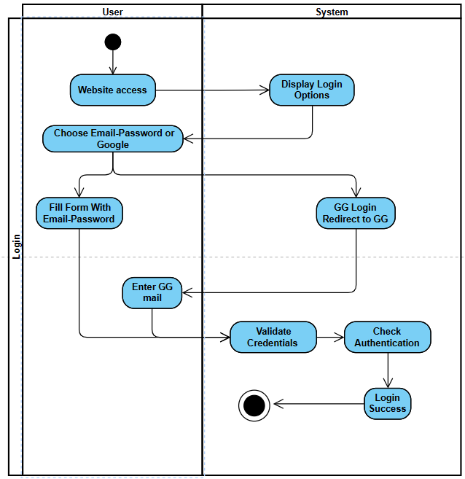

2. Upload Image

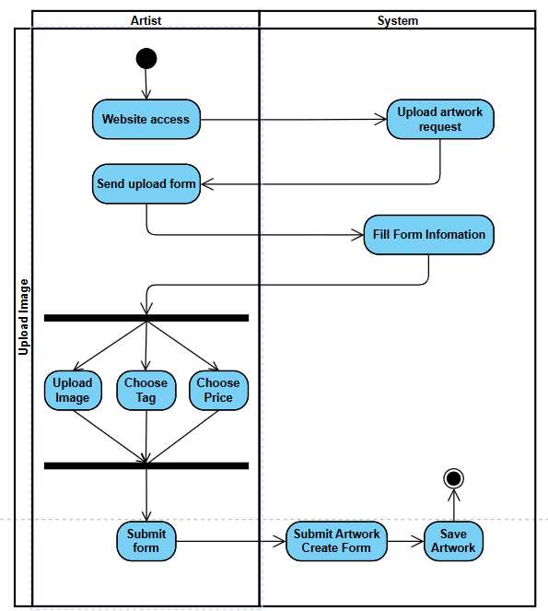

3. View Artwork

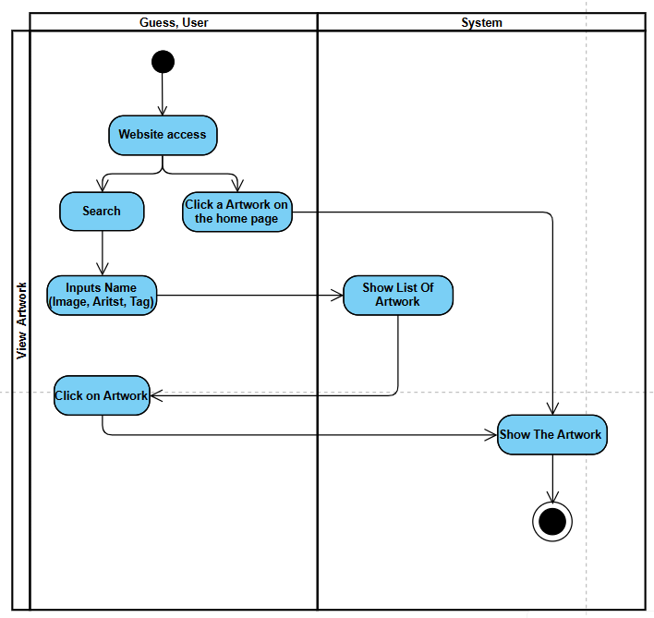

4. Artist Manage Artwork

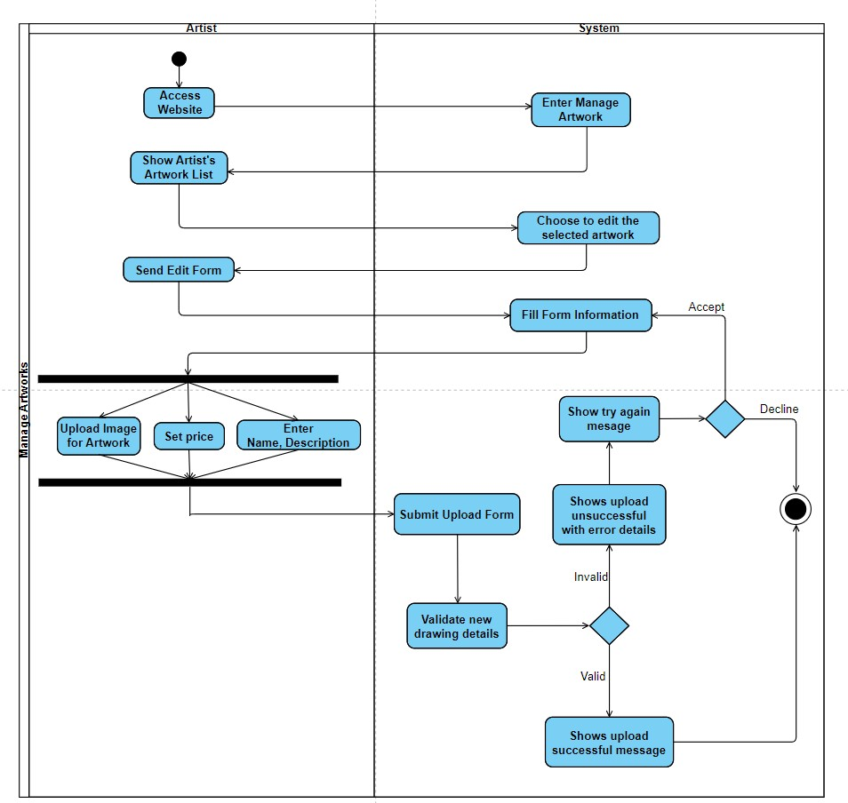

5. Receive and Update Commission

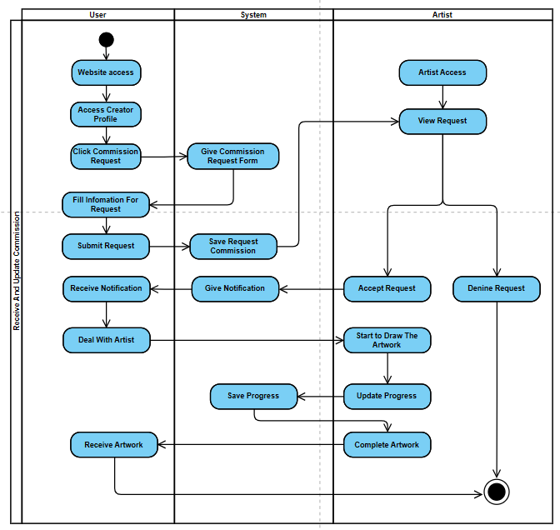

6. Manage User Report

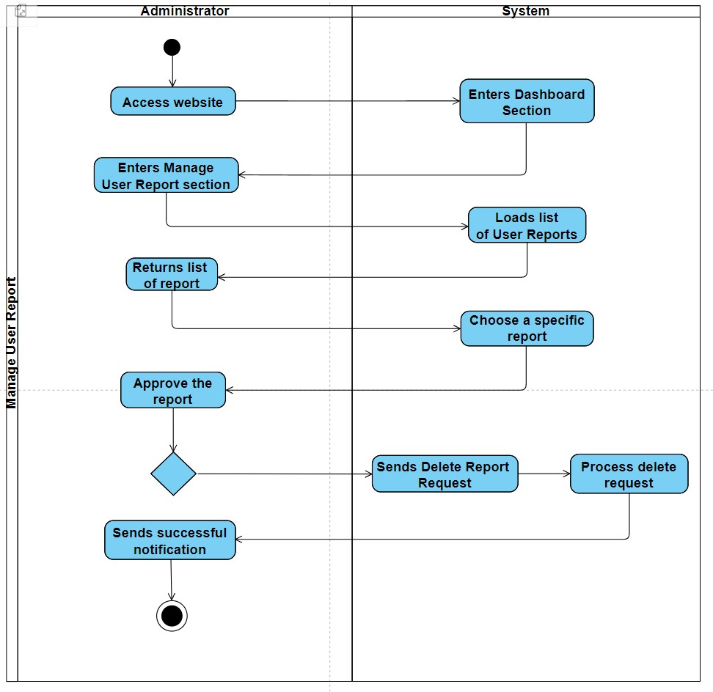

7. Manage User

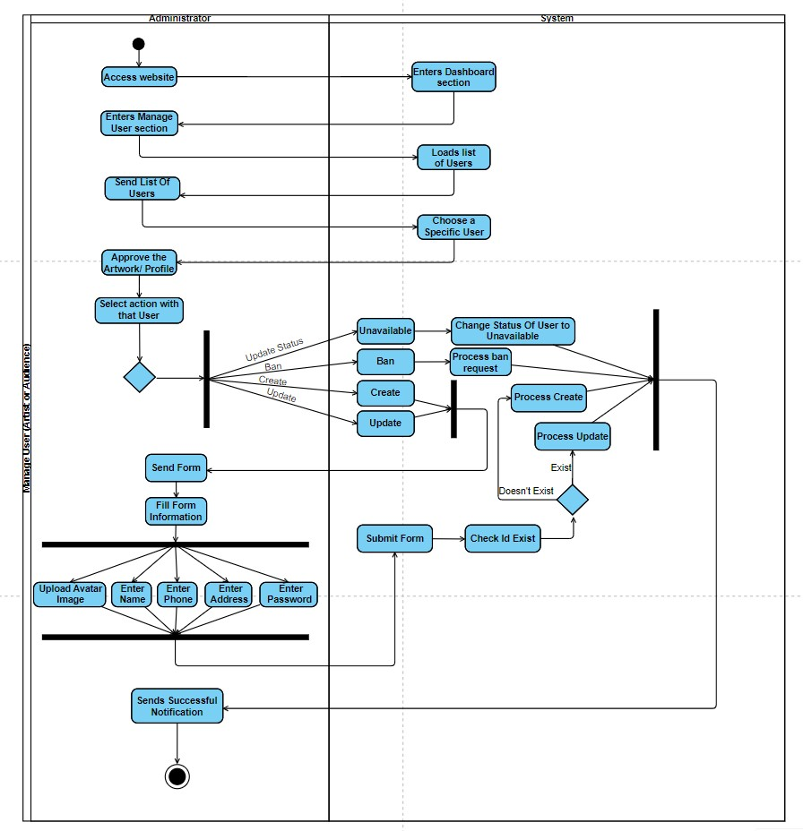

8. View Dashboard

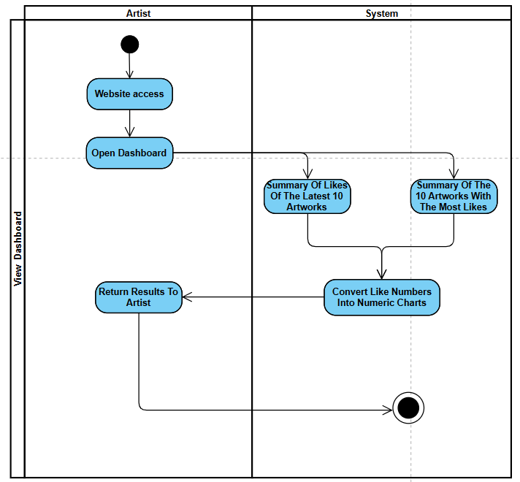

9. Payment

## 2. Audience Requirements

**2.1 Actors**

|  |  |  |
| --- | --- | --- |
| **#** | **Actor** | **Description** |
| 1 | Guest | A person who visits website but still not register an account |
| 2 | Audience | An Audience has already registered, can do basic functions like viewing, searching artworks, following Artists, liking, and commenting... |
| 3 | Artist | An Audience that registers to be an Artist, can post artwork and all the work of a normal Audience. |
| 4 | Administrator | A top-level Audience, they manage the website, artworks, and Audience’s complaints. |

### 2.2 Use Cases

#### 2.2.1 Use Case Diagram(s)

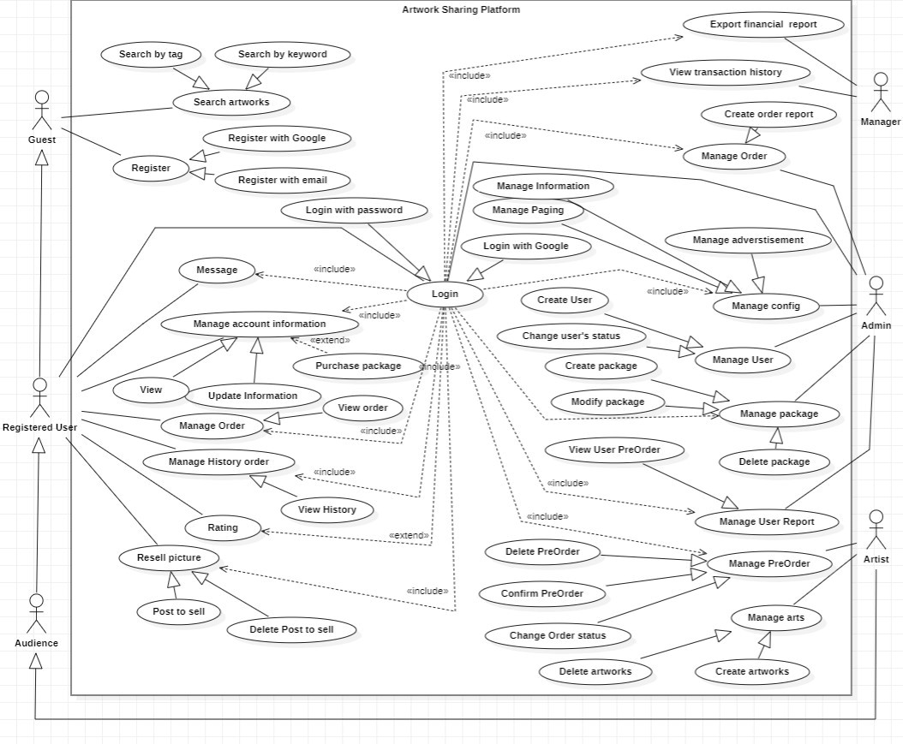

#### 2.2.2 Descriptions

|  |  |  |  |
| --- | --- | --- | --- |
| **ID** | **Use Case** | **Actors** | **Use Case Description** |
| 01 | Register | Guest | Registering account to access the website. |
| 02 | Login | Audience, Artist, Administrator | Using username (or email) and password that registered to log into the website. |
| 03 | Search Artworks | Audience, Artist, Guest | Using keywords or Artist’s name to search their artworks. |
| 04 | Upload Artwork | Artist | Artists upload their artwork files to the website. |
| 05 | Like | Audience, Artist. | Like an artwork. Then it is saved to the Like Collection. |
| 06 | Comment | Audience, Artist | Comment on an artwork to join the conservation. |
| 07 | Follow | Audience, Artist | Following an artist, Audiences will receive a notification when the artist uploads a new artwork. |
| 09 | Feedback and Report | Audience, Artist | All the issues and complaints will be submitted by Audiences to the system. |
| 10 | Profile Settings | Audience, Artist | Audiences can set up information about themself. |
| 12 | Purchase artworks | Audience | Audiences can buy artwork of specified Artists. |
| 13 | View personal transaction history | Audience, Artist | Administrator can view revenue of month or year |
| 14 | Export financial report | Administrator | Administrator can choose to export the financial report of the system. |
| 15 | View transaction history of the website | Administrator | Administrators can view the list of all transactions of the website. |
| 16 | Add User | Administrator | Administrators create an account for a User or a new administrator. |
| 17 | Delete artwork | Administrator | Administrators can delete a reported artwork. |
| 18 | View report | Administrator | Shows a complete report of user feedback on website bugs, or inappropriate artworks. |
| 19 | Approve report | Administrator | Administrator approves the report from user’s feedback. |
| 20 | Purchase artwork service package | Artist | Artists who want to create more posts of artworks, need to buy a service package of credits. 1 credit = 1 post |

|  |  |  |  |
| --- | --- | --- | --- |
| 22 | Manage Paging | Administrator | Administrator can choose what layout of the artwork, 2 rows 5 artworks or 1 row 10 artworks |
| 23 | Manage Website Information | Administrator | Administrator can change the information of the website, such as logo, telephone, address in system |
| 24 | Manage Advertisement | Administrator | Administrator can manage the advertisements on 2 sides of the platform, the advertisements include information of the phone and email |
| 25 | Manage Package | Administrator | The administrator can control the package by increasing or decreasing the price, as well as increasing or decreasing credits. And can change the status of the package. |
| 26 | Request Pre-Order | Audience | The audience contacts the artist to request Pre-Order. |
| 27 | Cancel Pre-Order | Audience, Artist | If the Pre-Order has a problem, the artist can cancel the Pre-Order. |
| 29 | Delete Artwork | Artist | If the artist completely sold the artwork for the audience, the artist can delete the artwork. Or basically, they want to delete it. |
| 30 | Resell Artwork | Artist | Audiences that register to become Artist resell the artwork that they bought from another Artist. |
| 31 | View Pre-Order Reported | Administrator | The administrator can check the reported artwork part to define the problem and make the correct judgment. |

***2.2.3 Use Case Specification:***

**2.2.3.1: Register**

|  |  |  |  |
| --- | --- | --- | --- |
| Use Case Specification | | | |
| Use Case ID and Name: | **ASP001 – Register** | | |
| Created By: | Nguyễn Minh Thức | Date Created: | Feb-18, 2024 |
| Primary Actor: | Guest | Secondary Actors: | None |
| Trigger: | A guest indicates that he/she wants to create an account. | | |
| Description: | The “Register” use case represents the process performed by the guest to create a new account to access the website in the future. | | |
| Preconditions: | PRE-1: The guest has already accessed the website. | | |
| Post–conditions: | POST-1: The guest successfully registers as a new audience.  POST-2: The system records the newly created audience in the database. | | |
| Normal Flow: | 1. Unregistered user goes to the register section (see 1-AF) 2. The guest fills out the registration form with personal information and submit them. 3. The system validates the data. (see 1.0.E1) 4. Upon successful validation, a new audience (user account) is created 5. The system redirects the audience to their homepage, where they can access all audience features. | | |
| Alternative Flows: | 1-AF: If user want to register with Google account   1. Select register with Google 2. Complete the process of Google sign up | | |
| Exceptions: | 1. **- EF:** The login process can’t be completed due to unsatisfactory personal information (e.g. wrong password format...) 2. **- EF:** The internet connection is interrupted. | | |
| Priority: | High | | |
| Frequency of Use: | Medium | | |
| Business Rules: | BR-01, BR-02, BR-03 | | |
| Other Information: | None | | |
| Assumptions: | None | | |

**2.2.3.2 Login**

|  |  |  |  |
| --- | --- | --- | --- |
| Use Case Specification | | | |
| Use Case ID and Name: | **ASP002 – Login** | | |
| Created By: | Huỳnh Thiện Nhân | Date Created: | Feb-18, 2024 |
| Primary Actor: | Audience, Artist | Secondary Actors: | Administrator |
| Trigger: | An audience, or Artist indicates that he/she wants to sign into an existing account. | | |
| Description: | The “Login” use case represents the process performed by the audience or Artist to sign into his/her existing account, using the login credentials. | | |
| Preconditions: | PRE-1: The audience has already accessed the website.  PRE-2: The audience has already registered an account. | | |
| Post–conditions: | POST-1: The audience successfully logs into the system, and is able to use audience features.  POST-2: The system records the audience login details into the database. | | |
| Normal Flow: | 1. User go to the login section (see 1-AF) 2. The audience enters their email address and password. 3. The system validates the data and checks if they are associated with a registered account. 4. If the process is successful, the system will log the audience in 5. The system redirects the audience to their homepage, where he/she can use all of the audience features. | | |
| Alternative Flows: | 1-AF: User logins with Google Account   1. Click to the Sign in with Google 2. Complete the process of Google sign in | | |
| Exceptions: | 1. **- EF:** The audience enters incorrect login credentials. 2. **- EF:** The internet connection is interrupted. | | |
| Priority: | High | | |
| Frequency of Use: | High | | |
| Business Rules: | BR-03, BR-04, BR-05 | | |
| Other Information: | None | | |
| Assumptions: | None | | |

**2.2.3.3 Search Artworks**

|  |  |  |  |
| --- | --- | --- | --- |
| Use Case Specification | | | |
| `Use Case ID and Name: | ASP003 – Search Artworks | | |
| Created By: | Nguyễn Minh Thức | Date Created: | Feb-20, 2024 |
| Primary Actor: | Guest, Audience | Secondary Actors: | Artist |
| Trigger: | A guest/audience indicates that he/she wants to search for a specific artwork. | | |
| Description: | The “Search Artworks” use case represents the process that guests, or the audience, searches for the desired artworks, using keywords or Artists’ names. | | |
| Preconditions: | PRE-1: The guest, or the audience has already accessed the website. | | |
| Post–conditions: | POST-1: The Artworks Sharing Platform will show up a list of results relevant to the guest/audience prompt. | | |
| Normal Flow: | 1. The guest/audience enters the keywords of the artwork they are looking for. 2. The Artworks Sharing Platform will display a list of artworks that match the search criteria. | | |
| Alternative Flows: | None | | |
| Exceptions: | **1 - EF:** The internet connection is interrupted. | | |
| Priority: | High | | |
| Frequency of Use: | High | | |
| Business Rules: | BR-06 | | |
| Other Information: | None | | |
| Assumptions: | None | | |

**2.2.3.4 Upload Image**

|  |  |  |  |
| --- | --- | --- | --- |
| Use Case Specification | | | |
| Use Case ID and Name: | ASP004 – Upload Image | | |
| Created By: | Nguyễn Dương Gia Bảo | Date Created: | Feb-22, 2024 |
| Primary Actor: | Artist | Secondary Actors: | None |
| Trigger: | A Artist indicates that he/she wants to upload his/her artworks to the website. | | |
| Description: | The “Upload Image” use case represents the process performed by the Artist to upload multiple artworks to the website. | | |
| Preconditions: | PRE-1: The Artist has already accessed the website.  PRE-2: The Artist has already logged in.  PRE-3: The Artist has entered the upload artwork menu.  PRE-4: The Artist has already prepared the artworks to be uploaded. | | |
| Post–conditions: | POST-1: The images are successfully uploaded to the system.  POST-2: The images are shown on the search results. | | |
| Normal Flow: | 1. The Artist enters the upload image menu. 2. The Artist puts in the images, then clicks upload 3. The system validates the images to check whether they match the requirements (e.g. size, dimensions...) 4. If the images are uploaded successfully, a success notification will be sent to the Artist. | | |
| Alternative Flows: | None | | |
| Exceptions: | 1. **- EF:** The images do not satisfy the upload requirements (e.g. size, dimensions are exceeded) 2. **- EF:** The internet connection is interrupted. | | |
| Priority: | High | | |
| Frequency of Use: | High | | |
| Business Rules: | None | | |
| Other Information: | None | | |
| Assumptions: | None | | |

**2.2.3.5 Like Image**

|  |  |  |  |
| --- | --- | --- | --- |
| Use Case Specification | | | |
| Use Case ID and Name: | ASP005 – Like Image | | |
| Created By: | Trần Ánh Tuyết | Date Created: | Feb-23, 2024 |
| Primary Actor: | Audience, Artist | Secondary Actors: |  |
| Trigger: | Audience or Artist indicates that he/she wants to like an image which he/she wants to. | | |
| Description: | The “like image” use case represents the process performed by the audience or Artist to like a post of image that they like on the website. | | |
| Preconditions: | PRE-1: Audience or Artist is logged into the system (appropriate authorization)  PRE-2: Audience or Artist selects the image that they like  PRE-3: Click on the image and go to the detail and hit the like button | | |
| Post–conditions: | POST-1: The image successfully liked. | | |
| Normal Flow: | 1. The audience or Artist goes to the website 2. The audience or Artist selects the image that they want to like 3. The audience or Artist clicks on the image to go to the detail of the post 4. The audience or Artist clicks the like button 5. The image will be liked and updated the count of likes. | | |
| Alternative Flows: | There is no alternative flow | | |
| Exceptions: | **1-EF:** If the Audience or Artist is not logged into the system, display an error message and prompt them to log in before processing.  **2-EF:** If there is an issue with the "like" process (e.g., network error, server issues), display an error message and prompt the user to try again later. | | |
| Priority: | Medium | | |
| Frequency of Use: | High | | |
| Business Rules: | BR-12 | | |
| Other Information: | None | | |
| Assumptions: | None | | |

**2.2.3.6 Comment a Post of Image**

|  |  |  |  |
| --- | --- | --- | --- |
| Use Case Specification | | | |
| Use Case ID and Name: | ASP006 – Comment a Post of Image | | |
| Created By: | Trần Ánh Tuyết | Date Created: | Feb-23, 2024 |
| Primary Actor: | Audience, Artist | Secondary Actors: |  |
| Trigger: | Audience or Artist indicates that he/she wants to comment on an image which he/she wants to. | | |
| Description: | The “comment on a post of image” use case represents the process performed by the audience or Artist to comment on a post of image that they want on the website. | | |
| Preconditions: | PRE-1: Audience or Artist is logged into the system (appropriate authorization)  PRE-2: Audience or Artist selects the post of image that they want  PRE-3: Click on the image and go to the detail and write the comment on the comment section | | |
| Post–conditions: | POST-1: The image successfully liked. | | |
| Normal Flow: | 1. The audience or Artist goes to the website 2. The audience or Artist selects the image that they want to comment 3. The audience or Artist clicks on the image to go to the detail of the post 4. The audience or Artist scrolls to the comment section and write the comment 5. The comment will be updated on the screen. | | |
| Alternative Flows: | There is no alternative flow | | |
| Exceptions: | **1-EF:** If the Audience or Artist is not logged into the system, display an error message and prompt them to log in before processing.  **2-EF:** If there is an issue with the "comment" process (e.g., network error, server issues), display an error message and prompt the user to try again later. | | |
| Priority: | Medium | | |
| Frequency of Use: | High | | |
| Business Rules: | BR-13 | | |
| Other Information: | None | | |
| Assumptions: | None | | |

**2.2.3.7 Follow**

|  |  |  |  |
| --- | --- | --- | --- |
| Use Case Specification | | | |
| Use Case ID and Name: | ASP007 – Follow | | |
| Created By: | Nguyễn Minh Thức | Date Created: | Feb-24, 2024 |
| Primary Actor: | Audience, Artist | Secondary Actors: |  |
| Trigger: | Audience or Artist indicates that he/she wants to follow another user which he/she likes. | | |
| Description: | The “follow” use case represents the process performed by the audience or Artist to follow a user that they like on the website. | | |
| Preconditions: | PRE-1: Audience or Artist is logged into the system (appropriate authorization)  PRE-2: Audience or Artist selects the user that they want  PRE-3: Audience or Artist clicks on follow button | | |
| Post–conditions: | POST-1: Follow successfully | | |
| Normal Flow: | 1. The audience or Artist goes to the website 2. The audience or Artist searches the user that they want to follow 3. The audience or Artist clicks to see the user profile 4. The audience or Artist clicks on the follow button 5. Following successfully | | |
| Alternative Flows: |  | | |
| Exceptions: | **1-EF:** If the Audience or Artist is not logged into the system, display an error message and prompt them to log in before processing.  **2-EF:** If there is an issue with the "follow" process (e.g., network error, server issues), display an error message and prompt the user to try again later. | | |
| Priority: | Medium | | |
| Frequency of Use: | High | | |
| Business Rules: | BR-21 | | |
| Other Information: | None | | |
| Assumptions: | None | | |

**2.2.3.9 Feedback and Report**

|  |  |  |  |
| --- | --- | --- | --- |
| Use Case Specification | | | |
| Use Case ID and Name: | ASP009 - Feedback and Report | | |
| Created By: | Nguyễn Minh Thức | Date Created: | Jan-12, 2024 |
| Primary Actor: | Audience | Secondary Actors: | Artist |
| Trigger: | A(n) audience indicates that he/she wants to give feedback and reports problems/issues. | | |
| Description: | The “Feedback and Report” use case represents the process performed by the audience that wants to write a report for the app and feedback for the system. | | |
| Preconditions: | PRE-1: The guest must be logged in as the audience/Artist role. | | |
| Post–conditions: | POST-1: The feedback/report successfully sent to the system. | | |
| Normal Flow: | None | | |
| Alternative Flows: | None | | |
| Exceptions: | **1-EF:** At any time, the app cannot communicate with the server/core system (internet problems), and the report cannot be sent. | | |
| Priority: | Low | | |
| Frequency of Use: | Low | | |
| Business Rules: |  | | |
| Other Information: | None | | |
| Assumptions: | None | | |

**2.2.3.10 Profile Settings**

|  |  |  |  |
| --- | --- | --- | --- |
| Use Case Specification | | | |
| Use Case ID and Name: | ASP010 - Profile Settings | | |
| Created By: | Nguyễn Dương Gia Bảo | Date Created: | Jan-12, 2024 |
| Primary Actor: | Audience | Secondary Actors: | None |
| Trigger: | A(n) audience/Artist indicates that he/she wants to edit a profile. | | |
| Description: | The “profile settings” use case represents the process performed by the Artist/audience to edit profile or change a target price. | | |
| Preconditions: | PRE-1: The guest must be logged in as the audience/Artist role. | | |
| Post–conditions: | POST-1: The profile is successfully edited and show for everyone | | |
| Normal Flow: | 1. The audience/Artist clicks the “My Profile” in Account. 2. The audience/Artist chooses “Edit my profile”. 3. The audience/Artist edits the information they want. 4. The audience/Artist clicks the Confirm button. | | |
| Alternative Flows: | None | | |
| Exceptions: | **1-EF:** At any time, the app cannot communicate with the server/core system (due to network malfunction/technical issues), the system displays an error message. The cashier calls the technical support for supporting purpose | | |
| Priority: | Medium | | |
| Frequency of Use: | Low | | |
| Business Rules: | BR-1: The system must support different payment method (cash, wallet, card…) | | |
| Other Information: | None | | |
| Assumptions: | None | | |

**2.2.3.12 Purchase artworks**

|  |  |  |  |
| --- | --- | --- | --- |
| Use Case Specification | | | |
| Use Case ID and Name: | ASP012 – Purchase artworks | | |
| Created By: | Phạm Minh Triều | Date Created: | Jan-12, 2024 |
| Primary Actor: | Audience | Secondary Actors: | Artist |
| Trigger: | An audience indicates that he/she wants to purchase the artworks. | | |
| Description: | The “Purchase artworks” use case represents the process performed by the Audience to purchase the artworks from the Artist. | | |
| Preconditions: | PRE-1: The audience has already accessed the website. | | |
| Post–conditions: | POST-1: The purchase is successfully completed.  POST-2: The audience now owns the artwork from the artist. | | |
| Normal Flow: | 1. The audience is surfing through the web. 2. The audience decides to buy an artwork. 3. The audience checks the information of the artwork and artist. 4. The audience contacts the artist directly (e.g., through provided contact details on the website). 5. The audience and artist negotiate the terms of the purchase (e.g., price, delivery method) directly. 6. The audience and artist complete the transaction (e.g., exchange of payment, delivery of artwork) directly. | | |
| Alternative Flows: | None | | |
| Exceptions: | None | | |
| Priority: | High | | |
| Frequency of Use: | High | | |
| Business Rules: |  | | |
| Other Information: | None | | |
| Assumptions: | None | | |

**2.2.3.13 View personal transaction history**

|  |  |  |  |
| --- | --- | --- | --- |
| Use Case Specification | | | |
| Use Case ID and Name: | ASP013 – View personal transaction history | | |
| Created By: | Nguyễn Dương Gia Bảo | Date Created: | Jan-13, 2024 |
| Primary Actor: | Audience, Artist | Secondary Actors: | None |
| Trigger: | An audience or Artist indicates that he/she wants to view their transactions. | | |
| Description: | The “View personal transaction history” use case represents the process performed by the Audience or Artist to view the transactions. | | |
| Preconditions: | PRE-1: The audience or Artist has already accessed the website.  PRE-2: The audience or Artist has access to the personal account details.  PRE-3: The audience or Artist has access to the view transaction history section. | | |
| Post–conditions: | POST-1: Audience or Artist completely checked their transaction history. | | |
| Normal Flow: | 1. Audience or Artist access to the personal account details 2. Audience or Artist access to the view transaction history section 3. Audience or Artist views their transaction history | | |
| Alternative Flows: | None | | |
| Exceptions: | None | | |
| Priority: | Medium | | |
| Frequency of Use: | Medium | | |
| Business Rules: | BR-23 | | |
| Other Information: | None | | |
| Assumptions: | None | | |

**2.2.3.14 Export financial report files**

|  |  |  |  |
| --- | --- | --- | --- |
| Use Case Specification | | | |
| Use Case ID and Name: | **ASP014 – Export financial report files** | | |
| Created By: | Phạm Minh Triều | Date Created: | Jan-13, 2024 |
| Primary Actor: | Administrator | Secondary Actors: | None |
| Trigger: | The Administrator exports files for financial reporting needs at the end of the month | | |
| Description: | The “Export financial report files” use case represents the process performed by the Administrator to export Excel, PDF file to perform financial reporting | | |
| Preconditions: | PRE-1: The Administrator has already login. | | |
| Post–conditions: | POST-1: The file was exported successfully.  POST-2: Data is extracted from the system accurately.  POST-3: Administrator receives files into the system. | | |
| Normal Flow: | 1. Administrator selects "Export File" in the "View Revenue" screen 2. Select the type of financial report 3. Select monthly report 4. Select the past month in the past 5. The system checks data and exports files 6. If successful, the system will return the file and request a download to Administrator computer | | |
| Alternative Flows: | 3.1 Select yearly report  4.1 Select the past month in the past  5.1 Return to the step 5 in Normal Flow | | |
| Exceptions: | 1.0. The Administrator close the app  1.1. Error retrieving data from SQL  1.2. Selected information about the month or year was incorrect in the past | | |
| Priority: | Medium | | |
| Frequency of Use: | Low | | |
| Business Rules: | BR-27 | | |
| Other Information: | None | | |
| Assumptions: | None | | |

**2.2.3.15 View transaction history**

|  |  |  |  |
| --- | --- | --- | --- |
| Use Case Specification | | | |
| Use Case ID and Name: | ASP015 – View transaction history | | |
| Created By: | Nguyễn Dương Gia Bảo | Date Created: | Jan-13, 2024 |
| Primary Actor: | Administrator | Secondary Actors: | None |
| Trigger: | A Administrator indicates that he/she wants to view all transactions on the web. | | |
| Description: | The “View transaction history” use case represents the process performed by the Administrator to view all the transactions on the web. | | |
| Preconditions: | PRE-1: The Administrator has already accessed the website.  PRE-2: The Administrator has appropriate authorization to view transaction history  PRE-3: The Administrator has navigated to the section for viewing transaction history. | | |
| Post–conditions: | POST-1: The Administrator has successfully viewed all transactions on the web | | |
| Normal Flow: | 1. The Administrator logs into the website. 2. The Administrator navigates to the section for viewing transaction history. 3. The system retrieves and displays all transactions on the web. | | |
| Alternative Flows: | None | | |
| Exceptions: | 1-EF: If the Administrator is not logged into the system, display an error message and prompt them to log in before proceeding.  2-EF: If the Administrator lacks the necessary authorization to view transaction history, display an error message and deny access. | | |
| Priority: | Medium | | |
| Frequency of Use: | Low | | |
| Business Rules: | BR-24 | | |
| Other Information: | None | | |
| Assumptions: | None | | |

**2.2.3.16 Add user**

|  |  |  |  |
| --- | --- | --- | --- |
| Use Case Specification | | | |
| Use Case ID and Name: | ASP016 – Add user | | |
| Created By: | Trần Ánh Tuyết | Date Created: | Jan-13, 2024 |
| Primary Actor: | Admin | Secondary Actors: | None |
| Trigger: | A Administrator indicates that he/she wants to add a user to the web. | | |
| Description: | The “Add User” use case represents the process performed by the admin to add a user the web. | | |
| Preconditions: | PRE-1: The admin has already accessed the website.  PRE-2: The admin has appropriate authorization to add a user  PRE-3: The admin has navigated to the section for adding a user. | | |
| Post–conditions: | POST-1: The Administrator has successfully viewed all transactions on the web | | |
| Normal Flow: | 1. The Administrator logs into the website. 2. The Administrator navigates to the section for adding a user. 3. The Administrator fills out all the information required for adding a user. 4. The system retrieves and displays a message notifying the admin that a user has successfully added. | | |
| Alternative Flows: | None | | |
| Exceptions: | 1-EF: If the admin is not logged into the system, display an error message and prompt them to log in before proceeding.  2-EF: If the admin lacks the necessary authorization to add a user, display an error message and deny access.  3-EF: If the admin did not fill out the required information, display an error message to notify the admin. | | |
| Priority: | Medium | | |
| Frequency of Use: | Low | | |
| Business Rules: | BR-25, BR-26 | | |
| Other Information: | None | | |
| Assumptions: | None | | |

**2.2.3.17 Delete Artwork**

|  |  |  |  |
| --- | --- | --- | --- |
| Use Case Specification | | | |
| Use Case ID and Name: | ASP017 – Delete Artwork | | |
| Created By: | Huỳnh Thiện Nhân | Date Created: | Jan-13, 2024 |
| Primary Actor: | Administrator | Secondary Actors: | None |
| Trigger: | A Administrator indicates that he/she wants to delete a artwork which is does not conform the standard of the website . | | |
| Description: | The “Delete Artwork” use case represents the process performed by the admin to delete the “indecorous” artwork on the web. | | |
| Preconditions: | PRE-1: The Administrator has already accessed the website.  PRE-2: The Administrator has spot the artwork that he/she want to delete | | |
| Post–conditions: | POST-1: The Administrator has successfully deleted the artwork from the web | | |
| Normal Flow: | 1. The Administrator logs into the website. 2. The Administrator navigates to the artwork that he/she want to delete. 3. The Administrator click on “Delete button”. | | |
| Alternative Flows: | None | | |
| Exceptions: | 1-EF: If the Administrator is not logged into the system, display an error message and prompt them to log in before proceeding. | | |
| Priority: | Medium | | |
| Frequency of Use: | Low | | |
| Business Rules: | BR-25 | | |
| Other Information: | None | | |
| Assumptions: | None | | |

**2.2.3.18 View Report**

|  |  |  |  |
| --- | --- | --- | --- |
| Use Case Specification | | | |
| Use Case ID and Name: | ASP018 – View Report | | |
| Created By: | Phạm Minh Triều | Date Created: | Jan-13, 2024 |
| Primary Actor: | Administrator | Secondary Actors: | None |
| Trigger: | An administrator indicates that he/she wants to view the user report. | | |
| Description: | The “View Report” use case represents the process that administrators retrieve information from the dashboard. The information concerns the audience feedback on the website bugs, as well as reports of artworks that violate the terms. | | |
| Preconditions: | PRE-1: The administrator has already logged in. | | |
| Post–conditions: | POST-1: The Artworks Sharing Platform will show up a full dashboard containing information about website bugs and reported artworks. Report export options are also shown. | | |
| Normal Flow: | 1. Administrator logs into the website. 2. The administrators access the dashboard. 3. The administrator can choose to download the reports as a document file, or view the information as normal. | | |
| Alternative Flows: | None | | |
| Exceptions: | **1-EF The internet connection is interrupted.** | | |
| Priority: | Medium | | |
| Frequency of Use: | Medium | | |
| Business Rules: | BR-29 | | |
| Other Information: | None | | |
| Assumptions: | None | | |

**2.2.3.19 Approve Report**

|  |  |  |  |
| --- | --- | --- | --- |
| Use Case Specification | | | |
| Use Case ID and Name: | ASP019– Approve Report | | |
| Created By: | Nguyễn Dương Gia Bảo | Date Created: | Jan-13, 2024 |
| Primary Actor: | Administrator | Secondary Actors: | None |
| Trigger: | An administrator indicates that he/she wants to approve the report of users. | | |
| Description: | The “Approve Report” use case represents the process performed by the administrator to approve the valid report of users on the web. | | |
| Preconditions: | PRE-1: The administrator has already accessed the website.  PRE-2: The administrator has appropriate authorization to view report list | | |
| Post–conditions: | POST-1: The administrator has successfully approved the valid report on the web | | |
| Normal Flow: | 1. Administrator logs into the website. 2. Administrator accesses the view report section. 3. Administrator selects the report that qualified. 4. Administrator clicks the button to approve the report. 5. The report of users has been approved successfully. | | |
| Alternative Flows: | None | | |
| Exceptions: | 1-EF: If there is an issue with the approval process (e.g., network error, server issues), display an error message and prompt the administrator to try again later. | | |
| Priority: | Medium | | |
| Frequency of Use: | Medium | | |
| Business Rules: | BR-29 | | |
| Other Information: | None | | |
| Assumptions: | None | | |

**2.2.3.20 Purchase artwork service package**

|  |  |  |  |
| --- | --- | --- | --- |
| Use Case Specification | | | |
| Use Case ID and Name: | ASP020– Purchase artwork service package | | |
| Created By: | Trần Ánh Tuyết | Date Created: | Jan-13, 2024 |
| Primary Actor: | Artist | Secondary Actors: | None |
| Trigger: | An Artist indicates that he/she wants to purchase a package in order to upload their artwork for selling. | | |
| Description: | The “Purchase artwork service package” use case represents the process performed by the audience/ artist to buy an artwork service package. | | |
| Preconditions: | PRE-1: The Artist has already accessed the website.  PRE-2: The Artist has appropriate authorization to buy a package | | |
| Post–conditions: | POST-1: The Audience/Artist‘s number of credits will be updated | | |
| Normal Flow: | 1. The Audience/Artist goes to the website and clicks on “Purchase artwork service package” 2. The Audience/Artist chooses which package he/she wants to purchase 3. The Audience/Artist scans the QR Code sent by the system 4. The system validates the transaction 5. The Audience/Artist’s number of credits is updated and he/she can upload artwork based on the number of credits he/she has | | |
| Alternative Flows: | None | | |
| Exceptions: | 1-EF: If there is an issue with the process (e.g., network error, server issues), display an error message and prompt the artist to try again later.  2-EF: If the transaction was invalid, display an error message and prompt the Artist to try again | | |
| Priority: | High | | |
| Frequency of Use: | Medium | | |
| Business Rules: | BR-36 | | |
| Other Information: | None | | |
| Assumptions: | None | | |

**2.2.3.22 Paging**

|  |  |  |  |
| --- | --- | --- | --- |
| Use Case Specification | | | |
| Use Case ID and Name: | ASP022 – Manage Paging | | |
| Created By: | Nguyễn Dương Gia Bảo | Date Created: | 25/01/2024 |
| Primary Actor: | Administrator | Secondary Actors: | System |
| Trigger: | Administrator indicates that he/she wants to manage paging of the website based on user needs. | | |
| Description: | The “Manage Paging” use case represents the process performed by the administrator to manage paging for the artwork section. For example, a section has 20 artworks, an administrator can manage paging that 1 page 10 artworks, | | |
| Preconditions: | PRE-1: Administrator is logged into the system (appropriate authorization)  PRE-2: Administrator access to the system section | | |
| Post–conditions: | POST-1: Setting changed successfully | | |
| Normal Flow: | 1. The administrator goes to the website. 2. The administrator goes to the setting section. 3. The administrator accesses the paging management. 4. The administrator modifies the paging 5. The paging is changed successfully. | | |
| Alternative Flows: | None | | |
| Exceptions: | None | | |
| Priority: | Medium | | |
| Frequency of Use: | Low | | |
| Business Rules: | BR-32 | | |
| Other Information: | None | | |
| Assumptions: | None | | |

**2.2.3.23 Website Information**

|  |  |  |  |
| --- | --- | --- | --- |
| Use Case Specification | | | |
| Use Case ID and Name: | ASP023 – Manage Website Information | | |
| Created By: | Trần Ánh Tuyết | Date Created: | 12/01/2024 |
| Primary Actor: | Administrator | Secondary Actors: |  |
| Trigger: | Administration indicates that he/she wants to change the website information (logos, telephone, address) | | |
| Description: | The “manage website information” use case represents the process performed by the administrator to manage overall website information. | | |
| Preconditions: | PRE-1: Administrator is logged into the system (appropriate authorization) | | |
| Post–conditions: | POST-1: Information updated successfully | | |
| Normal Flow: | 1. The administrator clicks on “Manage Website Information” button 2. The administrator chooses which information he/she wants to manage 3. The administrator changes the information they selected 4. The administrator clicks on the “Change” button 5. The system changes the information and displays message to administrator | | |
| Alternative Flows: |  | | |
| Exceptions: | 1-EF: If the Administrator is not logged into the system, display an error message and prompt them to log in before processing.  2-EF: If there is an issue with the "Manage Website Information" process (e.g., network error, server issues), display an error message and prompt the administrator to try again later. | | |
| Priority: | Medium | | |
| Frequency of Use: | High | | |
| Business Rules: | BR-33 | | |
| Other Information: | None | | |
| Assumptions: | None | | |

**2.2.3.24 Advertisement**

|  |  |  |  |
| --- | --- | --- | --- |
| Use Case Specification | | | |
| Use Case ID and Name: | ASP024 – Manage Advertisement | | |
| Created By: | Nguyễn Dương Gia Bảo | Date Created: | 25/01/2024 |
| Primary Actor: | Administrator | Secondary Actors: |  |
| Trigger: | Administrator indicates that he/she wants to manage advertisement of the third party on the website | | |
| Description: | The “Manage Advertisement” use case represents the process performed by the administrator to manage advertisements for the third party. For example, 2 side of the website are vertical banners contain information of the third parties, such as phone and email | | |
| Preconditions: | PRE-1: Administrator is logged into the system (appropriate authorization)  PRE-2: Administrator access to the system section | | |
| Post–conditions: | POST-1: Setting changed successfully | | |
| Normal Flow: | 1. The administrator goes to the website. 2. The administrator goes to the setting section. 3. The administrator accesses the advertisement management. 4. The administrator modifies the advertisement 5. The advertisement is updated successfully. | | |
| Alternative Flows: | None | | |
| Exceptions: | 1-EF: If there is an issue with the "manage advertisement" process (e.g., network error, server issues), display an error message and prompt the user to try again later. | | |
| Priority: | Medium | | |
| Frequency of Use: | Medium | | |
| Business Rules: | BR-35 | | |
| Other Information: | None | | |
| Assumptions: | None | | |

**2.2.3.25 Package**

|  |  |  |  |
| --- | --- | --- | --- |
| Use Case Specification | | | |
| Use Case ID and Name: | ASP025 – Manage Package | | |
| Created By: | Trần Ánh Tuyết | Date Created: | 12/01/2024 |
| Primary Actor: | Administrator | Secondary Actors: |  |
| Trigger: | Adminstratorindicates that he/she wants to change a package’s number of credits, price or status | | |
| Description: | The “manage package” use case represents the process performed by the Administrator to manage package’s information or availability. | | |
| Preconditions: | PRE-1: Administrators logged into the system (appropriate authorization) | | |
| Post–conditions: | POST-1: Package Information updated successfully | | |
| Normal Flow: | 1. The Administrator clicks on the “Manage Package Information” button 2. The administrator chooses which package he/she wants to update 3. The administrator changes the information of the package they selected 4. The administrator clicks on the “Change” button 5. The system changes the information and displays a message to administrator | | |
| Alternative Flows: | None | | |
| Exceptions: | 1-EF: If the Administrator is not logged into the system, display an error message and prompt them to log in before processing.  2-EF: If there is an issue with the "Manage Package" process (e.g., network error, server issues), display an error message and prompt the administrator to try again later. | | |
| Priority: | Medium | | |
| Frequency of Use: | High | | |
| Business Rules: | BR-34 | | |
| Other Information: | None | | |
| Assumptions: | None | | |

**2.2.3.26 Request Pre-Order**

|  |  |  |  |
| --- | --- | --- | --- |
| Use Case Specification | | | |
| Use Case ID and Name: | ASP026 – Request Pre-Order | | |
| Created By: | Nguyễn Dương Gia Bảo | Date Created: | 28/01/2024 |
| Primary Actor: | Audience | Secondary Actors: | Artist |
| Trigger: | Audience indicates that he/she wants to request a Pre-Order from an specific artist | | |
| Description: | The “request Pre-Order” use case represents the process performed by the audience to request artistic service from a specific artist on the platform. | | |
| Preconditions: | PRE-1: Audience logged into the system (appropriate authorization).  PRE-2: Audience browses and selects an artist that he/she wants to request. | | |
| Post–conditions: | POST-1: Audience and Artist dealt with each other successfully | | |
| Normal Flow: | 1. The audience going to the platform and browsing for artist 2. The audience click on the profile of the selected artist 3. The audience contacts the artist through contact information. 4. The audience express the description of the artwork for the artist 5. The artist accepts the request (see 1-AF) 6. Requested successfully | | |
| Alternative Flows: | 1-AF: The artist denies the request   1. Audience gives a price that not meet the target of the artist 2. Artist denies the request | | |
| Exceptions: | 1-EF: If the audience is not logged into the system, display an error message and prompt them to log in before processing. | | |
| Priority: | Medium | | |
| Frequency of Use: | Medium | | |
| Business Rules: | BR-39 | | |
| Other Information: | None | | |
| Assumptions: | None | | |

**2.2.3.27 Cancel Pre-Order**

|  |  |  |  |
| --- | --- | --- | --- |
| Use Case Specification | | | |
| Use Case ID and Name: | ASP027 – Cancel Pre-Order | | |
| Created By: | Nguyễn Dương Gia Bảo | Date Created: | 28/01/2024 |
| Primary Actor: | Artist | Secondary Actors: | Audience |
| Trigger: | Artist indicates that he/she wants to cancel a Pre-Order because of some problems | | |
| Description: | The “cancel Pre-Order” use case represents the process performed by the artist to cancel artistic service because of some problems. | | |
| Preconditions: | PRE-1: Artist logged into the system (appropriate authorization). PRE-2: Artist enters the pre-order section. | | |
| Post–conditions: | POST-1: Artist changes the status of the pre-order to “Cancel” | | |
| Normal Flow: | 1. The artist going to the platform and entering the pre-order section 2. The artist finds the pre-order information that he/she want to change 3. The artist selects the Update status button 4. The artist change the status to “Cancel” 5. The Status successfully changed | | |
| Alternative Flows: | None | | |
| Exceptions: | None | | |
| Priority: | Medium | | |
| Frequency of Use: | Medium | | |
| Business Rules: | BR-40 | | |
| Other Information: | None | | |
| Assumptions: | None | | |

**2.2.3.28 Forgot Password**

|  |  |  |  |
| --- | --- | --- | --- |
| Use Case Specification | | | |
| Use Case ID and Name: | ASP028 – Forgot Password | | |
| Created By: | Nguyễn Dương Gia Bảo | Date Created: | 28/01/2024 |
| Primary Actor: | Audience, Artist | Secondary Actors: |  |
| Trigger: | Audience or Artist indicates that he/she wants to reset their password because they forgot | | |
| Description: | The “forgot password” use case represents the process performed by the artist or audience to reset their password. | | |
| Preconditions: | PRE-1: Artist or Audience click to the forgot password on the login page | | |
| Post–conditions: | POST-1: Artist or Audience’s password is changed successfully | | |
| Normal Flow: | 1. The artist or audience click to the link name “Forgot Password“ 2. They will redirect into the forgot password page 3. They enter their registered email and click enter 4. An email with the link to reset the password will be sent to user 5. Audience or Artist click on the link and then reset their password | | |
| Alternative Flows: | None | | |
| Exceptions: | None | | |
| Priority: | Medium | | |
| Frequency of Use: | Low | | |
| Business Rules: | BR-03 | | |
| Other Information: | None | | |
| Assumptions: | None | | |

**2.2.3.29 Delete Artwork**

|  |  |  |  |
| --- | --- | --- | --- |
| Use Case Specification | | | |
| Use Case ID and Name: | ASP029– Delete Artwork | | |
| Created By: | Nguyễn Dương Gia Bảo | Date Created: | 28/01/2024 |
| Primary Actor: | Artist | Secondary Actors: |  |
| Trigger: | Artist indicates that he/she wants to delete the artwork | | |
| Description: | The “delete artwork” use case represents the process performed by the artist to delete their artwork. | | |
| Preconditions: | PRE-1: Artist logged into the system (appropriate authorization).  PRE-2: Artist select the post that want to delete | | |
| Post–conditions: | POST-1: The post of artwork is deleted successfully | | |
| Normal Flow: | 1. The artist go to the artwork section and select the artwork that they want to delete 2. The artist click to the “three dots” on the corner of the artwork post 3. Then click to the delete artwork 4. The artwork is deleted successfully | | |
| Alternative Flows: | None | | |
| Exceptions: | None | | |
| Priority: | High | | |
| Frequency of Use: | Medium | | |
| Business Rules: | None | | |
| Other Information: | None | | |
| Assumptions: | None | | |

**2.2.3.30 Resell Artwork**

|  |  |  |  |
| --- | --- | --- | --- |
| Use Case Specification | | | |
| Use Case ID and Name: | ASP030 – Resell Artwork | | |
| Created By: | Nguyễn Dương Gia Bảo | Date Created: | 28/01/2024 |
| Primary Actor: | Artist | Secondary Actors: |  |
| Trigger: | Artist indicates that he/she wants to resell the artwork | | |
| Description: | The “resell artwork” use case represents the process performed by the artist to resell their artwork. | | |
| Preconditions: | PRE-1: Artist logged into the system (appropriate authorization). | | |
| Post–conditions: | POST-1: The post of resold artwork is uploaded successfully | | |
| Normal Flow: | 1. The artist go to the artwork select upload artwork to resell 2. The artist fill all of the required information to upload artwork 3. After that, click the upload button to upload the resell artwork 4. The artwork is uploaded successfully | | |
| Alternative Flows: | None | | |
| Exceptions: | 1. **- EF:** The images do not satisfy the upload requirements (e.g. size, dimensions are exceeded) 2. **- EF:** The internet connection is interrupted. | | |
| Priority: | High | | |
| Frequency of Use: | Medium | | |
| Business Rules: | None | | |
| Other Information: | None | | |
| Assumptions: | None | | |

**2.2.3.31** View Pre-Order Reported

|  |  |  |  |
| --- | --- | --- | --- |
| Use Case Specification | | | |
| Use Case ID and Name: | ASP031 – View Pre-Order Reported | | |
| Created By: | Huỳnh Thiện Nhân | Date Created: | 29/01/2024 |
| Primary Actor: | Administrator | Secondary Actors: |  |
| Trigger: | Administrator can indicate that he wants to view the Pre-Order Reported part. | | |
| Description: | The “view pre-order reported” use case represents the process performed by the administrator to view reported pre-order and make a correct judment. | | |
| Preconditions: | PRE-1: Administrator logged into the system (appropriate authorization). | | |
| Post–conditions: | POST-1: The pre-order artwork has been reported by some audience for some reason. | | |
| Normal Flow: | 1. The administrator goes to the “View Report” section. 2. The administrator chooses the pre-order he/she want to inspect. 3. The administrator comfirm or refuse the reported. 4. The report has been approved. And then the artist who caused the trouble will be give a warned. Too many warnings will result in a ban from the system. | | |
| Alternative Flows: | None | | |
| Exceptions: | **1 - EF:** The internet connection is interrupted. | | |
| Priority: | Medium | | |
| Frequency of Use: | Low | | |
| Business Rules: | BR-29 | | |
| Other Information: | None | | |
| Assumptions: | None | | |

## 3. Functional Requirements

### 3.1 Guest: non-register

#### 3.1.1 Register

* Guests who do not have an existing account can register for a new account. When a guest registers for a new account, by default that account will be set up with access privileges corresponding to the role of the Audience within the system.

***3.1.2 Search artwork:***

* Visitors or guests can use the name of the Artist or a topic of the artwork to search.

***3.1.3 Login with Google Service***

* Visitors or guests can login with an email account from Google.

### 3.2 Audience

#### 3.2.1 Login

● Audiences can access the system by using the account they have registered with. Next, they can share, like, and comment.

#### 3.2.2 Like

● Audiences can show their support for a creative by liking them. Liking a creative will also save it into their Like Collection, where they can view all the creatives they have liked. The number of likes and reactions will be displayed under each creative.

#### 3.2.3 Comment

● Audiences can write comments to express their opinions or provide feedback to the Artist. They can also respond to other comments and participate in a discussion. The system will display the most recent comment that was left in the post. The system will allow audiences to modify or delete their comments, and the length limit is approximately 320 characters.

#### 3.2.4 Follow

● Audiences can also follow their favourite Artists to be notified of their most recent artworks. Following an Artist will also display their artworks on the main page, allowing visitors to browse and find new and attractive artworks. On their profile page, people can see the Artists they follow as well as the audiences who follow them.

#### 3.2.5 Purchase artworks

● Audiences can purchase artworks from their favourite Artists. The audience contacts the artist to purchase the artwork. If the artwork purchase is successful, the artist will change the status of the artwork, and the credit of that artwork will be given to audience.

#### 3.2.6 Request a Pre-Order

● Audiences can also request Pre-Orders from Artists they admire. To request a Pre-Order, audiences must complete a form with their information, such as the type, style, theme, and deadline of the artwork, which will be determined by the Artist. They also must pay a charge determined by the Artist, which will be returned if the Pre-Order is cancelled or rejected. The Artist will next analyse the request and decide whether to accept or deny it. If the author accepts the request, they will begin work on the artwork. They will be given the final artwork and licence once it is completed. Requesting a Pre-Order allows viewers to receive one-of-a-kind and personalised artwork from their favourite artist.

#### 3.2.7 Profile settings

● Audiences can also manage their account settings on the page. They can edit their profile information, such as their username, email, bio, and avatar. They can also change their target price.

#### 3.2.8 Report and Feedback

● The audience can report another audience or Artist who is Indecorous. Feedback occurs when the audience encounters an issue or bug with the system.

#### 3.2.9 View personal transaction history

* Audience can view the transaction history of them.

***3.2.10 Rating artwork.***

* Audience can rate artwork they feel interested from 1 to 5 stars.

***3.2.11 Package Purchase.***

* Artist can buy a package to upload an artwork with price.

#### 3.2.12 Cancle Pre-Order

● Audience has the option to cancel a Pre-Order if they request the wrong artist or are experiencing difficulties.

#### 3.2.13 Forgot Password

● To reset their password, audience must click "Forgot Password" on the login page and provide all necessary information, including the OTP message issued to their email address.

### 3.3 Artist

#### 3.3.1 Upload a single artwork

● Artists can upload their artwork for their account. If users want to buy the artwork, they will contact the artist for more information. If an audience purchases the artwork, the artwork ownership will be given to that audience.

#### 3.3.2 Accept or Decline Pre-Order

● Following the reading of the Pre-Order's details. Artists have the option to accept or decline a Pre-Order request from the Audience. If the Artist accepts the Pre-Order, the system should provide a timeline for the artwork's completion. If not, the system will notify the audience and provide an explanation for the decline.

#### 3.3.3 Resell Artwork

* Audience has purchased an artwork and wishes to resell it. They must purchase a package to receive credit for uploading artwork for sale.

***3.3.4 Delete Artwork***

* Artists can delete their post of artwork.

#### 3.4.1 Export financial report

● The Administrator can choose to export financial reports from different months. The financial report includes charts representing the trend of transaction history.

#### 3.4.2 View transaction history

● The Administrator can view the transaction history of all users. Administrator can choose which month or year to view transaction history.

### 3.5. Admin

#### 3.5.1 Add user

● Admin can add one user to the system. In order to add a new user to the system, the admin must fill out the required information.

#### 3.5.2 Update user

● Admin can update user profile to meet their needs. Admin can not update the user’s personal profile, he/she can only update the account’s status to ban/unban a user or change the role of each user to Audience or Artist.

#### 3.5.3 Delete artwork

● Admin can delete artwork that is not allowed to be uploaded. The Artist of deleted artwork must be notified.

#### 3.5.4 View report

● Admin can view user’s report. Report’s content can be a bug report or a report about artwork that is not appropriate.

#### 3.5.5 Approve report

● Admin can set the status of the artwork to “Approved” after he/she has viewed the report and conclude that the report is valid and actions are needed.

#### 3.5.5 Manage paging

● Admin can set the number of artwork to be displayed on each page/row of the website(e.g., 5 artworks on each row and 20 artworks on each page).

#### 3.5.6 Manage website information

● Admin can set the logo, telephone, address to be displayed on the website. Admin can change the content of these information on the website.

#### 3.5.7 Manage advertisement

● Admin can set the advertisement for the third party to be displayed on 2 sides of the website. Admin can change the phone and email of the third party.

#### 3.5.8 Manage Package

● Admin can modify the information such as the number of credits, price and status of the package.

#### 3.5.9 View Pre-Order Reported

● The admin can check the reported artwork part to define the problem and make the correct judgment.

#### 3.5.10 Export financial report

● The Administrator can choose to export financial reports from different months. The financial report includes charts representing the trend of transaction history.

#### 3.5.11 View transaction history

● The Administrator can view the transaction history of all users. Administrator can choose which month or year to view transaction history.

## 4. Non-Functional Requirements

### 4.1 External Interfaces

This section ensures proper communication between the artwork sharing platform and its users, as well as external hardware or software/system elements.

### 4.2 Quality Attributes

***4.2.1 Usability*** ● Training Time:

○ Normal Users: Users should be able to become proficient with basic operations within an average training time of one hour.

○ Power Users: Proficiency in advanced features should be attainable within three hours of training.

* Task Times:
  1. Measurable task times for typical actions, such as uploading artwork, browsing galleries, and interacting with comments, should be defined to ensure a seamless user experience.
* Conformance to Standards:
  1. The platform should adhere to common usability standards, such as those defined by leading design guidelines like Material Design, ensuring familiarity and ease of use.

***4.2.2 Reliability*** ● Availability:

○ The platform should maintain a minimum availability of 99.9%, excluding scheduled maintenance windows.

○ Degraded Mode: The platform should define and operate in a degraded mode during maintenance or unexpected outages, ensuring limited functionality remains accessible.

* MTBF (Mean Time Between Failures):
  1. The system should have an MTBF of at least 10,000 hours of continuous operation.
* MTTR (Mean Time To Repair):
  1. The system should be restored within four hours in the event of a failure.
* Accuracy:
  1. Artwork metadata and display should adhere to a precision of at least two decimal places, and accuracy should conform to industry-accepted standards for image representation.
* Bugs or Defects Rate:
  1. The platform should maintain a bug rate of fewer than 1 critical bug per 1,000 lines of code, with categorization defined for minor, significant, and critical bugs.

***4.2.3 Performance*** ● Response Time:

○ Average Transaction: User interactions, such as liking or commenting on artwork, should have an average response time of less than 1 second.

○ Maximum Transaction: No transaction should exceed a response time of 5 seconds. ● Capacity:

○ The system should be designed to accommodate a user base of at least 1000 active users concurrently.

* Throughput:
  1. The platform should support a minimum of 100 transactions per second during peak usage period.

***4.2.4 Security*** ● Authentication:

○ Users should be required to authenticate using strong and secure methods such as multi-factor authentication (MFA) to ensure the integrity of their accounts.

* Authorization:
  1. Fine-grained authorization mechanisms should be in place to control access to specific features and resources based on user roles and permissions.
* Secure File Uploads:
  1. Artwork uploads should undergo thorough validation to prevent common security issues like file-based exploits, ensuring only valid and safe file formats are accepted.
* Data Encryption:
  1. All data transmitted over the platform, including user credentials, artwork uploads, and communications, should be encrypted using industry-standard protocols such as TLS.
* Data Privacy:
  1. The platform must comply with data protection regulations (e.g., GDPR) and ensure that user data is handled with strict privacy controls, including obtaining explicit consent for data processing.

## 5. Requirement Appendix

### 5.1 Business Rules

|  |  |
| --- | --- |
| **ID** | **Rule Definition** |
| BR-01 | Only guests can register. |
| BR-02 | Each registered account must have a unique and valid email address. |
| BR-03 | Passwords must meet security requirements (minimum length, combination of letter and number,....). |
| BR-04 | Users (Audience, Artist, Administrator) must provide valid credentials (username or email and password) to log in. |
| BR-05 | Failed login attempts should be limited to prevent brute-force attacks. |
| BR-06 | Artwork can be searched using keywords or the Artist’s name. |
| BR-08 | Comments must adhere to community guidelines. |
| BR-10 | Collection must exist to add images. |
| BR-11 | Collection must have at least 0 and up to 20 images. |
| BR-12 | Each user can only give 1 like |
| BR-13 | Comment must adhere to the community guidelines outlined by the website |
| BR-15 | No revision allowed. User must contact admin to request a revision(if the artwork has obvious issues) |
| BR-17 | All package payment must be done via VNPAY |
| BR-19 | Only Artists can upload artwork |
| BR-20 | Pre-Order price’s limitation must be in the range of 100,000 VND to 100,000,000 VND |
| BR-21 | Users can only follow other users when they are logged in |
| BR-22 | Sharing artwork to other platforms should contain only the link redirected to the artwork page |
| BR-23 | Users can only view their own transaction |
| BR-24 | Only authorized Administrator can view all of the transactions on the web |
| BR-25 | Only authorized admin can add, update a user |
| BR-26 | A user must contains required information in order to be added to the database |
| BR-27 | When exporting financial report files, Administrators can only export reports for past times |
| BR-28 | Administrators can only view a month's financial statements if that month has ended |
| BR-29 | Only authorized administrators can approve the report |
| BR-30 | Audience can navigate between the audience's site and the artist's site. |
| BR-31 | Audience can register to be a Artist |
| BR-32 | One row in artwork section must has maximum 5 artworks |
| BR-33 | Only administrator can manage website information(logo, telephone, address) |
| BR-34 | Only Administrator can manage package information(number of credits, price, status) |
| BR-35 | Advertisements must comply with legal and ethical standards. |
| BR-36 | Only artist can purchase a package |
| BR-37 | Only authorized user can rate the artwork |
| BR-38 | Each user can only rate 1 time |
| BR-39 | Both the audience and the artist must agree to specific terms and conditions regarding the Pre-Order before proceeding. |
| BR-40 | Before canceling the pre-order, the artist must inform the audience that requested, and refund all the money that was dealt before. |

### 5.2 Common Requirements

**5.3 Application Messages List**

|  |  |  |  |  |
| --- | --- | --- | --- | --- |
| **#** | **Message code** | **Message**  **Type** | **Context** | **Content** |
| 1 | MSG01 | In line | There is not any search result | *No search results.* |
| 2 | MSG02 | In red, under the text box | Input-required fields are empty | *The * field is required.* |
| 3 | MSG03 | Toast message | Updating asset(s) information successfully | *Update asset(s) successfully.* |
| 4 | MSG04 | Toast message | Adding new asset successfully | *Add assets successfully.* |
| 5 | MSG05 | Toast message | Confirming email of asset hand-over is sent successfully | *A confirmation email has been sent to*  *{email_address}.* |
| 6 | MSG06 | Toast message | Resetting asset information successfully | *Return asset(s) successfully.* |
| 7 | MSG07 | Toast message | Deleting asset information successfully | *Delete asset(s) successfully.* |
| 8 | MSG08 | In red, under the text box | Input value length > max length | *Exceed max length of {max_length}.* |
| 9 | MSG09 | In line | username or password is not correct when clicking sign-in | *Incorrect username or password. Please check again.* |

### 5.4 Other Requirements…