Ryan Ditsworth

CSE360

Tests for Farkle game

In this test, the input is 2 which outputs the instruction.

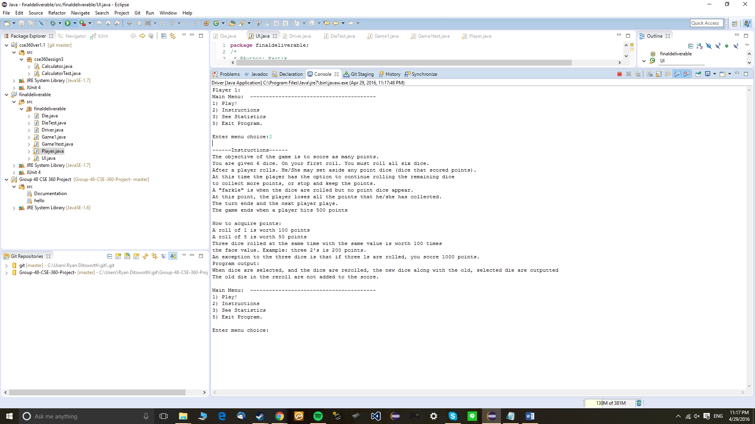

In this test, the input is 3 which outputs the current statistics.



For this test, the input is 5 which exits the program, once for Player 1 and another for Player 2.



For this test, the input is 1 which plays the game. It outputs that there are two players in the game, and rolls the die. It prompts the user to choose which die to select. After the selection, it prompts the user to either score points or roll the die again. In this case, the points are scores and 50 points are given to player 1.

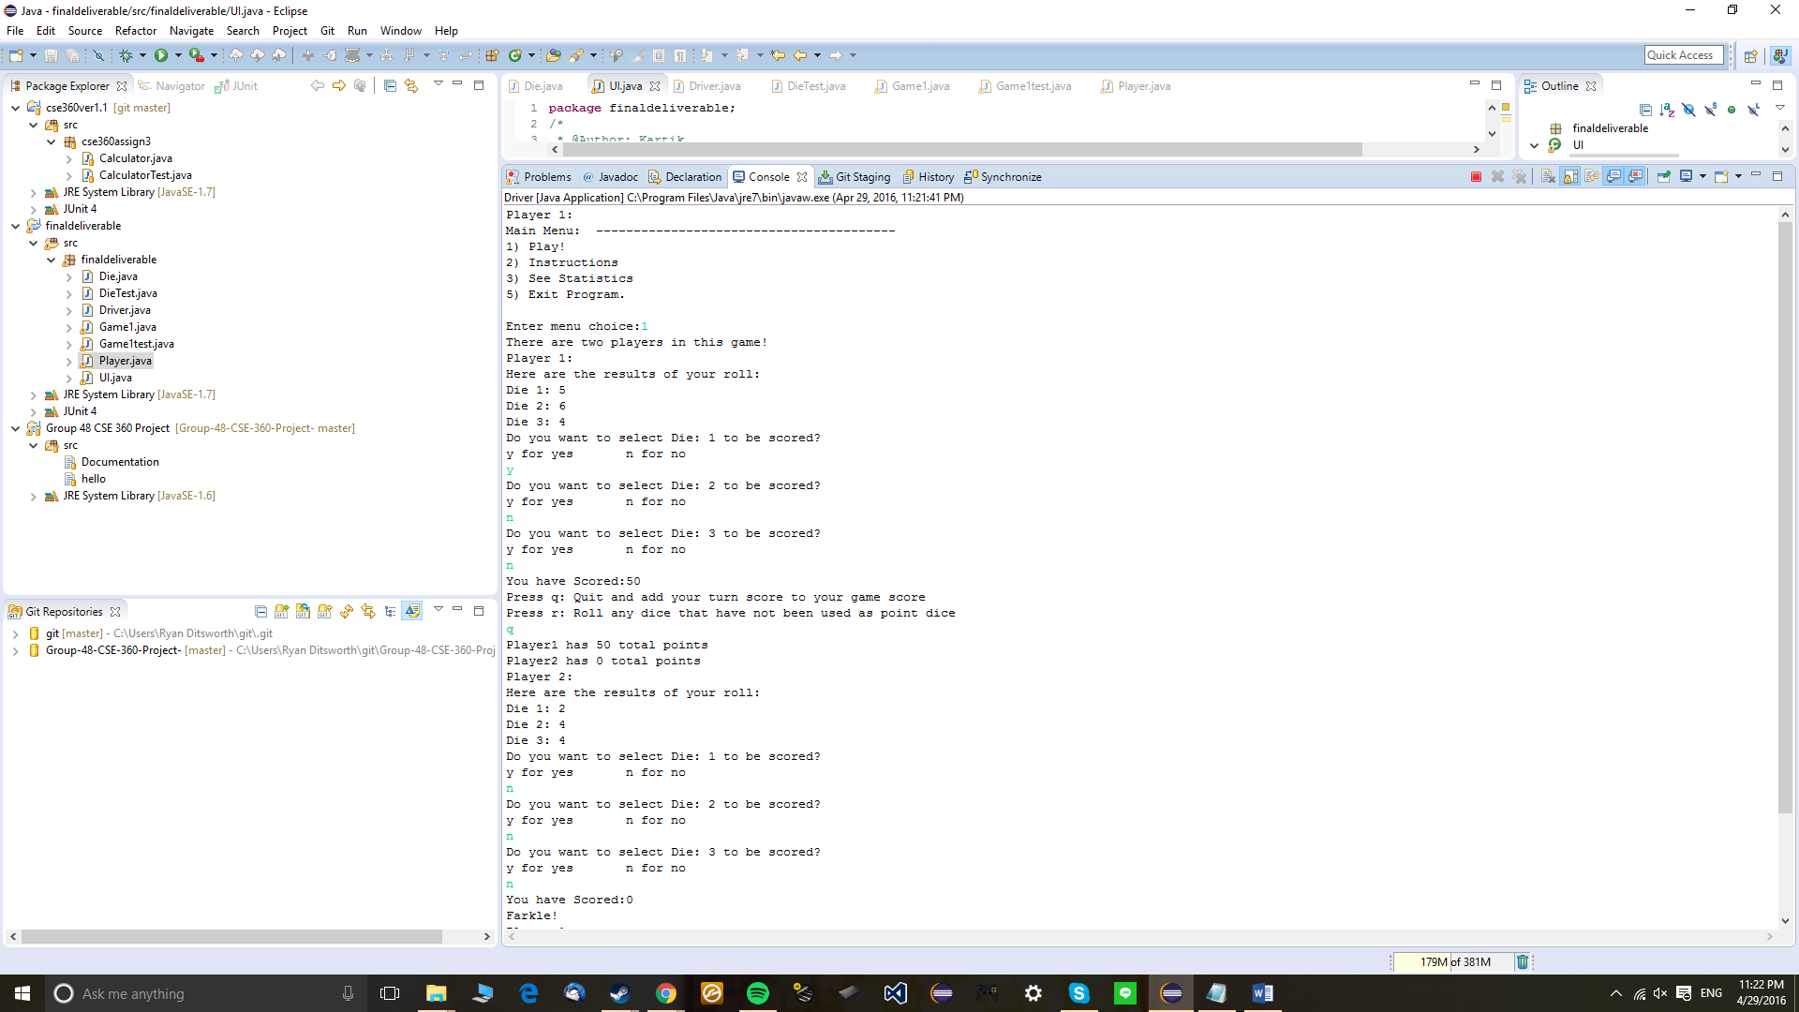

In this test, instead of scoring the points, Player 1 rerolls instead. However, there is a farkle because the two die that are rerolled do not score any points. So, it immediately goes to Player 2.

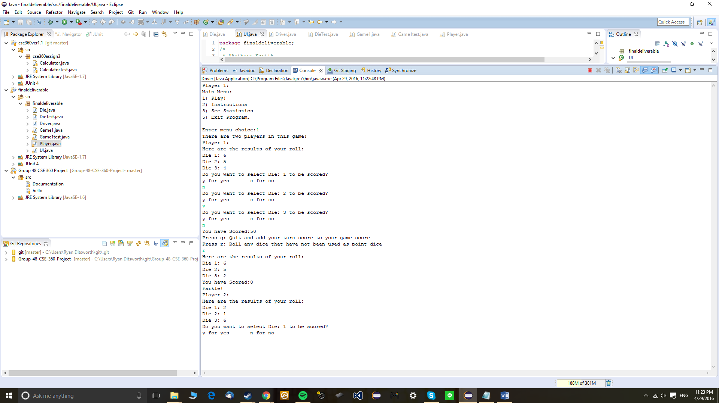

In this test, Player 2 gets 400 points by having three 4s with a roll, and wins with 800 points.

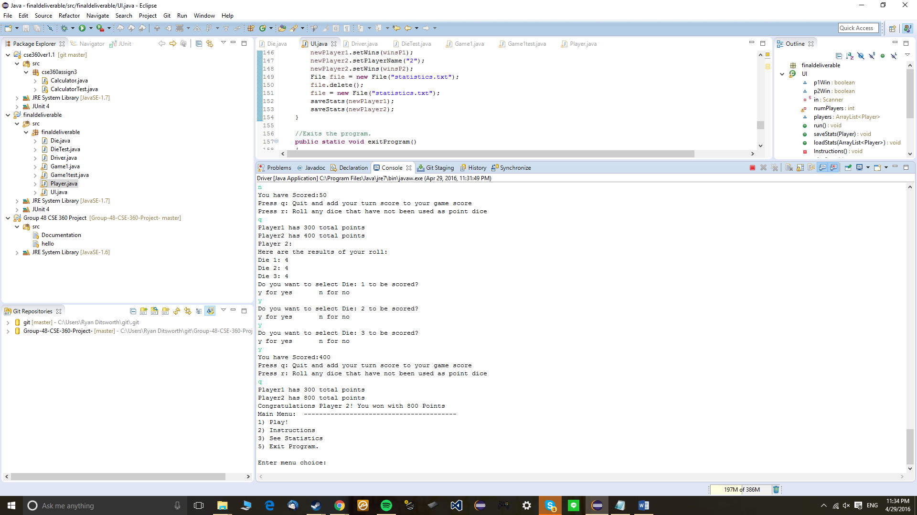

In this test, the statistics are outputted again, and it shows now that Player 2 has one win.

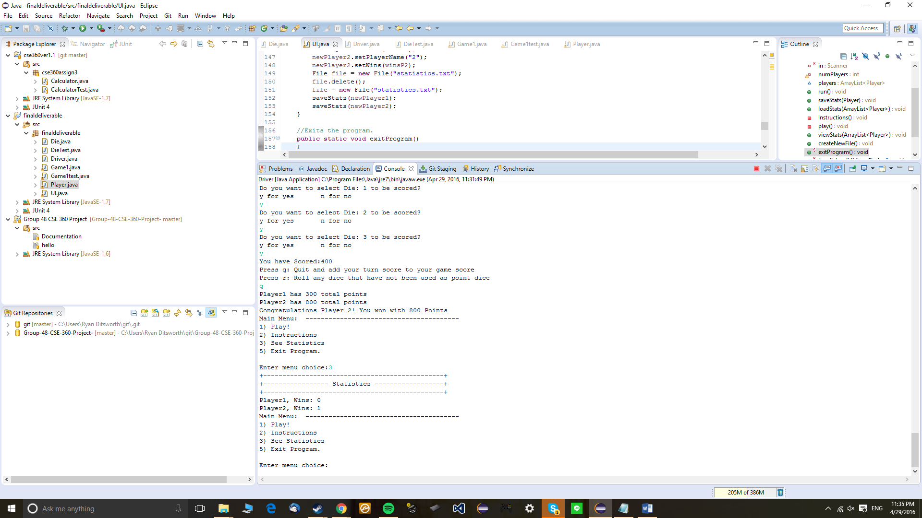

In this test, Player 1 gets a win and statistics is outputted again. It now shows that Player 1 has a win and Player 2 also has a win.

