Create Dynamic Web Pages

ICAWEB502A

Nolan Ryan

2016

Table of Contents

Task 1 2

Task 2 2

Task 3 4

## Task 1

I was able to organize access to a web server at [www.fixated84.net/redo](http://www.fixated84.net/tafe_101_1)

This is a screenshot of the test page loaded onto the server.  
  
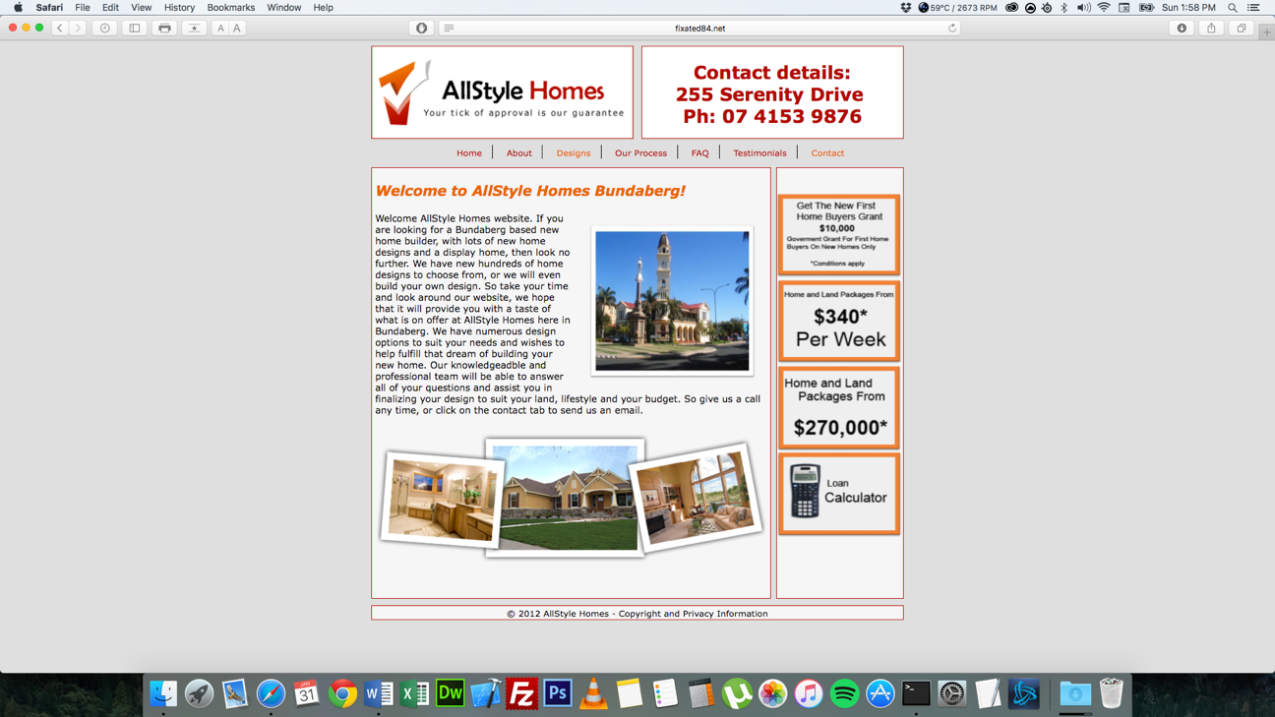

## Task 2

The hardware used in the development environment was a Metabox laptop and a MacBook Pro with an Asus monitor and razer keyboard and mouse. The software used was Windows 10, Mac OSX 10.11.3 and ftp client FileZilla. Dreamweaver and notepad++ was used to edit the html and css files. To test the websites for mobile I used an iPhone 6s and Samsung Galaxy S4 and Xcode on Mac OSX to emulate iPhones with 3.5inch and 4inch screens. The site administrator will only have access to the website because they are the only one with the knowledge to upload and change files correctly and login information.

I proposed a file system that is used in task 1 where folders such as pages, css, images, js and php.

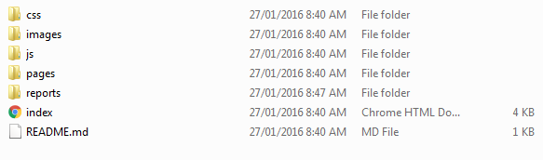

## Task 3

The dynamic content I used on my pages is listed below.

On the designs page I used an image gallery script. This script lists 14 images in boxes and when a user clicks on one it displays it in a larger image in a div.  
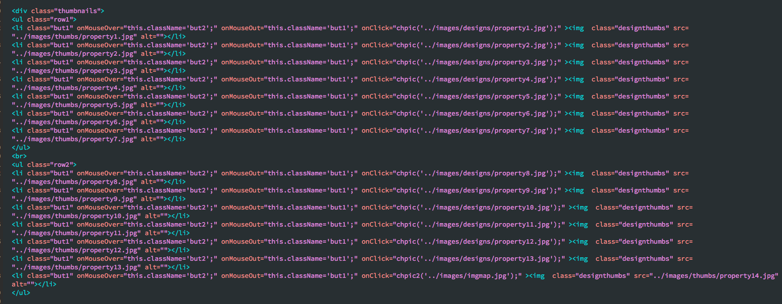

On the Our Process, FAQ and Privacy Policy pages I used a script to hide and show text in divs. This script hides a body of text and when the user clicks the link it shows the hidden text.  
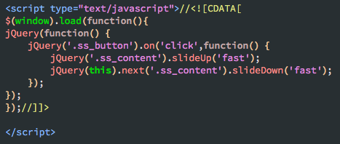

On the contact page I used a google map script. This script shows an address on google maps.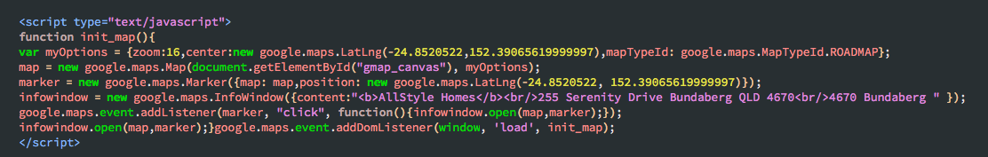

I used this JQuery on the testimonial page to make the images circle and spin when the page loads.

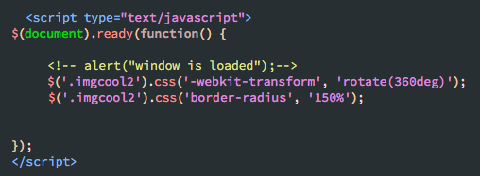

I used this JS I used on the index page and its so when a user clicks on the header image it will do a flip and then revert back it normal.

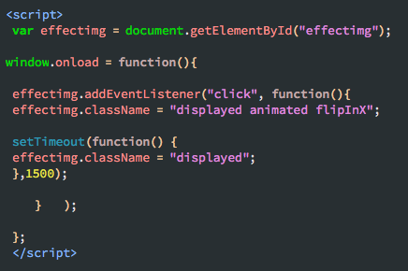

This code is used to find the class for the remove button and a hidden input value so it can be used to submit a form with the email address for removal from the database.

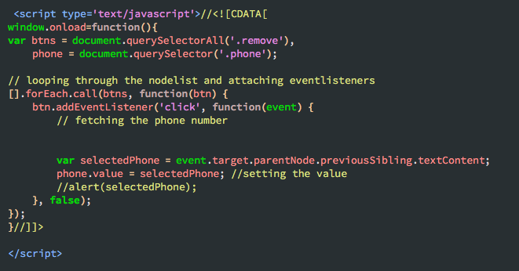

This code was used to open a new webpage with the string at the end to remove emails from the database.

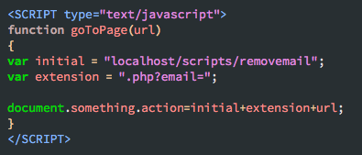

I tested the website and it works on pc on internet explorer, google chrome and Firefox and on mac os safari. Also tested the site on a galaxy s4 and iphone6s.  
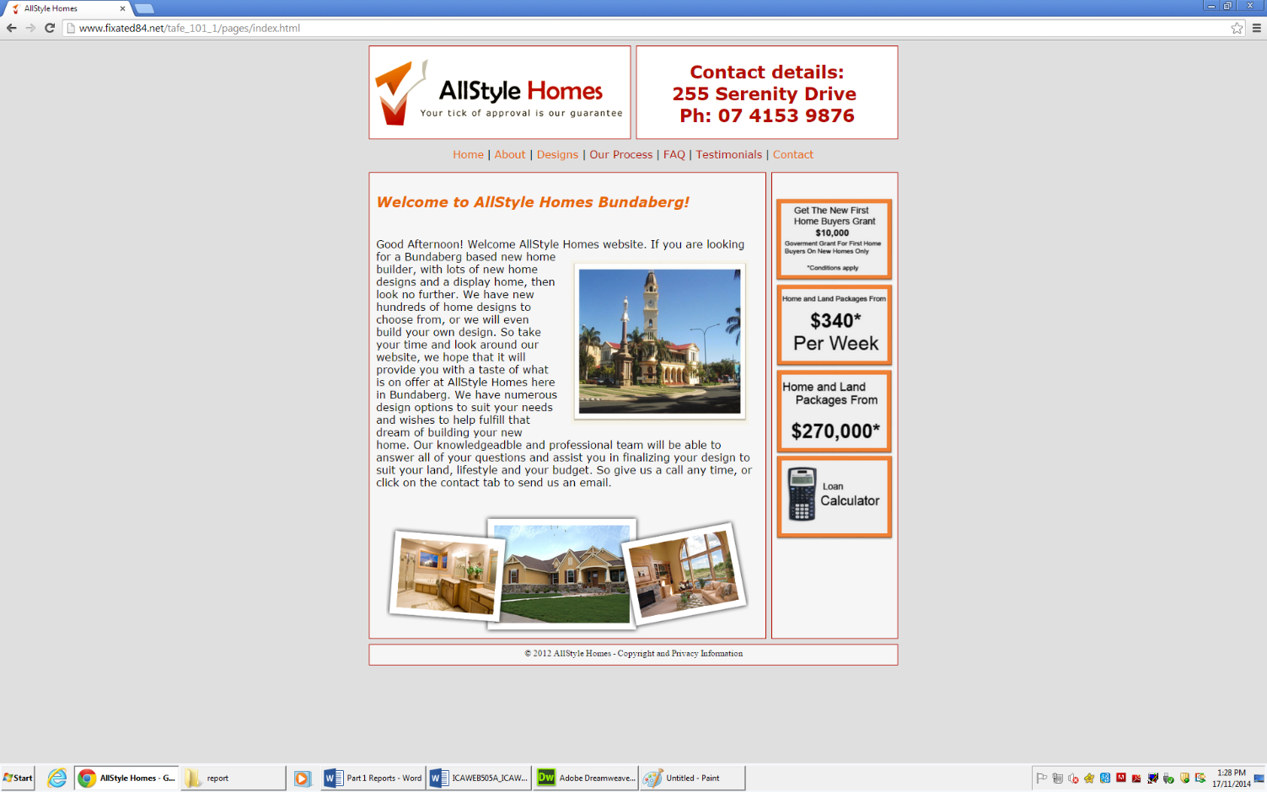  
  
Mobile site Layout Apple iPhone 6s

 

Mobile Layout Samsung Galaxy S4  
 