# Task 1

**Describe HTTP**

Short for HyperText Transfer Protocol, HTTP is the underlying protocol used by the World Wide Web. HTTP defines how messages are formatted and transmitted, and what actions Web servers and browsers should take in response to various commands. For example, when you enter a URL in your browser, this actually sends an HTTP command to the Web server directing it to fetch and transmit the requested Web page.

**Describe limitations of HTTP when developing web applications.**

Some of the limitations for web applications are they are slower because they run over the internet, require internet connection, they have to support different browsers and different versions as well as they can take longer to develop because they are more complex and there are also the security risks.

**Identify the advantages of HTTP when developing web applications.**

The advantage of web applications are they have no installation needed, they are available 24/7 and are always up-to-date. They also have centralized data do its easy to back up.

# Task 3

**Outline the output reports generated by your website, including screen shots of the reports and the SQL code used to fetch the data.**

Screenshots are at the bottom of task 3.

**Outline the security and access control for your website, including a documented test of the security system to ensure functionality.**

For the website security we used a simple username and password system that is stored in the database with encryption for the password. The username for the salespersons is there last name and the first letter of there first name. For example, john doe login would be doej.

**Outline and recommend a plan for implementing this web application.**

**Outline how to import old data into new database using phpmyadmin.**

Old data can be imported in a few ways, the first way is to manual enter all data via the website and the second is via the phpmyadmin’s insert data option but both of theses ways will take time depending on how much data you have to import. The third way is to import a backed up copy of your data from the previous database.

To import backed up data that was saved as a sql file follow theses steps.

1. Access the database you plan to use or create a new one in phpmyadmin.
2. Click the import tab at the top of the page.
3. Browse the computer for the backed up sql file.
4. Click Go.

**Identify and document user training requirements.**

Staff training will be simple they will be shown by the administrator how to add and view customers and vehicles. The administrator will need to know how to use database via phpmyadmin and how to maintain it.

**Outline the web application’s use of statefull/statelessness**

The web application uses sessions to store data such as current salesperson logged in. This allows the active salesperson to view secure pages. It is also used on the sales list page were it shows current salesperson logged in.

**Screenshots:**

Used vehicle page



This code is to display the year make model category and color of the car.

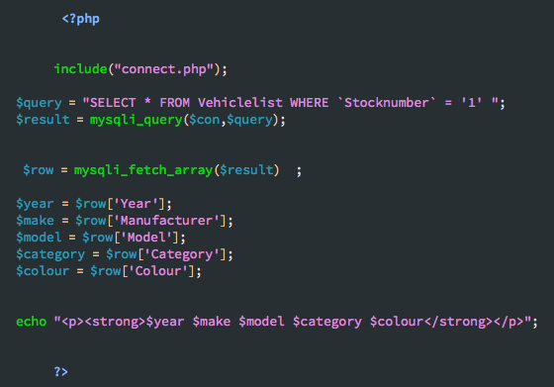

This code is to display the price of the car.

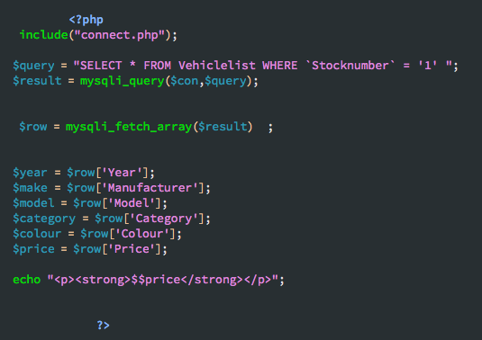

This code is to display a large picture of the of the car and when clicked it uses JS to display it even larger on the screen

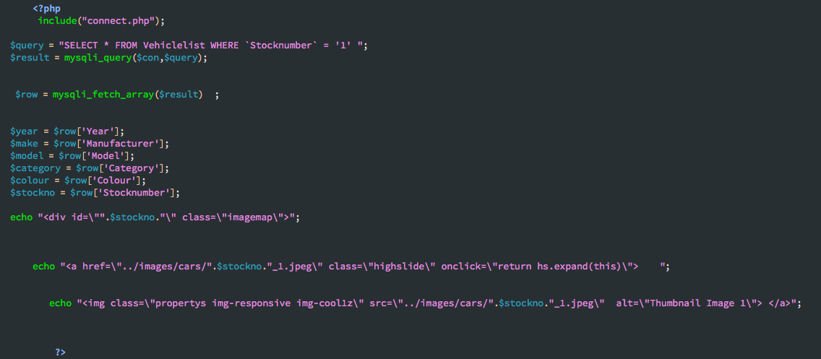

This code is to display the 4 thumbnail pictures of the car and when clicked it uses JS to display it in the larger picture.

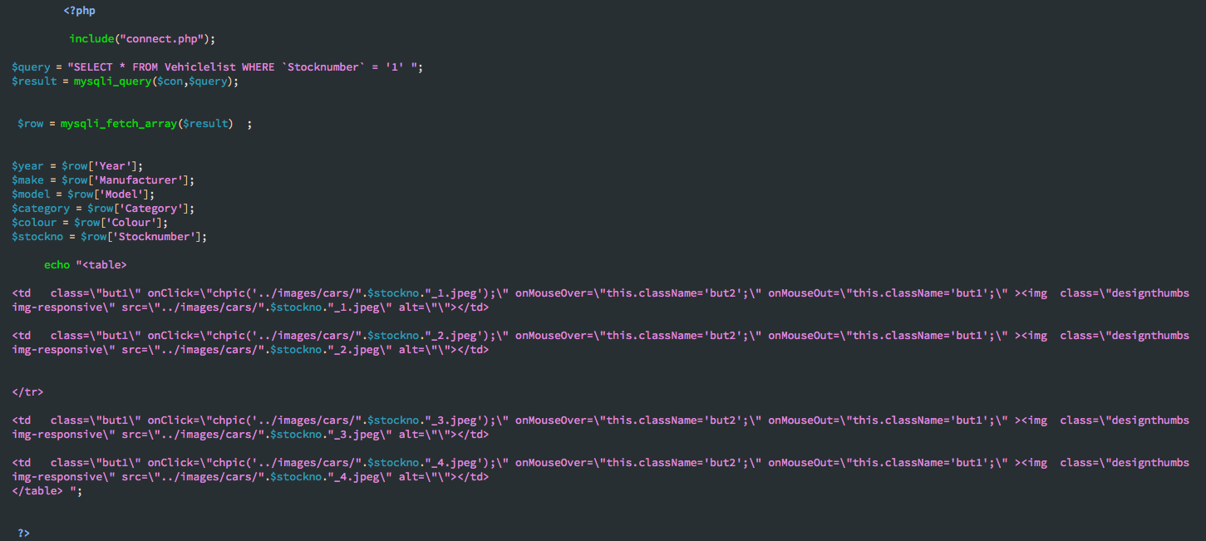

This code is to display information about the car such as kilometers and fuel type

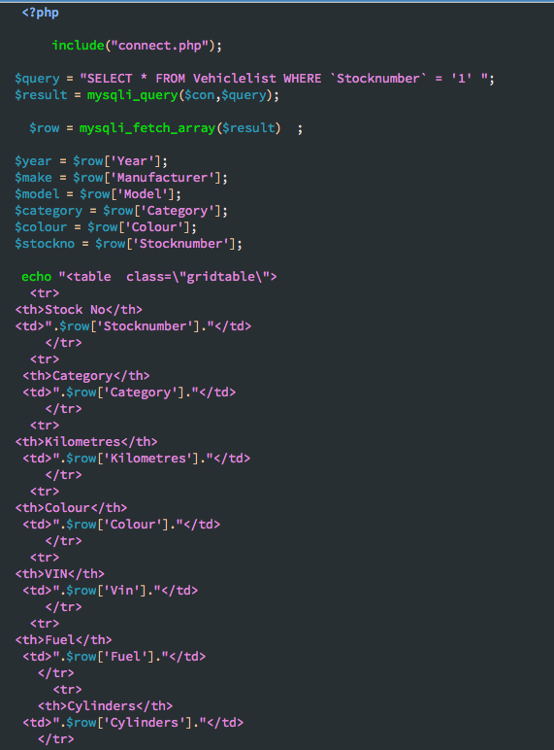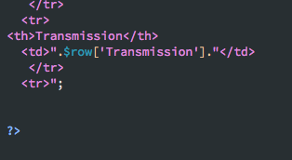

# Task 4