Victor Soto

01/13/2024

Assignment 1.4 – Business Rules

If the Object Relational Diagram (ORD) is:

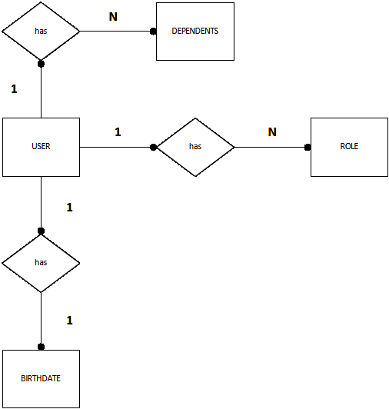

Then, Business Rules are:

One USER has many DEPENDENTS.

One USER has many ROLE.

One USER has one BIRTHDATE.