Victor Soto

01/21/2024

Excersize 2.3

Installed Python in VS Code:

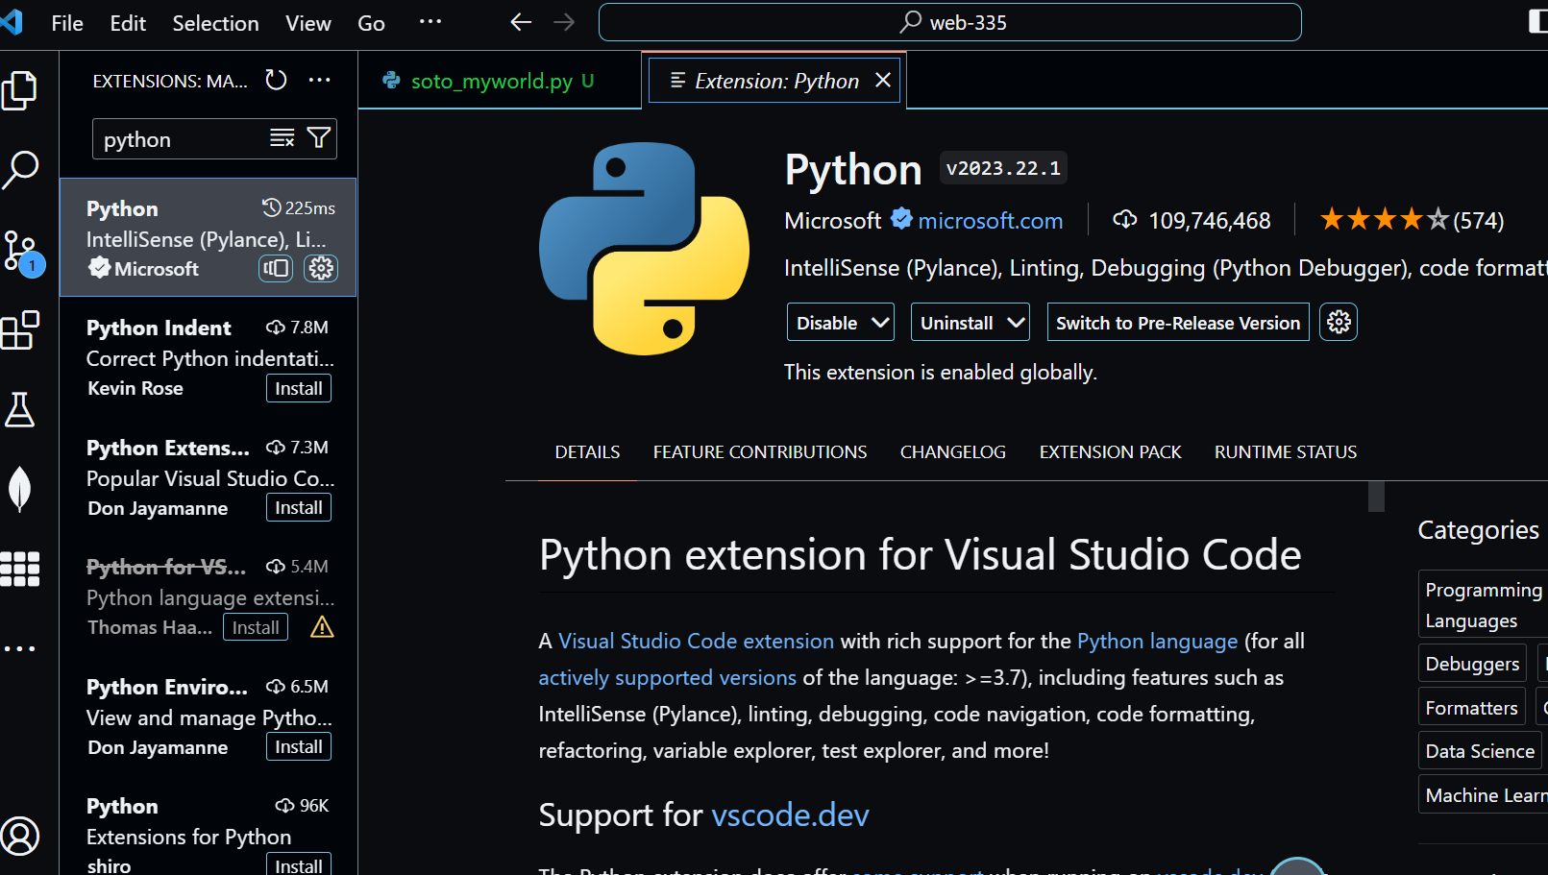

Version button in Status Bar:

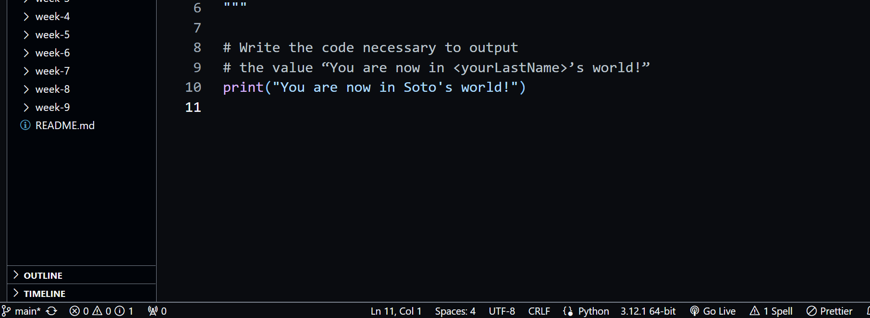

Command Palette search:

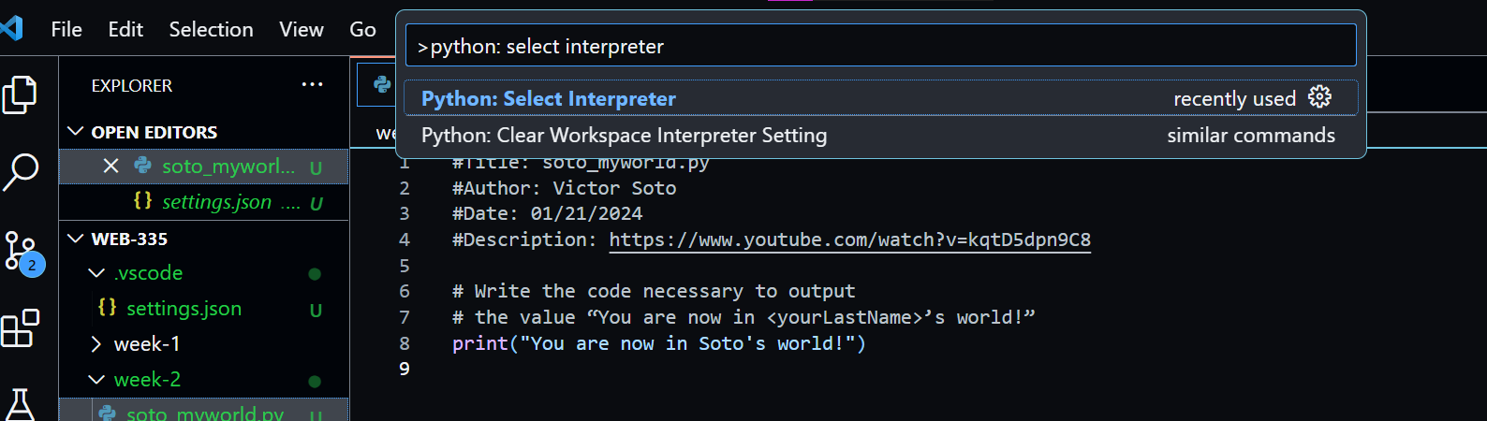

Selected Python 3.12.1 64-bit:

