Victor Soto

01/28/2024

Assignment 3.2

**NodeSecurity**

ORD:

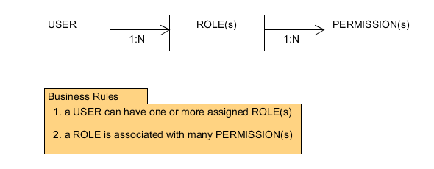

NoSQL Data Structure:

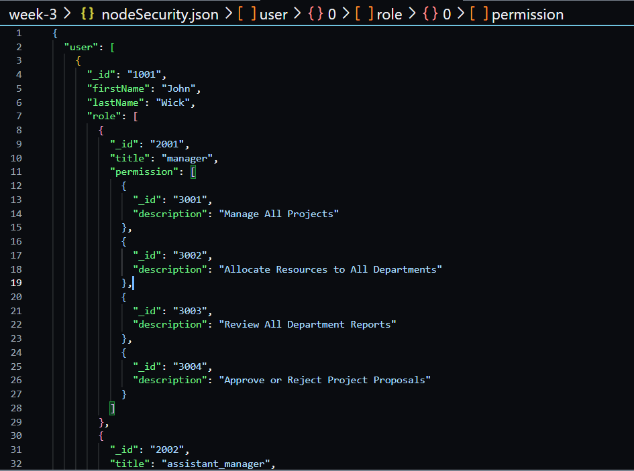cont..

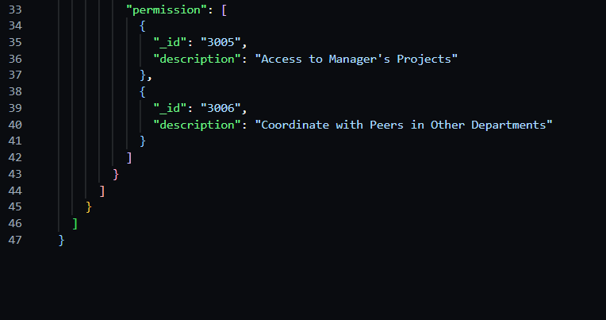

*Next Page*

**NodeBookCo**

ORD:

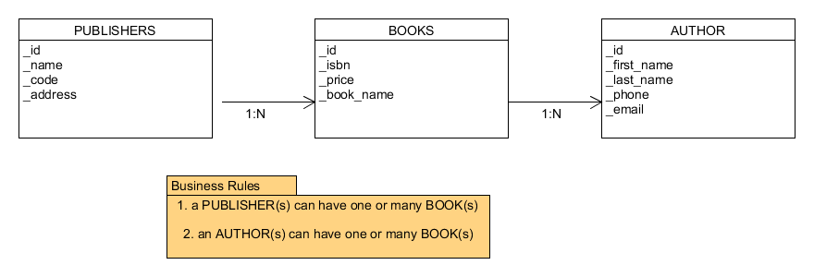

NoSQL Data Structure:

