Victor Soto

02/10/2024

Assignment 5.2

Connected to MongoDB:

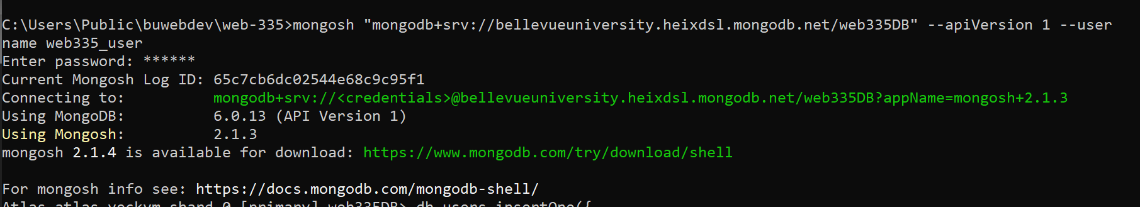

Adding a new user: This picture shows a new user being added.

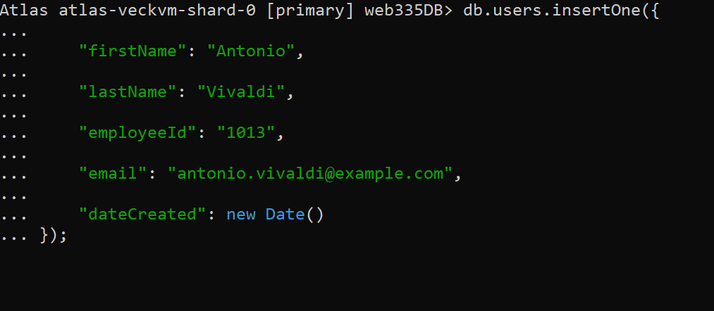

Updating Mozart’s email address: This picture shows Mozart’s email being updated.

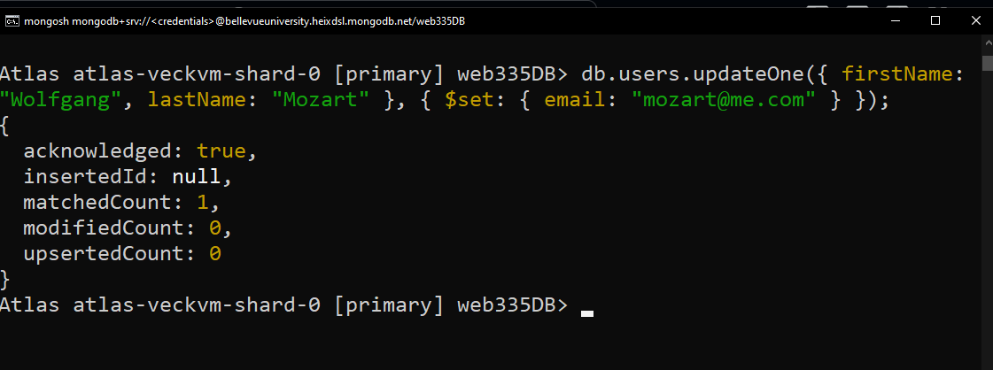

Verifying the email update: This picture shows Mozart’s new email.

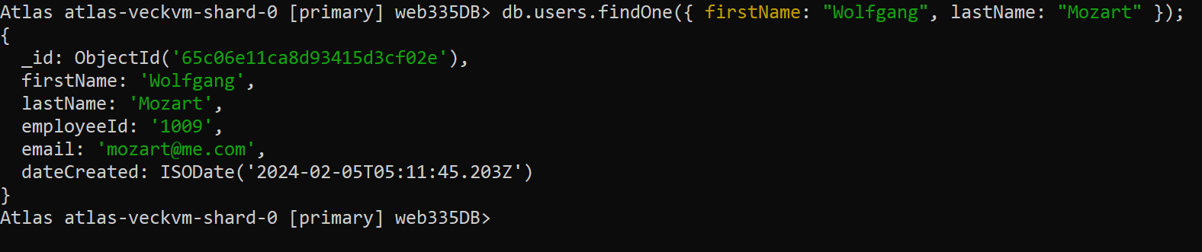

Listing all users: This picture shows a list of all users, with only their names and emails shown.

