Victor Soto

02/17/2024

Assignment 6.2

Load the house.js script from week six (6) of the courses GitHub repository.

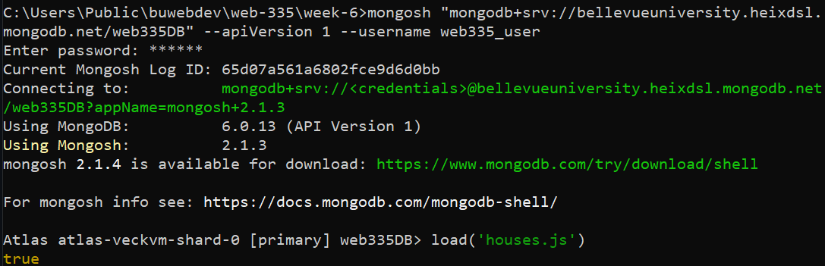

Write a query to show a list of documents in the houses collection. Take a screenshot of the output and save it as an image.

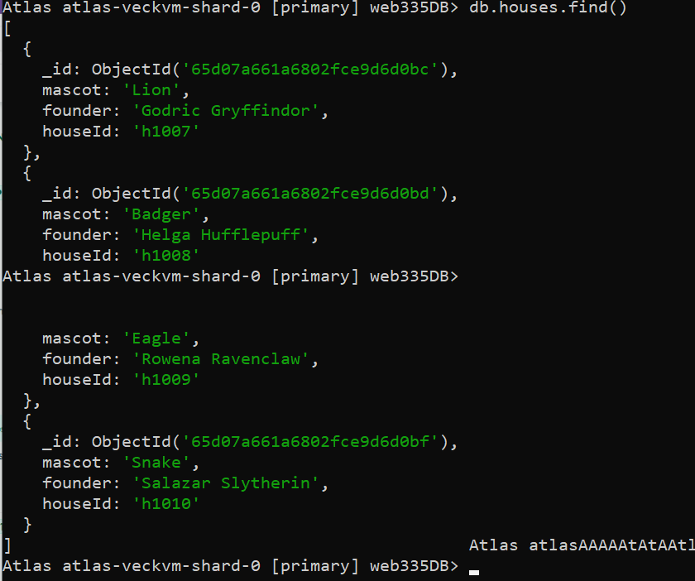

Write a query to show a list of documents in the student’s collection. Take a screenshot of the output and save it as an image.

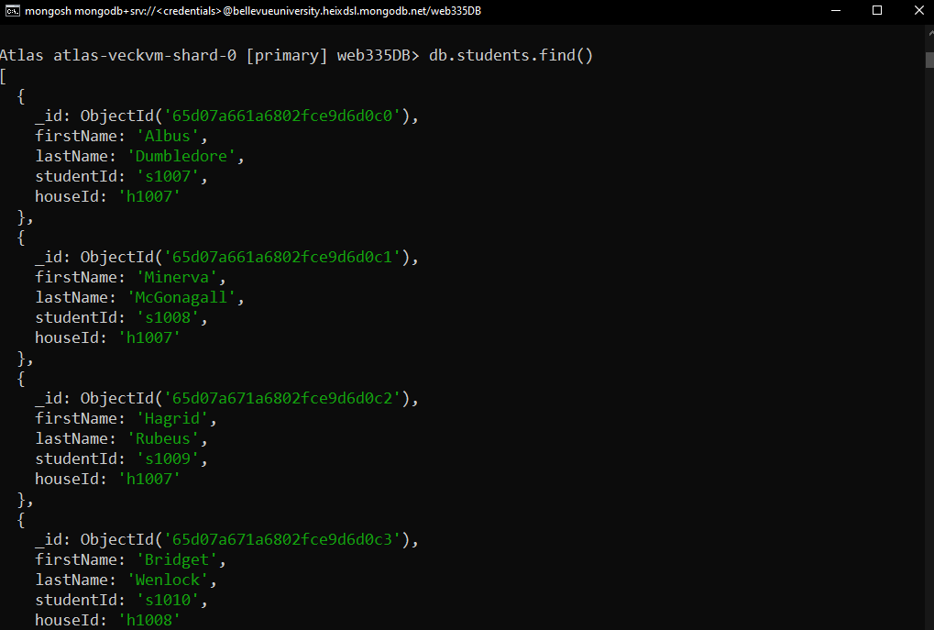

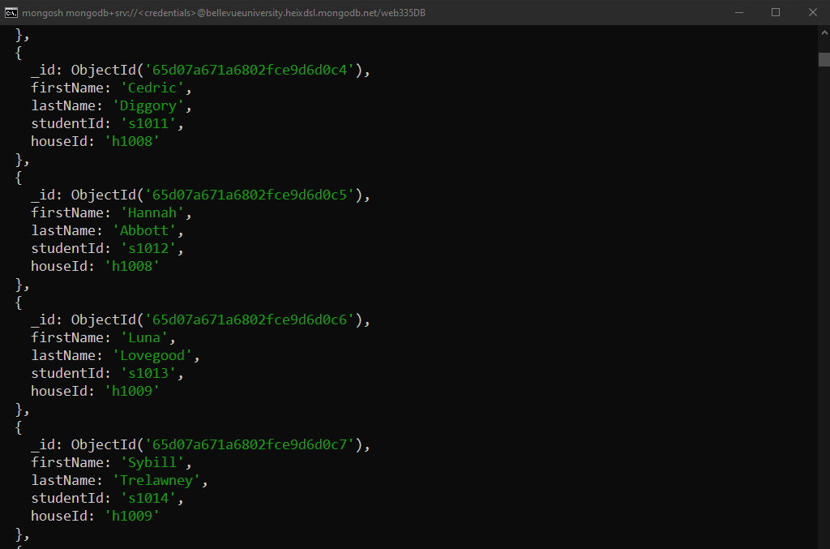

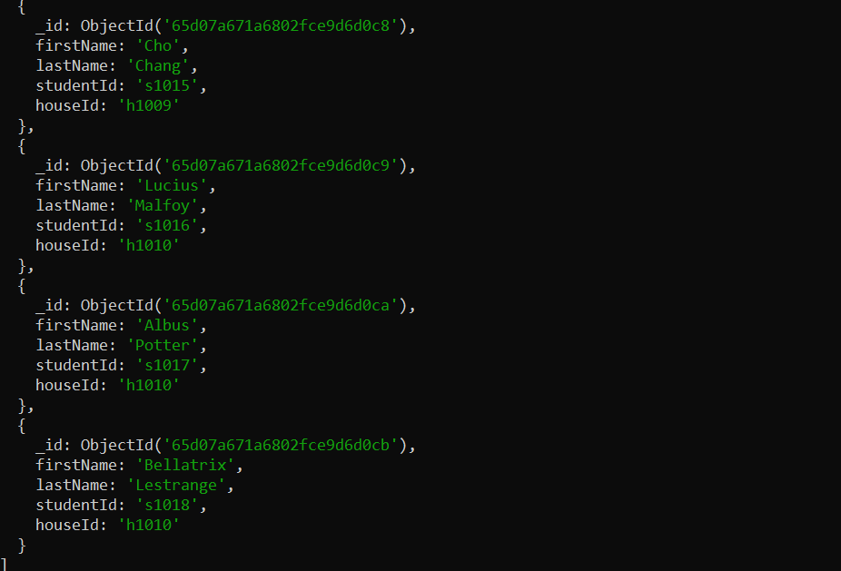

-Write a query to add a document to the student’s collection.

-Next, write a query to prove the document was added to the student’s collection. 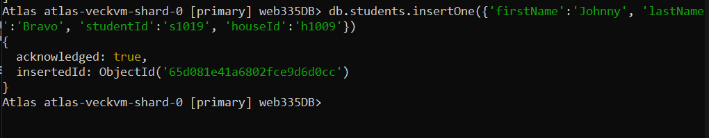

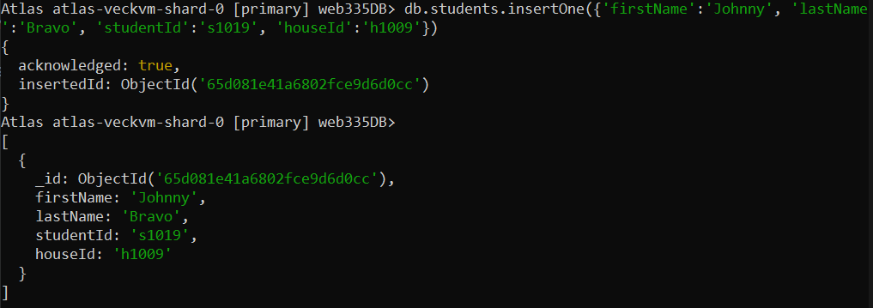

-Write a query to delete the document you created in step 4.

-Next, write a query to prove the document was removed from the student’s collection.

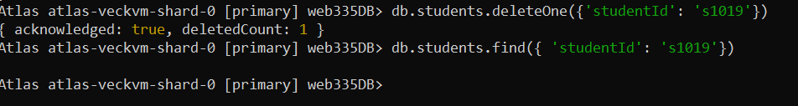

-Write a query to show a list of students by house (hint: use the lookup operation).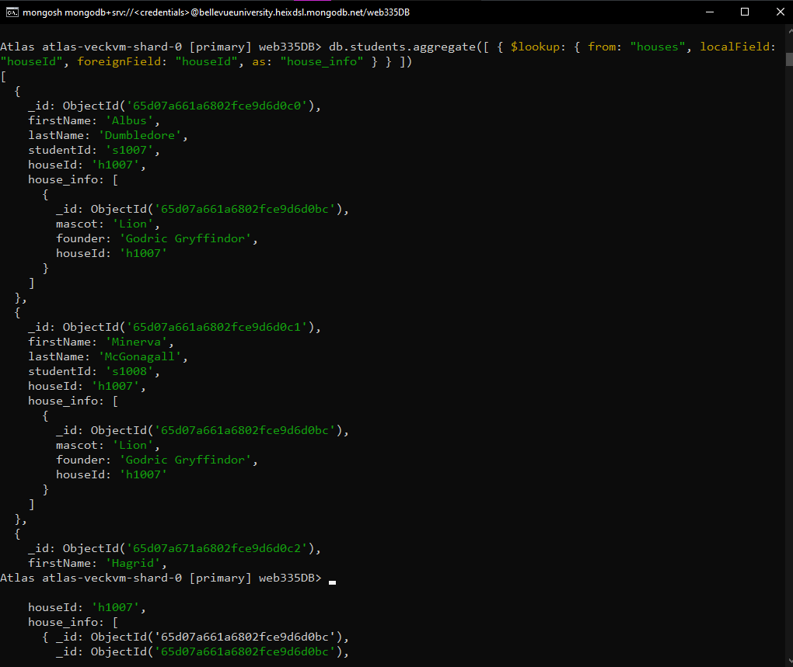

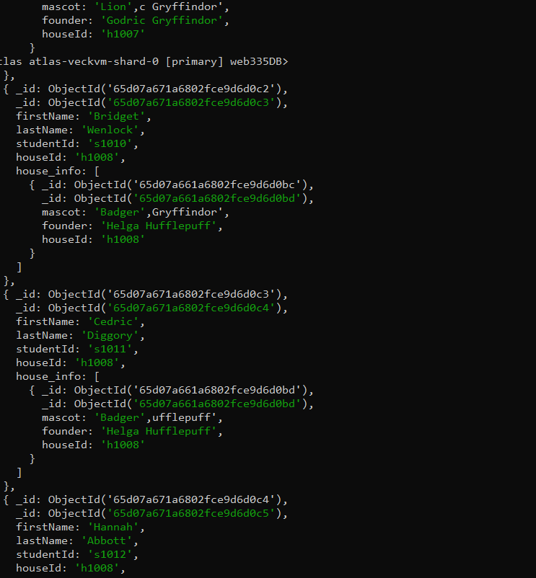

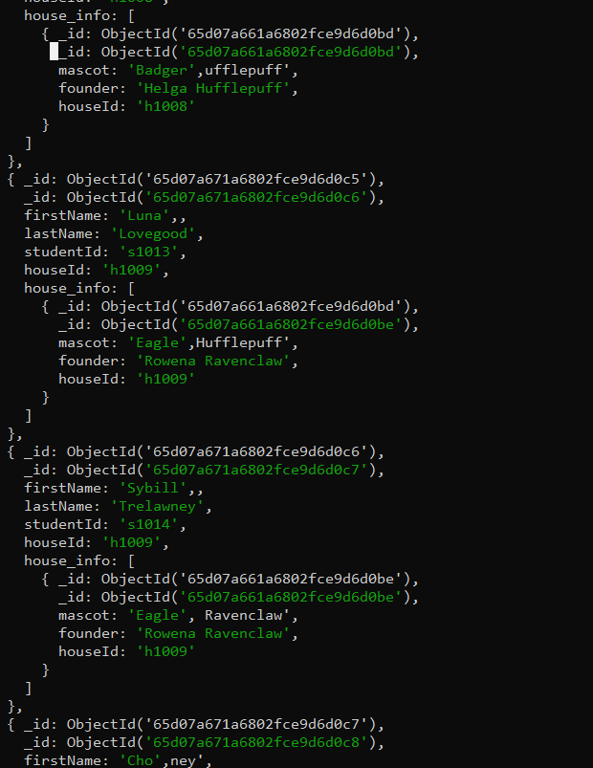

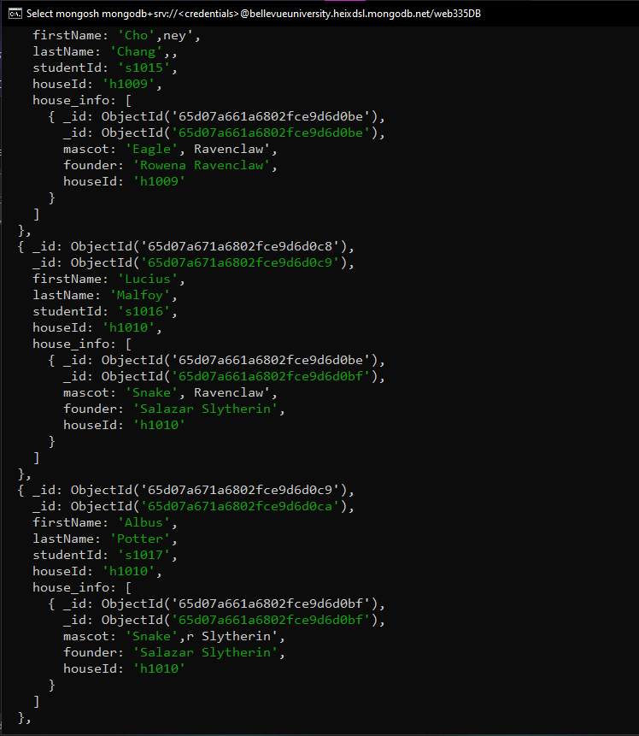

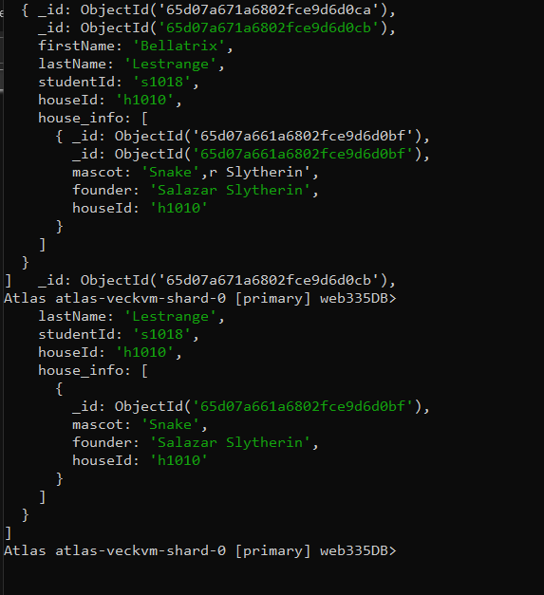

Write a query to show a list of students for house Gryffindor (hint: use the lookup and match operations).

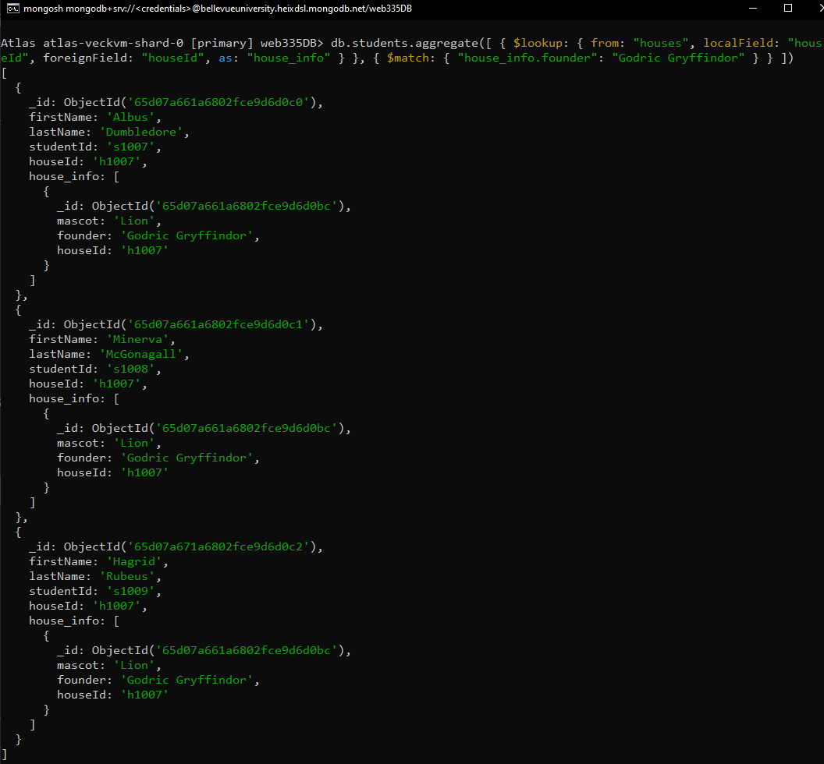

Write a query to show a list of students for the Eagle mascot (hint: use the lookup and match operations).

