Victor Soto

03/24/2024

Exercise 1.2 - GitHub Repository Setup

Local Directories:

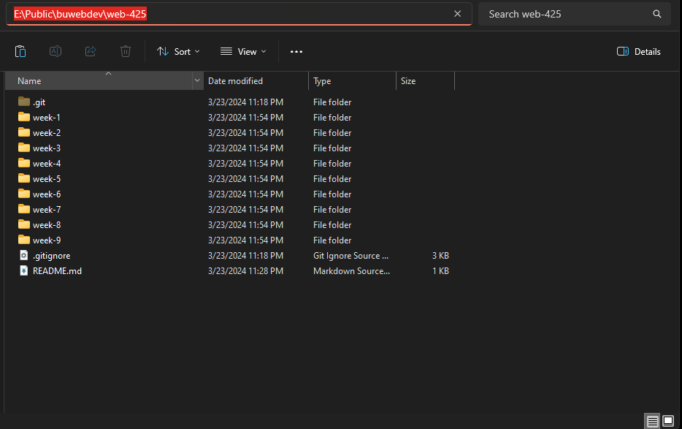

Web-425 GitHub Repo:

<https://github.com/FixedBits/web-425>