**Солдатова ФБ-11мп**

**Task 1-2**

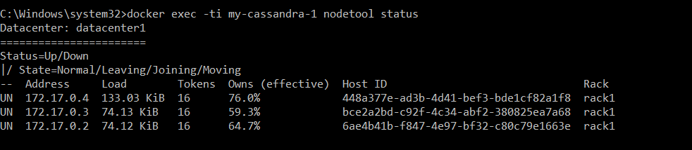

**Task 3**

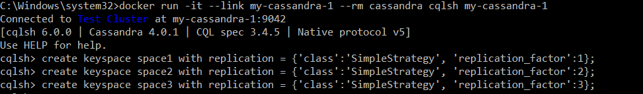

**Task 4**

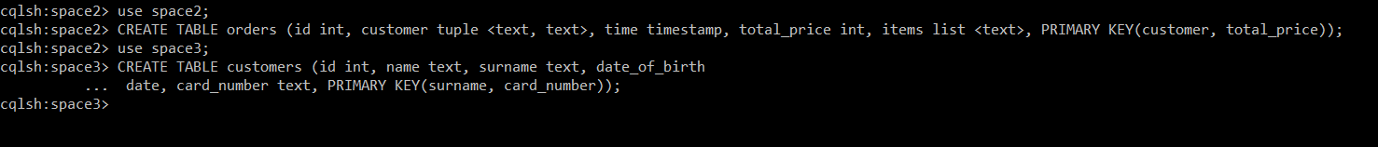

**Task 5**

Node 172.17.0.2

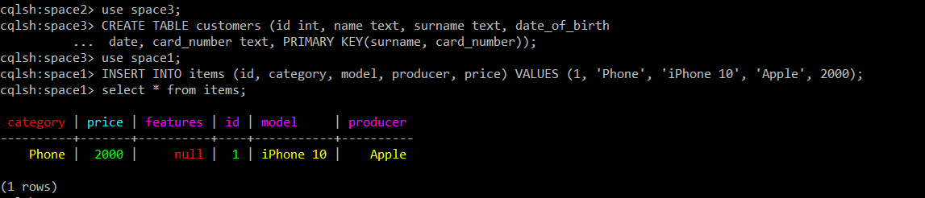

Node 172.17.0.3

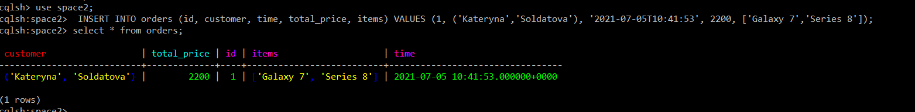

Node 172.17.0.4

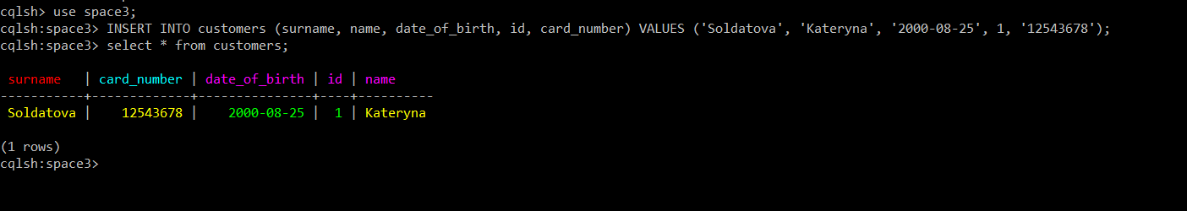

**Task 6**

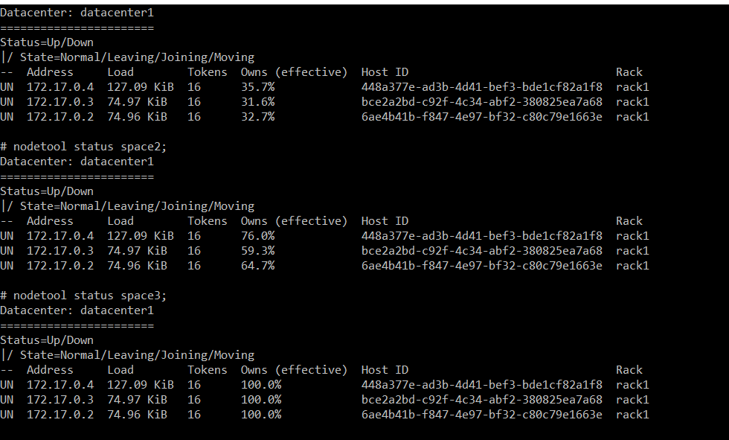

**Task 7**

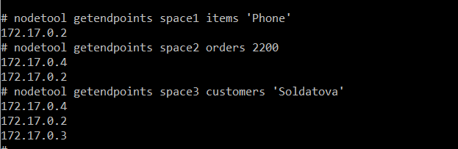

**Task 8**

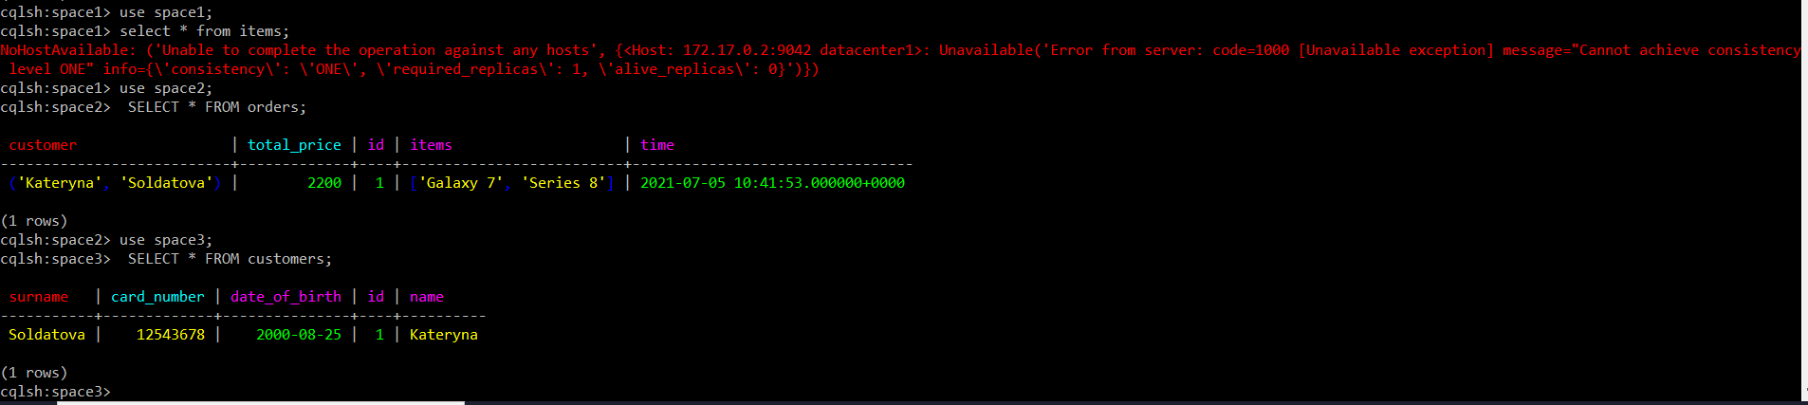



With one node with status unactive, READ is unavailable for replication level 1, WRITE is available.

**Task 9**

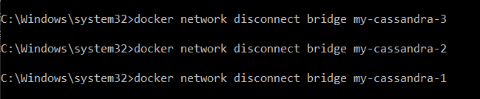

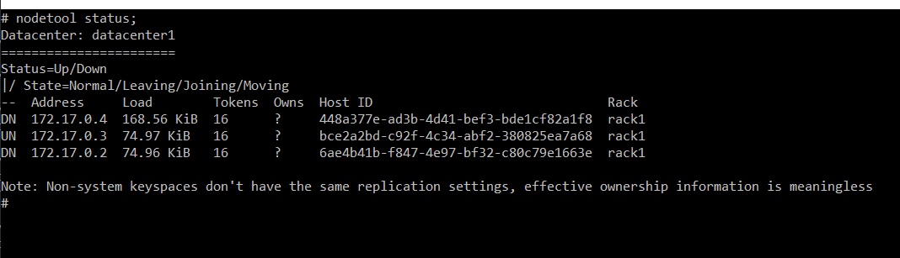

**Task 10**

Node 172.17.0.2

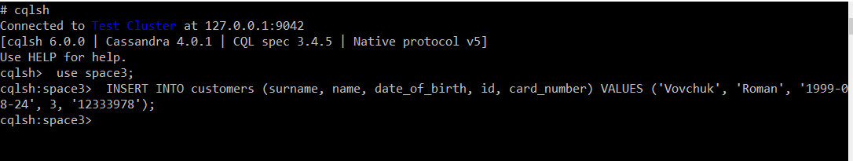

Node 172.17.0.3

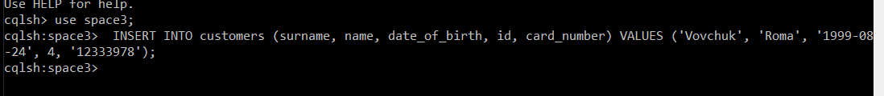

Node 172.17.0.4



**Task 11**

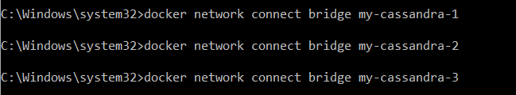

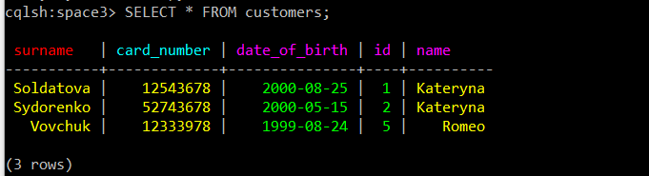

The latest entry was written.

**Task 12**

Node 172.17.0.2

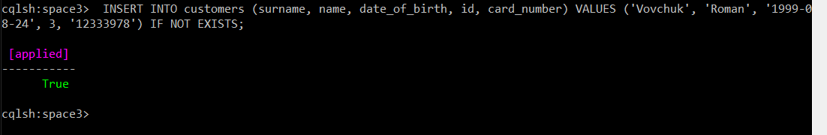

Node 172.17.0.3

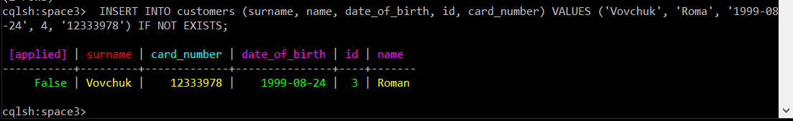

Node 172.17.0.4

