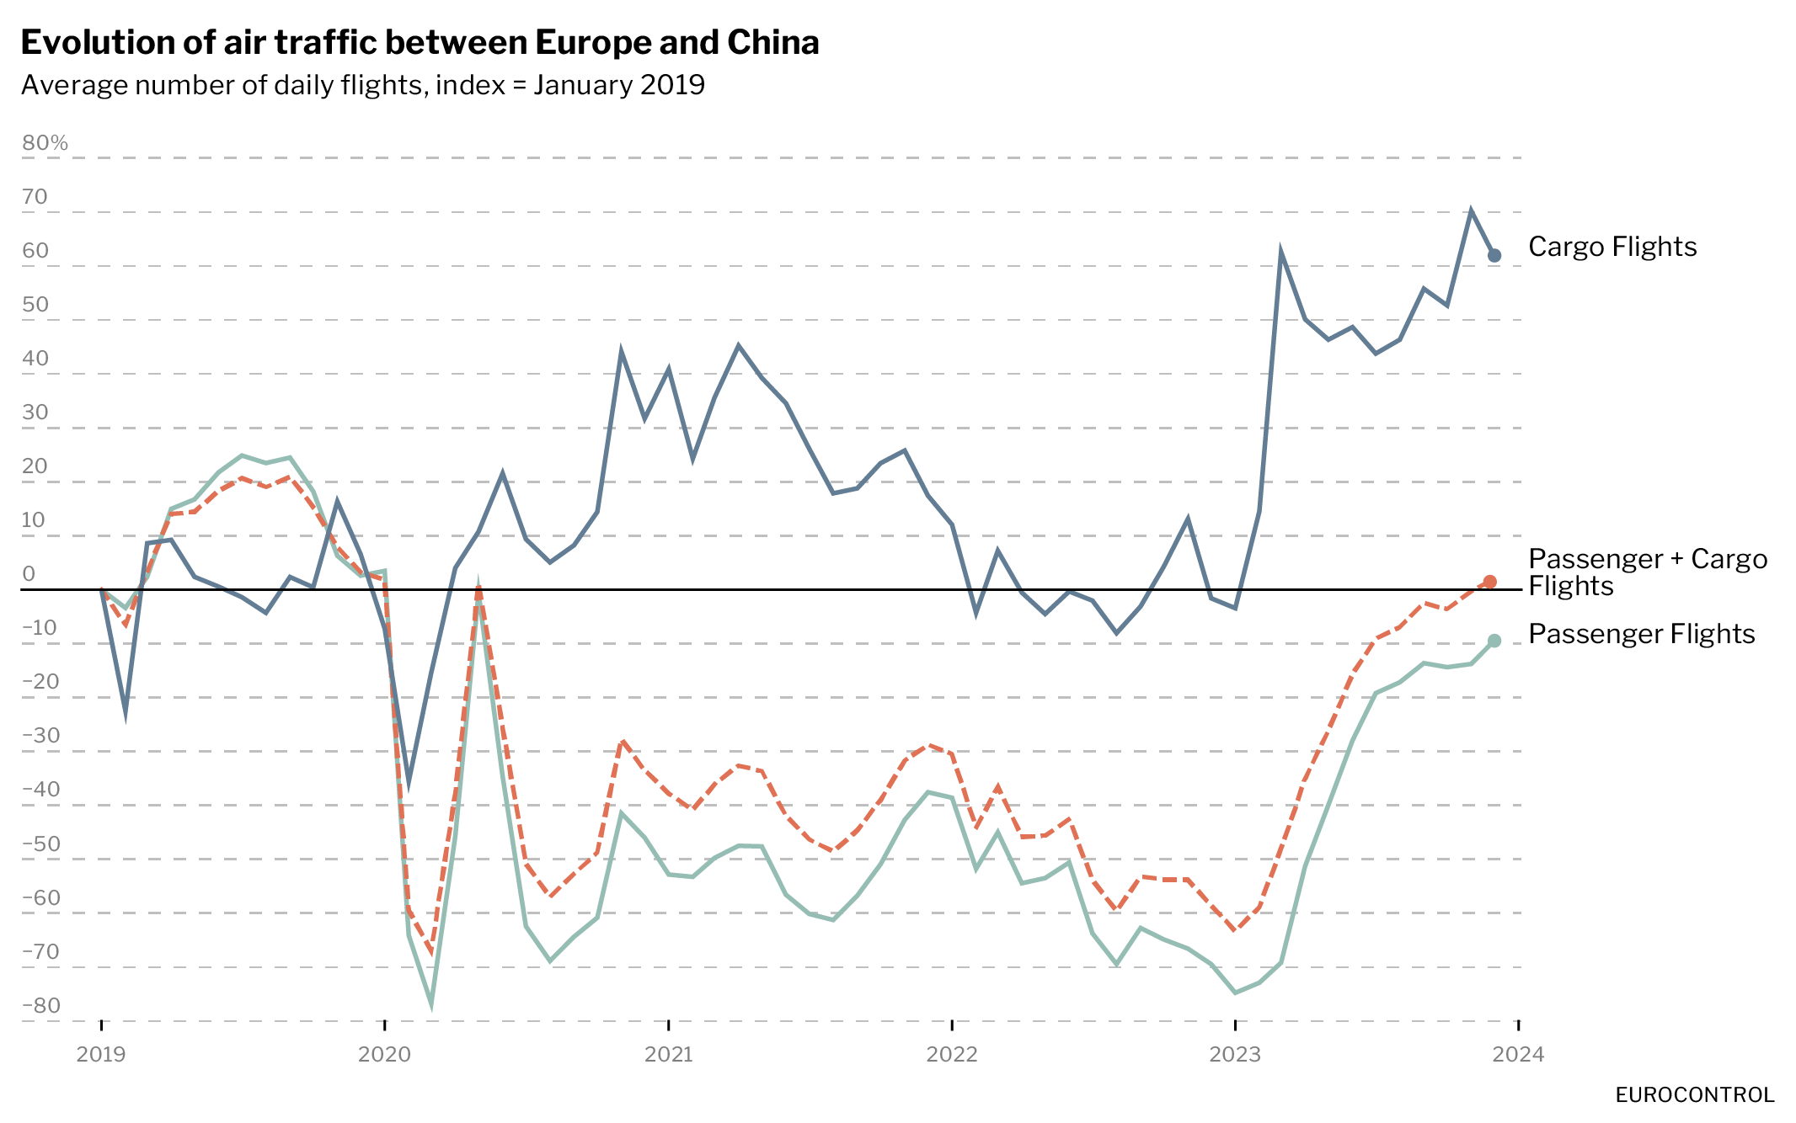

Since January 2019, air traffic between Europe and China has undergone significant changes, driven by global economic fluctuations and unprecedented health crises. A thorough analysis of the patterns in passenger and cargo flights demonstrates how the aviation industry has adapted to fluctuating demand and changing regulations. At the beginning of the period, in January 2019, the ratio of cargo to passenger flights was about 1 to 5, with a substantially higher number of passenger flights.

The outbreak of COVID-19 in early 2020 had a direct and dramatic effect on passenger traffic, which plummeted due to global travel restrictions and lockdowns. Meanwhile, cargo flights remained relatively stable, likely due to increased demand for the transport of essential goods and medical supplies. From 2021, passenger traffic showed gradual improvements, and this positive trend accelerated, culminating in a strong revival that nearly reached pre-pandemic levels by 2023. In contrast, cargo flights exhibited a fluctuating pattern, but the overall trend pointed towards stability and growth towards 2024.

By December 2023, the ratio of cargo to passenger flights had normalized to about 1 to 4, indicating a higher relative share of cargo flights compared to the start of the period. This suggests a sustained need for cargo transport and stabilization in passenger traffic.

The resilience and adaptability of the aviation sector during this period of challenges and changes highlight the essential role of air transport in supporting the global economy and facilitating recovery from crises. This Data Snapshot is produced by Eurocontrol, with data illustrating the dynamic nature of the aviation industry.