**OUTPUT SCREENSHOTS**



Fig 1: Home Page of Blog Site

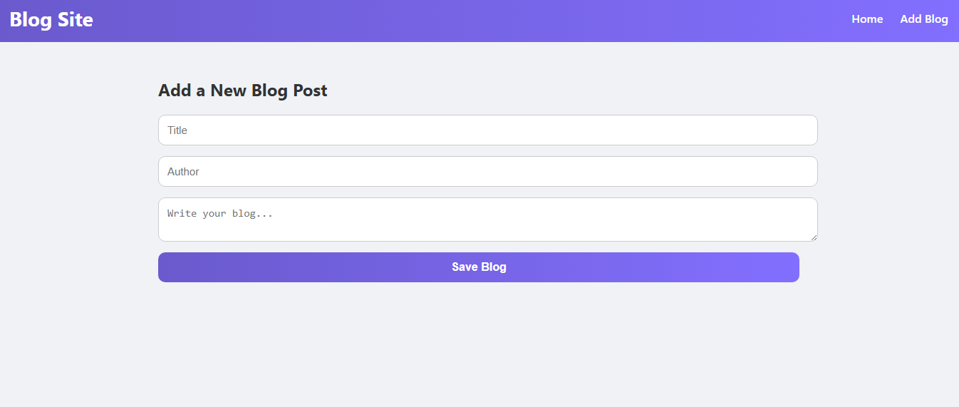

Fig 2: Add a New Blog Site



Fig 3: Blog with Comment Section