
Discovering Knowledge

COURSE: CSL 220
DATABASE MANAGEMENT SYSTEM
PROJECT REPORT
CLASS: BSE – 4C (SPRING - 2025)

HOSPITAL MANAGEMENT SYSTEM

Group Members

Student Name | Enrollment#
ALISHBA MAQSOOD (Group Leader) | 02-131232-118
FIZA KHAN | 02-131232-048
M.ABUBAKAR AFZAL | 02-131232-052

Submitted to:
Course Instructor: Dr. Sohaib Ahmed
Lab Instructor: Engr.Zoobia Zeesham

Department of Software Engineering
BAHRIA UNIVERSITY KARACHI CAMPUS

Abstract

The Hospital Management System (HMS) is a web-based application designed to automate and streamline hospital operations, including patient admissions, billing, diagnostics, and staff management. Developed using ASP.NET (C#), SQL Server, and Bootstrap, the system replaces outdated paper-based processes with a secure, centralized platform.
Key features include role-based access, real-time reporting, diagnostic record management, and automated notifications. Hosted on Azure, the HMS improves efficiency, reduces errors, and enhances patient care through seamless digital workflows. This project demonstrates the effective use of modern technologies to transform healthcare administration.

TABLE OF Contents
1. Introduction 4
2. Problem Statement 4
3. Proposed Solution 4
3.1. Features of the project 4
3.2. Methodology 4
3.3. Technologies 5
4. Software Design Description 5
4.1. Design Overview 6
4.2. Work Flow Diagram 6
6.1. Use Case Diagram 8
6.2. Sequence Diagram 9
6.3. Block Diagram 9
6.4. ER Diagram 10
10
6.5. Screen Images 11
7. Project Scope 15
8. Module Distribution 16
9. Code 16
10. Conclusion 26
11. References 26

Introduction
The Hospital Management System (HMS) is a web-based application designed to streamline hospital operations, including patient admissions, billing, discharge, in-patient services, outpatient services, consultant information, attendance record and setup screens. This system will help hospitals improve efficiency, reduce paperwork, and ensure seamless patient record management.

Problem Statement
Traditional hospital record-keeping is paper-based, leading to data mismanagement, manual errors, and delays in patient services. There is a need for a centralized system that automates patient admission, treatment tracking, billing, and discharge processes while ensuring secure and efficient data management

Proposed Solution

Features of the project
- Secure Login System – Role-based authentication for different users.
- Setup Module – Add room, area, city and users.
- Patient Admission & Registration – Record new admissions and maintain history.
- Billing & Payment Management – Generate invoices and manage transactions.
- Discharge & Reports – Automate discharge summary generation.
- Consultant & Doctor Management – Maintain consultant schedules and patient prescriptions.
- Medical & Diagnostic Services – Store X-ray, ultrasound, dental service records etc.
- Attendance & Staff Management – Track employee attendance and working hours
- Interactive Line Charts – Visualize patient data trends (e.g., vitals, admission rates) using Chart.js.
- Email Notifications – Automated emails (e.g., appointment reminders, billing updates) sent via SendGrid API.

Methodology
We followed a structured software development life cycle (SDLC), specifically the Incremental Model, to ensure gradual development and testing of each module. Our methodology involved the following key phases:
- Requirement Gathering: Collected functional and non-functional requirements from stakeholders.
- System Design: Created ER diagrams, use case diagrams, and system architecture for a clear blueprint.
- Module-wise Development: Each feature (e.g., patient registration, billing) was developed as an independent module.
- Integration of External Libraries:
  - Chart.js was used to develop real-time line charts for monitoring patient trends and hospital analytics.
  - SendGrid API was integrated for sending automated email alerts such as appointment confirmations and discharge summaries.
- Database Design: Structured the database in SQL Server with tables for patients, staff, billing, and diagnostics.
- Testing & Debugging: Each module was unit tested and later tested for integration to ensure smooth performance.
- Deployment: The final application was hosted on Azure, ensuring accessibility and scalability.
This methodology ensured effective time management, smooth integration of technologies, and user-focused design.

Technologies
The system will be built using ASP.NET Web Forms with C# and a Microsoft SQL Server database. The frontend will use Bootstrap, HTML, CSS, and JavaScript for a responsive UI.
• Frontend: ASP.NET, HTML, CSS, JavaScript, Bootstrap.
• Backend: C# (.NET Framework), SQL Server.
• Database: Microsoft SQL Server.
• Version Control: Git.
• Hosting: Azure.

Software Design Description

Design Overview
The Hospital Management System (HMS) is designed as a web-based application with a user-friendly interface developed using ASP.NET Web Forms. The backend logic is handled by C#. All data for the HMS is stored in a Microsoft SQL Server database. The HMS design aims to streamline hospital operations, including patient admissions, billing, and discharge. It will also help improve efficiency, reduce paperwork, and ensure seamless patient record management.

Work Flow Diagram
Use Case 1: Patient Admission
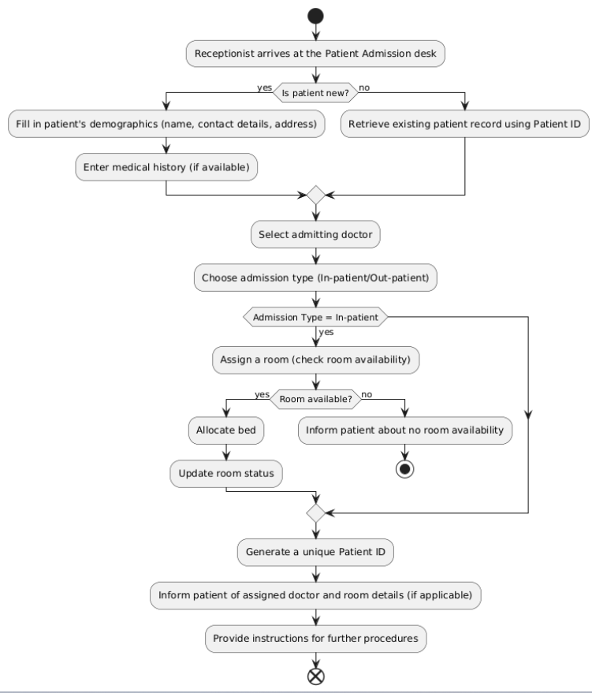

Use Case 2: Billing & Payment

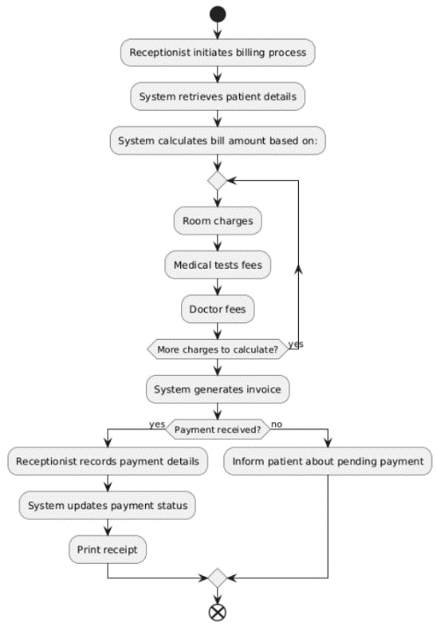

Use Case 3: Discharge Process
- 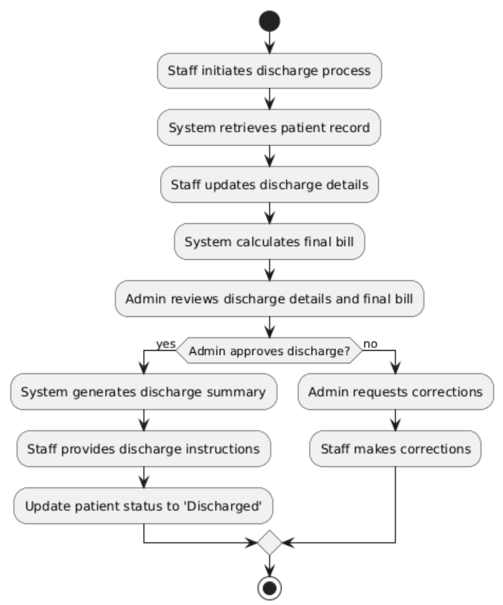

Use Case Diagram
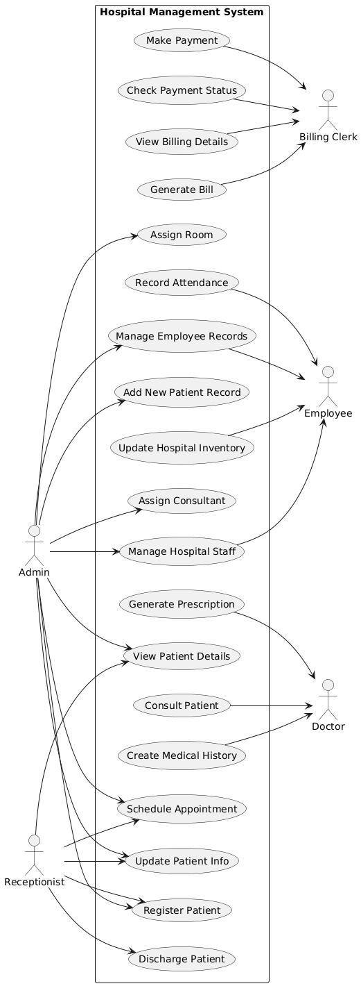

Sequence Diagram
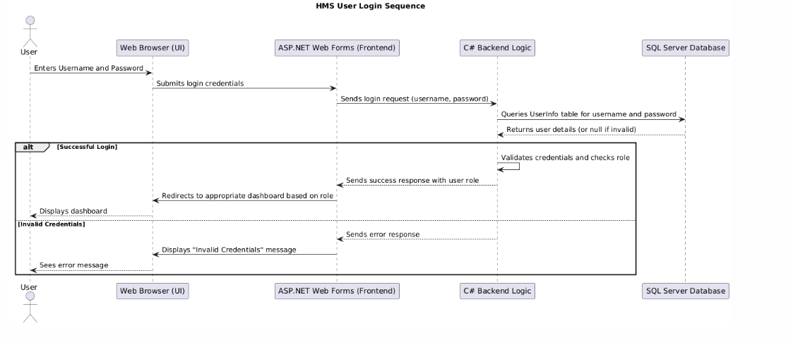

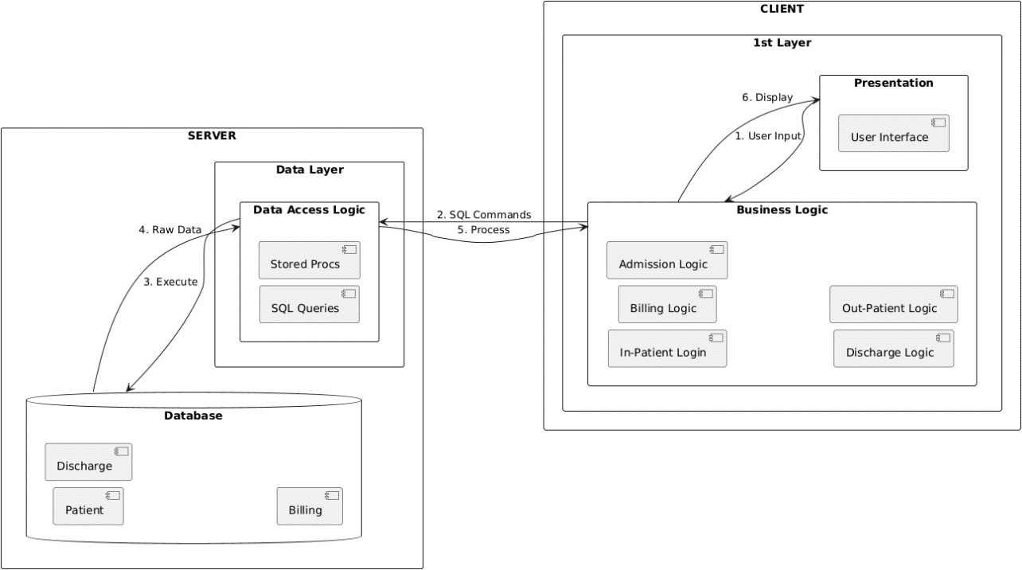
Block Diagram

ER Diagram
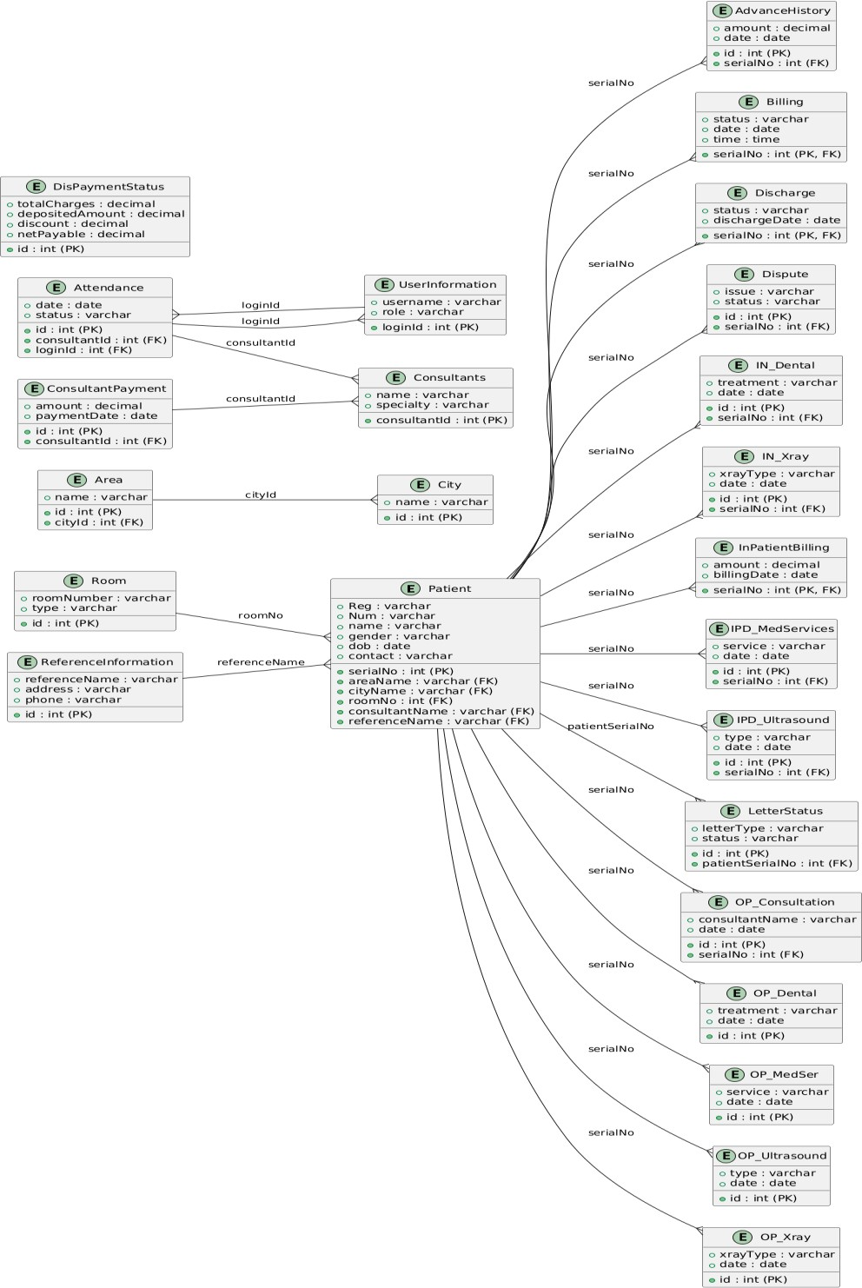

Screen Images
LOGIN PAGE
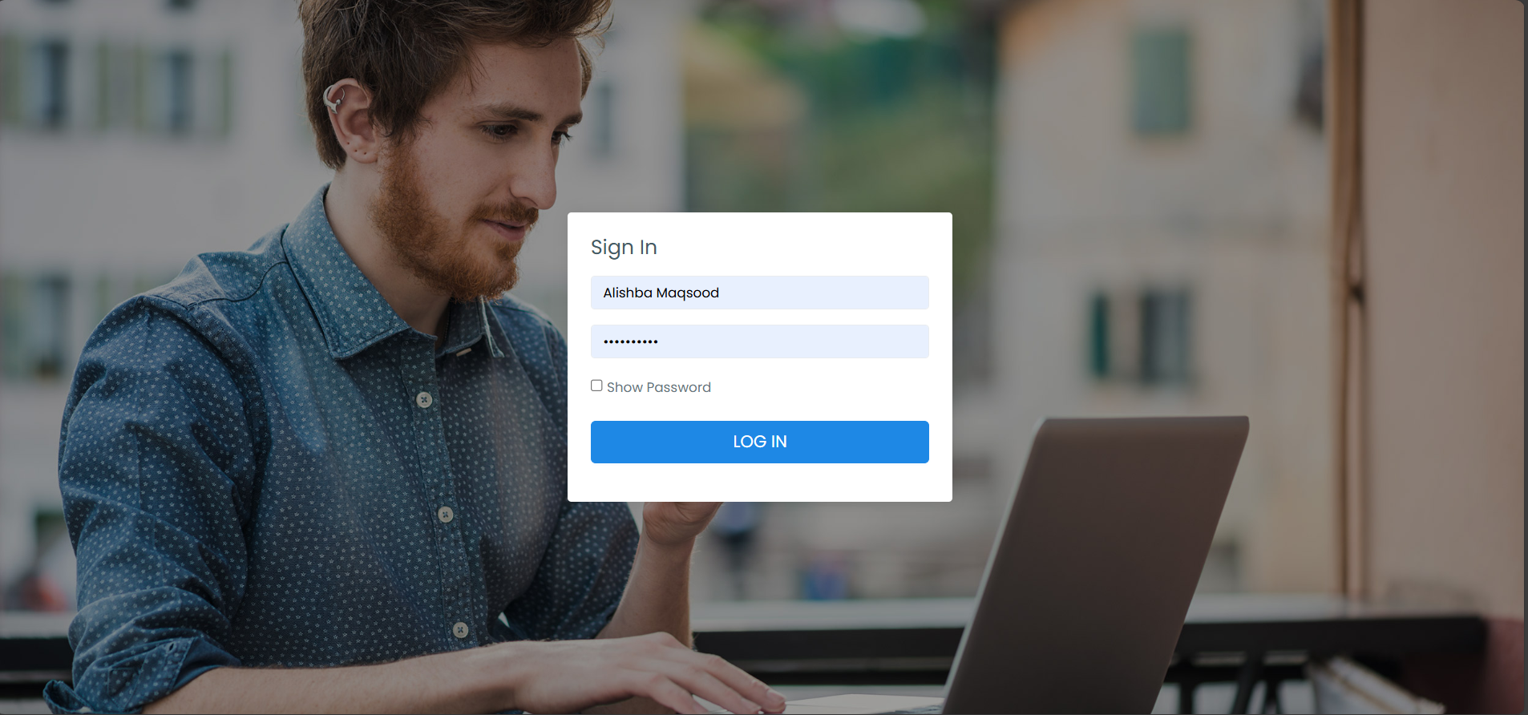
DASHBOARD
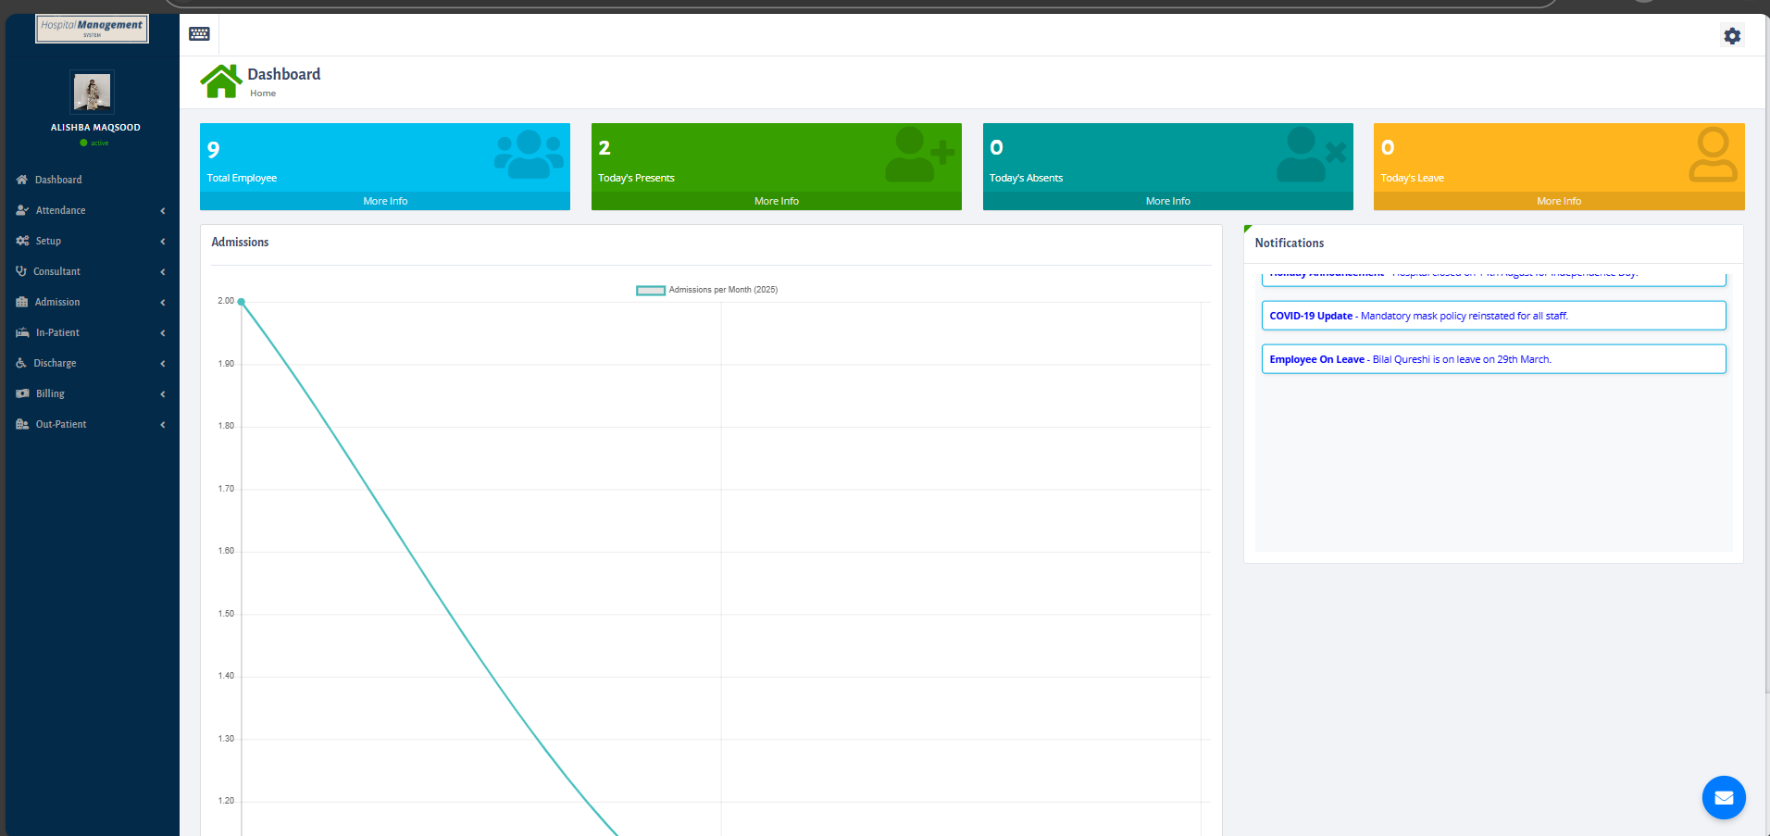

ATTENDANCE FORM
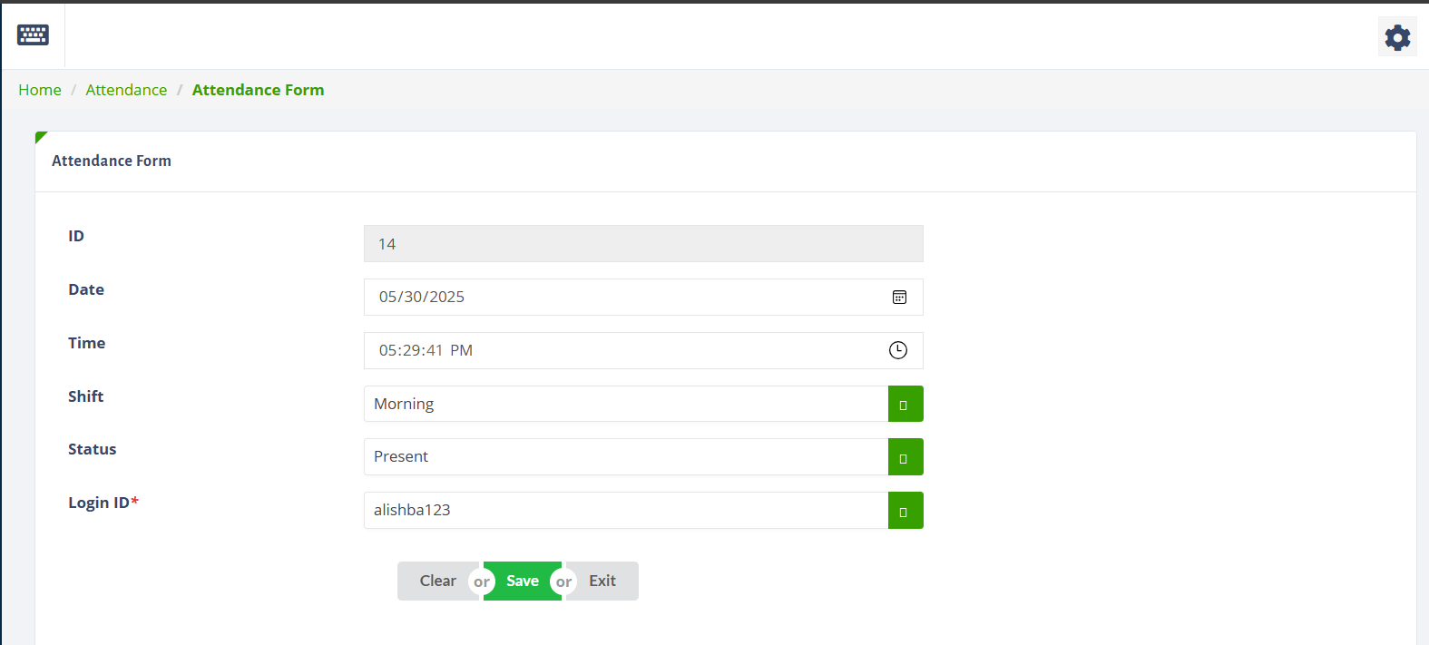
APPOINTMENT SCHEDULING
- VIEW APPOINTMENT

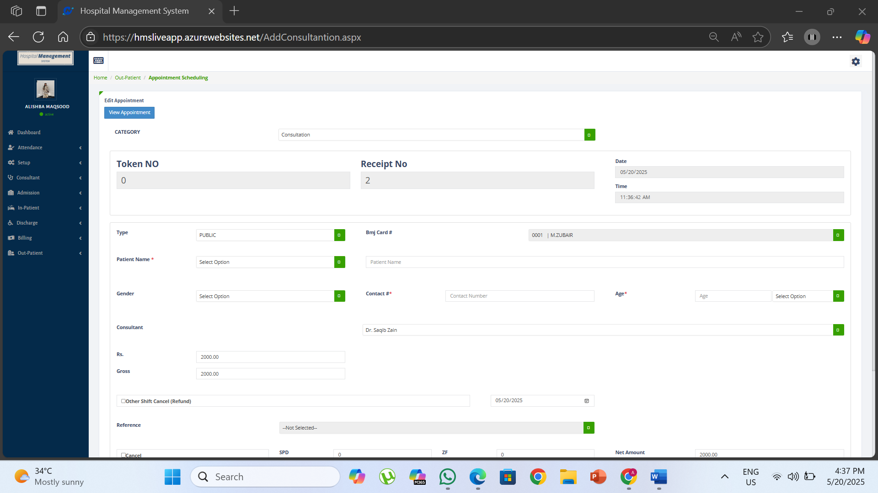
- ADD APPOINTMENT

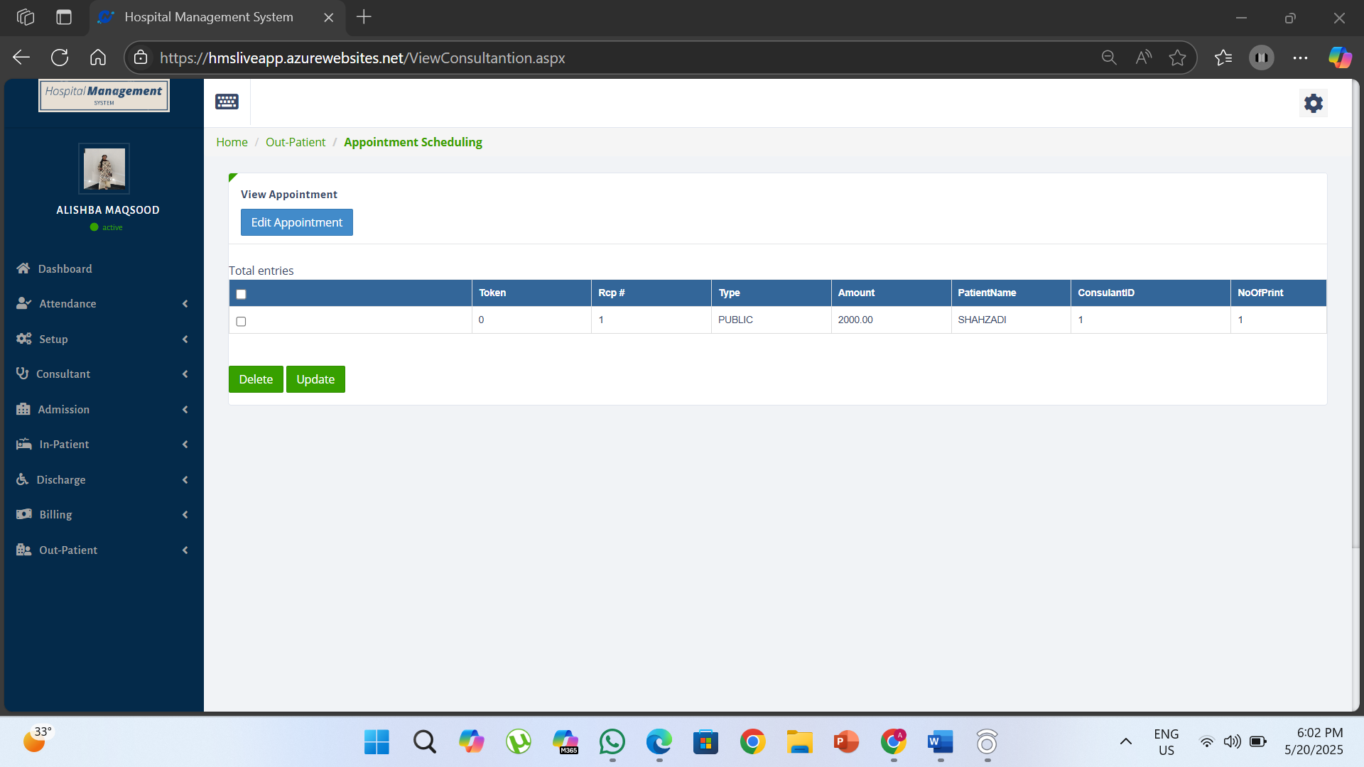
MEDICAL & DIAGNOSTIC SERVICES
- VIEW X-RAY

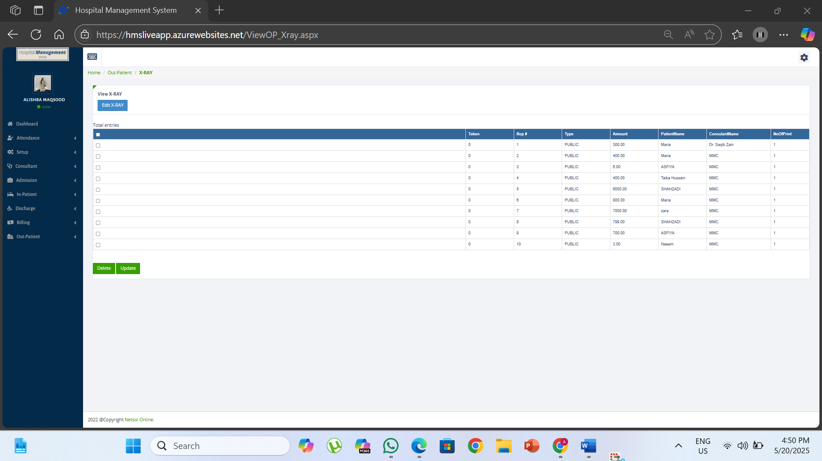
- ADD X-RAY:

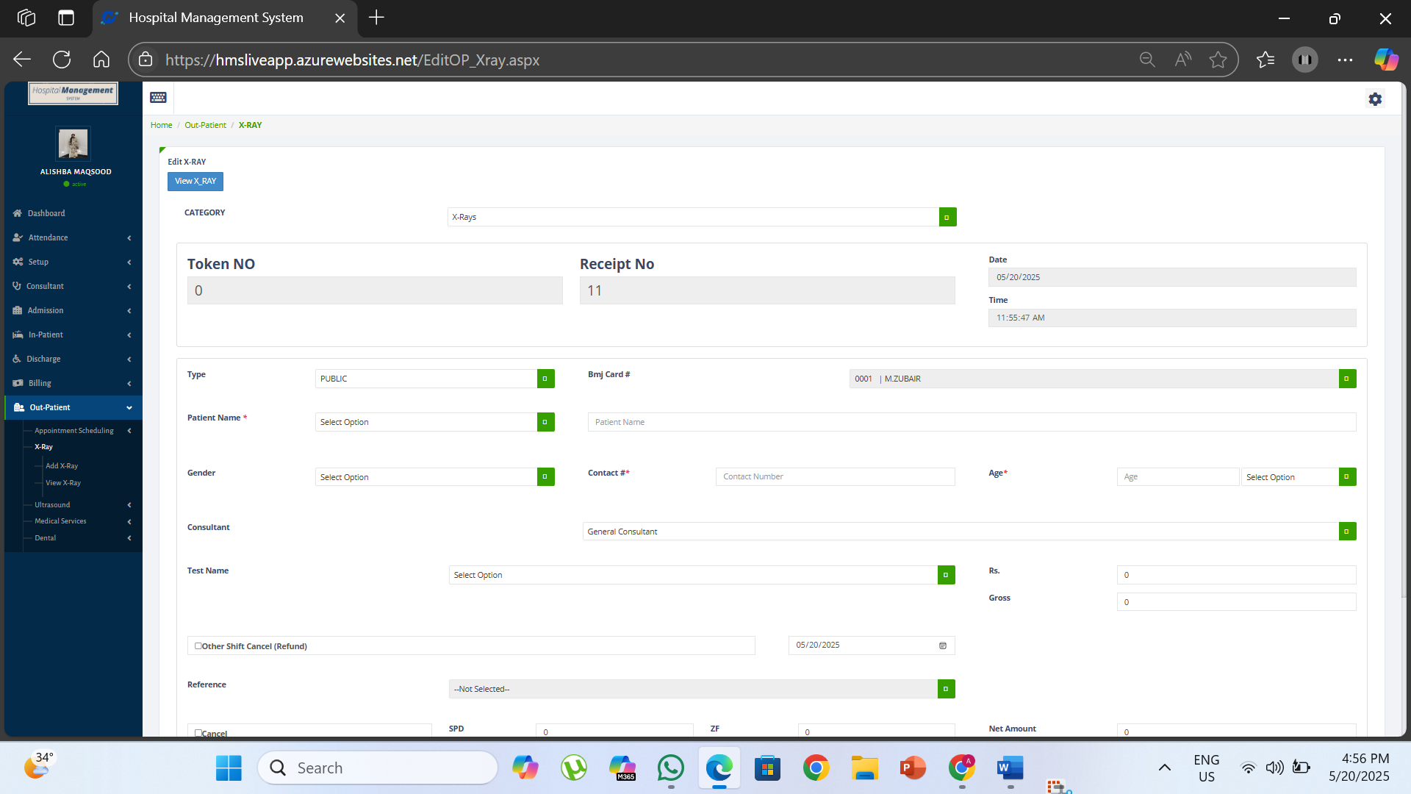
DOCTOR & CONSULTATION MANAGEMENT
- VIEW CONSULTANT

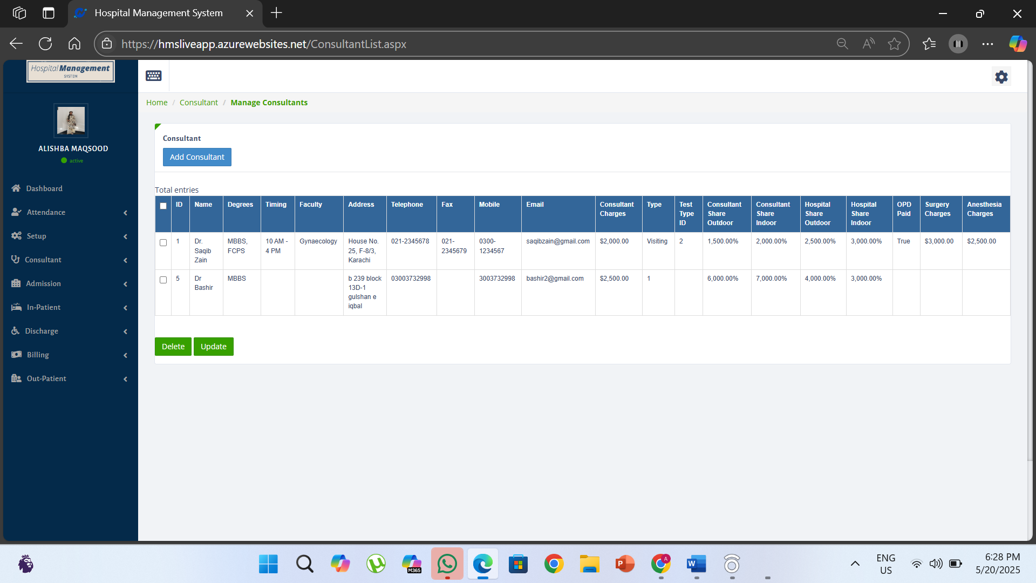
- ADD CONSULTANT

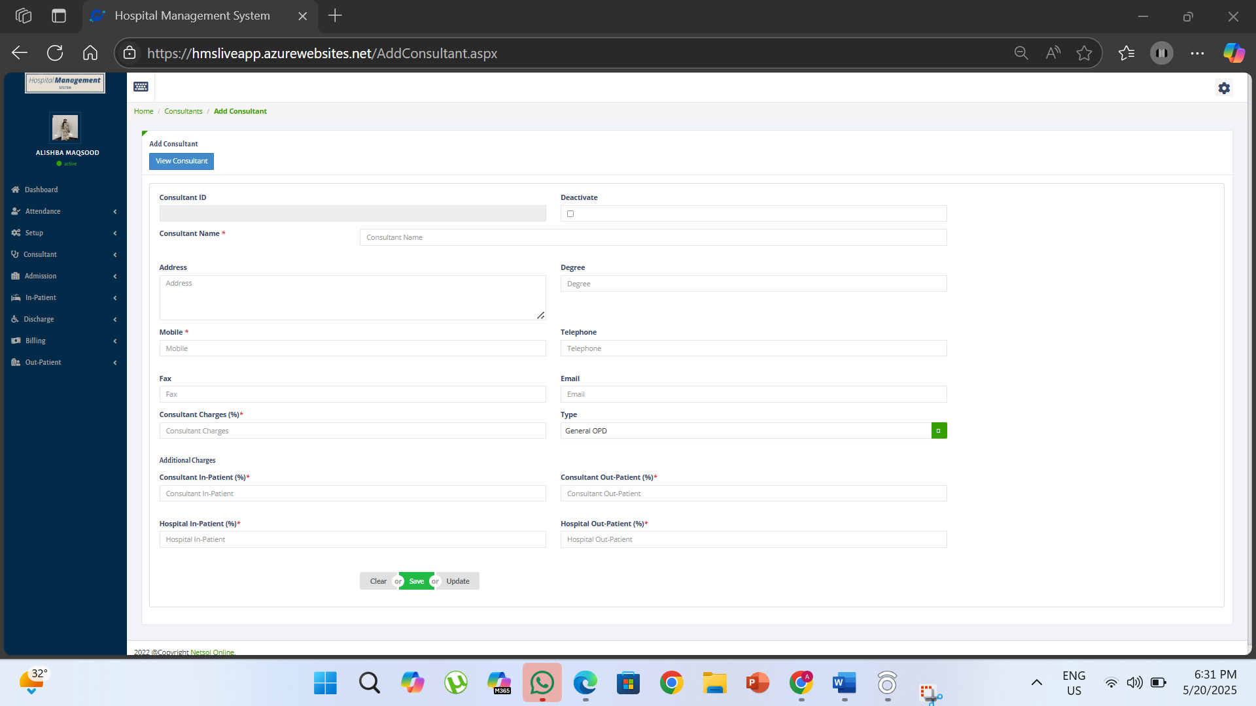

Project Scope
The project aims to develop a comprehensive Hospital Management System (HMS) that addresses the operational needs of hospitals, including patient management, billing, discharge processing, staff attendance, consultant scheduling, and diagnostic services. The HMS will offer a web-based interface for seamless interaction between staff, consultants, and administrative personnel, ensuring streamlined operations and improved healthcare service delivery.

Module Distribution
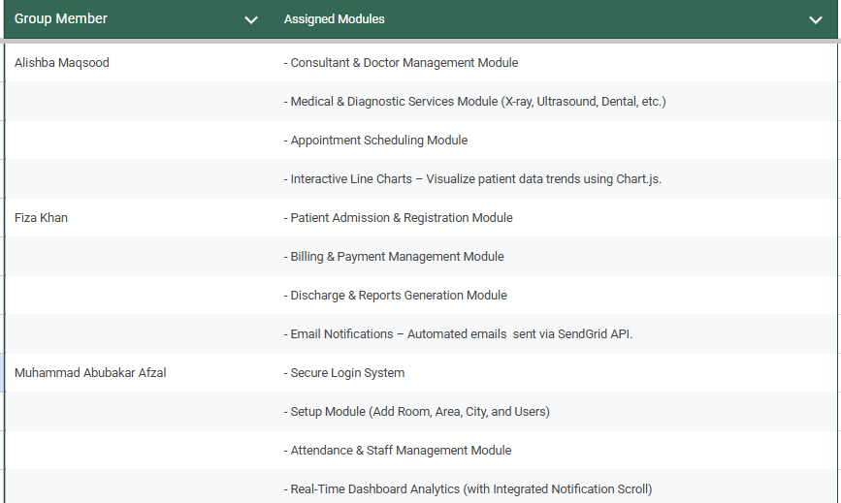

Code
create database HMS;
CREATE TABLE ReferenceInformation (
ID INT NOT NULL PRIMARY KEY,
ReferenceName NVARCHAR(100) NULL
);
create table City (
CityName varchar(50) primary key
)
create table Area (
AreaName varchar(50) primary key,
CityName varchar(50),
foreign key (CityName) references City(CityName)
)
create table Room(
Room varchar(6) primary key
)
create table patient(
serialno int primary key,
Reg char(1) not null,
Num int not null,
AdmDate date not null,
AdmTime time not null,
Bmj# varchar(50),
Title varchar(10) check (Title in ('Mr.', 'Mrs.', 'Miss', 'Baby')) not null,
PatientName varchar(50) not null,
Room varchar(6) not null foreign key references Room(Room),
ConsultantName varchar(255) not null,
Relation varchar(20) not null,
RelationName varchar(50) not null,
Emergency char(11) not null,
Mobile char(11),
OtherContact char(11),
Email varchar(100),
ReferenceName varchar(100),
AdmittedFor text not null,
AdmissionRemarks text,
AdmissionLoginId varchar(20),
Discharged char(1) check (Discharged in ('0', '1')),
DischargeDate date,
DischargeTime time,
DischargeRemarks text,
City varchar(50) not null foreign key references City(CityName),
AreaName varchar(50) not null foreign key references Area(AreaName),
Gender varchar(20) not null check (Gender in ('Male', 'Female', 'Other')),
AgeNum int not null,
AgeValue char not null check (AgeValue in ('Y', 'M', 'D')),
Typee varchar(10) not null check (Typee in ('PUBLIC','BMJ NEW','SPF','ZF')),
Address varchar(100) not null,
)
CREATE TABLE AdvanceHistory (
Receipt VARCHAR(20) PRIMARY KEY,
AdvanceDate DATE,
AdvanceTime TIME,
Amount DECIMAL(10,2),
Type VARCHAR(10),
Mode VARCHAR(10),
LastUpdate DATE,
LastUpdateTime TIME,
Loginld VARCHAR(20),
);

CREATE TABLE OP_Xray (
ID INT PRIMARY KEY IDENTITY(1,1), -- Primary key with auto-increment
Category VARCHAR(50) NOT NULL, -- Category (X-Rays)
TokenNo INT NOT NULL, -- Token No
ReceiptNo INT NOT NULL, -- Receipt No
Date DATE NOT NULL, -- Date
Time TIME NOT NULL, -- Time
Type VARCHAR(50) NOT NULL, -- Type (PUBLIC, BMJ NEW, etc.)
BmjCardNo VARCHAR(50), -- BMJ Card #
PatientName VARCHAR(100) NOT NULL, -- Patient Name
Gender VARCHAR(10), -- Gender
ContactNo VARCHAR(20), -- Contact #
AgeNum INT NOT NULL, -- Age number
AgeUnit CHAR(1) NOT NULL, -- Age unit (Y, M, D)
Consultant VARCHAR(100) NOT NULL, -- Consultant
TestName VARCHAR(200) NOT NULL, -- Test Name
Rupees DECIMAL(18, 2) NOT NULL, -- Rupees
Gross DECIMAL(18, 2) NOT NULL, -- Gross
OtherShiftCancel BIT, -- Other Shift Cancel (Refund)
RefundDate DATE, -- Refund Date (if applicable)
Reference VARCHAR(200), -- Reference
Cancel BIT, -- Cancel
SPD DECIMAL(18, 2), -- SPD
ZF DECIMAL(18, 2), -- ZF
NetAmount DECIMAL(18, 2) NOT NULL, -- Net Amount
Remarks TEXT, -- Remarks
NoOfPrints INT,
Title VARCHAR(10)
);
CREATE TABLE IPD_Ultrasound (
ID INT PRIMARY KEY, -- ID
TestTypeName NVARCHAR(255) NOT NULL, -- Test Type Name field
TestName NVARCHAR(255) NOT NULL, -- Test Name field
Charges DECIMAL(10, 2) NOT NULL,
ConsultantShare DECIMAL(5, 2) DEFAULT 0,
HospitalShare DECIMAL(5, 2) DEFAULT 0

);
CREATE TABLE IPD_MedServices (
ID INT PRIMARY KEY, -- ID
TestTypeName NVARCHAR(255) NOT NULL, -- Test Type Name field
TestName NVARCHAR(255) NOT NULL, -- Test Name field
Charges DECIMAL(10, 2) NOT NULL,
ConsultantShare DECIMAL(5, 2) DEFAULT 0,
HospitalShare DECIMAL(5, 2) DEFAULT 0

);
select * from Consultants;
CREATE TABLE UserInformation (
Id INT, -- Primary Key with auto-increment
LoginId VARCHAR(50) PRIMARY KEY NOT NULL, -- LoginId, non-nullable
Name VARCHAR(100) NOT NULL, -- Name, non-nullable
Designation VARCHAR(100), -- Designation
Email nvarchar(100),
[ProfilePic] VARBINARY(MAX)
);
select * from UserInformation

DELETE FROM UserInformation WHERE Id = 9;

CREATE TABLE Consultants (
ConsultantID INT PRIMARY KEY IDENTITY(1,1),
ConsultantName NVARCHAR(100) NOT NULL,
Degrees NVARCHAR(100),
Timing NVARCHAR(50),
Faculty NVARCHAR(100),
Address NVARCHAR(255),
Telephone NVARCHAR(20),
Fax NVARCHAR(20),
Mobile NVARCHAR(20) NOT NULL,
Email NVARCHAR(100),
ConsultantCharges DECIMAL(10, 2),
Type NVARCHAR(50),
TestTypeID INT,
ConsultantShareOutdoor DECIMAL(10, 2),
ConsultantShareIndoor DECIMAL(10, 2),
HospitalShareOutdoor DECIMAL(10, 2),
HospitalShareIndoor DECIMAL(10, 2),
OPDpaid BIT,
SurgeryCharges DECIMAL(10, 2),
AnesCharges DECIMAL(10, 2)
);
-----------------------------------------------------------------------
CREATE TABLE Bill_By_Employee (
SerialNo INT,
EmpName VARCHAR(50) NOT NULL,
FOREIGN KEY (SerialNo) REFERENCES patient(serialno)
);
----------------------------------------------------------------------------
CREATE TABLE Discharge (
SerialNo INT,
Dstatus CHAR(1) CHECK (Dstatus IN ('Y', 'N')) NOT NULL,
Ddate DATE NOT NULL,
Dtime TIME NOT NULL,
FOREIGN KEY (SerialNo) REFERENCES patient(serialno)
);
----------------------------------------------------------------------------
CREATE TABLE InPatientBilling (
BillNo INT PRIMARY KEY IDENTITY(1,1),
BillingDate DATE NOT NULL,
BillingTime TIME NOT NULL,
SerialNo INT NOT NULL FOREIGN KEY REFERENCES Patient(SerialNo),
PackageCheckbox BIT,
PackageList NVARCHAR(255),
Pharmacy DECIMAL(10, 2),
Laboratory DECIMAL(10, 2),
RoomCharges DECIMAL(10, 2),
XRay DECIMAL(10, 2),
MedicalServices DECIMAL(10, 2),
Misc DECIMAL(10, 2),
Consultant DECIMAL(10, 2),
Surgery DECIMAL(10, 2),
Delivery DECIMAL(10, 2),
Ultrasound DECIMAL(10, 2),
Physiotherapy DECIMAL(10, 2),
Echocardiography DECIMAL(10, 2),
TotalHospitalCharges DECIMAL(10, 2),
TotalConsultantCharges DECIMAL(10, 2),
CancelCheckbox BIT,
SPD DECIMAL(10, 2),
ZF DECIMAL(10, 2),
DischargeCheckbox BIT,
DischargeDate DATE,
DischargeTime TIME,
Remarks TEXT,
BillTotalCharges DECIMAL(10, 2),
DepositedAmount DECIMAL(10, 2),
Discount DECIMAL(10, 2),
ToBeRefunded DECIMAL(10, 2),
NetBalance DECIMAL(10, 2),
PackageBillCharges DECIMAL(10, 2),
PackageDepositedAmount DECIMAL(10, 2),
PackageDiscount DECIMAL(10, 2),
PackageToBeRefunded DECIMAL(10, 2),
PackageNetBalance DECIMAL(10, 2)
);
CREATE TABLE In_Pat_Xray (
RecieptNo INT PRIMARY KEY IDENTITY(1,1),
BillNo INT NOT NULL FOREIGN KEY REFERENCES InPatientBilling(BillNo),
TestName NVARCHAR(255),
Charges DECIMAL(10, 2),
ReceiptDate DATE,
RecieptTime TIME,
LoginID NVARCHAR(50)
);
==================================
CREATE TABLE Attendance (
ID INT IDENTITY(1,1) PRIMARY KEY,
Date DATE NOT NULL,
Time TIME NOT NULL,
Shift VARCHAR(20) CHECK (Shift IN ('Morning', 'Afternoon', 'Evening')) NOT NULL,
Status VARCHAR(20) CHECK (Status IN ('Present', 'Absent', 'On Leave', 'Half Day')) NOT NULL,
LoginID VARCHAR(50) NOT NULL,
FOREIGN KEY (LoginID) REFERENCES UserInformation(LoginId)
);
CREATE TABLE OP_Ultrasound (
ID INT PRIMARY KEY IDENTITY(1,1), -- Primary key with auto-increment
Category VARCHAR(50) NOT NULL,
TokenNo INT NOT NULL, -- Token No
ReceiptNo INT NOT NULL, -- Receipt No
Date DATE NOT NULL, -- Date
Time TIME NOT NULL, -- Time
Type VARCHAR(50) NOT NULL, -- Type (PUBLIC, BMJ NEW, etc.)
BmjCardNo VARCHAR(50), -- BMJ Card #
PatientName VARCHAR(100) NOT NULL, -- Patient Name
Gender VARCHAR(10), -- Gender
ContactNo VARCHAR(20), -- Contact #
AgeNum INT NOT NULL, -- Age number
AgeUnit CHAR(1) NOT NULL, -- Age unit (Y, M, D)
Consultant VARCHAR(100) NOT NULL, -- Consultant
TestName VARCHAR(200) NOT NULL, -- Test Name
Rupees DECIMAL(18, 2) NOT NULL, -- Rupees
Gross DECIMAL(18, 2) NOT NULL, -- Gross
OtherShiftCancel BIT, -- Other Shift Cancel (Refund)
RefundDate DATE, -- Refund Date (if applicable)
Reference VARCHAR(200), -- Reference
Cancel BIT, -- Cancel
SPD DECIMAL(18, 2), -- SPD
ZF DECIMAL(18, 2), -- ZF
NetAmount DECIMAL(18, 2) NOT NULL, -- Net Amount
Remarks TEXT, -- Remarks
NoOfPrints INT,
Title VARCHAR(10)
);
CREATE TABLE OP_MedSer (
ID INT PRIMARY KEY IDENTITY(1,1), -- Primary key with auto-increment
Category VARCHAR(50) NOT NULL, -- Category (X-Rays)
TokenNo INT NOT NULL, -- Token No
ReceiptNo INT NOT NULL, -- Receipt No
Date DATE NOT NULL, -- Date
Time TIME NOT NULL, -- Time
Type VARCHAR(50) NOT NULL, -- Type (PUBLIC, BMJ NEW, etc.)
BmjCardNo VARCHAR(50), -- BMJ Card #
PatientName VARCHAR(100) NOT NULL, -- Patient Name
Gender VARCHAR(10), -- Gender
ContactNo VARCHAR(20), -- Contact #
AgeNum INT NOT NULL, -- Age number
AgeUnit CHAR(1) NOT NULL, -- Age unit (Y, M, D)
Consultant VARCHAR(100) NOT NULL, -- Consultant
TestName VARCHAR(200) NOT NULL, -- Test Name
Rupees DECIMAL(18, 2) NOT NULL, -- Rupees
Gross DECIMAL(18, 2) NOT NULL, -- Gross
OtherShiftCancel BIT, -- Other Shift Cancel (Refund)
RefundDate DATE, -- Refund Date (if applicable)
Reference VARCHAR(200), -- Reference
Cancel BIT, -- Cancel
SPD DECIMAL(18, 2), -- SPD
ZF DECIMAL(18, 2), -- ZF
NetAmount DECIMAL(18, 2) NOT NULL, -- Net Amount
Remarks TEXT, -- Remarks
NoOfPrints INT,
Title VARCHAR(10)
);
CREATE TABLE OP_Dental (
ID INT PRIMARY KEY IDENTITY(1,1), -- Primary key with auto-increment
Category VARCHAR(50) NOT NULL, -- Category (X-Rays)
TokenNo INT NOT NULL, -- Token No
ReceiptNo INT NOT NULL, -- Receipt No
Date DATE NOT NULL, -- Date
Time TIME NOT NULL, -- Time
Type VARCHAR(50) NOT NULL, -- Type (PUBLIC, BMJ NEW, etc.)
BmjCardNo VARCHAR(50), -- BMJ Card #
PatientName VARCHAR(100) NOT NULL, -- Patient Name
Gender VARCHAR(10), -- Gender
ContactNo VARCHAR(20), -- Contact #
AgeNum INT NOT NULL, -- Age number
AgeUnit CHAR(1) NOT NULL, -- Age unit (Y, M, D)
Consultant VARCHAR(100) NOT NULL, -- Consultant
TestName VARCHAR(200) NOT NULL, -- Test Name
Rupees DECIMAL(18, 2) NOT NULL, -- Rupees
Gross DECIMAL(18, 2) NOT NULL, -- Gross
OtherShiftCancel BIT, -- Other Shift Cancel (Refund)
RefundDate DATE, -- Refund Date (if applicable)
Reference VARCHAR(200), -- Reference
Cancel BIT, -- Cancel
SPD DECIMAL(18, 2), -- SPD
ZF DECIMAL(18, 2), -- ZF
NetAmount DECIMAL(18, 2) NOT NULL, -- Net Amount
Remarks TEXT, -- Remarks
NoOfPrints INT,
Title VARCHAR(10)
);

use HMS;
CREATE TABLE OP_Consultantion (
ID INT PRIMARY KEY IDENTITY(1,1), -- Primary key with auto-increment
Category VARCHAR(50) NOT NULL, -- Category (X-Rays)
TokenNo INT NOT NULL, -- Token No
ReceiptNo INT NOT NULL, -- Receipt No
Date DATE NOT NULL, -- Date
Time TIME NOT NULL, -- Time
Type VARCHAR(50) NOT NULL, -- Type (PUBLIC, BMJ NEW, etc.)
BmjCardNo VARCHAR(50), -- BMJ Card #
PatientName VARCHAR(100) NOT NULL, -- Patient Name
Gender VARCHAR(10), -- Gender
ContactNo VARCHAR(20), -- Contact #
AgeNum INT NOT NULL, -- Age number
AgeUnit CHAR(1) NOT NULL, -- Age unit (Y, M, D)
ConsultantID INT NOT NULL, -- Consultant (FOREIGN KEY)
Rupees DECIMAL(18, 2) NOT NULL, -- Rupees
Gross DECIMAL(18, 2) NOT NULL, -- Gross
OtherShiftCancel BIT, -- Other Shift Cancel (Refund)
RefundDate DATE, -- Refund Date (if applicable)
Reference VARCHAR(200), -- Reference
Cancel BIT, -- Cancel
SPD DECIMAL(18, 2), -- SPD
ZF DECIMAL(18, 2), -- ZF
NetAmount DECIMAL(18, 2) NOT NULL, -- Net Amount
Remarks TEXT, -- Remarks
NoOfPrints INT, -- No. of Prints
Title VARCHAR(10), -- Title
-- Define FOREIGN KEY constraint
CONSTRAINT FK_OP_Consultantion_Consultants
FOREIGN KEY (ConsultantID)
REFERENCES Consultants(ConsultantID)
);

CREATE TABLE InPatientBilling (
BillNo INT PRIMARY KEY IDENTITY(1,1),
BillingDate DATE NOT NULL,
BillingTime TIME NOT NULL,
SerialNo INT NOT NULL FOREIGN KEY REFERENCES Patient(SerialNo),
PackageCheckbox BIT,
PackageList NVARCHAR(255),

RoomCharges DECIMAL(10, 2),
XRay DECIMAL(10, 2),
MedicalServices DECIMAL(10, 2),
Misc DECIMAL(10, 2),
Consultant DECIMAL(10, 2),
Dental DECIMAL(10, 2),
Ultrasound DECIMAL(10, 2),

TotalHospitalCharges DECIMAL(10, 2),
TotalConsultantCharges DECIMAL(10, 2),

SPD DECIMAL(10, 2),
ZF DECIMAL(10, 2),
DischargeCheckbox BIT,
DischargeDate DATE,
DischargeTime TIME,
Remarks TEXT,
BillTotalCharges DECIMAL(10, 2),
DepositedAmount DECIMAL(10, 2),
Discount DECIMAL(10, 2),
ToBeRefunded DECIMAL(10, 2),
NetBalance DECIMAL(10, 2),

);
CREATE OR ALTER TRIGGER CalculateCharges
ON InPatientBilling
AFTER INSERT, UPDATE
AS
BEGIN
-- Update the TotalHospitalCharges, TotalConsultantCharges, and BillTotalCharges
UPDATE ib
SET
ib.BillTotalCharges =
ib.TotalHospitalCharges + ib.TotalConsultantCharges
FROM InPatientBilling ib
INNER JOIN inserted i ON ib.BillNo = i.BillNo;
END;

use ADVANCEINFORMATION;
CREATE TABLE AdvanceHistory (
Receipt VARCHAR(20) PRIMARY KEY,
AdvanceDate DATE,
AdvanceTime TIME,
Amount DECIMAL(10,2), -- Adjust decimal places as needed
Type VARCHAR(10),
Mode VARCHAR(10),
LastUpdate DATE,
LastUpdateTime TIME,
SerialNo INT
);
-- In patient View

CREATE VIEW vw_InPatientFullInfo AS
SELECT
p.Reg,
p.Num,
p.AdmDate,
p.AdmTime,
p.PatientName,
p.Relation,
p.RelationName,
p.Room,
p.Gender,
p.AgeNum,
p.ConsultantName,
p.Address,
p.AreaName,
p.City,
p.OtherContact,
p.Email,
p.Mobile,
p.Emergency,
d.Dstatus AS DischargeStatus,
d.Ddate AS DischargeDate,
d.Dtime AS DischargeTime,
i.BillingDate,
i.BillingTime,
i.BillTotalCharges,
i.DepositedAmount,
i.Discount,
i.ToBeRefunded,
i.NetBalance,
i.Remarks,
a.Amount AS AdvanceAmount,
b.EmpName
FROM
patient p
LEFT JOIN
Discharge d ON p.serialno = d.SerialNo
LEFT JOIN
InPatientBilling i ON p.serialno = i.SerialNo
LEFT JOIN
Bill_By_Employee b ON i.SerialNo = b.SerialNo
LEFT JOIN
Consultants c ON p.ConsultantName = c.ConsultantName
LEFT JOIN
AdvanceHistory a ON p.serialno = a.SerialNo;

-- discharge report
CREATE VIEW vw_DischargeReport AS
SELECT
P.Reg,
P.Num AS BillNo,
P.AdmDate AS AdmissionDate,
DATEDIFF(day, P.AdmDate, ISNULL(P.DischargeDate, GETDATE())) AS Days,
P.PatientName,
P.Room AS RoomName,
P.ConsultantName,
D.Dstatus AS Dstatus,
D.Dtime AS Dtime,
D.Ddate AS Ddate
FROM
Discharge D
LEFT JOIN
Patient P ON D.SerialNo = P.SerialNo;

-- attendence summary procedure - dashboard
CREATE PROCEDURE sp_GetTodayAttendanceSummary
AS
BEGIN
SET NOCOUNT ON;

SELECT
SUM(CASE WHEN Status IN ('Present', 'Half Day') THEN 1 ELSE 0 END) AS PresentCount,
SUM(CASE WHEN Status = 'Absent' THEN 1 ELSE 0 END) AS AbsentCount,
SUM(CASE WHEN Status = 'On Leave' THEN 1 ELSE 0 END) AS LeaveCount
FROM
[dbo].[Attendance]
WHERE
CAST(Date AS DATE) = CAST(GETDATE() AS DATE);
END

EXEC sp_GetTodayAttendanceSummary;

-- fetch and fill patient info - billing
CREATE VIEW vw_PatientFullDetail AS
SELECT
p.SerialNo,
p.Reg,
p.Num,
p.AdmDate,
p.AdmTime,
p.PatientName,
p.Room,
p.Gender,
p.AgeNum,
p.ConsultantName,
c.ConsultantCharges,
p.City,
p.Mobile,
d.Dstatus AS DischargeStatus,
d.Ddate AS DischargeDate,
d.Dtime AS DischargeTime,
a.Amount AS AdvanceAmount
FROM
patient p
LEFT JOIN
Discharge d ON p.SerialNo = d.SerialNo
LEFT JOIN
Consultants c ON p.ConsultantName = c.ConsultantName
LEFT JOIN
AdvanceHistory a ON p.SerialNo = a.SerialNo;

-- admission report
CREATE VIEW vw_PatientAdmissionReport AS
SELECT
P.Reg,
P.Num AS BillNo,
P.PatientName,
P.Room AS RoomName,
P.ConsultantName,
P.AdmDate AS AdmDate,
P.AdmTime AS AdmTime,
P.Mobile AS Mobile
FROM
Patient P;

-- get discharge by serial no - dis repositry
CREATE VIEW vw_DischargeInfo AS
SELECT
d.SerialNo,
d.Dstatus,
d.Ddate,
d.Dtime,
p.Reg,
p.Num,
p.PatientName
FROM
Discharge d
INNER JOIN
patient p ON d.SerialNo = p.SerialNo;

Conclusion
This project has successfully developed a comprehensive Hospital Management System that automates key operations, improves efficiency, and enhances data management. The system provides a robust solution for modern hospitals, ensuring better patient care and administrative control.

References
- Meera Academy, “Hospital Management System Project in C#.Net”, Available: https://meeraacademy.com/hospital-management-system-project-in-c-net/. [Accessed: 27-April-2025].
- GeeksforGeeks, “Hospital Management System Project in Software Development”, Available: https://www.geeksforgeeks.org/hospital-management-system-project-in-software-development/. [Accessed: 27-April-2025].
- SSRN,” Hospital Management System Project Report”, Available: https://papers.ssrn.com/sol3/papers.cfm?abstract_id=4822025. [Accessed: 27-April-2025].
- YouTube, "C# Full Project (Hospital Management System) with Source Code," Available: https://www.youtube.com/watch?v=8VFfLJgxvcQ. [Accessed: 27-April-2025].

