A GUIDE TO THE EVENTSPHERE EXPO & EVENT MANAGEMENT PLATFORM
Event Sphere
Management System — User Guide
Faculty: Ms. Fiza Sahar
Batch: ACCP AI – Batch 2410b1

Aptech Computer Education | North Nazimabad Campus

OUR TEAM

Team Members
This user guide was prepared by Team as part of the Event Sphere Management System project.

▤ | Moiz Ahmed  Student ID: 1608966
▤ | Hassam Khan  Student ID: 1610109
▤ | Ayyan Jawaid  Student ID: 1609770
▤ | Muhammad Muneeb  Student ID: 1610519
▤ | Azhar Khursheed  Student ID: 1610634
▤ | Mavia  Student ID: 1605082
▤ | Hannan Ahmed  Student ID: 1610211

DOCUMENT INFORMATION

Document Title | EventSphere Expo Platform — User Guide
Audience | Attendees, Delegates, Exhibitors & Organizers
Version | 1.0
Last Updated | September 2026
Platform | Event Sphere Expo Platform (Web)
Support Contact | support@eventsphere.com · +1 (800) 555-EXPO
How to Use This Guide
This guide is organized to mirror the platform's own navigation bar — from account creation through every major page, ending with the interactive 3D Floor Plan and support channels. Each section includes an annotated screenshot and a short list of the actions available on that screen. Read it start to finish for full onboarding, or jump to any section using the Table of Contents on the next page.
Platform Snapshot
500+  Expos Hosted | 12,400+  Registered Exhibitors | 1.2M+  Verified Delegates | 99.98%  Platform Uptime

CONTENTS

Table of Contents
Team Members 1
Table of Contents 1
01 1
Key Capabilities 1
02 1
2.1 Creating an Account 1
2.2 Signing In 1
03 1
What You Can Do Here 1
04 1
How to Use This Page 1
05 1
How to Use This Page 1
06 1
How to Use This Page 1
07 1
How to Use This Page 1
08 1
8.1 Ground Floor 1
8.2 VIP Sky Floor 1
How to Use This Page 1
09 1
How to Use This Page 1
10 1
Platform Technology Highlights 1
11 1
How to Use This Page 1
12 1

01 | Introduction

EventSphere is a commercial-grade SaaS platform designed to unify trade shows, interactive 3D floor plan management, AI-powered assistance, and real-time delegate communication into one seamless ecosystem. This guide walks you through every major screen of the platform and explains how attendees, exhibitors, and organizers can use each feature effectively.

Key Capabilities
- Interactive WebGL 3D rendering for touring expo halls in real time with exact spatial positioning.
- A contextual AI engine that provides instant answers, conflict-free timetable generation, and booth locator guidance.
- Real-time synchronization so booth reservations, messages, and schedule changes appear instantly across all connected sessions.
- Digital VIP passes with cryptographically verified QR codes for fast, secure venue entry.

02 | Getting Started

2.1 Creating an Account
New users can join the EventSphere platform as an Attendee/Delegate, Exhibitor, or Organizer. From the homepage, click “Get Started” or “Register here” on the Sign In screen to open the registration form.
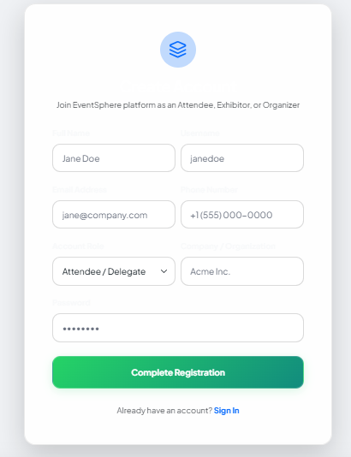
FIGURE 2.1 · Registration form for new accounts
- Enter your full name, username, email address, and phone number.
- Select your account type: Attendee/Delegate, Exhibitor, or Organizer.
- Add your company or organization name.
- Create a password and click “Complete Registration” to finish.

2.2 Signing In
Returning users can sign in from the top navigation bar at any time by clicking “Sign In.” The Welcome Back screen accepts an email address and password, and also offers quick demo logins for Admin, Exhibitor, and Attendee roles for testing purposes.
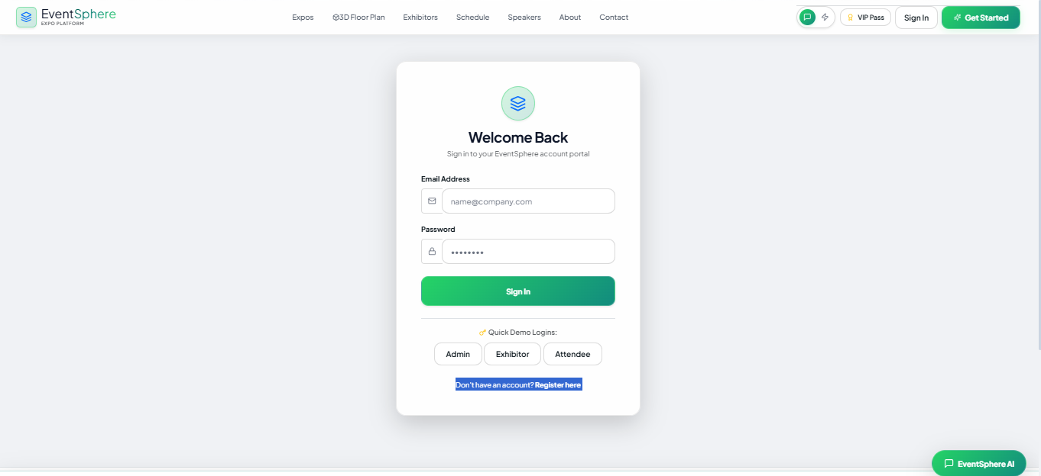
FIGURE 2.2 · Sign In screen with quick demo login options
Tip
Use the “Quick Demo Logins” buttons (Admin, Exhibitor, Attendee) to preview the platform instantly without creating a full account.

03 | Home Page

The Home page is the first screen visitors see. It introduces EventSphere as “The Modern Standard for Global Trade Shows & Expos” and highlights the platform's core value proposition, along with live platform statistics.
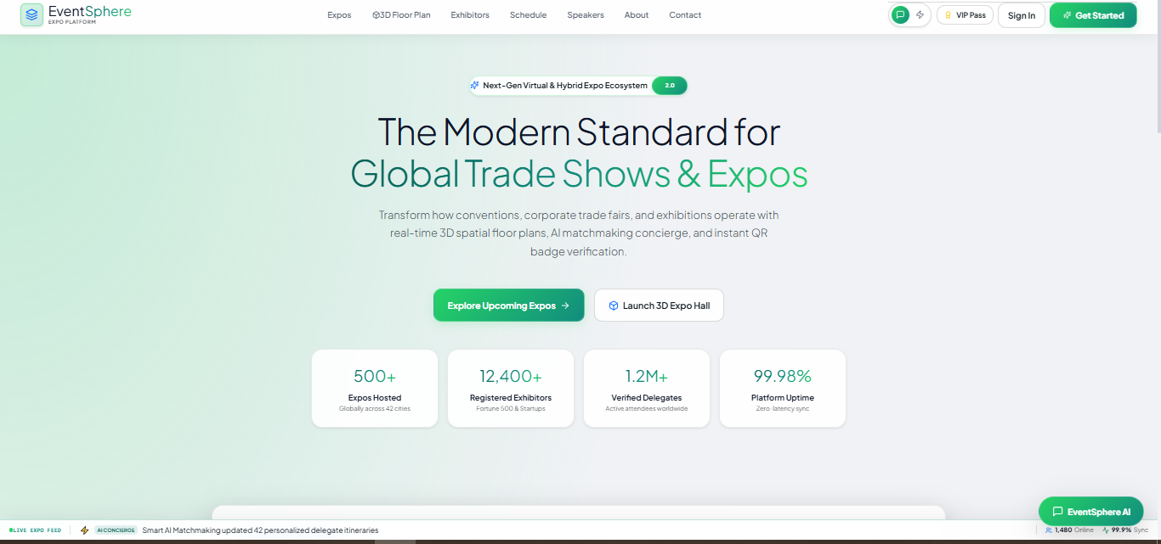
FIGURE 3.1 · EventSphere Home page

What You Can Do Here
- Click “Explore Upcoming Expos” to browse all scheduled trade shows.
- Click “Launch 3D Expo Hall” to jump directly into the interactive 3D floor plan viewer.
- View live platform statistics: Expos hosted, registered exhibitors, verified delegates, and platform uptime.
- Use the top navigation bar to reach Expos, 3D Floor Plan, Exhibitors, Schedule, Speakers, About, and Contact at any time.

04 | Explore Expos

The Expos page lets users discover major international exhibitions, reserve a VIP delegate entry pass, and explore each venue's interactive 3D layout.
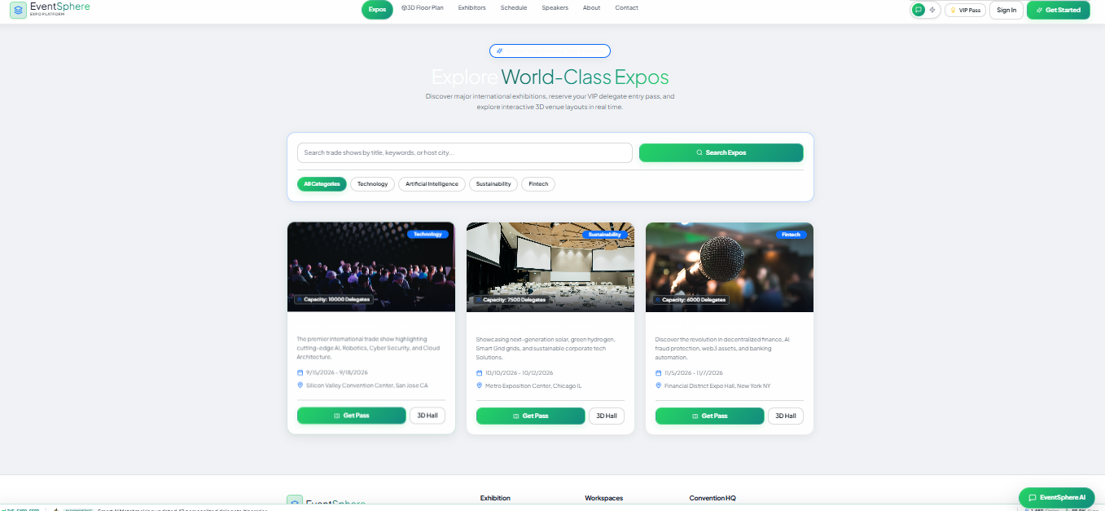
FIGURE 4.1 · Explore World-Class Expos listing

How to Use This Page
- Use the search bar to find trade shows by title, keyword, or host city.
- Filter results by category: Technology, Artificial Intelligence, Sustainability, or Fintech.
- Each expo card shows its capacity, description, and dates.
- Click “Get Pass” to reserve your entry pass, or “3D Hall” to preview the venue in 3D before attending.

05 | Exhibitors & Partners

This page showcases world-class exhibitors, their products, and their corporate services, organized by industry category such as Artificial Intelligence, Cybersecurity, Cloud Computing, Robotics, Clean Technology, and Fintech.
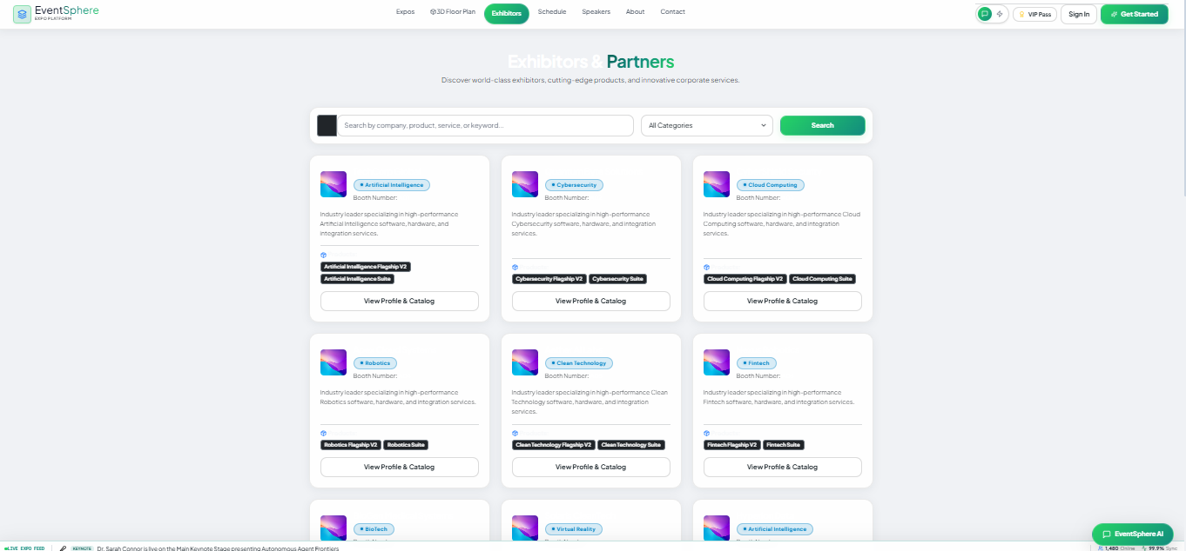
FIGURE 5.1 · Exhibitors & Partners directory

How to Use This Page
- Search exhibitors by company name, product, service, or keyword.
- Filter the directory using the “All Categories” dropdown.
- Each exhibitor card lists their booth number, specialization, and flagship products.
- Click “View Profile & Catalog” to see full exhibitor details.

06 | Event Schedule

The Schedule page lets attendees explore panels, technical workshops, and keynote speeches, then bookmark sessions to build a personal timetable.
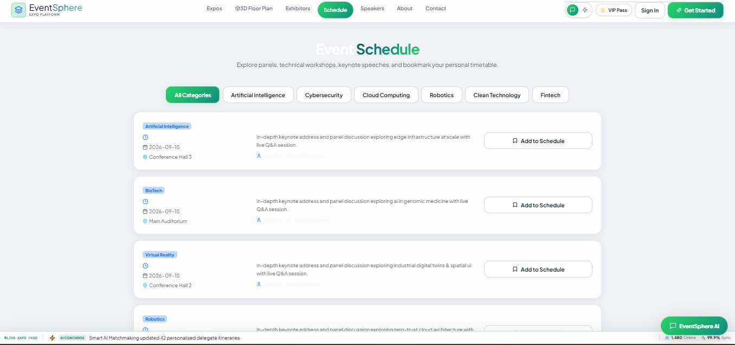
FIGURE 6.1 · Event Schedule with category filters

How to Use This Page
- Filter sessions by category: Artificial Intelligence, Cybersecurity, Cloud Computing, Robotics, Clean Technology, or Fintech.
- Each session card shows the date, time, venue (e.g., Conference Hall, Main Auditorium), and a short description.
- Click “Add to Schedule” to bookmark a session to your personal timetable.

07 | Keynote Speakers

The Speakers page introduces distinguished researchers, global innovators, and executive leaders presenting at the event.
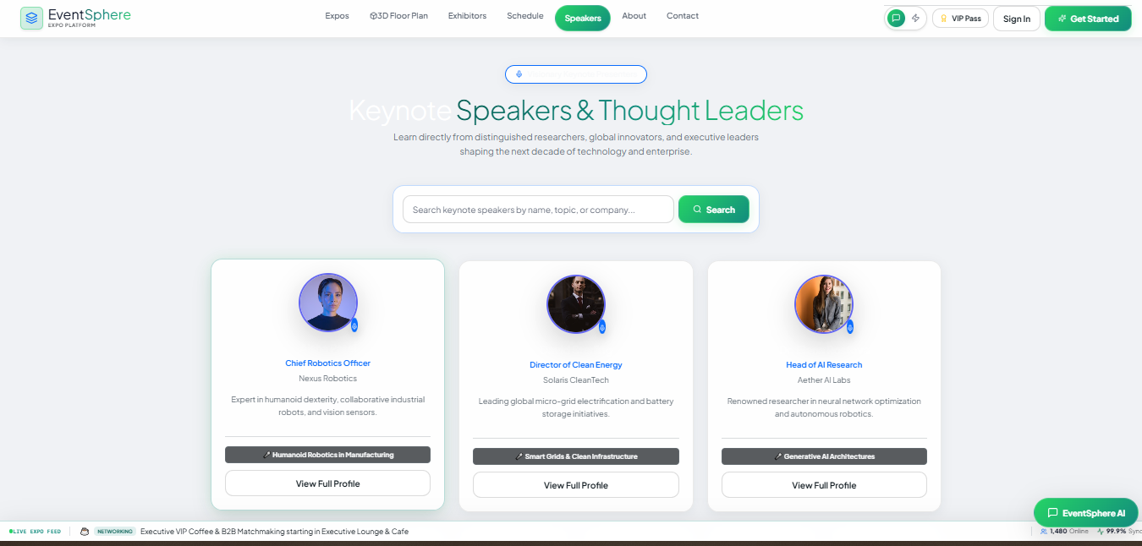
FIGURE 7.1 · Keynote Speakers & Thought Leaders

How to Use This Page
- Search speakers by name, topic, or company using the search bar.
- Each speaker card shows their title, company, area of expertise, and keynote topic.
- Click “View Full Profile” to read a speaker's complete biography and session details.

08 | 3D Floor Plan

The 3D Floor Plan is EventSphere's signature feature: an interactive WebGL rendering of the entire convention center, allowing users to navigate between floors, view booth availability, and locate key zones in real time.

8.1 Ground Floor
The Ground Floor view displays the EventSphere Arena main stage, exhibitor booths, the AI & Tech Innovation Arena, the Executive Lounge & Cafe, the VIP B2B Networking Suite, and the Workshop & Breakout Rooms.
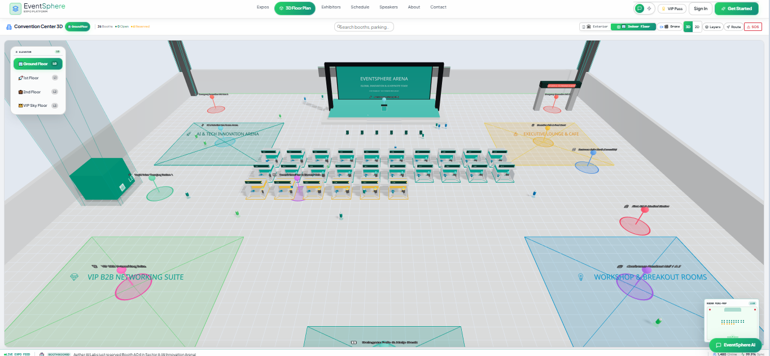
FIGURE 8.1 · Ground Floor 3D view

8.2 VIP Sky Floor
Switching to the VIP Sky Floor using the elevator panel on the left reveals a dedicated upper-level layout with its own booths and lounges, reserved for VIP delegates and premium exhibitors.
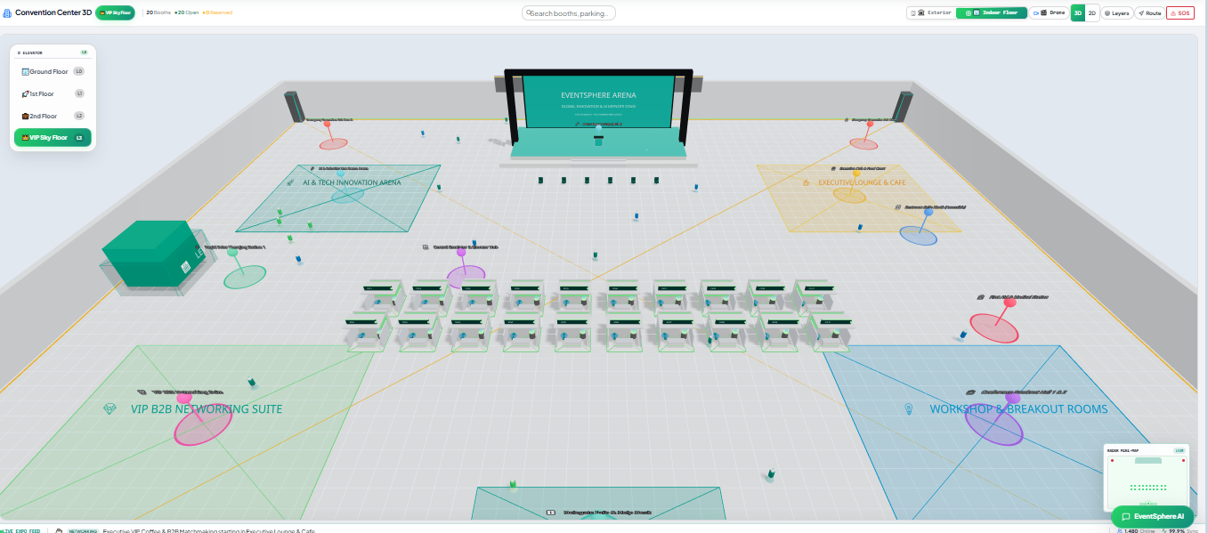
FIGURE 8.2 · VIP Sky Floor 3D view

How to Use This Page
- Use the elevator panel (top-left) to switch between Ground Floor, 1st Floor, 2nd Floor, and VIP Sky Floor.
- Use the search bar at the top to search for booths or parking.
- Toggle between Exterior and Indoor floor views, and between 3D and 2D display modes.
- Use Drone, Layers, and Route buttons for advanced navigation, and the SOS button for emergency assistance.
- Colored zones on the map (green, yellow, blue, pink) represent different functional areas such as networking suites, lounges, and breakout rooms.

09 | VIP Pass

Registered delegates can access a personal, cryptographically verified digital VIP pass containing a unique QR code for fast venue entry and booth check-ins.
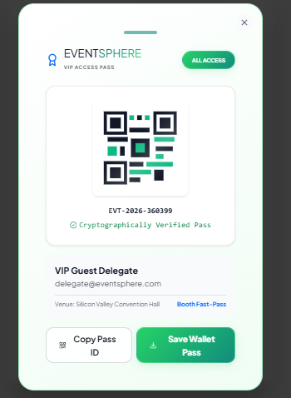
FIGURE 9.1 · Digital VIP Access Pass

How to Use This Page
- Click the “VIP Pass” button in the top navigation bar to open your pass.
- Your pass displays a unique event ID, your name, email, and venue.
- Click “Copy Pass ID” to copy your verification code, or “Save Wallet Pass” to add it to your mobile wallet.
- Present the QR code at entry points and exhibitor booths for instant, verified check-in.

10 | About EventSphere

The About page explains the platform's mission and the technology behind it, describing EventSphere as a commercial-grade SaaS platform that unifies trade shows, 3D floor plan management, AI assistance, and real-time delegate communication.
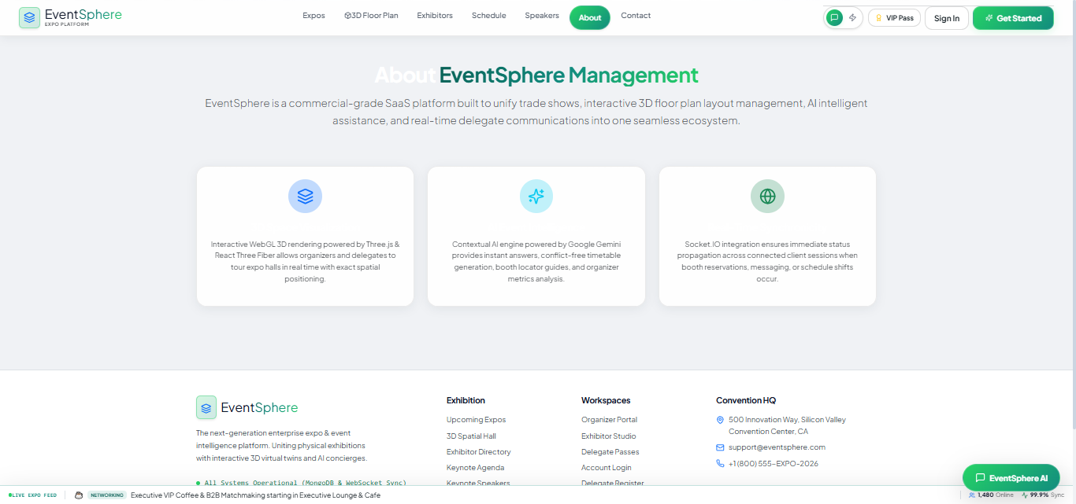
FIGURE 10.1 · About EventSphere Management

Platform Technology Highlights
- Interactive WebGL 3D rendering powered by Three.js and React Three Fiber for real-time expo hall tours with exact spatial positioning.
- A contextual AI engine that provides instant answers, conflict-free timetable generation, booth locator guides, and organizer metrics analysis.
- Socket.IO integration for immediate status propagation across all connected sessions when reservations, messages, or schedule changes occur.

11 | Contact & Support

The Contact page allows users to reach the EventSphere team for questions about organizer subscriptions, exhibitor booth spaces, or technical support.
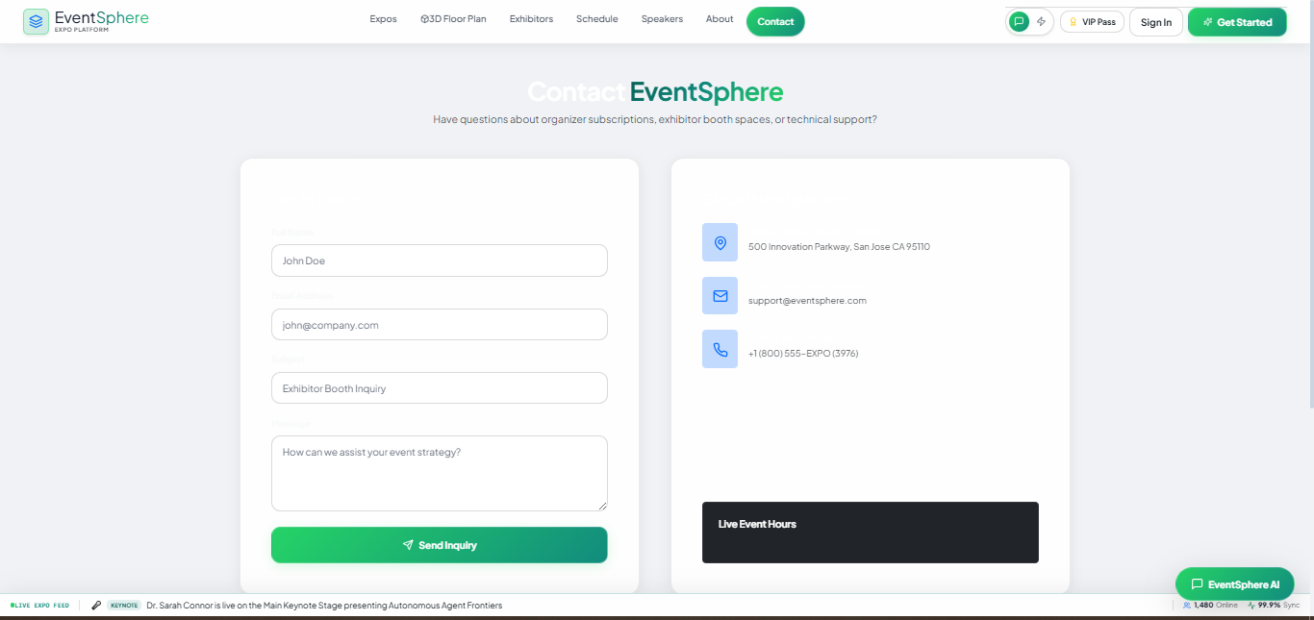
FIGURE 11.1 · Contact EventSphere form

How to Use This Page
- Fill in your full name, email address, subject, and message, then click “Send Inquiry.”
- Alternatively, reach the team directly using the listed address, email, or phone number.
Contact Details
Address: 500 Innovation Parkway, San Jose, CA 95110
Email: support@eventsphere.com
Phone: +1 (800) 555-EXPO (3976)

12 | Getting Help

A floating “EventSphere AI” chat assistant is available on every page (bottom-right corner) to answer questions instantly, help locate booths, and guide you through the platform. A live status bar at the bottom of the screen also shows real-time event updates, current online user counts, and system sync status.
Need More Help?
Use the EventSphere AI assistant for instant answers, or visit the Contact page to reach our support team directly.

