**Name: Fiza Mansoor Patel**

**Roll no: 191 Div.: C**

**PRNo: 0120190425 Batch: C3**

**Assignment 1**

Write shell scripts to

a. Rename all files in the current directory that end in \.jpg" to begin with today's date.

b. Delete the zero sized files

c. Take an input file and remove identical lines (or duplicate lines from the file)

**a. Rename all files in the current directory that end in \.jpg" to begin with today's date.**

touch cc18.sh

vi cc18.sh

**In shell script:**

**---------------------------------------------------------------------------------------------------------------------**

**DAY=$(date +%F)**

**echo $DAY**

**for filename in *.jpg**

**do**

**mv $filename ${DAY} - ${filename}**

**done**

**---------------------------------------------------------------------------------------------------------------------**

ls

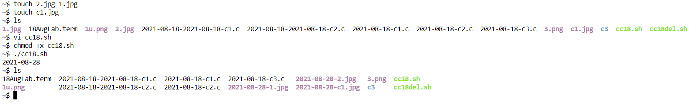Output:

**b. Delete the zero sized files**

touch cc18del.sh

vi cc18del.sh

**In shell script:**

**---------------------------------------------------------------------------------------------------------------------**

**echo "Enter the filename"**

**read filename**

**if [ -e $filename ]**

**then**

**echo "The file exists"**

**if [ -s $filename ]**

**then**

**echo "The file is not empty"**

**else**

**rm $filename**

**echo "The file is empty so its deleted"**

**fi**

**else**

**echo "The file does not exists"**

**fi**

**---------------------------------------------------------------------------------------------------------------------**

chmod +x cc18del.sh

./cc18del.sh

Output:

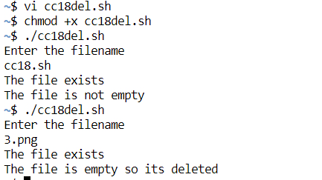

**c.** **Take an input file and remove identical lines (or duplicate lines from the file)**

touch 1.txt

vi 1.txt

**In 1.txt**

**---------------------------------------------------------------------------------------------------------------------**

**good**

**hello**

**hello**

**good**

**better**

**nice**

**people**

**nice**

**better**

**---------------------------------------------------------------------------------------------------------------------**

touch c325.sh

vi c325.sh

**In c325.sh**

**---------------------------------------------------------------------------------------------------------------------**

**echo "Enter filename"**

**read filename**

**echo "The unique words are: "**

**cat -n $filename | sort -k2 | uniq -f1 | sort -k1 | cut -f2**

**#sorting on numbers and removing the numbers**

**---------------------------------------------------------------------------------------------------------------------**

touch 1.txt

chmod +x c325.sh

./c325.sh

Output:

