**ANUDIP FOUNDATION**

A Project Report on

**Restaurant Reservation System**

By

Batch: ANP-D0453

Student ID: AF0477659

Name: Fiza Patel

**Under the Guidance of**

Mrs. Rajshri Chandrabhan Thete

**Restaurant Reservation System**

**Introduction:**

The **Restaurant Reservation System** is a web-based application designed to simplify and automate the process of table reservations in restaurants. Traditional reservation methods often lead to mismanagement, long wait times, and customer dissatisfaction. This system aims to overcome these challenges by providing a seamless platform where customers can book tables in advance, restaurants can manage reservations efficiently, and administrators can oversee operations securely.

**Entities:**

* Customer
* Restaurant
* Resevation
* Admin
* Reservation Table
* Review

**VARIOUS ENTITIES:**

**1.Customer:**

* Customer_Id(Primary Key)
* customerName
* email
* customerContactNo
* totalReservations

**2. Restaurant:**

* restaurantId(Primary Key)
* restaurantName
* contactNo
* Menu
* Address

**3. Resevation:**

* reservationId(Primary Key)
* restaurantId(Foreign Key)
* customerId(Foreign Key)
* tableId(Foreign Key)
* reservationTime
* reservationDate

**4. Admin:**

* adminId(Primary Key)
* userName
* email
* password

**5. Reservation Table:**

* tableId(Primary Key)
* table_no
* capacity
* isavailable
* reservations

**6.Feedback:**

* FeedbackId(Primary Key)
* restaurantId(Foreign Key)
* customerId­­­­­(Foreign Key)
* Feedback

**­­­**

**ENTITY RELATIONSHIP DIAGRAM - Restaurant Reservation System:**

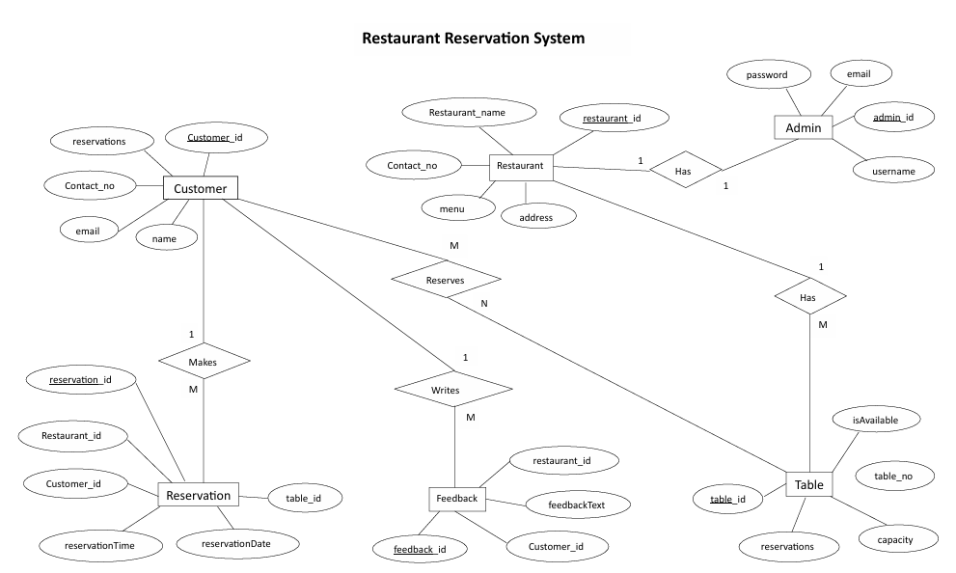

**DATABASE CREATION QUERY:**

mysql>CREATE TABLE Customer (Customer_Id INT PRIMARY KEY,customerName VARCHAR(50) NOT NULL,email VARCHAR(50) NOT NULL, customerContactNo VARCHAR(10) NOT NULL,totalReservations INT);

Query OK, 1 row affected (0.01 sec)

mysql>CREATE TABLE Restaurant (restaurantId INT PRIMARY KEY,restaurantName VARCHAR(50) NOT NULL,contactNo VARCHAR(15) NOT NULL,Menu NOT NULL,Address NOT NULL);

Query OK, 1 row affected (0.02 sec)

mysqlCREATE TABLE Reservation (reservationId INT PRIMARY KEY,restaurantId INT NOT NULL,customerId INT NOT NULL,tableId INT NOT NULL,reservationTime TIME NOT NULL,reservationDate DATE NOT NULL,FOREIGN KEY (restaurantId) REFERENCES Restaurant(restaurantId),FOREIGN KEY (customerId) REFERENCES Customer(Customer_Id),FOREIGN KEY (tableId) REFERENCES RestaurantTable(tableId));

Query OK, 1 row affected (0.01 sec)

mysql>CREATE TABLE Admin (adminId INT PRIMARY KEY, userName VARCHAR(30) NOT NULL,email VARCHAR(50) NOT NULL, password VARCHAR(10) NOT NULL);

Query OK, 1 row affected (0.01 sec)

mysql>CREATE TABLE ReservationTable (tableId INT PRIMARY KEY,table_no INT NOT NULL,capacity INT NOT NULL,isAvailable INT NOT NULL,reservations INT NOT NULL);

Query OK, 1 row affected (0.01 sec)

mysql>CREATE TABLE Feedback (FeedbackId INT PRIMARY KEY,restaurantId INT NOT NULL,customerId INT NOT NULL,Feedback TEXT NOT NULL,FOREIGN KEY (restaurantId) REFERENCES Restaurant(restaurantId),FOREIGN KEY (customerId) REFERENCES Customer(Customer_Id));

Query OK, 1 row affected (0.02 sec)

**CONCLUSION:**

The **Restaurant Reservation System** is designed to streamline and automate the table booking process, enhancing efficiency and improving the overall customer experience. It enables customers to book tables online, reducing wait times and ensuring a smooth dining process. Restaurants can efficiently manage table availability, capacity, and reservations while also gathering valuable customer feedback to enhance their services. The system includes an admin module for managing restaurant details, reservations, and customer interactions securely. A well-structured database ensures seamless integration between restaurants, customers, reservations, and feedback, maintaining data integrity and improving operational efficiency. Overall, this system provides a **reliable, scalable, and efficient** solution for restaurant reservations, benefiting both customers and restaurant businesses.