Intelligent Driver Drowsiness Monitoring & Alert System
Abstract
Drowsiness detection is a safety technology which helps prevent accidents caused by the driver who fell asleep while driving. Various studies have suggested that around 20% of all road accidents are fatigue-related, up to 50% on certain roads. The objective of this project is to build an intelligent drowsiness detection system that will detect that a persons eyes are closed for a few seconds. This system will monitor and alerts the driver when drowsiness is detected. This intelligent drowsiness detection system uses computer vision to observe the driver's face, either using a built-in camera or on mobile devices.

Modules
Step 1  Take image as input from a camera.
Step 2  Detect the face in the image and create a Region of Interest (ROI).
Step 3  Detect the eyes from ROI and feed it to the classifier.
Step 4  Classifier will categorize whether eyes are open or closed.
Step 5  Calculate score to check whether the person is drowsy.

Advantages
- The system helps prevent accidents caused by sleepy drivers.
Hardware Requirement:

➢ i3 Processor Based Computer
➢ 4 GB RAM
➢ 150 GB Hard Disk
➢ Monitor

❖ Software Requirement:

➢ Linux 14.04 or higher.
➢ Python
➢ Notepad++.
➢ OpenCV.
➢ Keras
➢ Pygame
➢ Tensorflow

Block Diagram
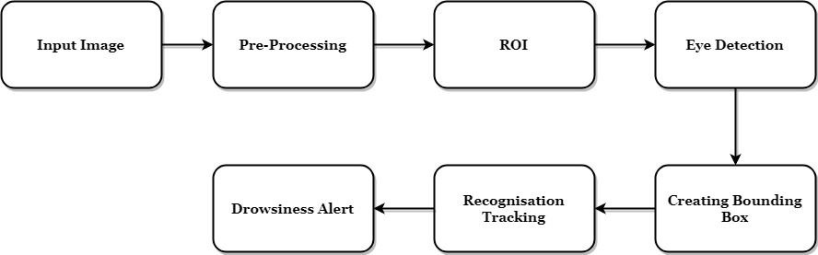

Existing System
Currently, the possible causes of accidents are detected by overspeeding, rash driving factors. Like, the speed of the car and frequent braking etc. But this simply does not help in detecting an accident that could happen because of a sleepy driver. Accident can happen even if the driver is going slow but is not completely aware of the road since he is tired or drowsy.

Proposed System
In the proposed system we have built an intelligent drowsy driver alert system that takes pictures of the drivers face and alerts if the driver is sleepy even for a few seconds. A webcam is used to take images as input. So to access the webcam an infinite loop that will capture each frame is made. OpenCV is then used to detect faces and eyes using a haar cascade classifier. Finaly, a CNN model is used to predict the status of the driver.
CONCLUSION
In this project, a hardware-based system was presented for driver drowsiness detection using facial expressions. The implemented hardware is based on infrared light. Using infrared light has provided benefits such as simplicity of used methods, independent from environment lighting conditions. In the proposed method, after determining the face region using the background subtraction technique, the facial components are obtained by horizontal projection and template matching. In tracking phase using template matching elements found in the previous step are followed up and eventually the incidence of sleepiness was investigated using determination of the facial state from the changes of the facial components. Based on the previous investigation, three changes, eyebrows raising up, eyes closing and yawning for a certain period are considered as starting symptoms in the driver's drowsiness and the system will warn. The results indicate that the system in the presence of glasses or beard and mustache on the driver face will produce appropriate response, too.

