Filtering political sentiment in social media from textual information
Abstract
Social media is now playing a vital role in influencing people's sentiment in favour or against a government or an organization. Therefore, to understand the sentiment of any posting in social media, an efficient method is an ultimate necessity. We have analyzed some facebook postings to understand political sentiments. In any politically motivated posting there are some dominant keywords. At first, we have prepared a dictionary consisting of unique words collected from political or non political posts or comments and then trained using Naïve Bayes algorithm based on probability theory. To identify the sentiment expressed in a new post or comment, we have extracted each word of the posting and then matched those with the dictionary words for classification.
Modules
User
- Login-The user needs to login in order to get access to the system
- Post- The user of this system can post any political comments
- View Post- The authorised user van view things posted by other users.
- Comment- The authorised user van view as well as comment on the post

Advantages
- The method can classify posts or comments with good accuracy.
Hardware Requirement:

➢ i3 Processor Based Computer
➢ 4 GB RAM
➢ 50 GB Hard Disk
➢ Monitor
➢ Internet Connection

❖ Software Requirement:

➢ Windows 7 or higher.
➢ WAMP Server
➢ Notepad++.
➢ My SQL 5.6.
Block Diagram
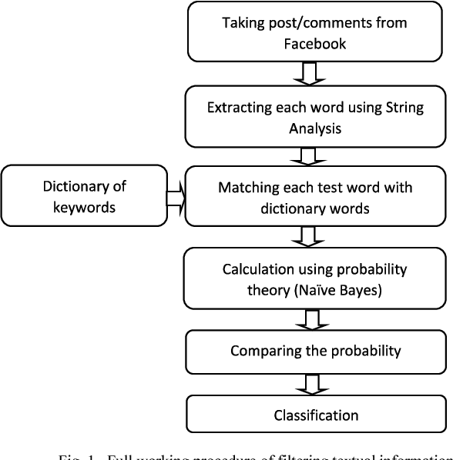

Existing System
The sentiment analysis of political comments in social media is one of the critical problem being solved by many AI engineers. The existing system of sentiment analysis uses a broad set of rules to identify the nature of the comments and tag them for positive, negative or neutral accordingly. The process involves either a set of rules or a bag of words for the classifying.

Proposed System
In the proposed system for sentiment analysis of political comments, machine learning is used. A Naive Bayes algorithm is used in the place of rules and lexicons. Using Naive Bayes algorithm, the proposed solution can continuously learn and improve the classification efficiency which is not possible in existing systems. In addition, the dictionary used in the proposed system is fine tuned to include politically related words and hence the accuracy of the output of the proposed solution will be better than the current systems available.

