ALLAMA IQBAL OPEN UNIVERSITY, ISLAMABAD
(Department of Science Education)
[WARNING
- PLAGIARISM OR HIRING OF GHOST WRITER(S) FOR SOLVING THE ASSIGNMENT(S) WILL DEBAR THE STUDENT FROM AWARD OF DEGREE/CERTIFICATE, IF FOUND AT ANY STAGE.
- SUBMITTING ASSIGNMENT(S) BORROWED OR STOLEN FROM OTHER(S) AS ONE’S OWN WILL BE PENALIZED AS DEFINED IN “AIOU PLAGIARISM POLICY”.

Course: General Mathematics and Statistics (6401) Semester: Autumn, 2023
Level: B.Ed. (4 Years)
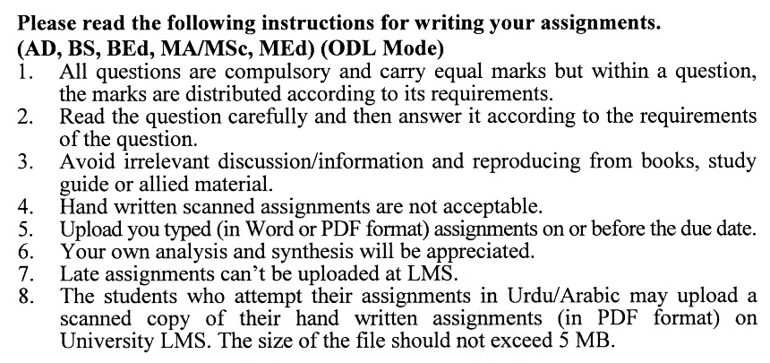
Total Marks 100 Pass Marks: 50
ASSIGNMENT No. 1
(Units: 1–4)

Q. 1 If U = {1, 2, 3……………………………………………20} (10+10)
A = {1, 3, 5, 7, 9}
B = {1, 2, 3, ……………………………………………10}}
Prove De Morgan’s laws and verify by using Venn diagrams.

Q. 2 (20)
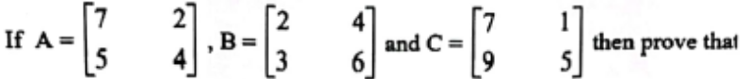

- A (b + c) = AB + AC
- A (B - C) = AB - AC

Q. 3 (20)
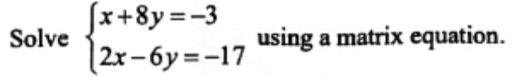

Q. 4 Use the quadric formula to solve equations. (20)
i. x² +- 8Px + 12P² = 0

ii.
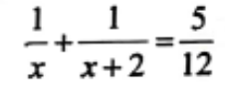

Q. 5 Find the relation independent of y for the following equations: (20)
i. y² – 2y + 1 = 0; -y²+3y + m + 0
ii. 7y² – ty + 5 = 0; 3 y² + s y – 3 + 0

Total Marks: 100 Pass Marks: 50
ASSIGNMENT No. 2
(Units: 5–9)

Q. 1 i. Find the area of the quadrilateral region ABCD When m AB = 4cm, m BC =
3cm, m CD = 9cm, m AD = 8cm & m AD = 10cm. (20)
ii. Prove that the sum of the measures of the three angles of a triangle is 180°.

Q. 2 (i) From top of the house the angle of depression of appoint on the ground is 25°.
The point is 35 meters from the base of the building. How high is the e building? (10)
(ii) Solve triangle ABC, when a + 2cm, b + 2 2cm and m<B + 90°. (10)

Q. 3 (a) Radius of sphere is 70mm. Find the cost of painting its surface @ Rs. 02 per mm². (10)
(b) Finds area of base of cylinder if volume of cylinder is 200m³ . Height is 5.4m.
(10)
Q. 4 The marks obtained by ten students for the first year in the subject of statistics are, 75, 62, 58, 50, 72, 65, 60, 70, 55, 53. Calculate the mean score by (20)
(i) Direct Methods
(ii) Indirect Method
(iii) Step- division Method.

Q. 5 Following are the scores made by two batsmen A and B in a series of Innings: (20)

A | 12 | 15 | 6 | 73 | 7 | 19 | 199 | 36 | 84 | 29
B | 47 | 12 | 73 | 48 | 4 | 51 | 37 | 48 | 13 | 0
Who is better as a run getter? Who is more consistent players?

