Hanoi University of Science and TechnologySchool of Information and Communication Technology

**---------------o0o---------------**

**PROJECT REPORT**

**ITSS Embedded Linux**

**Electric Power Supply Control System**

**Instructor: Ph.D Banh Thi Quynh Mai**

**Group 5**

|  |  |
| --- | --- |
| **Đặng Quốc Tú** | **20194871** |
| **Đinh Thế Kiệt** | **20194783** |
| **Hồ Trần Anh Vũ** | **20194885** |
| **Vũ Hoàng Nam** | **20194809** |

**Class Code: 131092**

**Hanoi,2022**

Contents

**I.Introduction** 3

**1. Overview** 3

**II.Requirement** 3

**1.** **Equipment specification** 3

**2.** **System specification** 4

**2.1 Electric power supply** 4

**2.2** **Power supply** 4

**2.3 Record of electric power supply history** 4

**III. Application Design & Implementation** 4

**1.** **Architecture** 4

**2.** **Design** 5

**3.** **Implementation** 5

# **I.Introduction**

## **1. Overview**

We develop the electric power supply control system

The main function of the electric power system is as follows.

+) The power supply is monitored and managed by the electric power system.

+) The electrical system provides the associated electrical devices with electricity

+) The history of the electric power supply is tracked by the electrical system.

# **II.Requirement**

1. **Equipment specification**

* The equipment name and the use mode are set to each equipment.   
  There are three kinds of the following use mode of the equipment : off mode,normal mode, saving mode. The equipment can switch the use mode.　The electric power system supplies the electric power corresponding to the mode to the equipment.
* When the equipment connects it with the electric power system, the use mode is assumed to be a turning off mode.

1. **System specification**

**2.1 Electric power supply**

The electric power system compulsorily prevents supply-over by changing equipment to power-saving mode.

Even though the electric power system limited the power supply, it stops all power supplies by activating the safety device if oversupply cannot be stopped for a predetermined amount of time (ten seconds). The electric power system then restarts the supply of the electric power after the oversupply is resolved by cutting associated equipment.

* 1. **Power supply**

Each linked piece of equipment receives electric power from the electric power system in accordance with how it is being used.

The electric power system s warning at threshold over time and the status notice such as error

**2.3 Record of electric power supply history**

**The electric power system records power supply history of system :**

Status of system

Quantity of electric power supply

Log collection time

**Electric power supply history of each equipment**

Equipment name

Quantity of electric power supply

Electric power supply beginning time

Electric power supply end time

# **III. Application Design & Implementation**

1. **Architecture**

We build an application based on  client-server architecture using TCP protocol  and a concurrent TCP server : one thread per client.

The application can handle multiple users by using multithreaded server to handle each client connections. To send and receive messages, the client and server agree on a common protocol.

1. **Design**

**connectMng :** Create, and terminate thread (powerSupply) according to the connection and cutting from eleEquip.

**powerSupply :** PowerSupply writes power supply information on the equipment. Moreover, powerSupply regularly notifies eleEquip the power supply and the status.

**elePowerCtrl :** ElePowerCtrl changes the power supply information on the equipment and the condition of the power supply of the system in response to the electric power supply situation when the equipment is attached and disconnected. Additionally, elePowerCtrl records the history of the power supply in the log.

**powSupplyInfoAccess** : PowSupplyInfoAccess reads and writes power supply information in response to requests for access from other processes.

**logWrite :** LogWrite writes the log according to the demand to write the log from the other process.

1. **Implementation**

* Client :

After asking the user for device information, we create a TCP connection to the server. We set up two threads, one for transmitting mode changes and the other for receiving server responses.

Device input

Connect to server and send info :

Create thread to receive and send message :

Server :

Power system structure Devices structure

Structure of message in message queue

Server initial necessary data structure for application

Create message queue :

To handle each mission, the server creates 4 threads: connectMng, elePowerCtrl, powSupplyInfoAccess, and logWrite.

Thread connectMng establish connection,waiting for user connection.This thread will create new thread called powerSupply_handle for each conenction.

* Function logWrite :

Write log to file

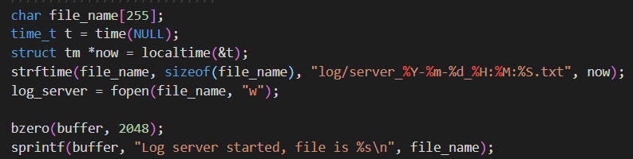

Check message queue when receiving message from other thread require to write log

* Function powerSupply_handle : Receive mode from user and send message to message queue so that powerSupplyInfoAccess can record supply info .

Format of message in message queue :

If new connection : n | thread_id | client_msg | connect_socket

Change mode : m | thread_id | client_msg

Disconnect : d | thread_id

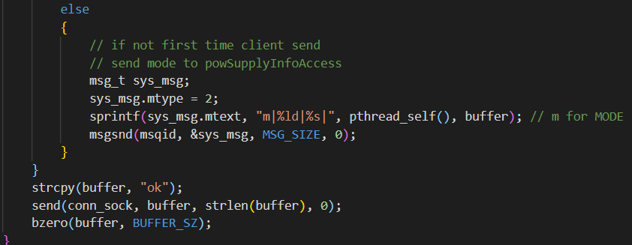

Function powerSupplyInfoAccess_handler : read and writes powerSupplyEquipInfo , check mode change and update

Function elecPowerCtrl_handler : controls limitation/release of control the power supply by changing powerSupplySystemInfo.All devices will enter a saving mode and alert users if there is an over supply. It will wait 10 seconds before attempting a user mode change if the problem is still present. After 10 seconds, the supply will be cut off.

Check over supply

Change all devices to limited mode when over supply

Check system status in 10 seconds before cut off

Cut off devices

Notify to user after system back to normal

