Software Requirement Specifications
Online Internship Management System



Submitted by
Fizza Riaz roll no 1141

Submitted to
Dr. Syed Ali Nawaz Shah

Department of Information Technology
Faculty of Computing
The Islamia University of Bahawalpur

Summary

The Online Internship Management System is a web-based platform created to improve how internships are managed in universities. Traditionally, internship tasks such as applying, submitting documents, and tracking progress are handled manually, which leads to delays, missing information, and communication problems. From the findings, it was observed that students struggle to find suitable internships, companies lack a proper channel to manage opportunities, and administrators spend a lot of time on paperwork and approvals. To address these issues, the system requires features that allow students to register, search, and apply for internships online, companies to post and review applications, and administrators to approve users, track progress, and generate reports or certificates. The system must also be secure, user-friendly, and accessible on different devices. Overall, this platform provides a centralized and efficient solution that connects all stakeholders and makes internship management easier and more organized.

Table of Contents
1. Introduction 4
1.1. Purpose 4
1.2. Scope 4
1.3. Product Perspective 4
1.4. User Characteristics 4
1.5. Similar apps and systems/Literature Review 4
1.6. Proposed Technologies 4
2. Requirements 6
2.1. Function Requirements 6
2.1.1. Sign Up 6
2.2. Non-Functional Requirements 7
3. Use Cases and Flow of Processes 7
3.1. Use Case 1 8
4. References 9

- Introduction
The Online Internship Management System is a web-based platform that helps students, companies, and universities manage internships easily. Instead of using manual forms and emails, this system allows students to apply for internships online, companies to post opportunities, and admins to monitor the whole process. It makes internship management faster, more organized, and more convenient for everyone.
  - Purpose

The purpose of this Software Requirements Specification (SRS) is to describe the functional and non-functional requirements of the Online Internship Management System. This document defines the system’s purpose, features, constraints, and the interaction among users (students, company representatives, and administrators). The SRS will serve as a reference for developers, testers, and project stakeholders throughout the development lifecycle.
  - Scope

The Online Internship Management System is a web-based platform designed to automate the entire process of internship management. It allows:
  - Students to register, browse internships, apply, and submit reports.
  - Companies to post internships, review applications, and select interns.
  - Administrators to manage users, approve posts, monitor progress, and generate certificates and reports.
  - The system reduces manual paperwork, improves communication between stakeholders, and provides a centralized solution for internship tracking and management.
  - Product Perspective

The system is an independent web application that connects three user roles within a unified ecosystem.
It interacts with:
  - A backend database for storing user and internship data
  - Web-based UI for user interaction
  - Server-side logic for processing requests
  - It replaces traditional manual forms and email-based internship processes with a structured digital workflow.
  - Similar apps and systems/Literature Review

Similar systems exist in universities and job portals, such as:
  - Handshake – manages student career & internship opportunities
  - Internshala – connects students and companies
  - LinkedIn Jobs – enables internship search & applications
  - However, these platforms are generic and not tailored to university-level administrative workflows.
The proposed system offers structured university-specific management, centralized reporting, and controlled verification processes.
  - Proposed Technologies
- Frontend:
HTML, CSS, JavaScript, Bootstrap
- Backend:
PHP or Python (Flask/Django)
- Database:
MySQL
- Server:
XAMPP / WAMP (for PHP), Flask Server (for Python)
- Version Control:
Git & GitHub

- Requirements
  - Function Requirements
    - Sign Up
• The system shall allow users (students, companies, admins) to create accounts.
• The system shall validate email and password during registration.
• The system shall store user data securely in the database.

2.1.2 Login
- The system shall allow authenticated login for all user types.
- The system shall restrict access based on user role.

2.1.3 Student Module
- Students shall create and update their profiles.
- Students shall search and apply for available internships.
- Students shall upload resumes and required documents.
- Students shall submit internship progress reports.
- Students shall receive notifications about application status.

2.1.4 Company Module
- Companies shall create and manage internship postings.
- Companies shall review student applications.
- Companies shall approve or reject applicant requests.
- Companies shall evaluate interns and submit feedback.

2.1.5 Admin Module
- Admin shall manage and approve student and company registrations.
- Admin shall verify and approve internship postings.
- Admin shall oversee student applications and internship progress.
- Admin shall generate internship completion certificates.
- Admin shall generate system-wide reports for analysis.

2.1.6 Reporting System
- The system shall generate progress reports for admins.
- The system shall allow viewing and downloading of reports.
  - Non-Functional Requirements
2.2.1 Performance Requirements
- The system must handle up to 500 simultaneous users.
- Response time for page loading should not exceed 3 seconds.
2.2.2 Security Requirements
- Passwords must be stored using encryption.
- Access control must be role-based (Admin/Student/Company).
- System must prevent unauthorized data access.
2.2.3 Usability Requirements
- Interface must be simple, responsive, and user-friendly.
- All pages must support mobile, tablet, and desktop views.
2.2.4 Reliability Requirements
- The system shall ensure 99% uptime.
- All critical data must be backed up regularly.
2.2.5 Maintainability Requirements
- Code shall be modular and well-documented.
- System shall allow easy addition of new features.
- Use Cases and Flow of Processes

3.1 Use Case Diagram Summary

Primary Actors:
- Student
- Company Representative
- Administrator

Main Use Cases:
- User Registration
- Apply for Internship
- Post Internship
- Approve Applications
- Submit Reports
- Generate Certificates
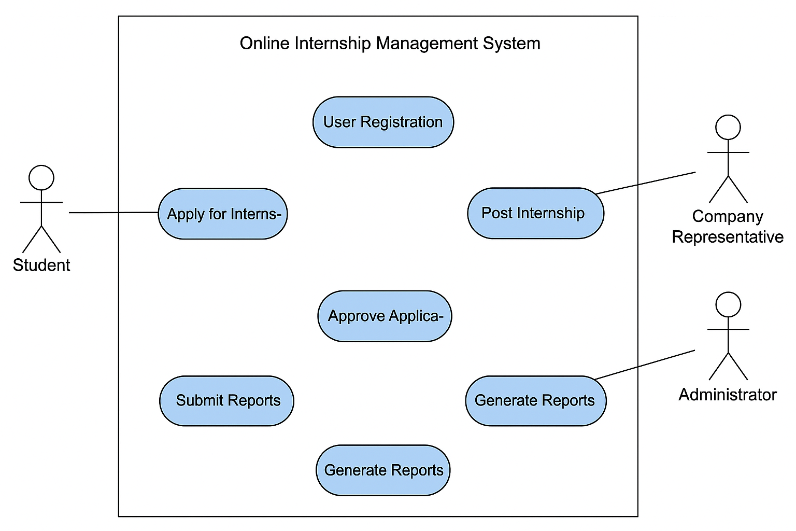
  - Use Case 1

Use Case 1: Student Applies for Internship

Actor: Student

Preconditions:

Student must be registered and logged in.

Main Flow:
- Student logs into the system.
- Student views available internships.
- Student selects an internship.
- Student uploads required documents.
- Student clicks "Apply".
- System sends application to company for review.

Post-conditions:

Application status is updated in the system.
- References
- IEEE Standard 830-1998
- Internshala – Online internship portal
- Handshake – Student career & internship management system
- LinkedIn Jobs – Online job and internship searching portal

