## Task1:

### Code:

#include <stdio.h>

#include <pthread.h>

#include <unistd.h>   // ✅ getpid() ke liye include karna zaroori hai

#define NUM_THREADS 4

int varg = 0;

void *thread_function(void *arg) {

    int thread_id = *(int *)arg;

    int varl = 0;

    varg++;   // global variable increment

    varl++;   // local variable increment

    printf("Thread %d is executing. Global value = %d | Local value = %d | Process ID = %d\n",

           thread_id, varg, varl, getpid());

    return NULL;

}

int main() {

    pthread_t threads[NUM_THREADS];

    int thread_args[NUM_THREADS];

    for (int i = 0; i < NUM_THREADS; ++i) {

        thread_args[i] = i;

        pthread_create(&threads[i], NULL, thread_function, &thread_args[i]);

    }

    for (int i = 0; i < NUM_THREADS; ++i) {

        pthread_join(threads[i], NULL);

    }

    printf("Main is executing. Final Global value = %d | Process ID = %d\n", varg, getpid());

    return 0;

}

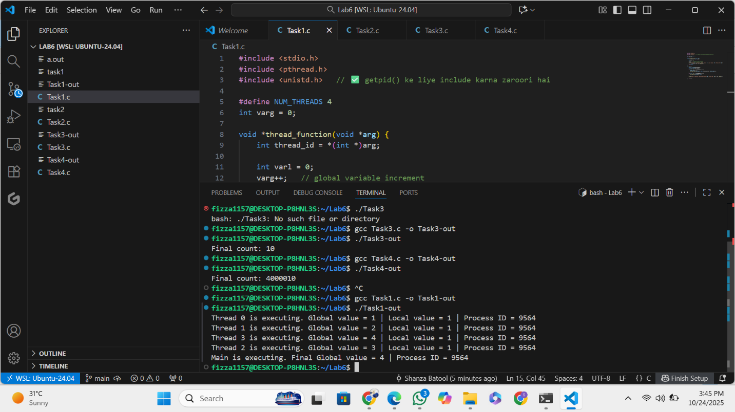

## Task2:

### Code:

#include <stdio.h>

#include <pthread.h>

#include <unistd.h>

#define NUM_ITERATIONS 1000000

int count=10;

// Critical section function

void critical_section(int process) {

    //printf("Process %d is in the critical section\n", process);

    //sleep(1); // Simulate some work in the critical section

    if(process==0){

        for (int i = 0; i < NUM_ITERATIONS; i++)

        count--;

    }

    else

    {

        for (int i = 0; i < NUM_ITERATIONS; i++)

        count++;

    }

}

void *process0(void *arg) {

        // Critical section

        critical_section(0);

        // Exit section

    return NULL;

}

void *process1(void *arg) {

        // Critical section

        critical_section(1);

        // Exit section

    return NULL;

}

int main() {

    pthread_t thread0, thread1, thread2, thread3;

    // Create threads

    pthread_create(&thread0, NULL, process0, NULL);

    pthread_create(&thread1, NULL, process1, NULL);

    pthread_create(&thread2, NULL, process0, NULL);

    pthread_create(&thread3, NULL, process1, NULL);

    // Wait for threads to finish

    pthread_join(thread0, NULL);

    pthread_join(thread1, NULL);

    pthread_join(thread2, NULL);

    pthread_join(thread3, NULL);

    printf("Final count: %d\n", count);

    return 0;

}

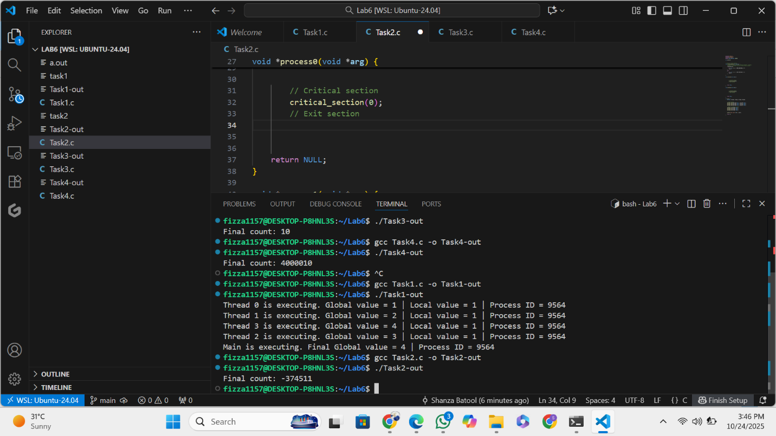

## Task3:

### Code:

## #include <stdio.h>

## #include <pthread.h>

## #include <unistd.h>

## #define NUM_ITERATIONS 1000000

## int count=10;

## pthread_mutex_t mutex; // mutex object

## // Critical section function

## void critical_section(int process) {

## //printf("Process %d is in the critical section\n", process);

## //sleep(1); // Simulate some work in the critical section

## if(process==0){

## for (int i = 0; i < NUM_ITERATIONS; i++)

## count--;

## }

## else

## {

## for (int i = 0; i < NUM_ITERATIONS; i++)

## count++;

## }

## //printf("Process %d has updated count to %d\n", process, count);

## //printf("Process %d is leaving the critical section\n", process);

## }

## // Peterson's Algorithm function for process 0

## void *process0(void *arg) {

## 

## pthread_mutex_lock(&mutex); // lock

## // Critical section

## critical_section(0);

## // Exit section

## 

## pthread_mutex_unlock(&mutex); // unlock

## 

## return NULL;

## }

## // Peterson's Algorithm function for process 1

## void *process1(void *arg) {

## 

## 

## pthread_mutex_lock(&mutex); // lock

## // Critical section

## critical_section(1);

## // Exit section

## pthread_mutex_unlock(&mutex); // unlock

## 

## 

## return NULL;

## }

## int main() {

## pthread_t thread0, thread1, thread2, thread3;

## pthread_mutex_init(&mutex,NULL); // initialize mutex

## // Create threads

## pthread_create(&thread0, NULL, process0, NULL);

## pthread_create(&thread1, NULL, process1, NULL);

## pthread_create(&thread2, NULL, process0, NULL);

## pthread_create(&thread3, NULL, process1, NULL);

## // Wait for threads to finish

## pthread_join(thread0, NULL);

## pthread_join(thread1, NULL);

## pthread_join(thread2, NULL);

## pthread_join(thread3, NULL);

## pthread_mutex_destroy(&mutex); // destroy mutex

## printf("Final count: %d\n", count);

## return 0;

## }

## Task2:

### Code:

#include <stdio.h>

#include <pthread.h>

#include <unistd.h>

#define NUM_ITERATIONS 1000000

int count=10;

// Critical section function

void critical_section(int process) {

    //printf("Process %d is in the critical section\n", process);

    //sleep(1); // Simulate some work in the critical section

    if(process==0){

        for (int i = 0; i < NUM_ITERATIONS; i++)

        count--;

    }

    else

    {

        for (int i = 0; i < NUM_ITERATIONS; i++)

        count++;

    }

}

void *process0(void *arg) {

        // Critical section

        critical_section(0);

        // Exit section

    return NULL;

}

void *process1(void *arg) {

        // Critical section

        critical_section(1);

        // Exit section

    return NULL;

}

int main() {

    pthread_t thread0, thread1, thread2, thread3;

    // Create threads

    pthread_create(&thread0, NULL, process0, NULL);

    pthread_create(&thread1, NULL, process1, NULL);

    pthread_create(&thread2, NULL, process0, NULL);

    pthread_create(&thread3, NULL, process1, NULL);

    // Wait for threads to finish

    pthread_join(thread0, NULL);

    pthread_join(thread1, NULL);

    pthread_join(thread2, NULL);

    pthread_join(thread3, NULL);

    printf("Final count: %d\n", count);

    return 0;

}

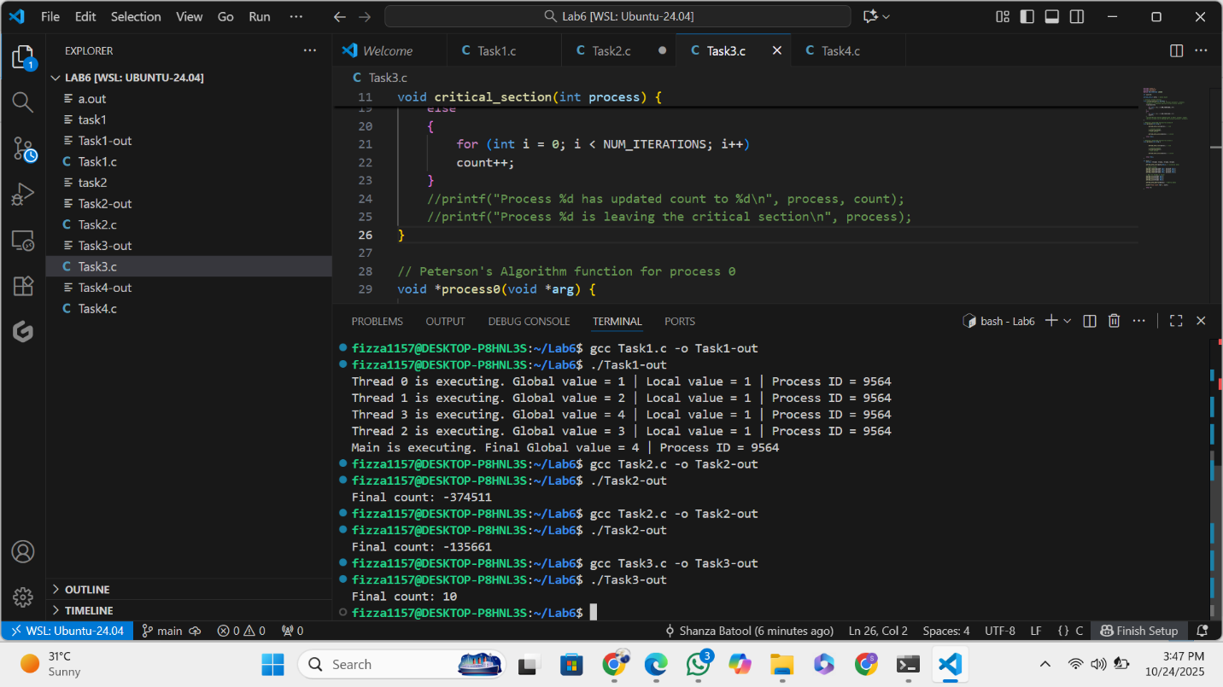

## Task4:

### Code:

#include <stdio.h>

#include <pthread.h>

#include <unistd.h>

#define NUM_ITERATIONS 1000000

int count = 10;

pthread_mutex_t mutex; // mutex object

// Critical section function

void critical_section(int process) {

    if (process == 0) {

        for (int i = 0; i < NUM_ITERATIONS; i++)

            count--;

    }

    else if (process == 1) {

        for (int i = 0; i < NUM_ITERATIONS; i++)

            count++;

    }

    else if (process == 2) {

        for (int i = 0; i < NUM_ITERATIONS; i++)

            count += 2;  // third process modifies differently

    }

}

// Process 0

void *process0(void *arg) {

    pthread_mutex_lock(&mutex);   // lock

    critical_section(0);

    pthread_mutex_unlock(&mutex); // unlock

    return NULL;

}

// Process 1

void *process1(void *arg) {

    pthread_mutex_lock(&mutex);

    critical_section(1);

    pthread_mutex_unlock(&mutex);

    return NULL;

}

// ✅ Process 2 (newly added)

void *process2(void *arg) {

    pthread_mutex_lock(&mutex);

    critical_section(2);

    pthread_mutex_unlock(&mutex);

    return NULL;

}

int main() {

    pthread_t thread0, thread1, thread2, thread3, thread4, thread5;

    pthread_mutex_init(&mutex, NULL); // initialize mutex

    // Create threads for all processes

    pthread_create(&thread0, NULL, process0, NULL);

    pthread_create(&thread1, NULL, process1, NULL);

    pthread_create(&thread2, NULL, process2, NULL);

    pthread_create(&thread3, NULL, process0, NULL);

    pthread_create(&thread4, NULL, process1, NULL);

    pthread_create(&thread5, NULL, process2, NULL);

    // Wait for all threads to complete

    pthread_join(thread0, NULL);

    pthread_join(thread1, NULL);

    pthread_join(thread2, NULL);

    pthread_join(thread3, NULL);

    pthread_join(thread4, NULL);

    pthread_join(thread5, NULL);

    pthread_mutex_destroy(&mutex); // destroy mutex

    printf("Final count: %d\n", count);

    return 0;

}

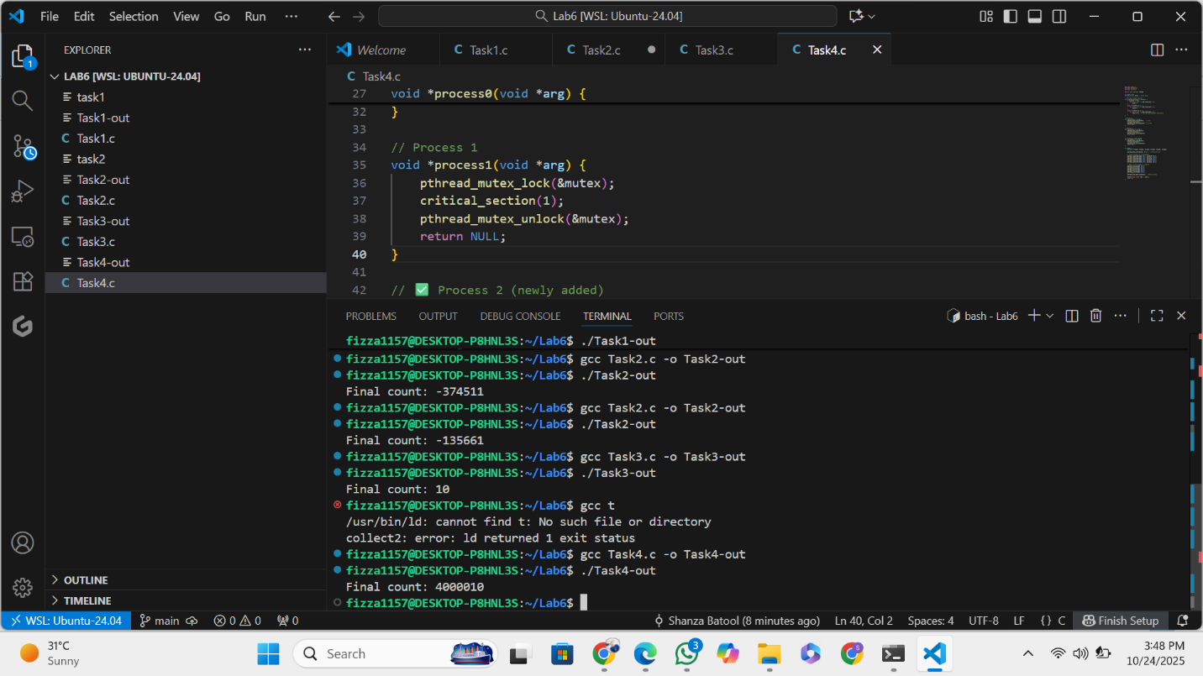

**Difference of Peterson’s Algorithm and Mutex in last two codes:**

**Peterson Algoritm:**

* Two shared variables: flag[2] and turn.

|  |
| --- |
| * Sets flag[i] = true; turn = j; then waits while (flag[j] && turn == j) |
| * Logic ensures only one process’s flag allows entry. |
| * Sets flag[i] = false; * Process continuously checks the flag and turn variables. * Works only for 2 processes (cannot directly handle 3). |

**Mutex:**

* Calls pthread_mutex_lock(&mutex).
* Multiple threads but logically 2 process types (increment/decrement).
* Operating System kernel.
* OS ensures only one thread runs this part at a time.