

NATIONAL TEXTILE
UNIVERSITY
DEPARTMENT OF COMPUTER SCIENCE
Subject
Operating System
SUBMITTED BY:
Fizza Shameen 23-NTU-CS-1157
BSSE- 5TH (A)
SUBMITTED TO:

Sir Nasir

Lab 10

Task2 Producer consumer problem:
Code:
#include <stdio.h>
#include <pthread.h>
#include <semaphore.h>
#include <unistd.h> #define BUFFER_SIZE 5 int buffer[BUFFER_SIZE]; int in = 0; // Producer index int out = 0; // Consumer index sem_t empty; // Counts empty slots sem_t full; // Counts full slots pthread_mutex_t mutex; void* producer(void* arg) { int id = *(int*)arg; for(int i = 0; i < 3; i++) { // Each producer makes 3 items int item = id * 100 + i; // TODO: Wait for empty slot sem_wait(&empty); // TODO: Lock the buffer pthread_mutex_lock(&mutex); // Add item to buffer buffer[in] = item; printf("Producer %d produced item %d at position %d\n", id, item, in); in = (in + 1) % BUFFER_SIZE; // TODO: Unlock the buffer pthread_mutex_unlock(&mutex);
// TODO: Signal that buffer has a full slot sem_post(&full); sleep(1);
} return NULL;

} void* consumer(void* arg) { int id = *(int*)arg;
for(int i = 0; i < 3; i++) {
// TODO: Students complete this similar to producer sem_wait(&full); pthread_mutex_lock(&mutex); int item = buffer[out]; printf("Consumer %d consumed item %d from position %d\n", id, item, out); out = (out + 1) % BUFFER_SIZE; pthread_mutex_unlock(&mutex); sem_post(&empty); sleep(2); // Consumers are slower
} return NULL;
} int main() { pthread_t prod[2], cons[2]; int ids[2] = {1, 2}; // Initialize semaphores sem_init(&empty, 0, BUFFER_SIZE); // All slots empty initially sem_init(&full, 0, 0); // No slots full initially pthread_mutex_init(&mutex, NULL); // Create producers and consumers for(int i = 0; i < 2; i++) { pthread_create(&prod[i], NULL, producer, &ids[i]); pthread_create(&cons[i], NULL, consumer, &ids[i]);
}
// Wait for completion for(int i = 0; i < 2; i++) { pthread_join(prod[i], NULL); pthread_join(cons[i], NULL);
}
// Cleanup sem_destroy(&empty);
sem_destroy(&full); pthread_mutex_destroy(&mutex); return 0;
}

// Here we have two producer threads and two consumer threads // Each producer is making 3 slots of items and we have 2 producer so we have total 6 slots of items that is producing the producer
//then we decrement by sem_wait(&empty) and showing that one slot is taken form the buffer

//then we will secure the critical section by mutex lock and unlock
//sem_post(&full) Signal that buffer has a full slot

// Each consumer is consuming 3 slots of items and we have 2 consumers so we have total 6 slots of items that is consuming the consumer
//then we decrement by sem_wait(&full) and showing that one item is taken from the buffer
//then we will secure the critical section by mutex lock and unlock
//sem_post(&empty) Signal that buffer has a empty slot

Output:
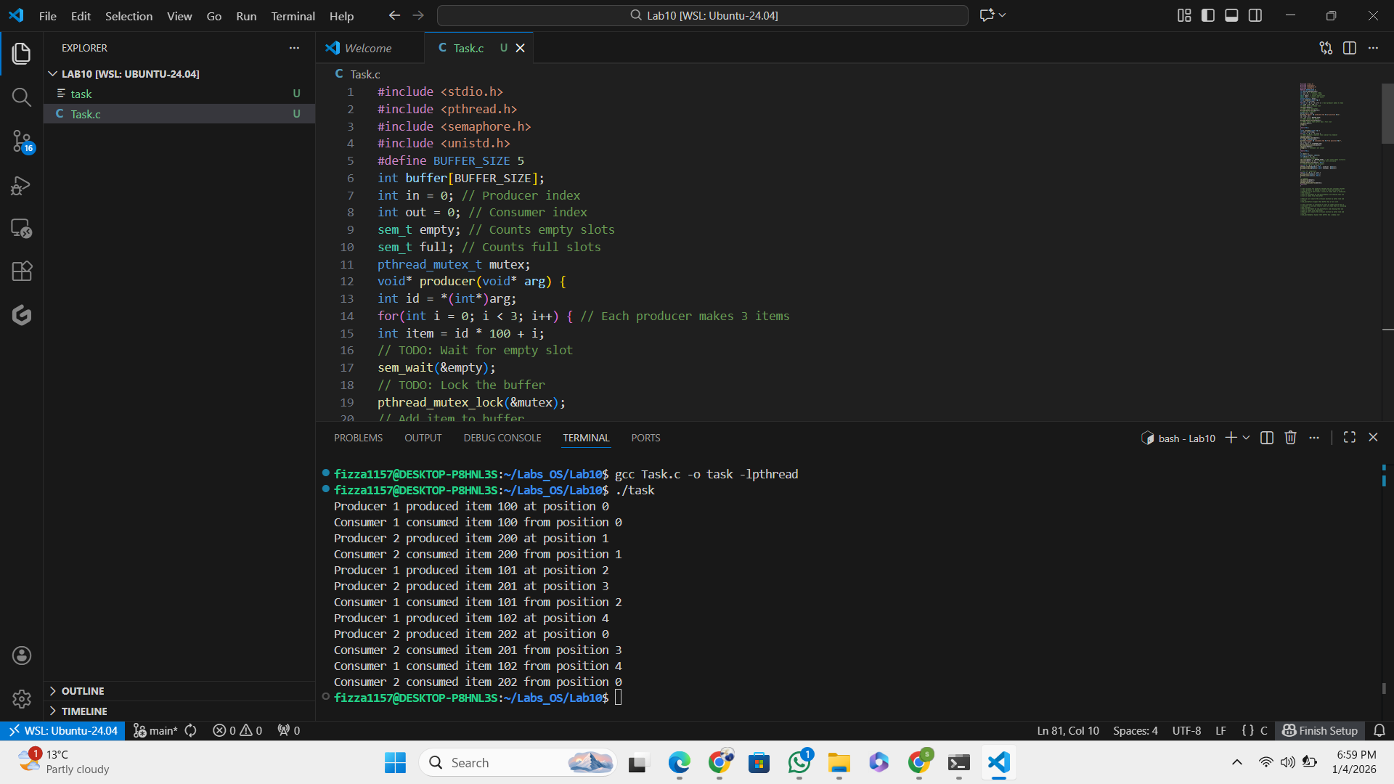

Consumer steps:

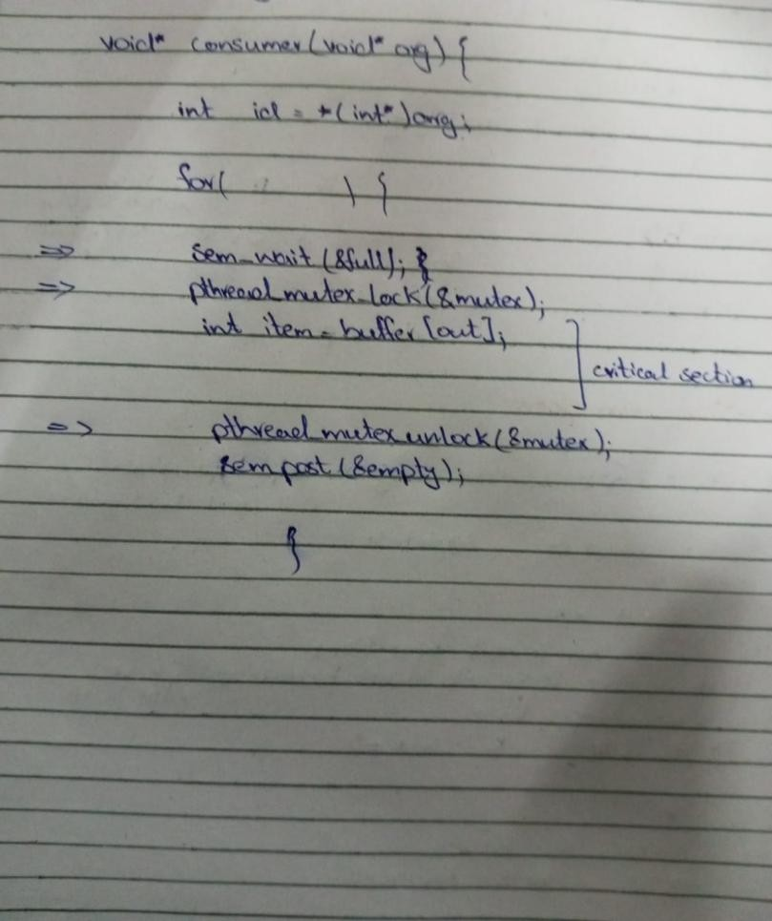

How many ids producer will produce?
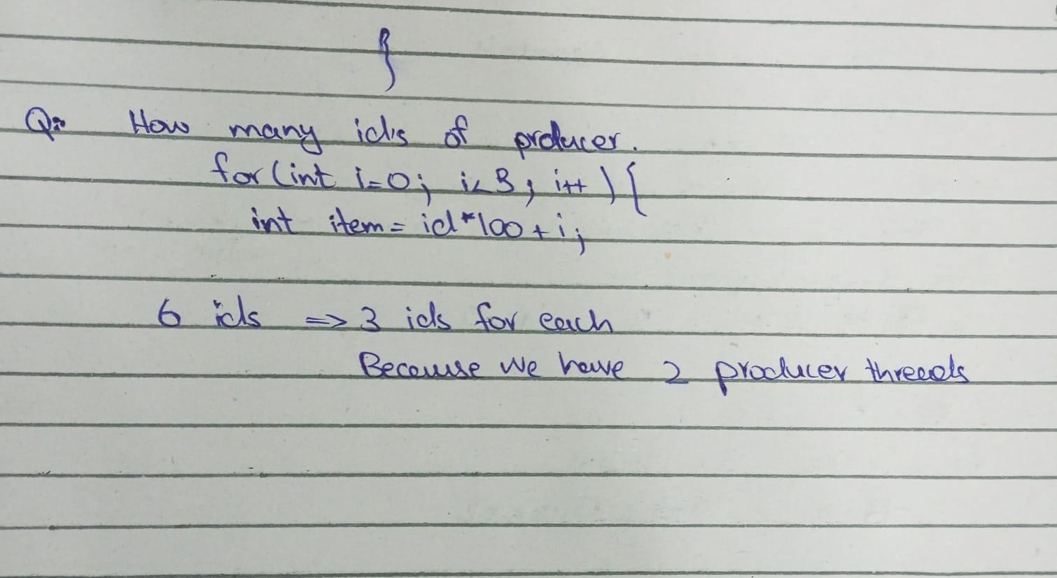

Q: What will happen if consumer is set to consume 8 items and we have 6 items then it will go in deadlock situation?

