203L-COMPUTER NETWORKING LAB (Fall 2025)

Open Ended Lab

Secure Chat Application
Project Report

Supervised By:
Sir Muhammad Noman

Submitted By:
Mehwish Maqbool (2024-SE-15)
Fizza Faisal (2024-SE-41)
Malaika Shabbir (2024-SE-21)

University of Engineering and Technology Lahore, New Campus

1. Project Overview
The Secure Chat Application is a robust, real-time communication platform designed to facilitate secure and efficient interaction between users. Built using a Client-Server architecture, the system ensures reliable message delivery, user authentication, and support for multimedia sharing.
The primary goal of this project is to demonstrate the practical implementation of network programming concepts, including socket communication, multi-threading for concurrent user handling, and graphical user interface (GUI) design.

1.1 Key Features
- User Authentication: Secure login mechanism verifying credentials against a server-side database to prevent unauthorized access.
- Real-Time Messaging: Instant delivery of text messages with low latency using TCP sockets.
- Multimedia Support: Capabilities for Voice and Video calling, as well as file and image transfers.
- Group Communication: Dynamic creation of chat groups allowing multi-user conversations.
- GUI Interface: A modern, user-friendly interface built with Tkinter, featuring a responsive layout and visual feedback.

1.2 Technology Stack
- Language: Python 3
- Network: Socket API (TCP/IP) for reliable communication.
- Concurrency: Python threading module to handle multiple clients simultaneously.
- GUI: Tkinter for the client-side application interface.
- Data Format: JSON for structured communication packets.

2. System Architecture
This section visualizes the system's structural and behavioral design using UML diagrams.

2.1 Class Diagram
The Class Diagram illustrates the object-oriented structure, defining the ClientApp class for UI management and Server Core for connection handling.

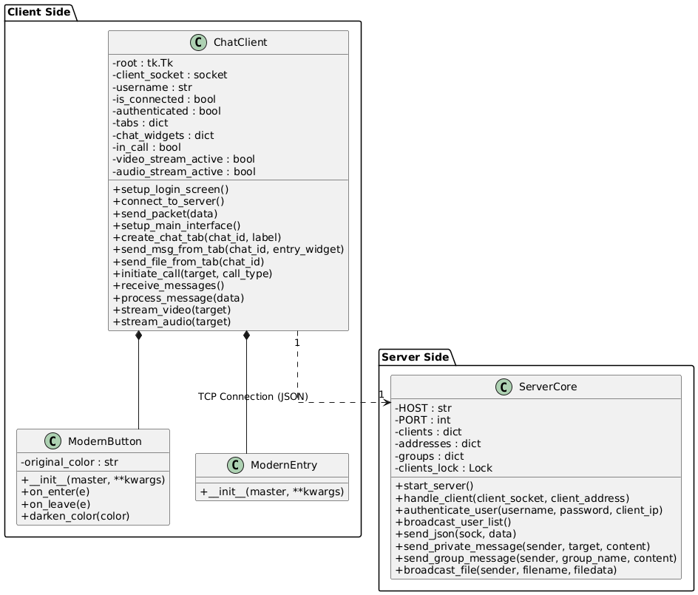
Figure: Class Diagram

2.2 Use Case Diagram
The Use Case Diagram depicts the available interactions between the User actor and the System.
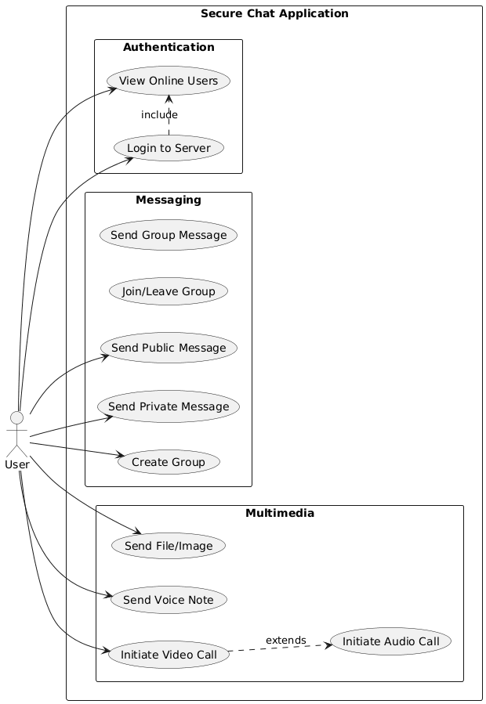
Figure: Use Case Diagram

3. Implementation Details
This section highlights the core logic used to implement the system's functionality.

3.1 Server Logic (Client Handling)
The server maintains a continuous loop for every connected client to process incoming JSON packets and route them appropriately.
def handle_client(client_socket, client_address):
"""
Main server loop handling individual client connections.
Uses threading to ensure non-blocking operations.
"""
while True:
try:
data = client_socket.recv(65536)
if not data: break
# Parse incoming JSON packet
message_data = json.loads(data.decode('utf-8'))
msg_type = message_data.get("type")
if msg_type == "LOGIN":
# Validate credentials
authenticate_user(message_data['name'], message_data['password'])
elif msg_type == "PRIVATE_MSG":
# Route message to specific target
target = message_data["target"]
send_json_to_user(target, message_data)
elif msg_type == "VIDEO_STREAM":
# Relay video frames to peer
target = message_data["target"]
send_json_to_user(target, message_data)
except Exception as e:
print(f"Error handling client: {e}")
break

3.2 Client Logic (Message Reception)
The client application uses a dedicated background thread to listen for server responses, ensuring the UI remains responsive during network operations.
def receive_messages(self):
"""
Background thread running on the client to listen for
incoming data from the server without freezing the GUI.
"""
while self.is_connected:
try:
data = self.client_socket.recv(65536)
message_data = json.loads(data.decode('utf-8'))
msg_type = message_data["type"]
if msg_type == "CHAT":
# Update Chat UI
self.append_to_chat(message_data["from"], message_data["msg"])
elif msg_type == "VIDEO_CALL_REQUEST":
# Trigger incoming call popup
self.show_incoming_call_window(message_data["from"])
elif msg_type == "AUTH_SUCCESS":
self.setup_main_interface()
except Exception as e:
print(f"Connection error: {e}")
break

4. Core Functionality Implementation

4.1 User Authentication

1. Server Authentication Code

def handle_client(self, client_socket, address): username = None try: while True: data = client_socket.recv(65536).decode('utf-8') if not data: break
message_data = json.loads(data)
msg_type = message_data.get("type")
if msg_type == "LOGIN":
username = message_data["name"]
password = message_data["password"]
# Authenticate user against database
if username in self.authenticated_users and self.authenticated_users[username] == password:
if username not in self.clients:
self.clients[username] = client_socket
self.send_to_client(client_socket, {
"type": "AUTH_SUCCESS",
"msg": f"Welcome {username}!"
})
print(f"✅ User {username} authenticated successfully")
else:
self.send_to_client(client_socket, {
"type": "AUTH_ERROR",
"msg": "User already logged in"
})
else:
self.send_to_client(client_socket, {
"type": "AUTH_ERROR",
"msg": "Invalid username or password"
})

2. Client Authentication Code
def connect_to_server(self): username = self.username_entry.get().strip() password = self.password_entry.get()
if not username:
messagebox.showwarning("Input Error", "Please enter a username")
return
if not password:
messagebox.showwarning("Input Error", "Please enter a password")
return
try:
self.client_socket = socket.socket(socket.AF_INET, socket.SOCK_STREAM)
self.client_socket.connect((SERVER_IP, PORT))
self.is_connected = True
# Send login credentials
self.send_packet({
"type": "LOGIN",
"name": username,
"password": password
})
# Start receiving messages
threading.Thread(target=self.receive_messages, daemon=True).start()
except Exception as e:
messagebox.showerror("Connection Error", f"Failed to connect: {e}")
def receive_messages(self): while self.is_connected: try: data = self.client_socket.recv(65536) message_data = json.loads(data.decode('utf-8')) msg_type = message_data["type"]
if msg_type == "AUTH_SUCCESS":
self.root.after(0, self.setup_main_interface)
elif msg_type == "AUTH_ERROR":
self.root.after(0, lambda: messagebox.showerror("Login Failed", message_data['msg']))
self.is_connected = False
except Exception as e:
break

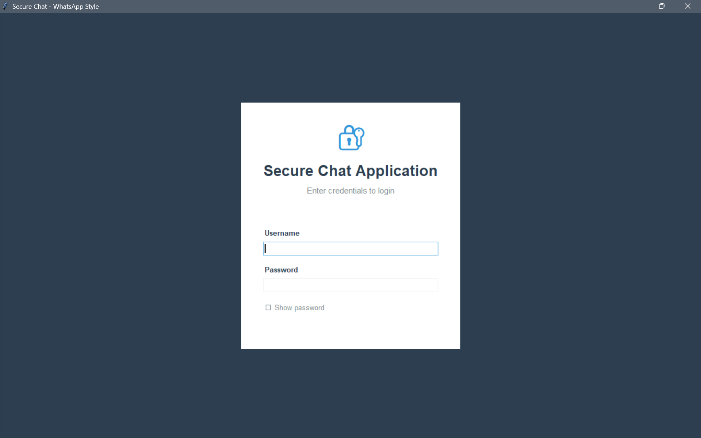

4.2 Multi-Client Communication

def handle_client(self, client_socket, address):
while True:
data = client_socket.recv(65536)
if not data:
break message_data = json.loads(data.decode('utf-8')) self.process_client_message(client_socket, message_data)

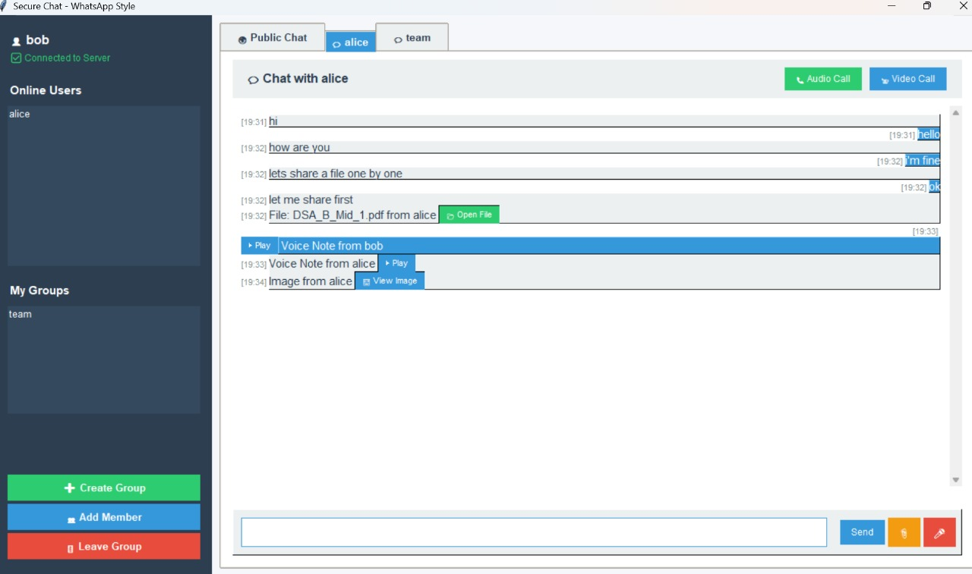

4.3 Active Clients Display
def broadcast_user_list(self):
online_users = list(self.clients.keys()) for client_socket in self.clients.values(): self.send_to_client(client_socket, { "type": "USER_LIST", "users": online_users })

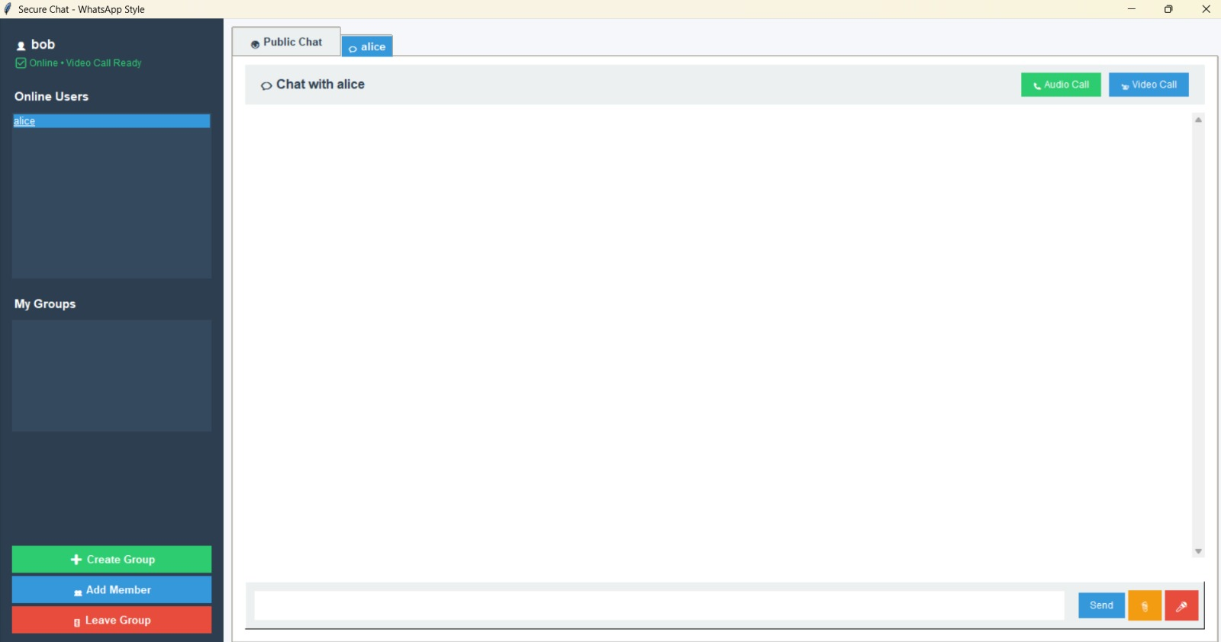

4.4 Group Chat with Room creation

def create_group_dialog(self):
name = simpledialog.askstring("Create Group", "Enter Group Name:")
if name:
self.send_packet({"type": "CREATE_GROUP", "group_name": name})

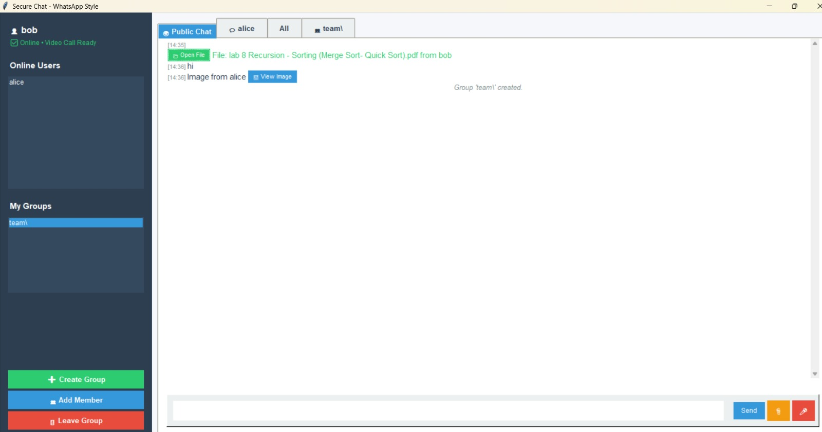

4.5 Private one-to-one chat

def on_user_double_click(self, event): selection = self.user_listbox.curselection() if selection: user = self.user_listbox.get(selection[0]) self.create_chat_tab(user, f"💬 {user}")

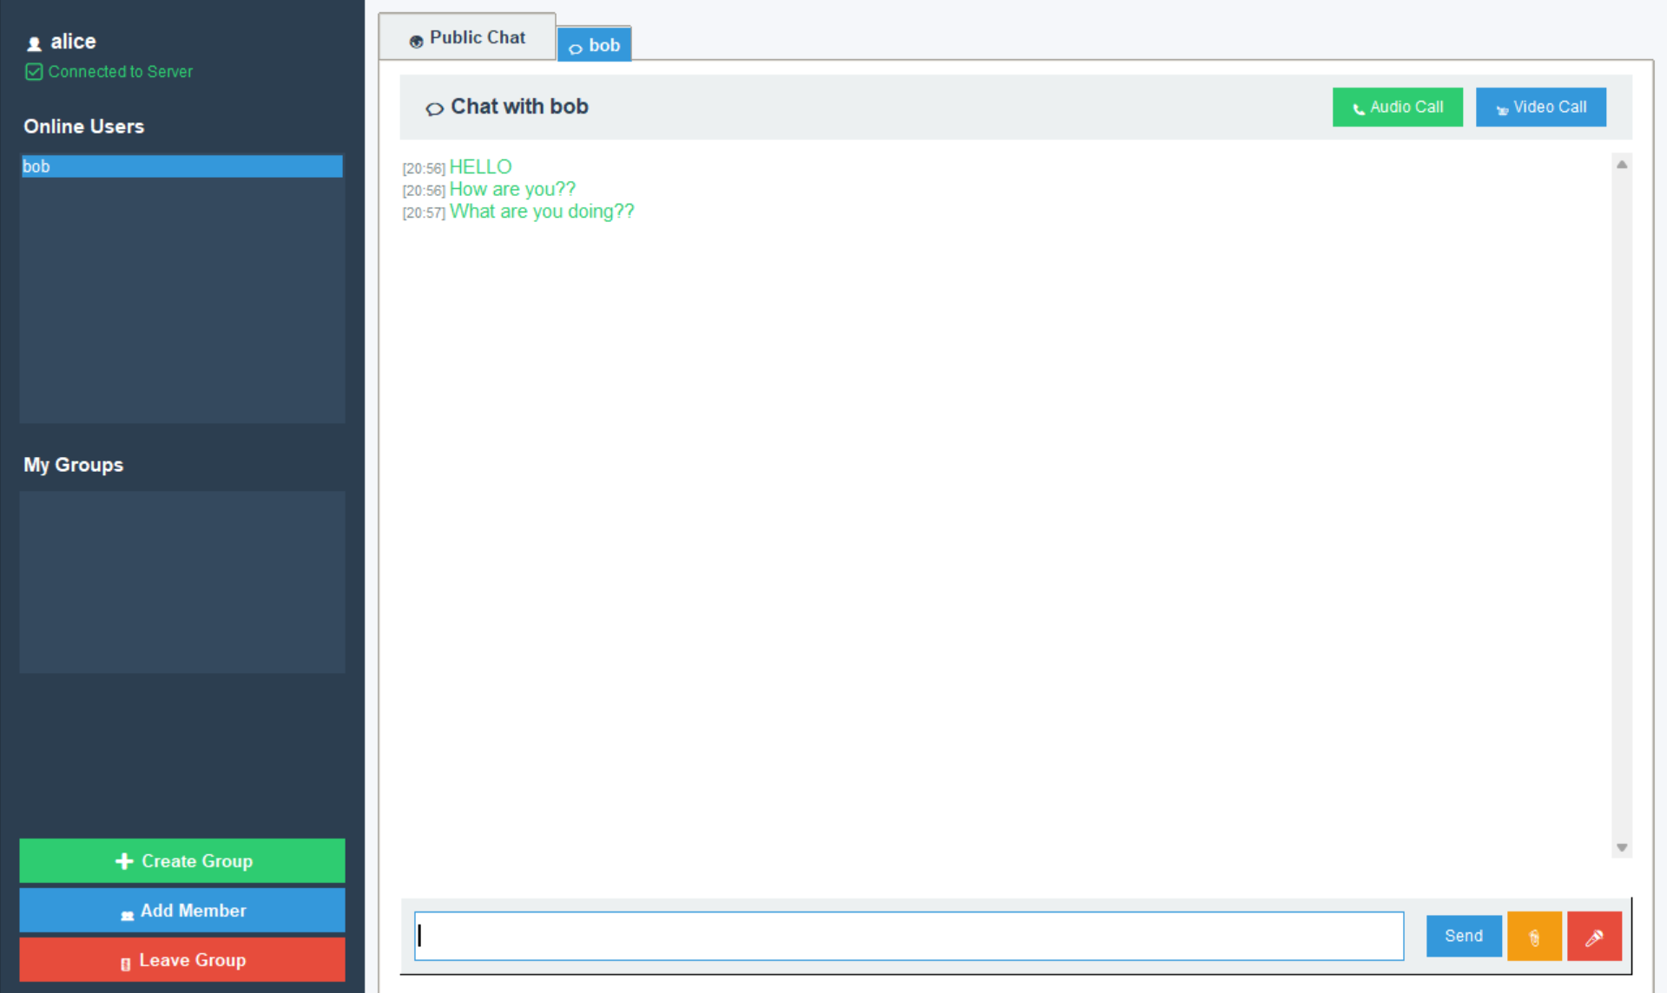

4.6 File Transfer and Voice Note

def send_file_from_tab(self, chat_id): filepath = filedialog.askopenfilename() with open(filepath, "rb") as f: encoded = base64.b64encode(f.read()).decode('utf-8') self.send_packet({ "type": "FILE", "filename": os.path.basename(filepath), "data": encoded, "target": chat_id })



4.7 Image and Video Sharing
def append_image_button(self, chat_id, text, filename, is_self=False): btn = ModernButton(widget, text="View Image", command=lambda: self.open_image_file(filename)) widget.window_create(tk.END, window=btn)


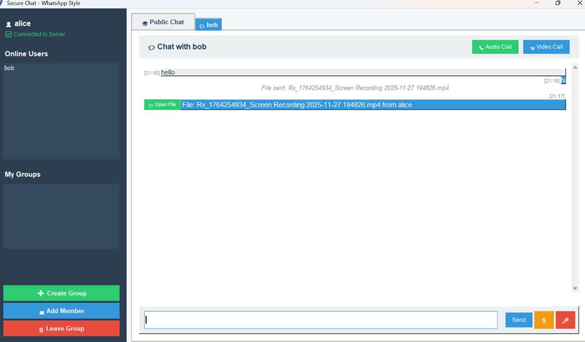

4.8 Audio call Implementation

def initiate_call(self, target, call_type): self.send_packet({ "type": f"{call_type.upper()}_CALL_REQUEST", "target": target }) self.show_calling_window(target, call_type)

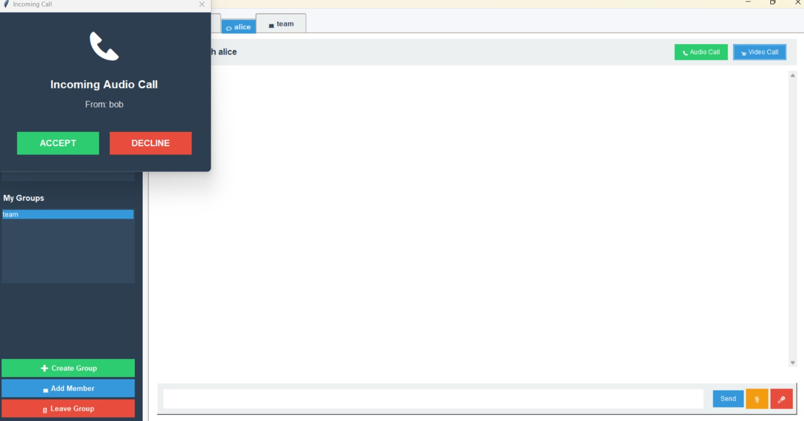
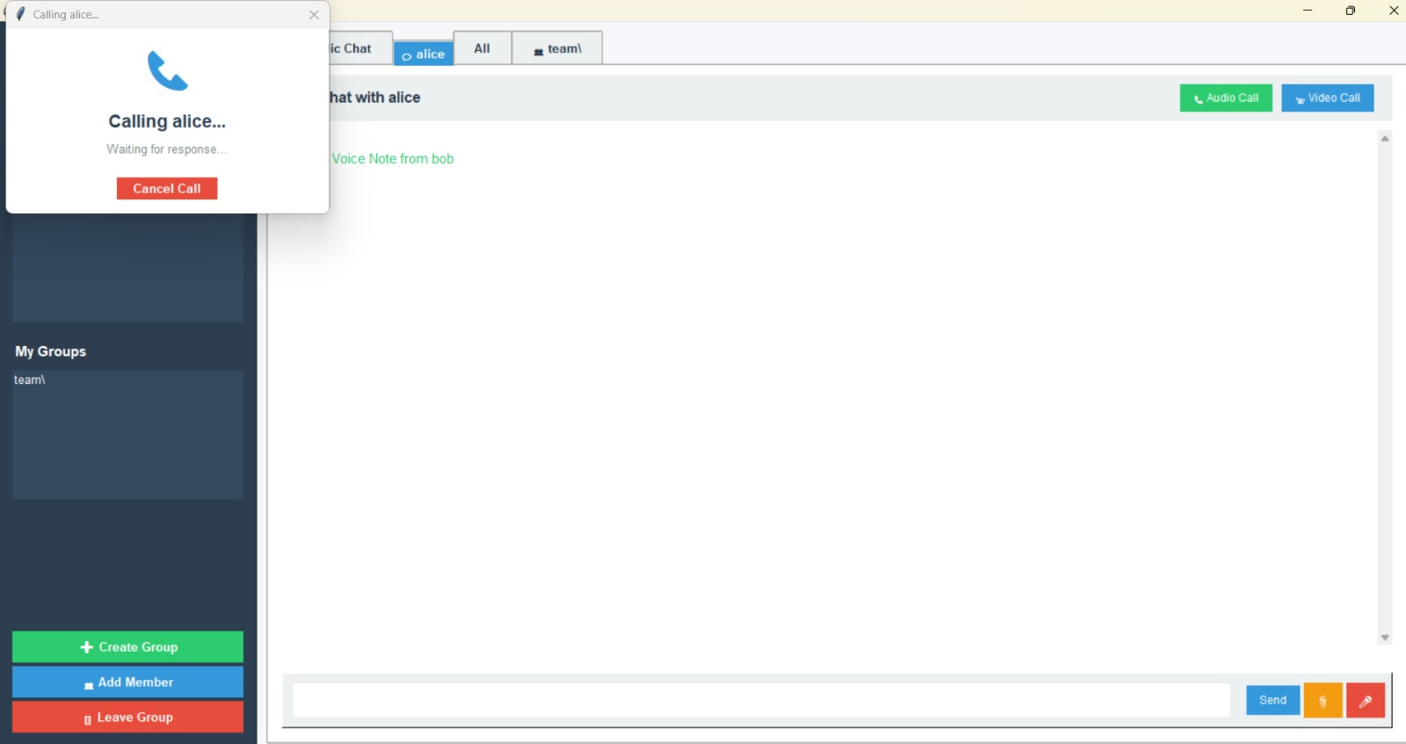

4.9 Video call Implementation

def stream_video(self, target): cap = cv2.VideoCapture(0) while self.video_stream_active: ret, frame = cap.read() if ret: encoded, buffer = cv2.imencode('.jpg', frame) b64_data = base64.b64encode(buffer).decode('utf-8') self.send_packet({ "type": "VIDEO_STREAM", "target": target, "data": b64_data })

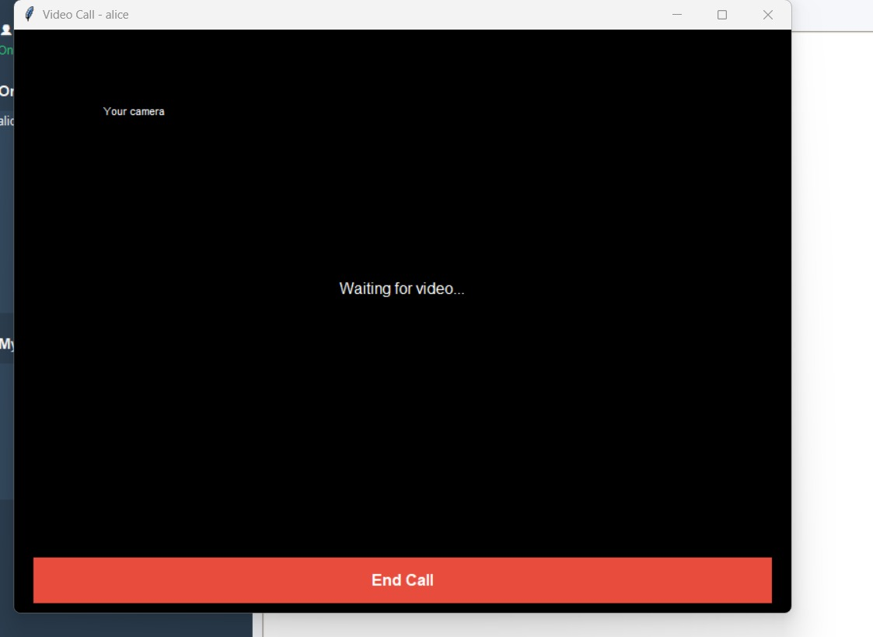

5. Conclusion
In conclusion, the Secure Chat Application successfully demonstrates the power and flexibility of Python for network programming and GUI development. By integrating core concepts such as TCP/IP socket communication, multi-threading for concurrent connection handling, and event-driven UI design with Tkinter, the project delivers a functional and user-friendly communication platform.
The application satisfies all primary requirements, including secure user authentication, real-time messaging, and multimedia support (video/audio calls and file transfers). It serves as a solid foundation for future enhancements, such as end-to-end encryption, offline messaging, and mobile platform integration. This project provided valuable hands-on experience in building scalable client-server architectures and managing real-time data flows.

