

**ICT 2104 Embedded Systems**

Team E.Steam

Requirements Report

|  |  |
| --- | --- |
| **Name** | **Matriculation No.** |
| Muhammad Faiz Bin Rahmat | 1801148 |
| Muhammad Hafiz Bin Rosli | 1802237 |
| Pravinraj S/O Subramaniam | 1802252 |
| Chia Kai Xiang | 1802133 |

# Table Of Contents

Contents

Table Of Contents 2

Motivation 3

Review of Existing Product 4

Proposed Idea 5

Requirements and Specifications 6

Functional Requirements 6

Specifications 6

Ideal Embedded System 7

Hardware CAD Design 8

High-Level Design 9

Flowchart 9

Use Case Diagram 10

Code Repository 10

Collaborators 10

Team Designation and Roles 11

Potential Challenges 12

# Motivation

With the current trends of relying on technology to conduct our day-to-day business and making our lives easier through convenience, we decided that we can aim to do the same with home security. Although Smart Door Lock has been around for awhile, it is not widely used in households.

We believe that the reason for this is the security and user-friendly usage of the smart door lock. This could be due to the complexity and vast functions that currently exists in smart door locks. Hence, we would like to improve on the security and usability aspect of the current door lock so that more homeowners would take interest in using a smart door lock.

Being new to embedded systems, we as a team, would like to push ourselves to implement out-of-the-box ideas that currently does not exist in current smart door locks. With the underlying assumption that smart door locks are inherently safe due to the technological advancements, we would like to further enhance the security aspects of smart door locks to bridge the gulf gap between the mental and conceptual model of what is secure.

# 

# Review of Existing Product

Smart door locks have existed for quite some time with the main purpose to provide homeowners convenience without having to use a traditional key. It is an electromechanical lock that is designed to lock and unlock doors. Like a traditional door lock, its main functions are to lock and unlock doors but, a smart door lock automate this process upon receiving verification from authorized users (e.g. homeowners).

Likewise, a smart door lock consists of a lock and key in the form of keycards or passcodes. Homeowners are able to control and grant users the ability to access the locks. In addition, they can also change their passcode when need be.

Powered by electricity or batteries, a smart door lock is an extension of a smart home where internet-connected devices are used to enable remote monitoring and management of household appliances such as lights. This also includes enhanced security capabilities where devices can communicate to their users for updates or alert.

However, the more a smart door lock can do, the higher the cost will be. For example, some smart door locks allows the use of virtual key where homeowners can unlock their doors using their smartphones. The more expensive smart door locks comes with a built in camera and Wi-Fi connection for monitoring purposes which will then captures an image of suspicious activity which will be sent to the users.

Many think have the impression that having a smart door lock would mean their house is generally safer and secured. However, in times of robbery, forceful entry or unwilling entry, homeowners are limited to existing security features and unable to deter perpetrators or alert the local police force.

With all these features packed in a smart door lock system, it requires a lot of memorization and recall processes while accessing all the functions in a smart door lock. This makes a smart door lock either beneficial or a bane depending on the user.

# Proposed Idea

Basic features

* Auto locking
* Passcode
* Key card

Improve security features

* In times of forceful unwilling entry - reverse keypad
* Camera for suspicious activities
* Forceful entry alarm

The S.M.A.R.T (Secure Microcontroller Alarm Reporting Technology) Door Lock aims to further enhance the security capabilities of current existing smart door locks to better protect homes with MSP432P401R microcontroller serving as the brain of the system.

Features include locking/unlocking by scanning of keycard through the use of an RFID reader. Owners of the S.M.A.R.T doorlock will also be able to unlock by entering their passcode into a keypad as well. The in-built infrared sensor will detect the alignment of the door to its door latch and will auto-lock the door after around 1-2 seconds.

Aside from the basic features mentioned above, the S.M.A.R.T door lock will also provide additional security features to further enhance the home security. One such features is the forceful entry alarm that will go off in the event that attackers attempts to break down the door, causing the alarm to go off to warn the occupants in the breach of security. Another feature would be the use of motion sensing technology to detect suspicious activity near the home and after a set time, will activate the camera module to snap a picture of the activity and send it as an email notification to alert the user of the suspicious activity. Lastly, in the event the user is held against his will and is forced to open the door for their perpetrators, the user can enter their passcode in reverse which will send an alert to the Emergency Department to respond to their location.

With these security implementations, the S.M.A.R.T doorlock aims to be the security option people will trust to keep their home safe and secure.

# Requirements and Specifications

### Functional Requirements

1. Access with Passcode
   1. The system should allow owners to lock and unlock with a passcode
2. Access with RFID
   1. The system should allow owners to access their lock with a keycard using RFID
3. Lock Door Automatically
   1. The system should automatically lock when the door is in closed position through the use of an infrared sensor
4. Display Door Status
   1. The system should display door status on the LCD when it is locked or unlocked
5. Alert Suspicious Activity
   1. The system should detect presence in front of the door
      1. After 15 seconds of no system interaction, the system will trigger the camera and email the user on suspicious activity
6. Alert Forceful Entry
   1. The system should detect forceful entry based on structural damage
7. Send Distress Signal
   1. The system should allow owners to enter their passcode in reverse for a distress signal
8. Change Passcode
   1. The system should allow user to change passcode to strengthen their security

### Specifications

|  |  |
| --- | --- |
| **Component** | **Specifications** |
| ESP8266 WiFi Module | Wifi connectivity to send image captured to email |
| Relay (5V, 1 channel) | Sends signal to toggle the solenoid |
| HC-SR04 Ultrasonic Sensor | Detect presence in front of the door |
| Solenoid lock (6V) | Simulates the door lock |
| MPU6050 IMU | Used to detect forceful entry such as temper or physical damage |
| HD44780 Character LCD Display Module | Display system messages and password entry |
| RFID Reader ID-12LA (125 kHz) | Allow keycard access |
| 971-UCAM-III | Capture and store image of suspicious person |
| 12 Key Membrane Switch Keypad (NJ) | Allow the users to enter passcode access |
| KEYES Infrared Sensor | To detect whether the solenoid is in the closed position so as to lock the door. |

# Ideal Embedded System

Our team decided that Arduino Uno will be the ideal embedded system. Arduino Uno is more versatile than MSP432 due to more complete and open source libraries that developers can use to implement their programs. This meant that the program implemented will contain less bugs and with the vast support available, it would be easy to debug.

Both microcontrollers are relatively cheap and uses low power which does not hinder our project’s capabilities. Although MSP432 uses RTOS (Real Time Operating System) which performs time-critical tasks using interrupt handlers and timers, our project does not require these capabilities due to its soft real time constraints. In addition, MSP432 has better control over hardware if performance is critical but the functionalities of our project does not require to execute performance critical tasks.

Overall Arduino Uno is simpler to use due to its Arduino framework simplifying the process of hardware and software development to get a system running. It allows for easy and fast prototyping. The Arduino hardware platform and the circuitry is already set-up with the I/O pins fed out to sockets/headers for easy access. MSP432 on the other hand requires learning and fiddling of the pins to understand its functionality. In addition, the drivers have to be coded from scratch and tested iteratively to test its functionality.

# Hardware CAD Design

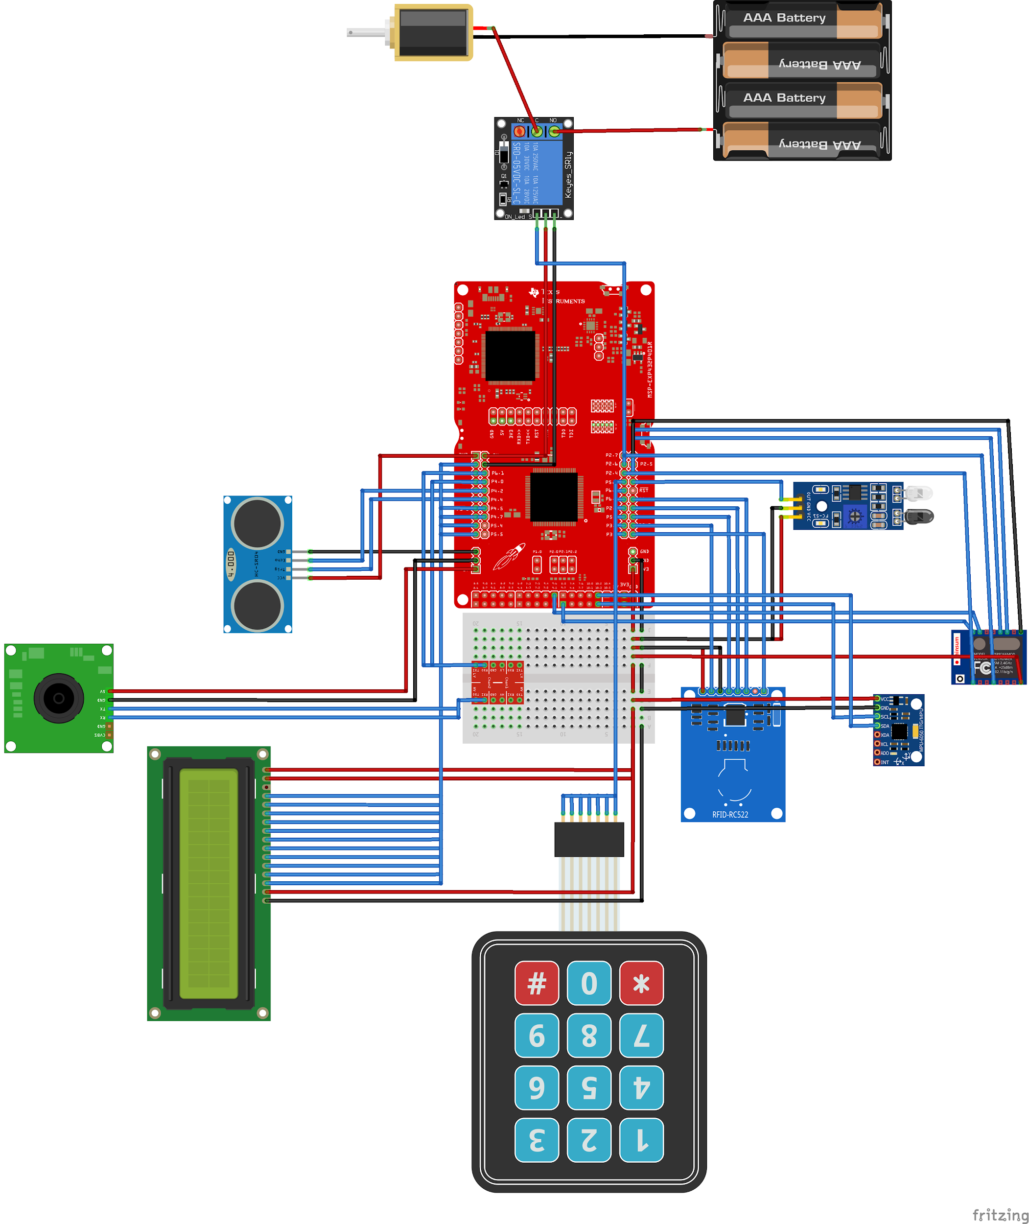

# High-Level Design

## Flowchart

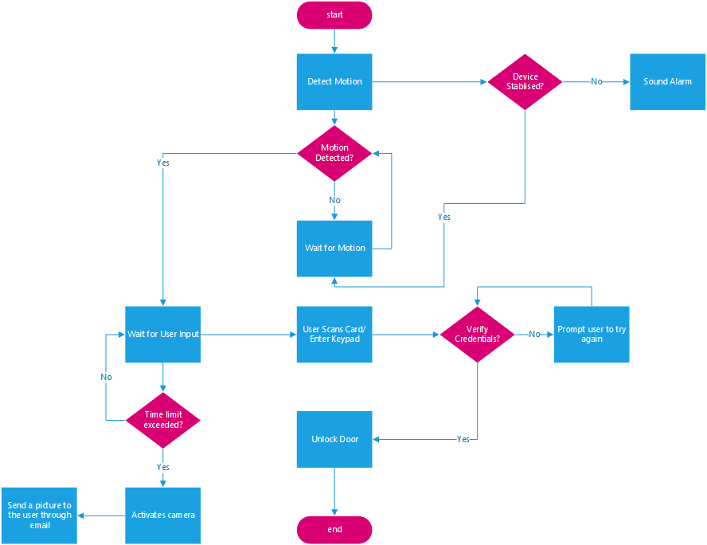

## 

## Use Case Diagram

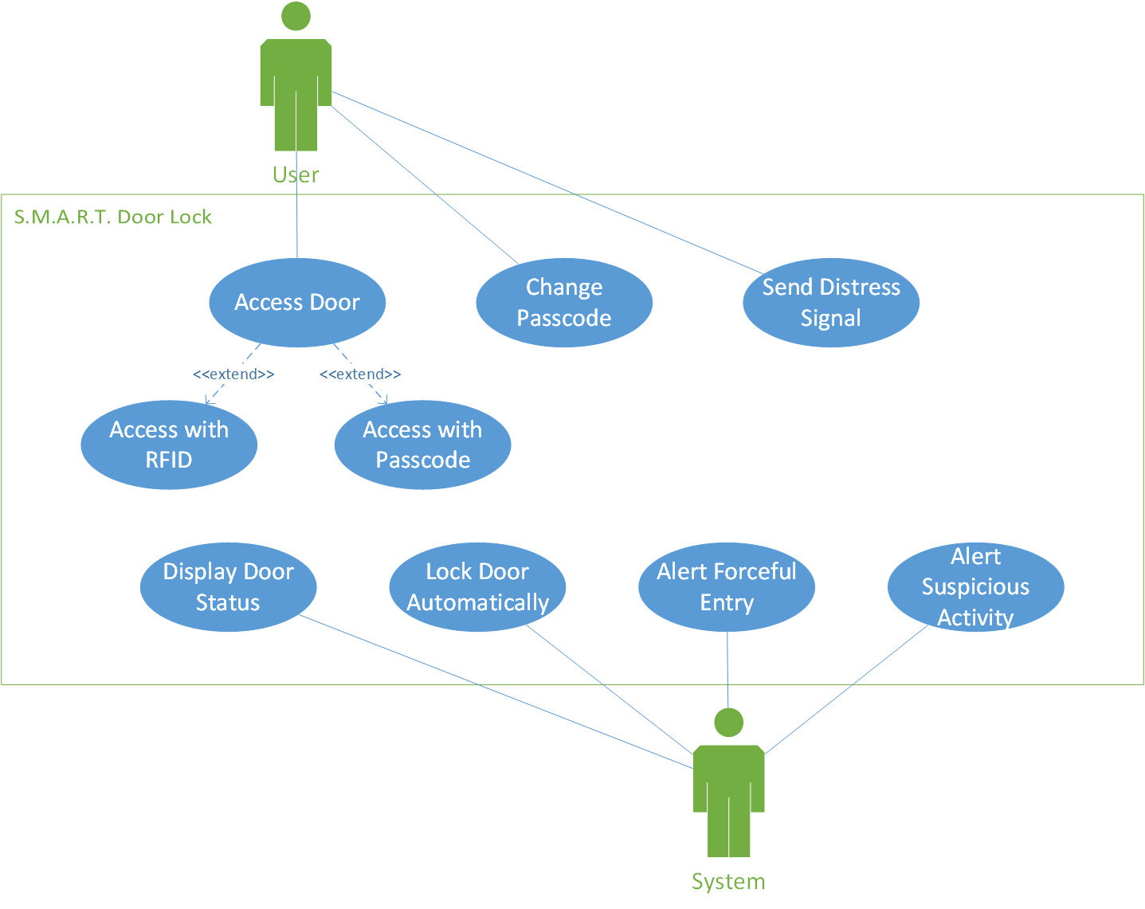

# Code Repository

<https://github.com/FizzleFaiz/ict2104_e_steam_code>

To collaborate among team members more efficiently, a code repository has been created to facilitate code distribution and work.

## Collaborators

|  |  |
| --- | --- |
| **Name** | **Github Username** |
| Muhammad Faiz Bin Rahmat | FizzleFaiz |
| Chia Kai Xiang | 1802133 |
| Muhammad Hafiz Bin Rosli | mrdhaffy |
| Pravinraj S/O Subramaniam | SilverBeardRJ |

# Team Designation and Roles

As this project requires different component modules to interact and work together into displaying results, we have spilt the project based on the following:

|  |  |
| --- | --- |
| **Member** | **Roles** |
| Muhammad Hafiz Bin Rosli | Accelerometer Detection of Forceful Entry |
| Muhammad Faiz Bin Rahmat | Infrared Sensor for Automatic closing of door when it contact with its latch |
| Pravinraj S/O Subramaniam | Ultrasonic Sensor & Camera Module for Proximity Alert |
| Chia Kai Xiang | RFID and Keypad to Solenoid for Locking/Unlocking of Door and LCD door status |

**Accelerometer for Detection of Forceful Entry**

The accelerometer will be used as the main component in detecting the structural integrity issues of the smart door lock system. It will make use of the accelerometer as well as the gyroscope axes of the component to determine whether the smart door lock is in an upright position or there has been a sudden change in angle or vibrations, simulating a forceful entry, before sounding off an alarm.

**Infrared Sensor for Automatic closing of door when it contact with its latch**

The infrared sensor is used to detect the door being in alignment and contact with its latch. Upon a set time of being in this position, the solenoid will extend out automatically to lock the door. When the door is closed, the LCD will display that the door is locked.

**Ultrasonic Sensor & Camera Module for Proximity Alert**

The ultrasonic sensor will be used to detect motion near the door and will send a signal to activate the camera module so as to take a picture of the suspicious activity. This will later be sent to the owner through email to alert them.

**RFID and Keypad to Solenoid for Locking/Unlocking of Door and LCD door status**

THe RFID breakout module will be used to scan the owner card in which the solenoid will then retract itself, unlocking the door. The keypad will be configured to a passcode that the user will be able to configure, allowing them to enter a passcode to also cause the solenoid to unlock the door. When successfully scanning or entering of passcode, the solenoid will retract and the LCD will display the status to be unlocked.

# Potential Challenges

During the course of implementing the project, there are bound to be challenges in both hardware and software.

1. Accelerometer will require some allowance to prevent false error in detection
2. The ultrasonic sensor may not be able to differentiate between suspicious and normal activities due to the possibility of countless scenarios
   1. May trigger the camera **n**-times and sending unnecessary spam notifications to the user
   2. The sensor may also not detect the movement during a suspicious event and not trigger the camera module
3. The camera module may not capture clear details of suspicious activity rendering the image useless
4. Limited memory size, will require the use of SD card to store images and constant checking to ensure that it does not exceed storage space
5. Wi-Fi has to be constantly on to allow sending of notifications
   1. Wi-Fi signal may be weak, sending the information late
6. Keypad button may be unresponsive/faulty after long usage due to wear and tear
7. Infrared sensor to detect the door latch may be faulty and may not automatically lock the door upon closing

As some of the features may not be fully implemented due to the challenges posed, we will demonstrate it as proof of concept (e.g. the sound alarm being replaced as LED light going off).