Purpose: To describe the code used for the first release of the begin plan check script.

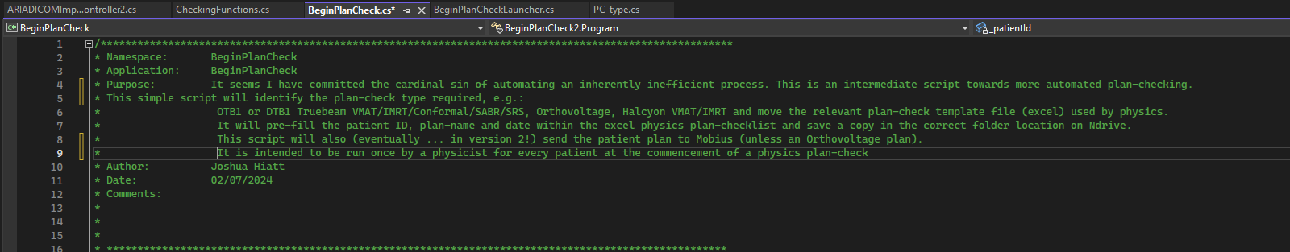
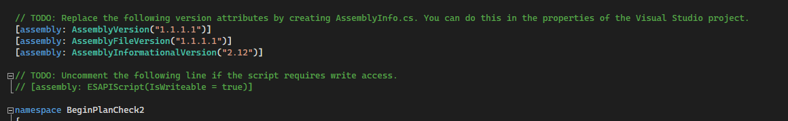
Code location: \\Ordcari-mfs001\va_data$\PublishedScripts\StandAlone\BeginPhysicsPlanCheck\BeginPlanCheck\
Executable location: \\Ordcari-mfs001\va_data$\PublishedScripts\StandAlone\BeginPhysicsPlanCheck\BeginPlanCheck\bin\release
Location of back-up copy of version 1 code:
N:\Team\Orange\Radonc\Physics\Projects\039_AutoPhysics_PlanChecks\Code_BackUp_13122024

Overall structure:
Using scripting tool in ARIA will start the BeginPlanCheckLauncher, this BeginPlanCheckLauncher.cs file will use the context of the users currently open radiotherapy patient and plan, extract the required information and send it to the BeginPlanCheck.cs file. The BeginPlanCheck is the main file that determines the plan-check type and performs the plan-check accordingly. It will create the patient folder, copy the relevant spreadsheet, and will run the required checks by calling them from the CheckingFunctions.cs file. Once all the checks have been completed, a tick or cross symbol is written to the spreadsheet and it is saved in the patients folder.

Known limitations:
- Does not work for orthovoltage, electrons.
- May occasionally misclassify SABR plans (believed to be fixed in this release).
- SABR checklist item ‘all beams share same isocentre and is within PTV’ will be marked as true (✓) when all beams share same isocentre, but the script does not actually check that this isocentre is within the PTV. Item will be marked as false (x) if the beams have multiple isocentres.
- Dose-grid spacing in sup-inf direction (for HFS) is not checked (but this is consistent with our current manual process).
- Behaviour has not been tested for exotic situations e.g. mixed technique electron + VMAT, or mixed FiF + VMAT. Conventional Hybrid (IMRT + VMAT) should work, but if multiple techniques are used, manual checks are recommended.

High-Level Overview:
This script is designed to run a specific executable (BeginPlanCheck_v1.exe) that checks and processes a patient's radiotherapy plan in the ARIA system. The script will use the current patient, course, and structure set to gather necessary data, then start the plan-check process by launching an external application (the executable). It also checks for issues in the patient data, such as missing IDs or structure sets, before launching the executable.

Step-by-Step Documentation – BeginPlanCheckLauncher.cs:
Scott Pigott wrote the original launcher code that is used here. Only minor modifications were made.

1. Class Definition:
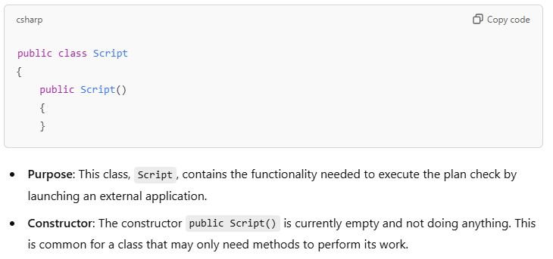
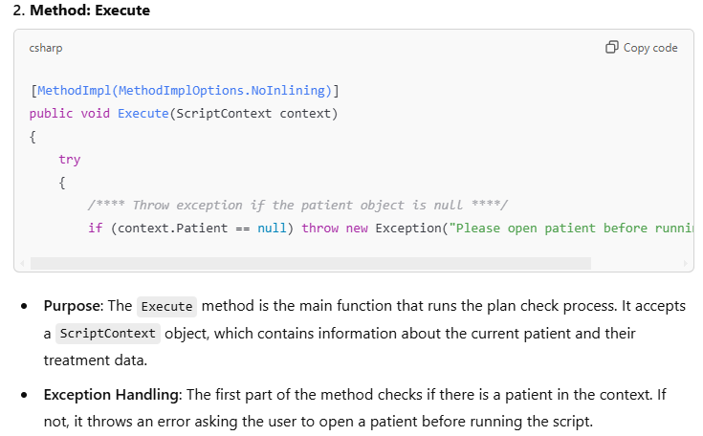
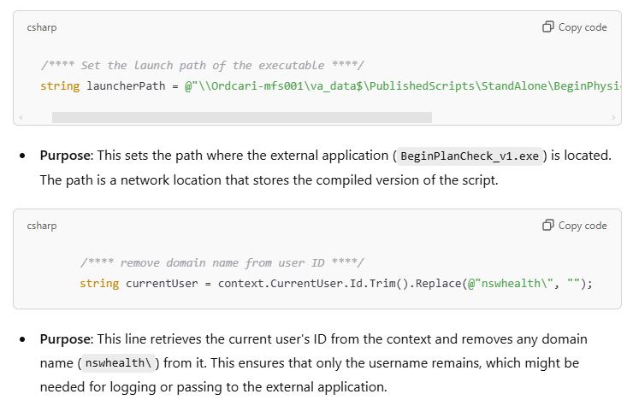
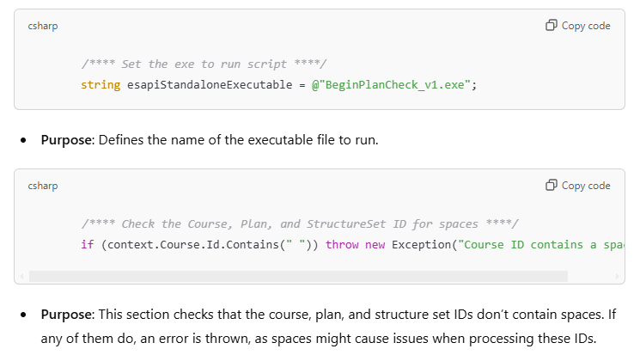
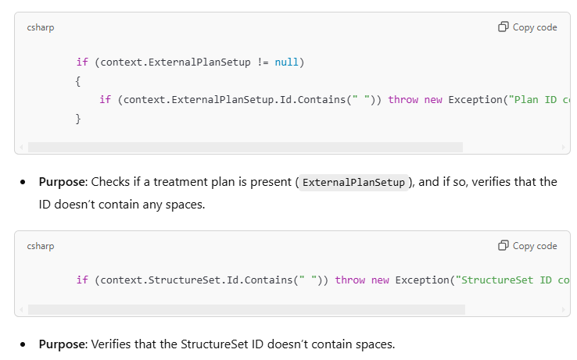
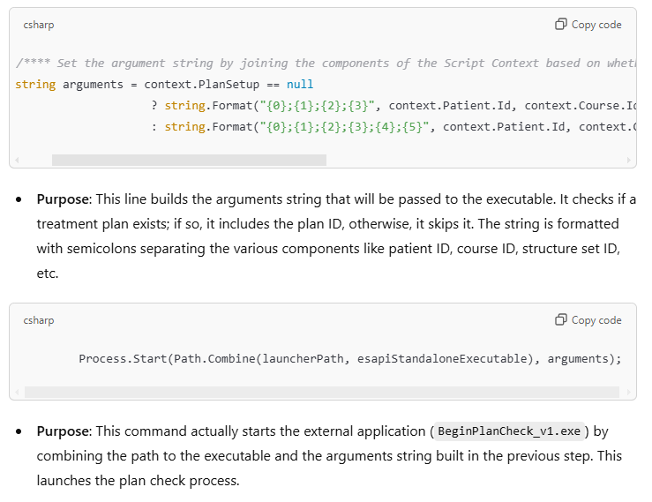
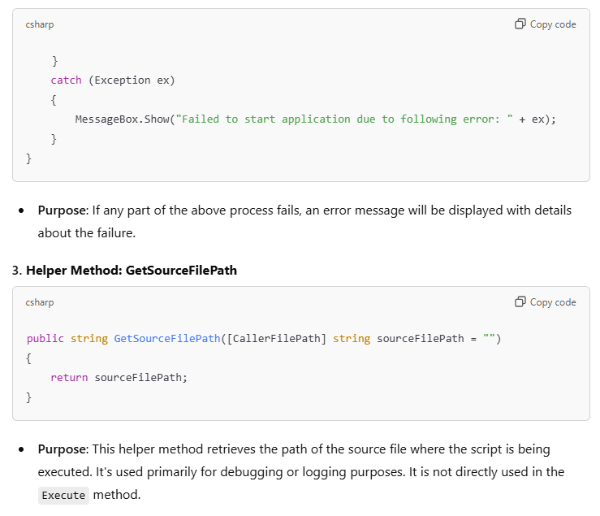

Key Concepts for Non-Coders:
- ScriptContext: This is an object that contains all the information about the current patient, course, treatment plan, and structure set. It provides the context needed for the plan check.
- Arguments: The arguments passed to the external application are simply a series of identifiers and user information that tell the executable what to process.
- Error Handling: The script ensures that if there are any issues (like missing data or improperly formatted IDs), the user is notified, and the process doesn’t run incorrectly.

Final Thoughts:
This script is used to automatically run a plan check for a radiotherapy patient in ARIA by calling an external executable. It ensures that all necessary patient data is present and properly formatted, and then launches the plan check with the required parameters. Any errors in patient data or during execution will result in a clear error message, allowing for easier troubleshooting.

BeginPlanCheck.cs

Overview
The script is the one that is run once the launcher starts the executable. It automates the process of filling out some items of the plan-check checklists for different treatment types and machines (like OTB1, DTB1, and others). It fills in the patient's data into an Excel template for each plan type and moves the filled template to the correct directory.

Key Features:
- Treatment Types and Checklists:
  - This section defines various treatment types (e.g., Conformal, IMRT, VMAT, SABR, etc.) and their associated checklists (like OTB1, DTB1, Halcyon).
  - Each treatment type has different plan-checklists, and the script identifies which checklist template to use based on the treatment plan.
- Variables:
  - Several variables are defined to store details such as patient ID, course ID, plan ID, structure set ID, treatment machine type, treatment technique, and various flags for different treatment characteristics.
- Template and Destination Setup:
  - The script sets up paths for the Excel templates and destination folders. These paths are dynamically determined based on the type of treatment plan (Conformal, Electron, Field in Field, etc.).
- Beam Analysis:
  - The script identifies the treatment technique (e.g., VMAT, IMRT, SABR) by inspecting the last non-setup beam in the treatment plan and checks for other treatment characteristics, such as if the treatment is a hybrid plan.
- Plan-check Type Identification:
  - Based on the machine type (e.g., OTB1, DTB1, OHAL) and the treatment technique (e.g., IMRT, VMAT, etc.), it determines the appropriate plan-check type.
  - The planchecktype variable is assigned a number that corresponds to a specific checklist (e.g., 1 for Conformal, 2 for Electron, 3 for Field in Field, etc.).
- Setting up Default Values:
  - The script assigns default values for fields like dose grid size (desired), algorithm used (desiredphotoncalcalgo), and other fields like reviewer and approver names.

Workflow:
- The script checks the machine type and treatment technique.
- Based on these checks, it assigns a planchecktype and determines which template and folder to use.
- The script also handles edge cases for hybrid plans, special treatment techniques like SABR or SRS, and different treatment machines.

Next Steps:
The script continues with a switch case structure to assign the correct template path, destination folder, and other values based on the treatment type. Below is a line-by-line description of the code.
Section 1- header and meta-data (green lines are comments and not used by code).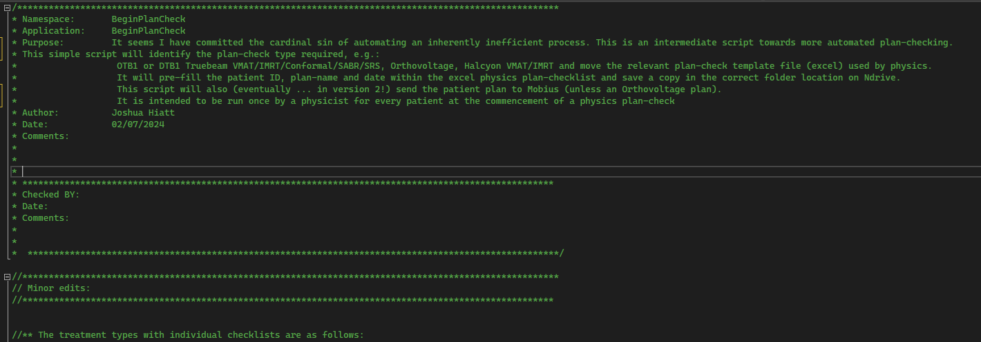
This section contains comments that provide a high-level overview of the script.
- Namespace: It defines the namespace BeginPlanCheck, which organizes the code logically.
- Purpose: Describes the goal of the script. It automates part of the physics plan-checking process for patients in a medical system.
- Author/Date: Information about who wrote the code and when.
- Comments: Placeholder for future comments on revisions or issues checked by other developers.
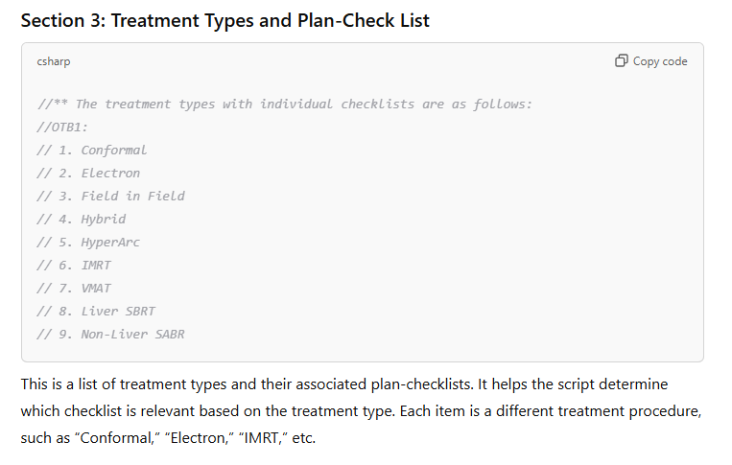
These are just comments that describe the numbering system that is later called by the switch case. Modifications to this section do not change any code behaviour.
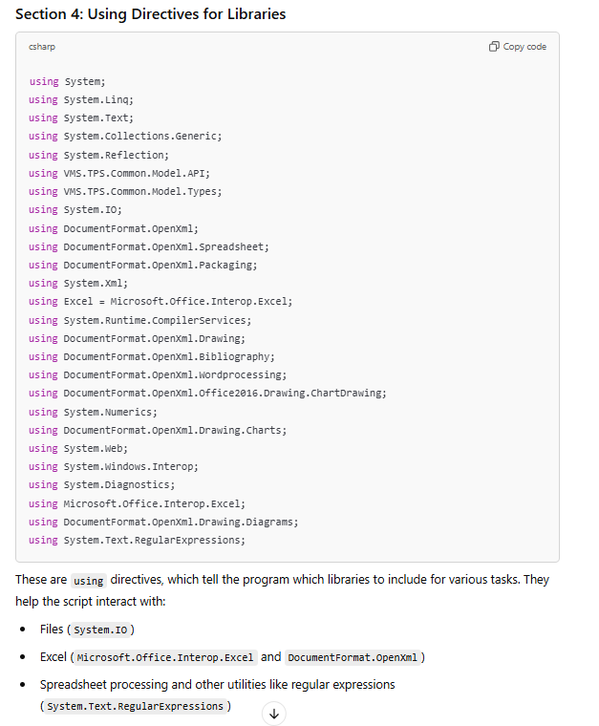
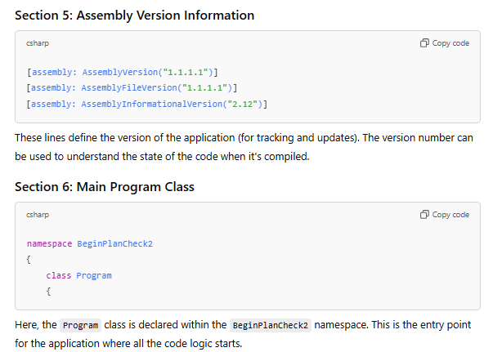
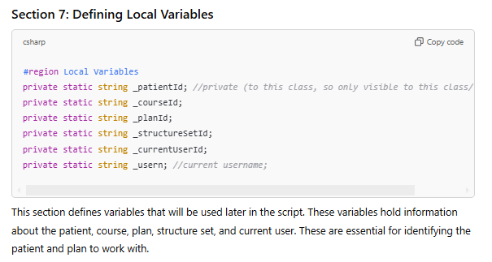
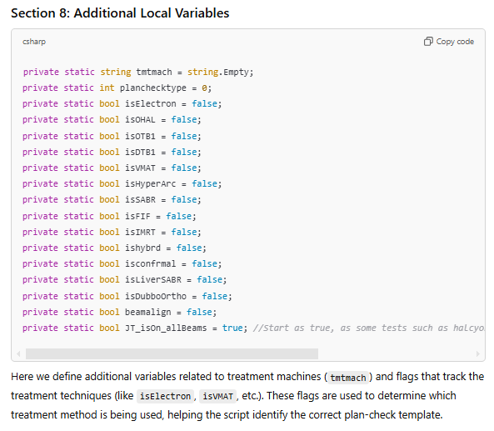
In C# language, it is preferred to initialise or assign variables before they are used. Often placeholder values are assigned until they are used-proper.
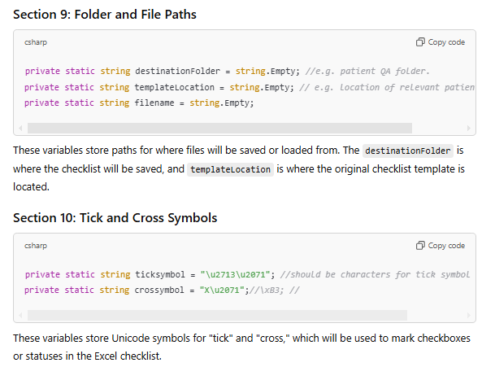

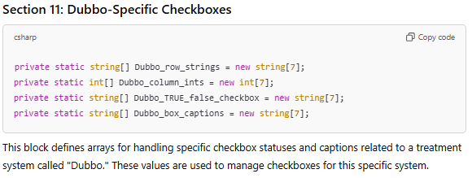
The Dubbo specific check boxes are not actually used in this release version. But could be modified to contain values to send to the create check-box function for a future release.
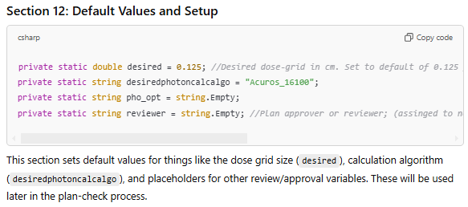

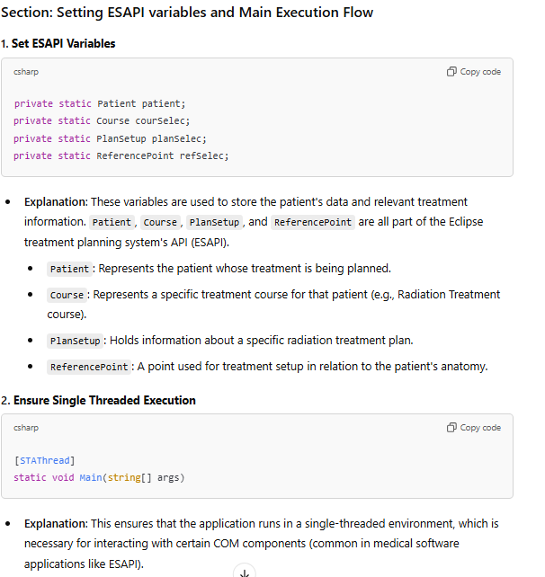

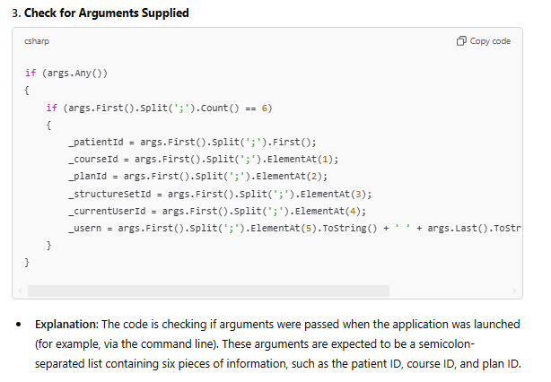
These arguments should have been populated with the context of the users environment when the script started to run, and come from the beginplanchecklauncher.cs.

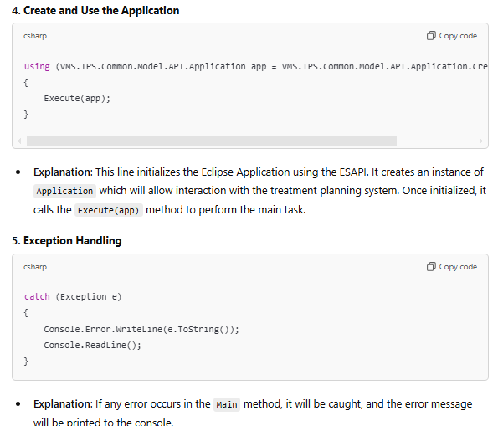
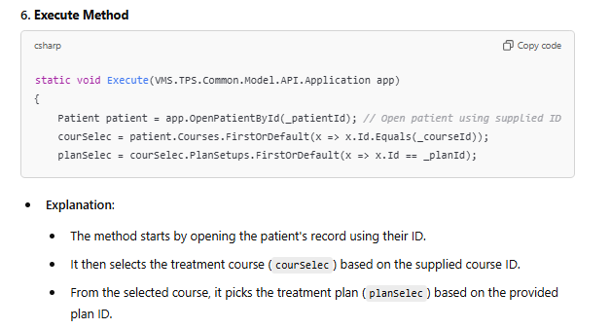
The patient record ID, treatment course and plan are populated by the launcher when the user starts the script. It pulls these values from the users context which is whatever patient, course and plan the user has open when the script is launched. It is the users responsibility to ensure they have opened the correct plan from which to perform the plan-check.
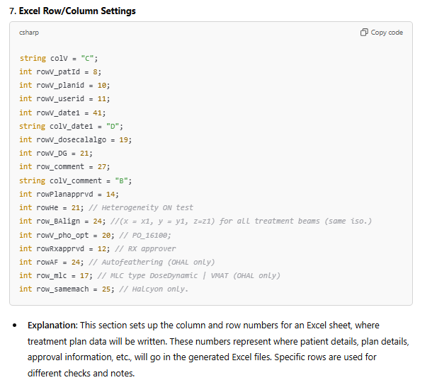
These are the default row and columns, later within the code they might be redefined depending upon the plan-check type; as each type of plan-check currently has different formatting in the excel checklist sheet.

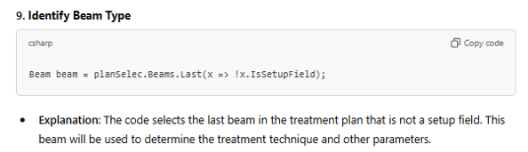
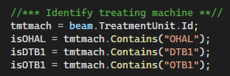
A treatment machine is assigned, and then tested to see if it is halcyon, DTB1 or OTB1. The relevant of the following: isOHAL, isDTB1, isOTB1 booleans will return true if the treatment unit ID contains the relevant string, and be false otherwise.

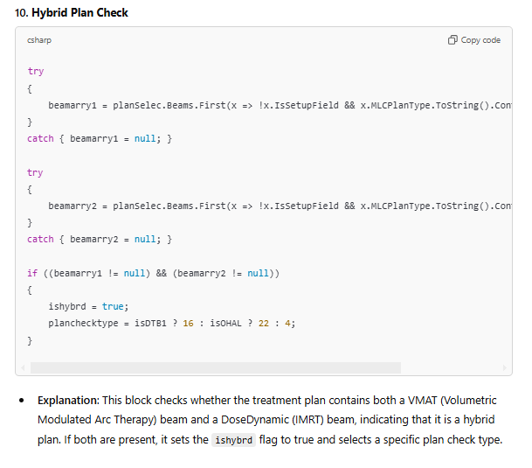
It does so by searching all the beams in the plan for beams that meet the condition that they are non-setup fields and the MLC plan-type is VMAT, if any one or more meet that criteria, then the beamarry1 boolean value is set to a non-null value. Then it repeats the search, this time checking that any of the non-setup fields contained in the plan have the MLC plan-type set to DoseDynamic. If this criteria is met for any beam in the plan, than the beamarry2 boolean is set to a non-null value. If both beamarry1 and beamrry2 variables get assigned, then the plan must be a hybrid. A hybrid plan-check type is then assigned based on whether the treatment machine is DTB1 or Halcyon, or finally by elimination OTB1. This bloc of the code has not been extensively tested, as hybrid plans are rare.

These lines just write the beam technique and the plan-name to the console window (this is the black command line box that pops-up each time the user runs the script). They can be useful for debugging purpose but serve no functional use.
Now that we have established the plan is or isn’t hybrid – can continue to classify the plan-type (which is essential if non-hybrid). It is assumed from this point forward that the fields are all homogenous in treatment type. E.g. there is no mixed conformal or mixed VMAT or mixed electrons. Only the last non-setup beam in the plan has these classification tests run on it. Users will need to revert to a manual plan-check for any very unusual plan-types (e.g. mixed).
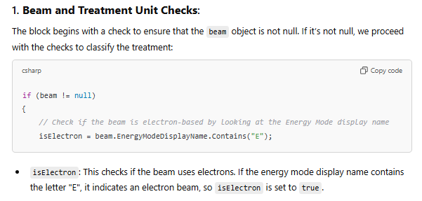
This is case sensitive.
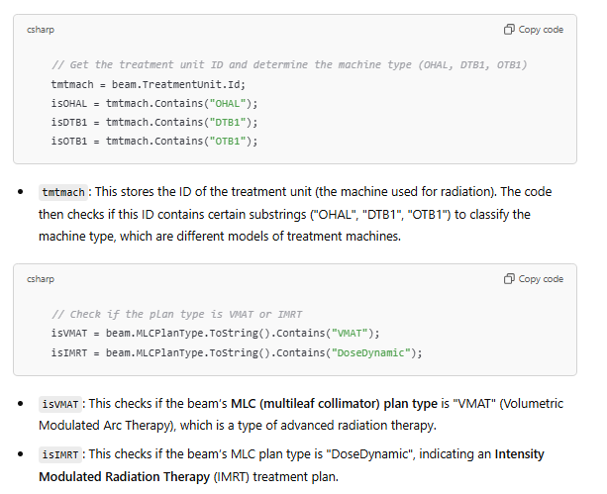

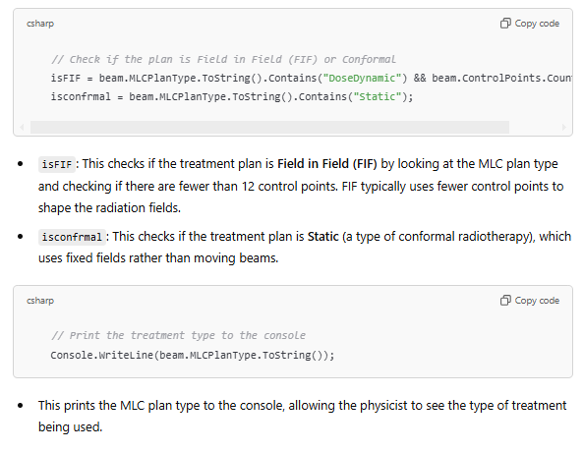

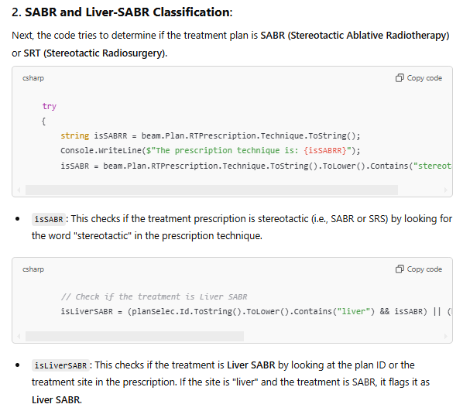
If either the plan ID or the RT prescription site contains the word liver, and the RT prescription technique contains the word stereotactic then it will classify the plan-check type as Liver SABR. There is a small risk of misclassification here, as sometimes the technique can be given as other types. So be vigilant for liver SABR (it should be obvious when the script gets it wrong, as liver SABR will have many other associated tasks). I have not encountered any misclassifications in liver SABR over the 200 plan-checks that the script has been tested on.
SRT_criteria: This checks if the treatment meets certain conditions for Stereotactic Radiosurgery (SRT):
- The plan must involve more than one fraction.
- The dose per fraction must be at least 6 Gy.
- The treatment cannot be IMRT.
isSABR (continued): If it’s not already determined to be SABR, the code further checks if the plan ID contains the word "sabr" or "SRT", or if the treatment meets the SRT criteria defined earlier.
Noting that for SRT (non-HyperArc) we use the non-liver SABR plan-checklist.
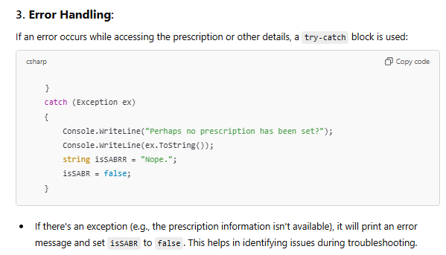
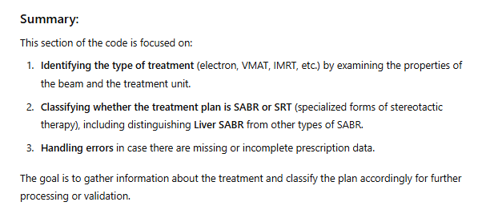

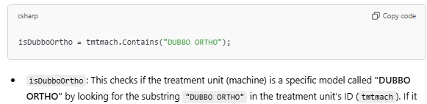
Note that the script does not currently work properly for orthovoltage plans. This is for a future release.

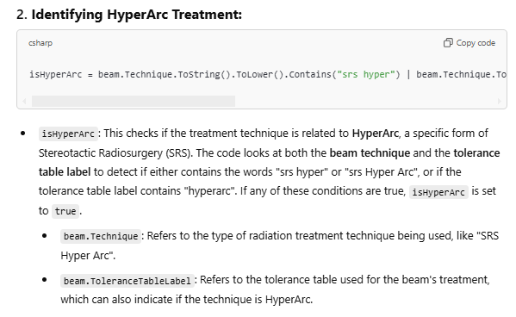
If a HyperArc plan-check is misclassified, then I suggest users must check the tolerance table is correctly set to HyperArc as this is most likely incorrect.
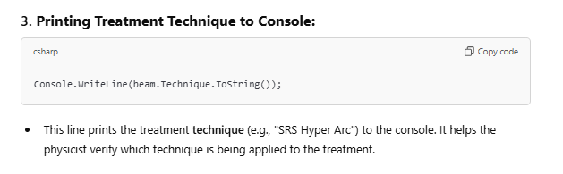

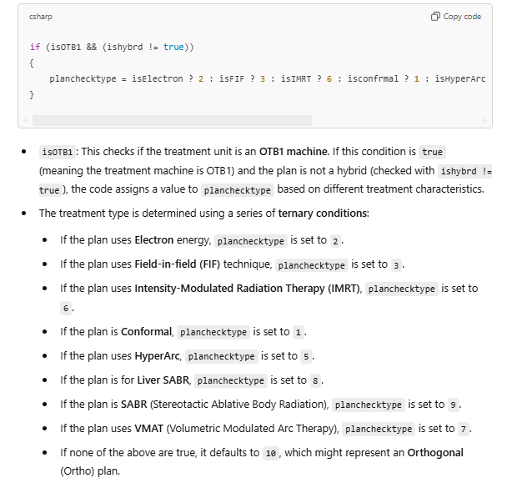
*Obviously Ortho is short for orthovoltage, not orthogonal.
Full nested ternary conditions (zoom in to see):
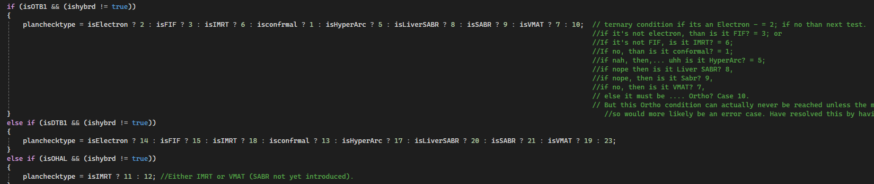
A ternary condition has the following syntax: “(condition) ? (value if true) : (value if false)”; they are similar to nested IF statements in excel. Note that this series of ternary conditions will only give 1 number and will give the first plan-check type that evaluates to true. The order of evaluation is important, so be very careful if you ever want to edit these.

Note that this script assumes that IMRT can never be SABR.
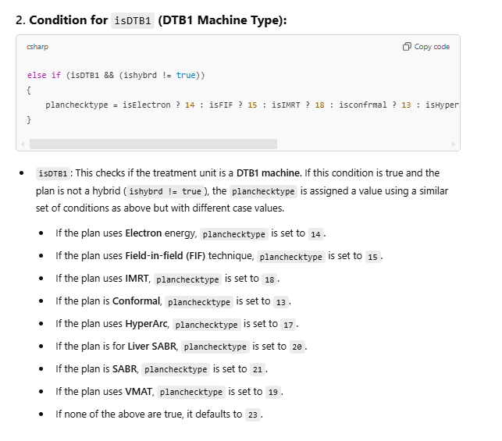
The possible plan-check types within this script are: //** The treatment types with individual checklists are as follows:
//OTB1:
// 1. Conformal
// 2. Electron
// 3. Field in Field
// 4. Hybrid
// 5. HyperArc
// 6. IMRT
// 7. VMAT
// 8. Liver SBRT
// 9. Non-Liver SABR

//Ortho:
// 10. Ortho

//Halcyon:
// 11. IMRT
// 12. VMAT

//(repeat for DTB1? unless different plan-checklists).
// 13. Conformal
// 14. Electron
// 15. Field in Field
// 16. Hybrid
// 17. HyperArc
// 18. IMRT
// 19. VMAT
// 20. Liver SBRT
// 21. Non-Liver SABR

// 22. Halcyon Hybrid.

//23. Dubbo Ortho.
Note that the following plan-check types do not currently work in this release: Ortho (both sites), Electrons.
The following plan-check types are not tested at all: Halcyon Hybrid.
The following have not been extensively tested: Conformal, FiF, All Dubbo (But think these work).
Extensive testing for Orange has been done for: VMAT/IMRT for both OTB1 and Halcyon. Moderate testing has been done for SBRT/SABR and HyperArc.
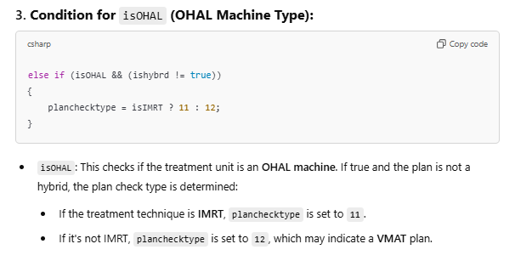
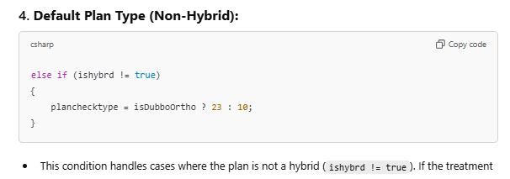
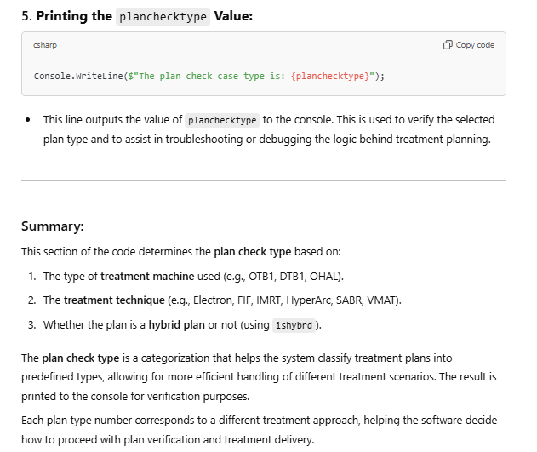
Now that the plan-check type has been assigned, a switch case will be used to assign the location of the plan-check template, as well as the applicable formatting on the excel sheet:
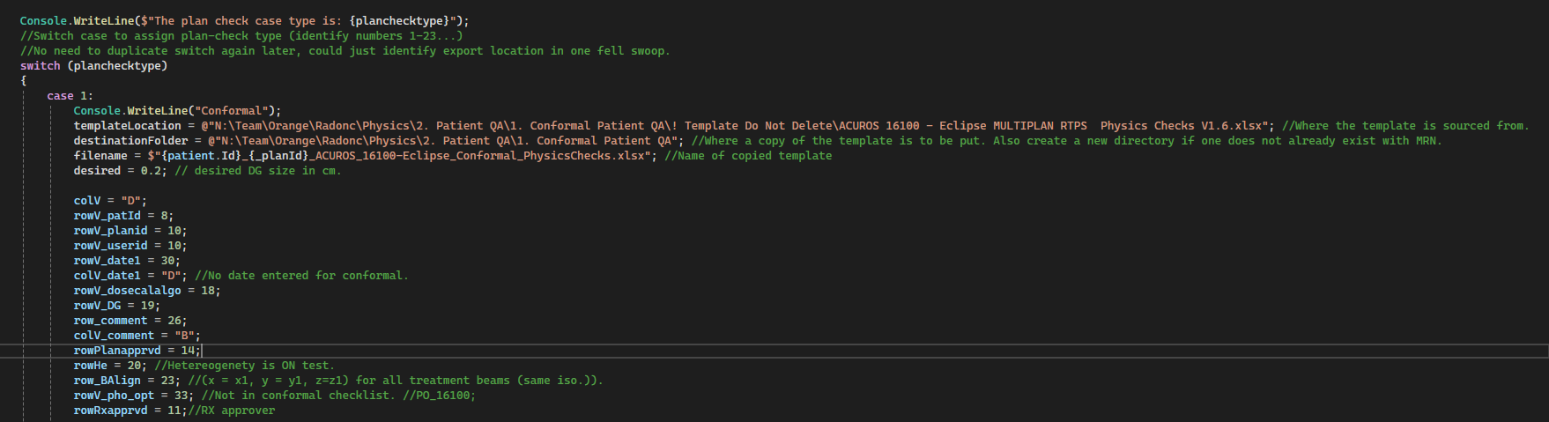
This is the formatting required for case 1, a conformal plan on OTB1.
Some other cases:
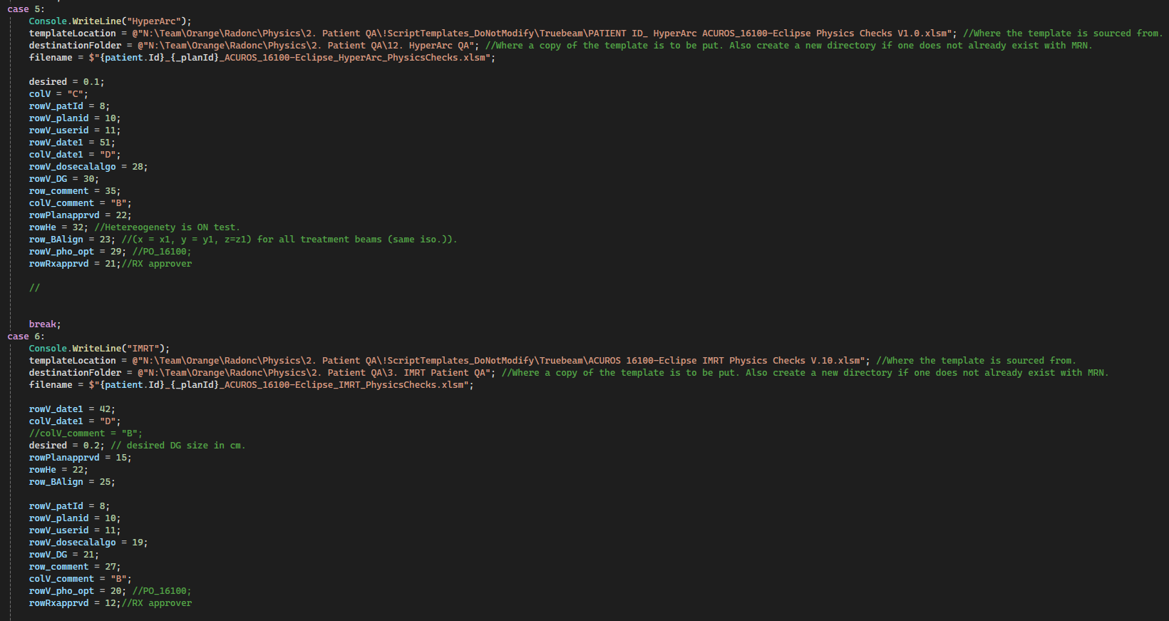
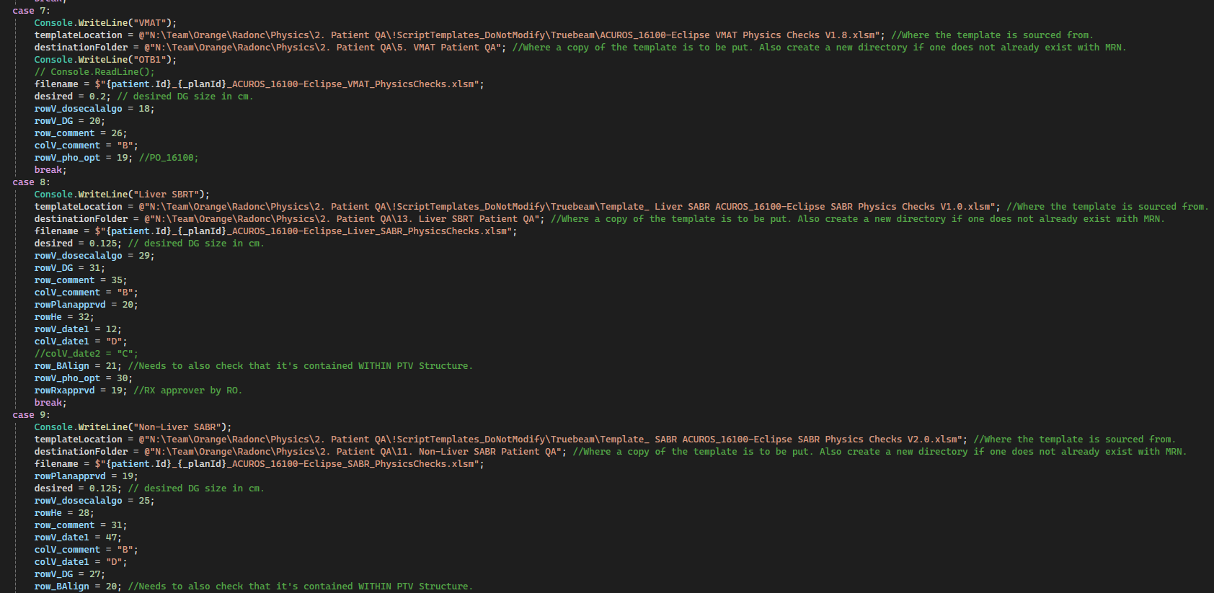
….
The case number corresponds to the planchecktype number that was assigned earlier. The switch-case command will apply only the one, the relevant case. In this section the path to the excel plan-checklist template is specified (specific to the particular plan-check type), as well as the path to the destination folder for this plan-check type. The other values are the unique row and column mappings specific to the plan-check type and associated excel plan-checklist. E.g. Case 5 – HyperArc plan-check type sets the ‘rowV_DG = 30’, this is the cell row number of the dose-grid test check-box in the associated excel sheet. Changing this number will change where in the excel sheet a tick is written when the dose-grid test is perform. The ‘desired = 0.1’ parameter refers to the desired dose-grid size (in cm) for this plan-check type. Later in the script a function is called that will check if the plan has a dose-grid less than or equal to this desired value. Note that it is set to 0.1 for HyperArc, 0.125 for SABR and 0.2 cm for all other plan-check types.

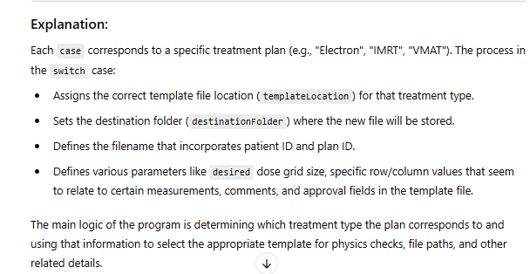

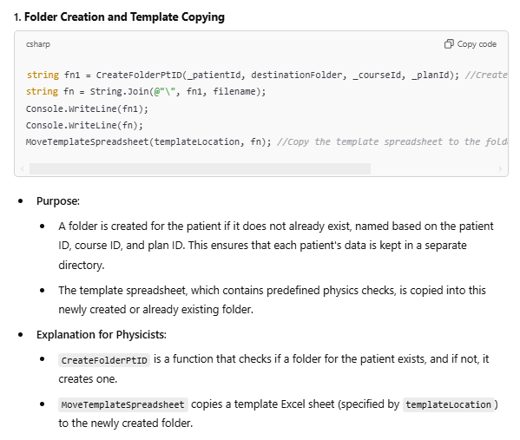
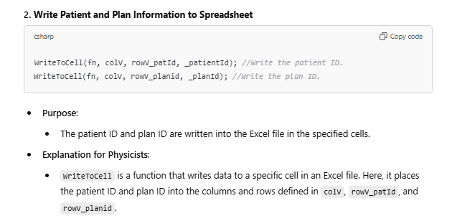

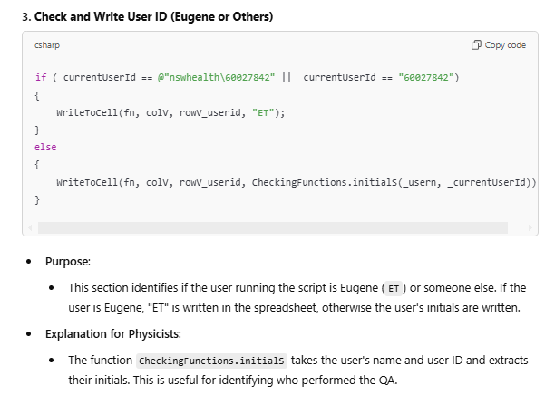
Customised behaviour for ET, as by default this function would return initials of ST.
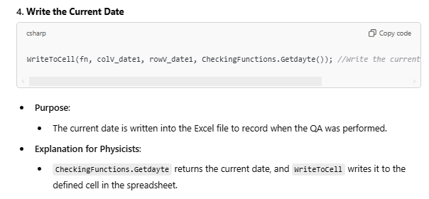
Getdayte is the name of the function, this function is stored in another .cs file within the C# solution, known as CheckingFunctions.cs. The documentation of the CheckingFunctions code is given in a later section.

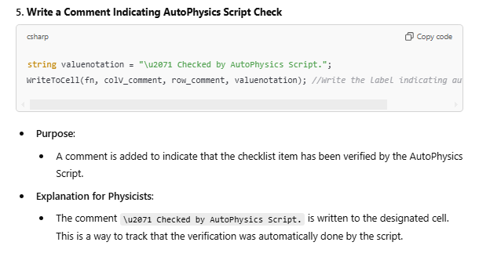
This is written into the comment cell on the excel sheet.
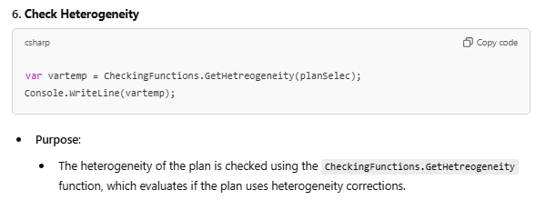
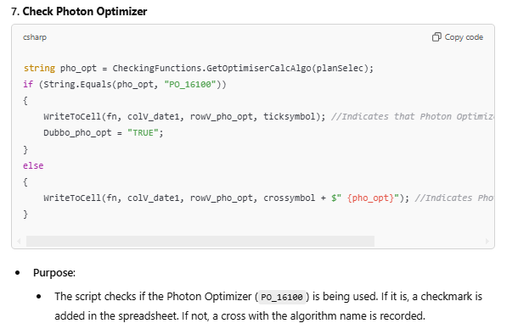
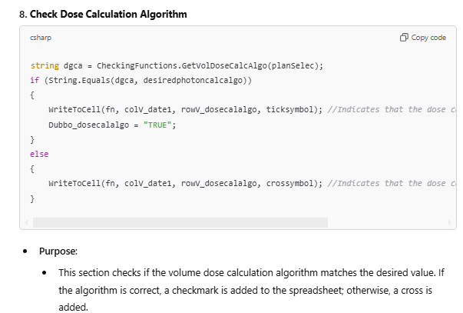
E.g. Acuros.
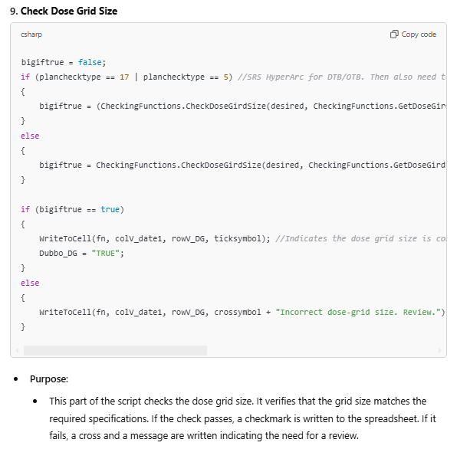
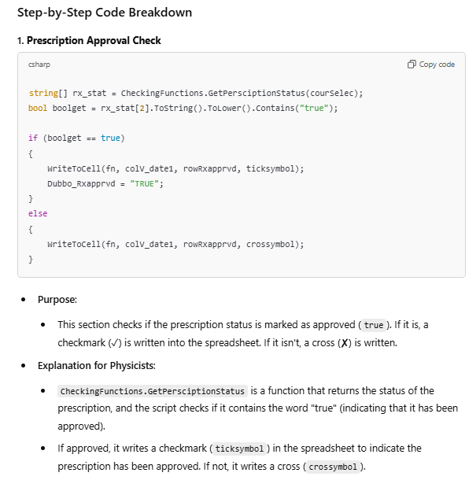
Misspellings are intentional (sometimes), it helps identify functions that I’ve written, as opposed to inbuilt esapi commands.
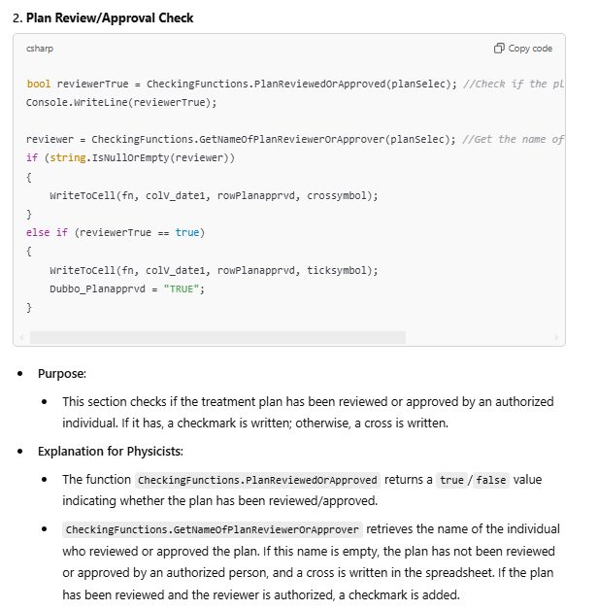
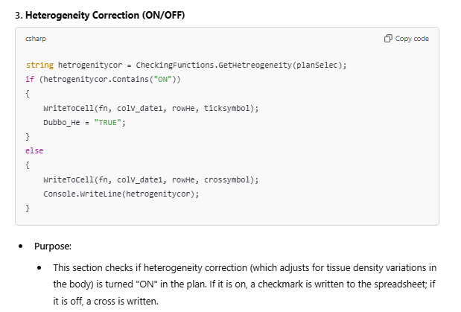
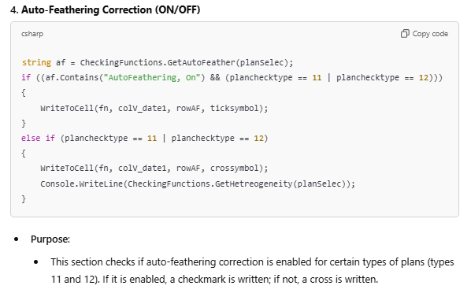
Planchecktypes 11 and 12 refer to Halcyon IMRT and VMAT.
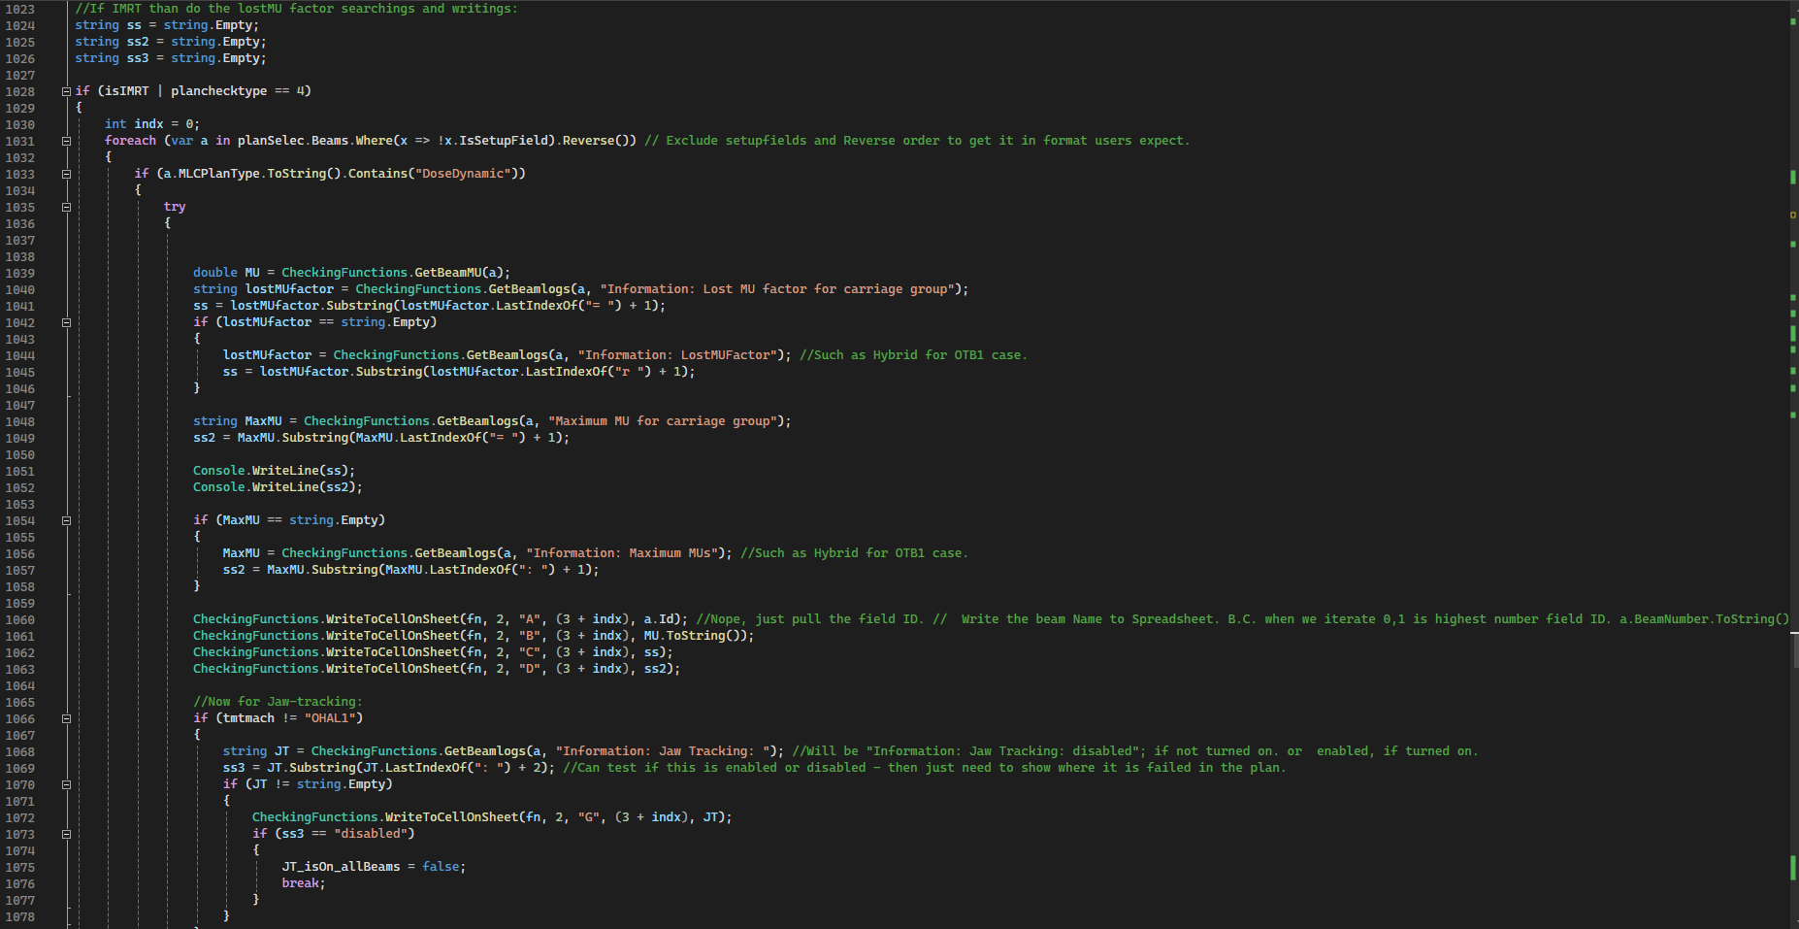
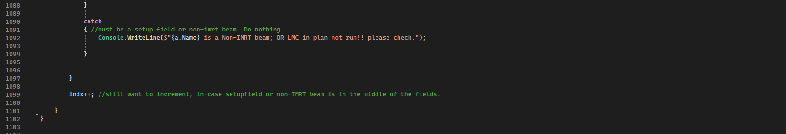
This check-list item is applicable only to IMRT plans (Truebeam or Halcyon). It will iterate through each IMRT type treatment field, searching the beam calculation logs for specific search strings (Lost MU factor, maximum MU, etc…). If it identifies occurrences of these exact strings it will pull the relevant index of where this string occurs from the field calculation log, and knowing the indexing pattern it should pull the relevant value. It then writes these into the relevant sheet in the plan-check spreadsheet. This is for the checking if the LMC has been run, to ensure there are no lost MUs. It is unknown exactly how this test will perform when there are multiple carriage groups for a given field – presumably it will give incomplete values.
If this test fails to completely write values for ALL the IMRT fields, then it is very likely that the LMC calculation has not been run correctly and the physicist will need to manually check – with the expectation that the plan will likely have failed this test.

Continuing on, the next bloc of the code will, if it’s not the Halcyon, repeats the log examination process, to search the logs to identify if jaw-tracking is turned on for each beam. And records this is the same sheet, in the rows on the far-right hand side.
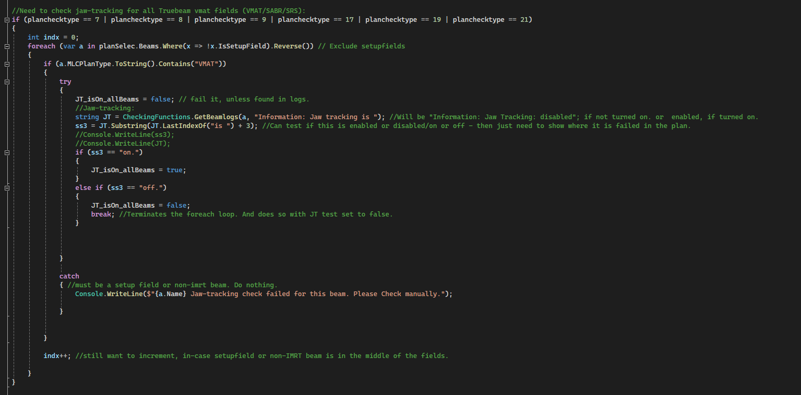
This section tests for all non-Halcyon, non-IMRT photon fields (so VMAT, SABR, …), that jaw-tracking is on. By searching through the calculation logs for each beam.
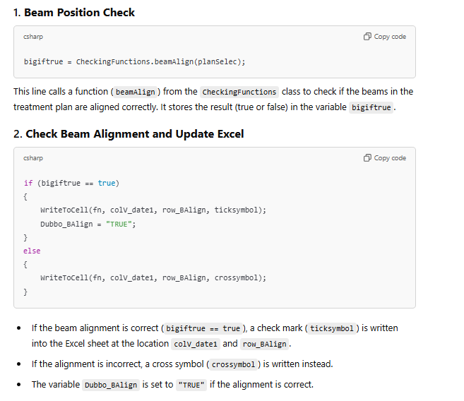
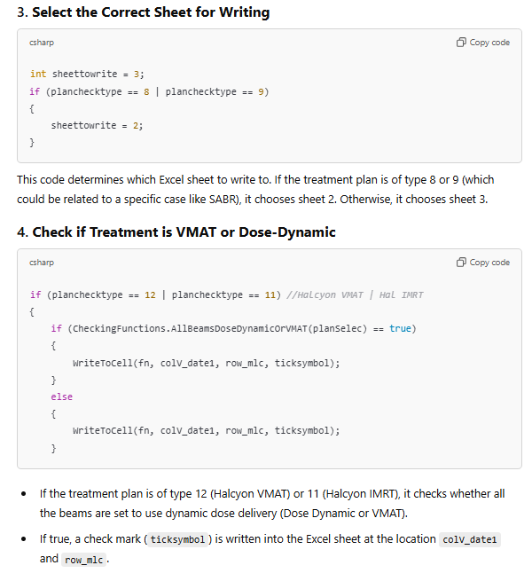
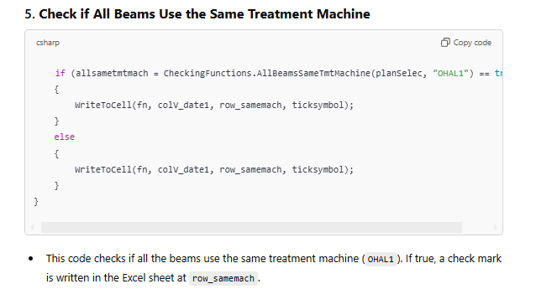
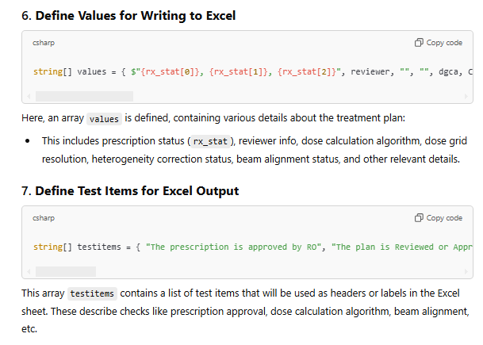
These two arrays (values and names) are then written to sheet3 (or sheet2 for SABR/SRS plan-checks), this is the additional sheet that can be used as a reference to check what values the script has pulled from the plan.
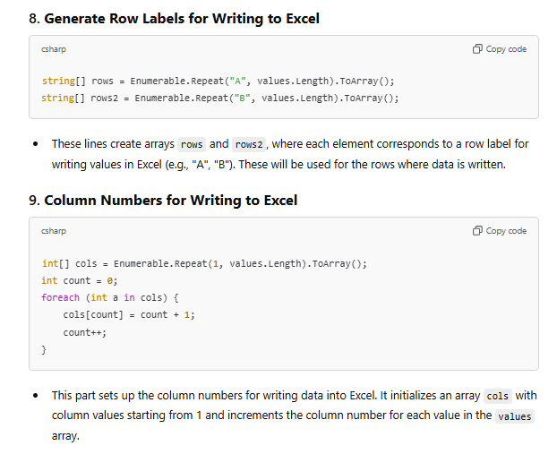
This is just the formatting to get it to be able to write these arrays to sheet2.
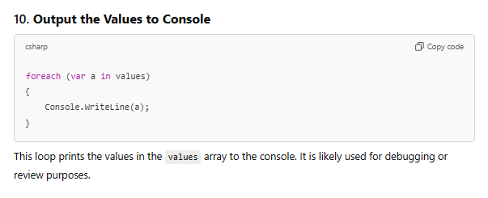
Yes.
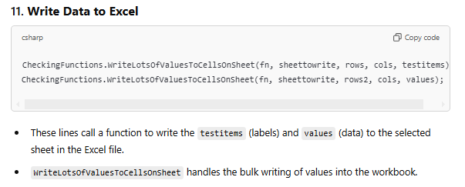
This is for the sheet2/as applicable.
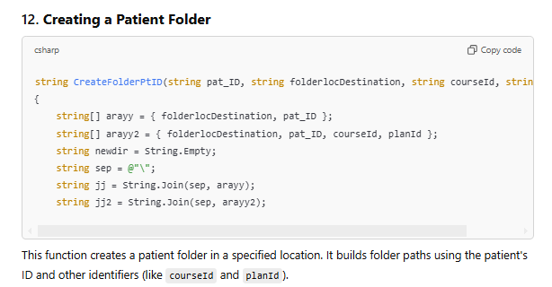
The function continues below:
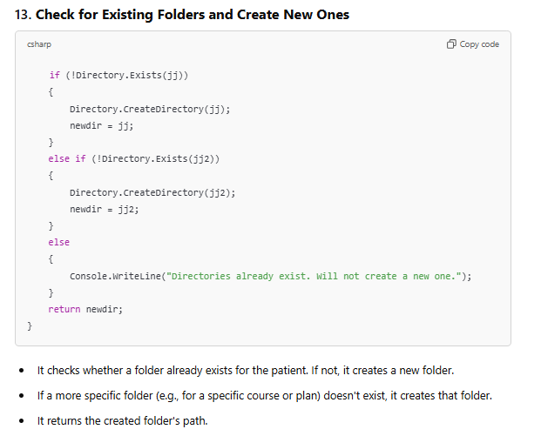
It uses the folderlocation destination (e.g. N:/…./physics/patient_QA/whatevertreatmenttype) that has been assigned by the switch-case and planchecktype logic. Note that this is the definition of the function that performs this task. But it is actually called earlier in the code. Will consider moving this to the CheckFunctions.cs file in future releases. If the patient already has a folder for this planchecktype, it will create a new more specific one, with format: Course ID/plan ID. If there already exists a patient folder and a patient folder/course ID, then this function will do nothing (so it won’t over-write anything). For complex patients with multiple plans of the same type in the same course, consider renaming the second folder the script will create, to something that differs from the course ID. Then further iterations of the script for that patient for that plan-check type for that course may continue to be run. Will consider addressing these edge cases so that such workarounds are not required in future releases.

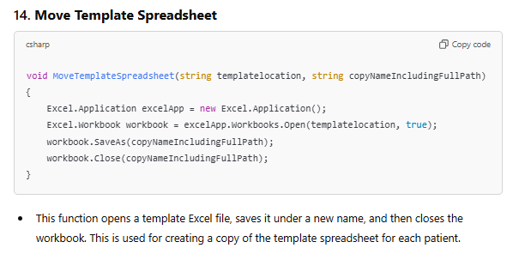
Once again, this is just the function definition. This was called earlier in the code (after the planchecktype was assigned).

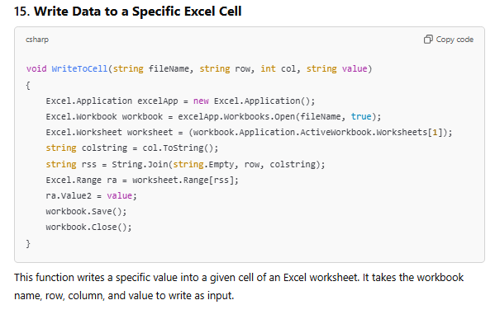
Called earlier in the code, when writing single values to a single cell. Future re-writes of this code should avoid using this function when possible and should instead use the CheckingFunctions write to many cells functions. This is because this function will open the spreadsheet, save as and then close again. Would avoid calling this hundreds of times in quick succession on a single excel sheet for obvious reasons.
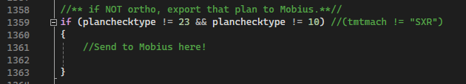
This is place-holder code, does nothing in this release. Is intended for all non-ortho plans to do other tasks, e.g. export to Mobius. But this requires a complex Dicom Daemon to be configured and accessible. Watch this space!

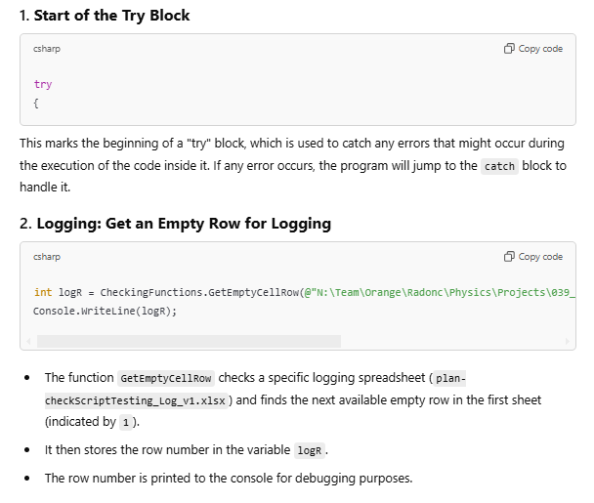
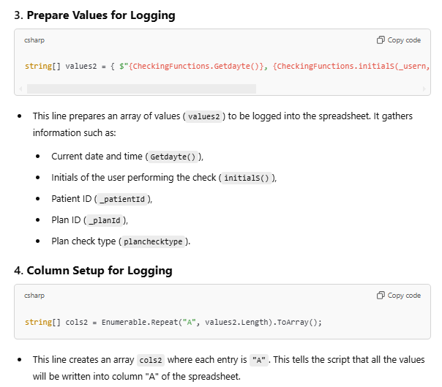
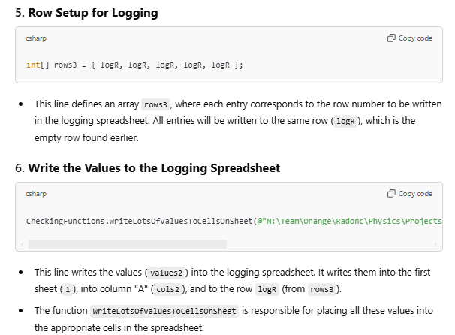
This log sheet is saved to: N:\Team\Orange\Radonc\Physics\Projects\039_AutoPhysics_PlanChecks\
Please make a copy of it before opening it. If it open whilst someone runs the script, logging for this patient will fail.

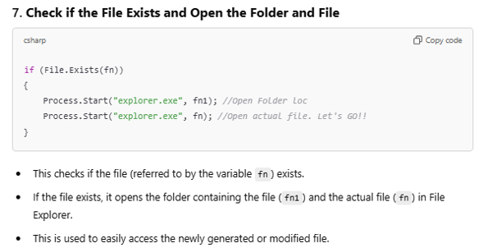
If the plan-check (and logging) completed successfully without any major errors, then the script will then open the folder location in which the plan-checklist excel sheet has been saved, as well as opening the actual checklist. Users can then continue to complete the manual components of the plan-check. It is still important to ensure that the file is in the correct folder location (e.g. the plan check type VMAT/IMRT/SABR/etc… has been correctly identified).
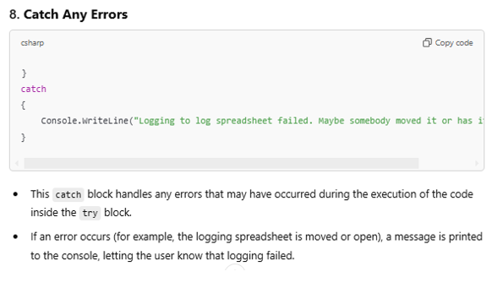
Note that the console will most likely close before you can read this error message (unless your very quick). If you are trying to troubleshoot a specific bug, consider adding a Console.ReadLine(), into the code. This will make the black command prompt window wait for the user to press a button before it continues to the next section (or exits).
That concludes the main function for BeginPlanCheck.cs. The next section documents the inner workings of the CheckingFunctions.cs file.

--------------------------------------------------------------------------------------------------------------------------------------
Here’s a comprehensive documentation for each function in the CheckingFunctions.cs file. This documentation follows a typical C# style, explaining the purpose, parameters, and return values for each function. Comments on specific functionality or known behaviours are also included for clarity.

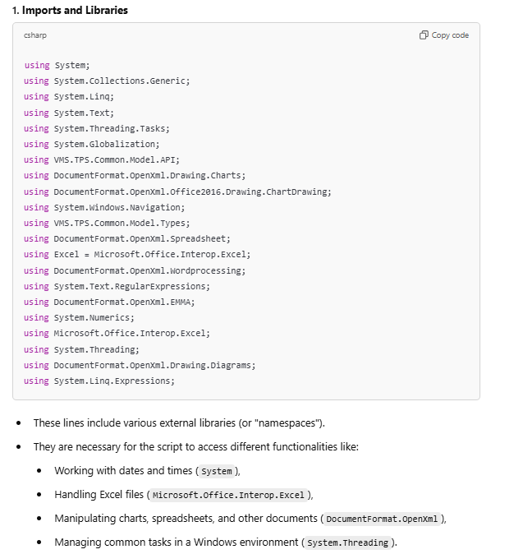
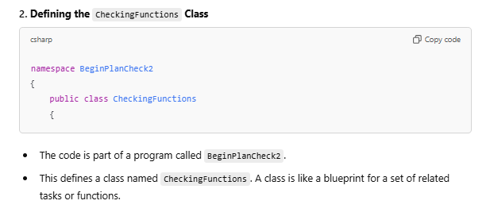
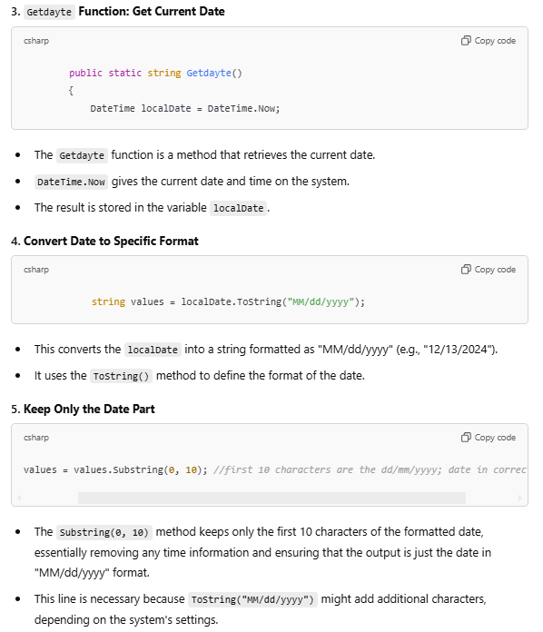
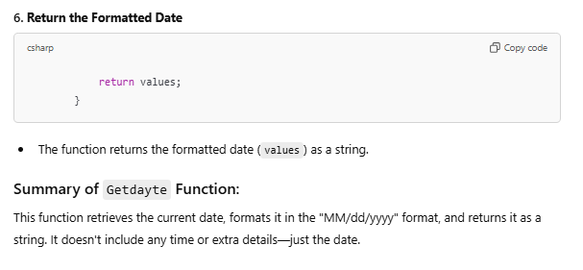
Note that the formatting appears incorrect. This is true, it is in US standard – however it works in the current script setup and environment (has to do with formatting style of server, maybe?). Previously, prior to an unknown change occurring (presumably by IT somewhere), I had it formatted in dd/MM/yyyy format; using:
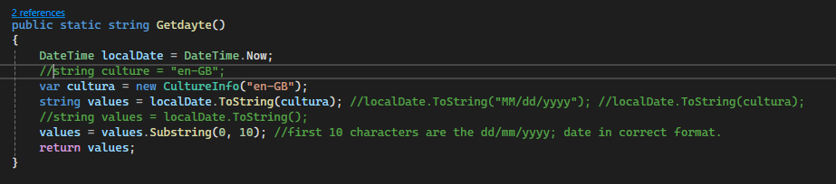
But then one-day this mysteriously stopped working. Changing to US format mysteriously fixed the problem. Keep this in mind if the behaviour ever reverts.

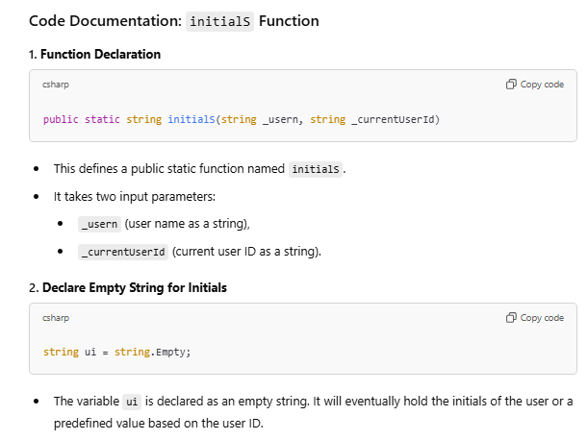
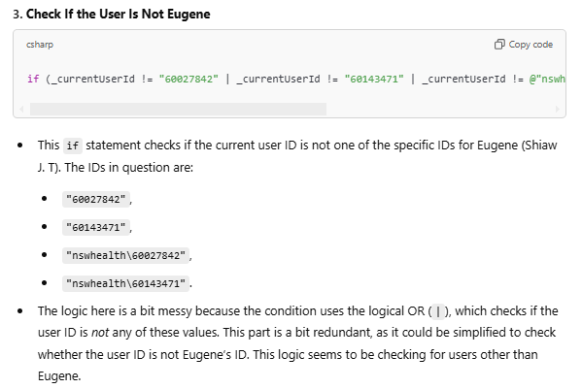
Yes, it doesn’t even use the short-cut (||) logical. I agree with ChatGPT’s assessment, but obviously had some trouble getting this code to function as intended. As it, it works – if it isn’t broke…

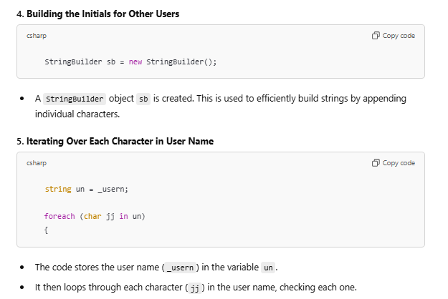
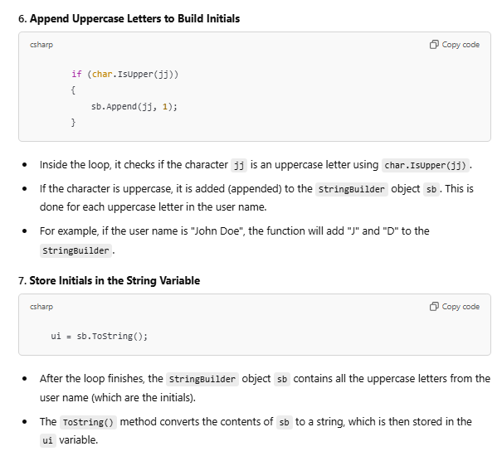
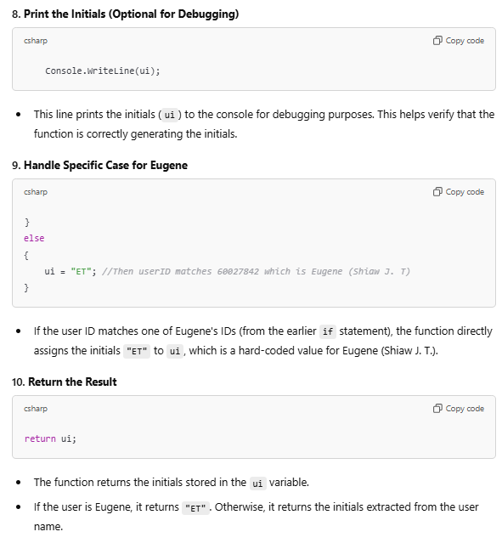
C# handles strings in a really weird way (via the stringbuilder function). This function was actually the one that caused the most grief. Feel free to re-write it.

CheckingFunctions.PlanReviewedOrApproved
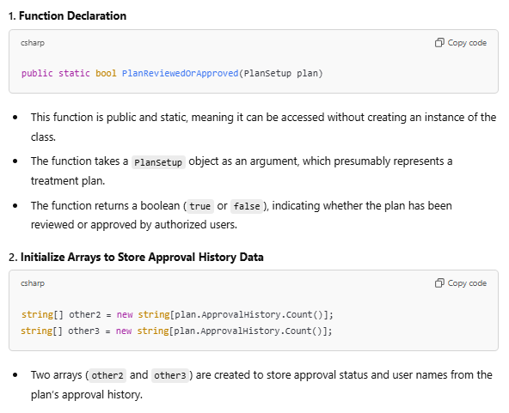
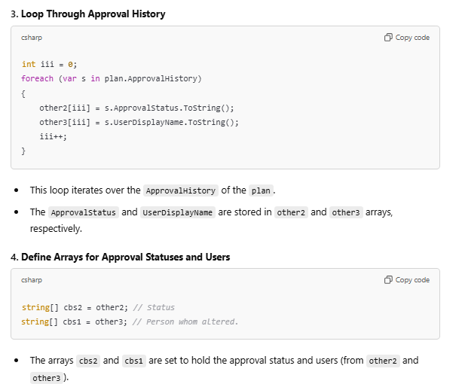
string[] authorisedreviers = { "Thomas Eade", "Patrick Horsley", "Kandeepan Thuraisingam", "Johnson Lam", "Simon Tang", "Gillian Lamoury", "George Hruby", "Michael Back", "Dasantha Jayamanne", "Gabrielle Metz", "Susan Carroll", "Sarah Bergamin", "Andrew Kneebone", "Joseph Chan" };
string[] allowedstati = { "Treatment Approved", "Reviewed", "TreatmentApproved" };
string[] disallowedstati = { "Unapproved", "UnApproved", "Rejected", "Retired" }; //Yes - case sensitive.
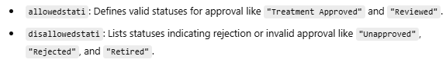
Note that the authorisedreviers in this function is a hard-coded string. If there is a new RO, or a change of name, this will need to be manually edited (in this and at least one other function). Future releases will likely want to read the names from a text file stored on Ndrive.

(**EDIT Feb 2025) Note that allowed statuses were updated to be “Planning Approved”, or “Reviewed”; consistent with manual check protocol. A value of Treatment Approved, by an RO will return a fail (unless the RO also set one of the allowed statuses).

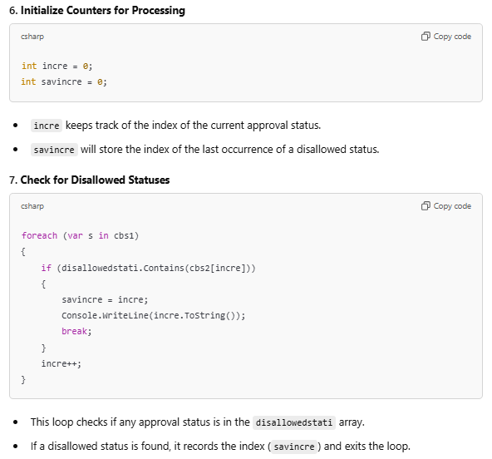
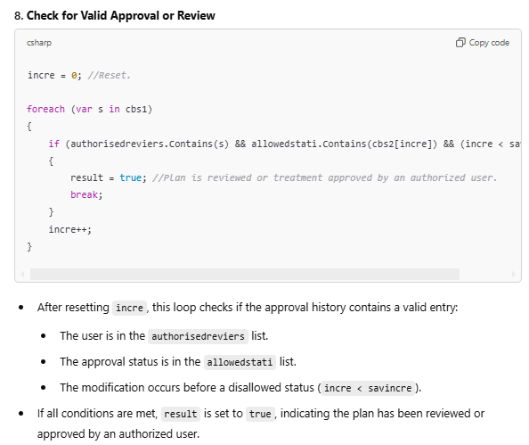
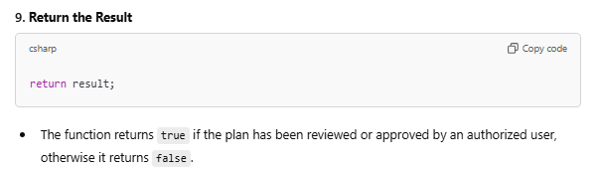
This function will return false, even if the plan has been reviewed or approved by an authorised user (on the list), if it has subsequently been changed to a disallowed status such as rejected or unapproved. The function will return true again, if it has subsequently been tmt approved or reviewed by someone on the authorised list (RO). The function will return true if the plan has been reviewed or treatment approved by an RO on the list, and no subsequent disallowed statuses have been applied to the plan, at the time the script has been run.

CheckingFunctions.GetNameOfPlanReviewerOrApprover
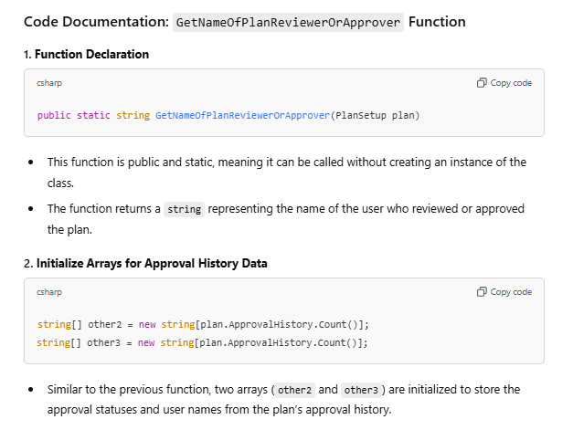

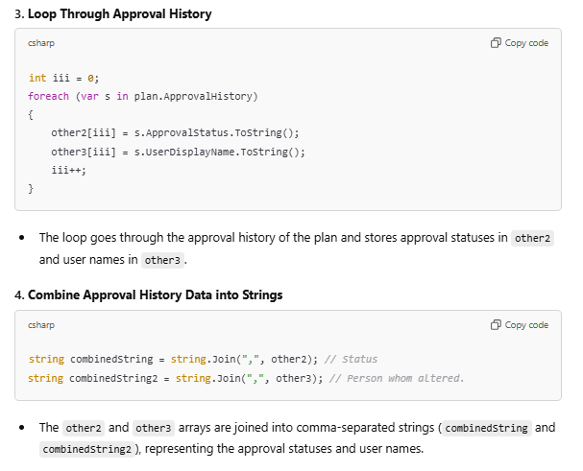
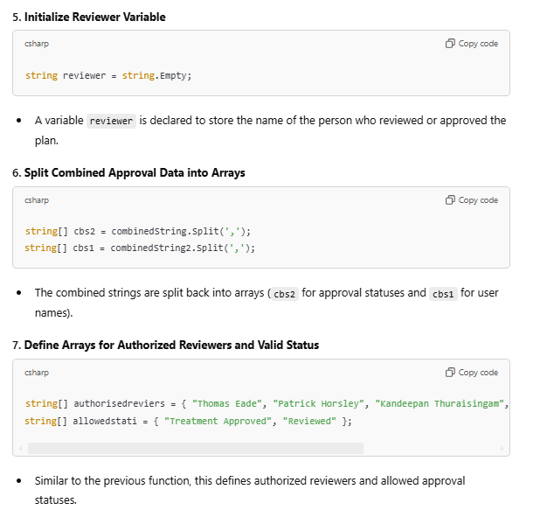
Note that allowed statuses were updated to be “Planning Approved”, or “Reviewed”; consistent with manual check protocol. A value of Treatment Approved, by an RO will return a fail (unless the RO also set one of the allowed statuses).
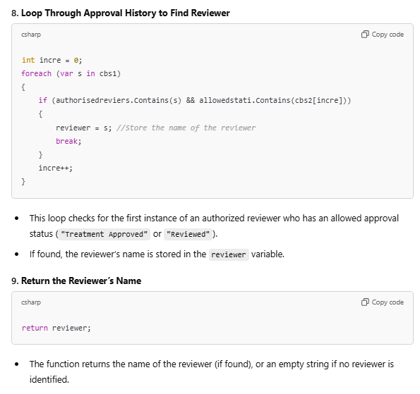
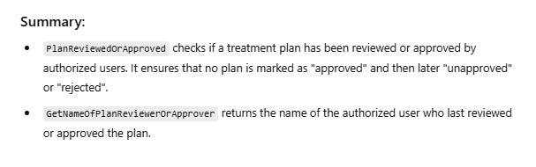
This is pretty much the same as the previous function, but gives the name of the authorised person, rather than just a true/false value.

CheckingFunctions.GetPersciptionStatus
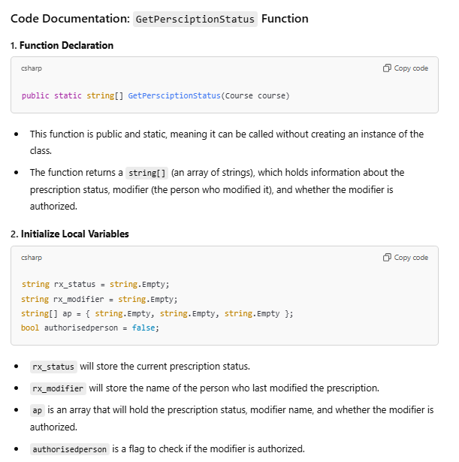

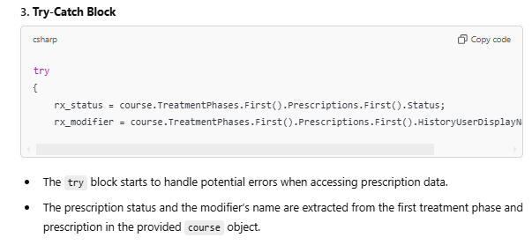
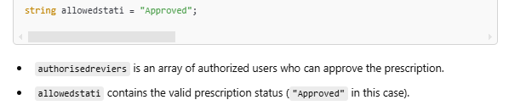
Once again, the authorised reviewers is hard-coded and will need to be modified in this function if the RO’s ever change.
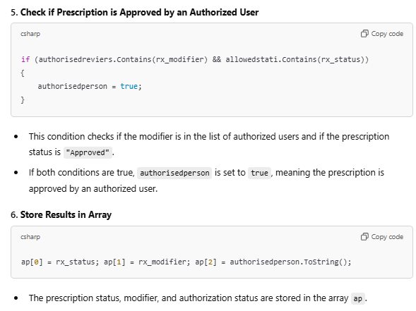
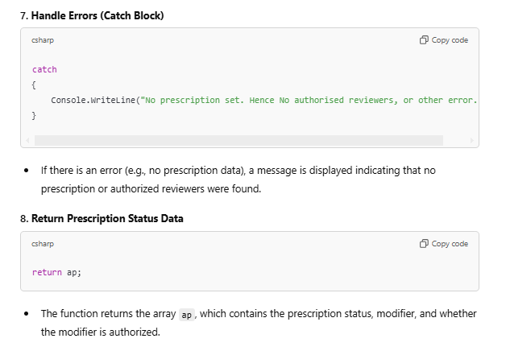
This function is quite similar to the previous one, but is looking at the prescription, rather than plan approval status. The only allowed status is approved and by somebody within the authorised reviewers list, all others will not pass the plancheck test.

CheckingFunctions.GetDoseGird
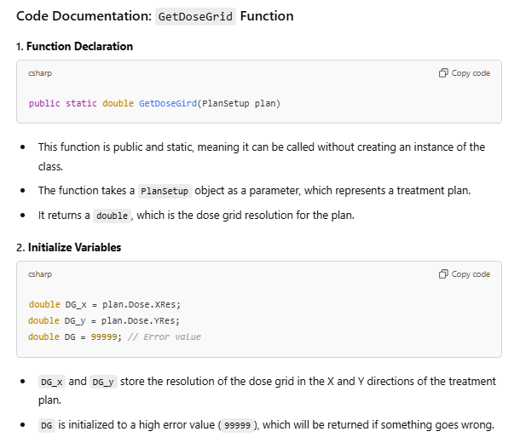
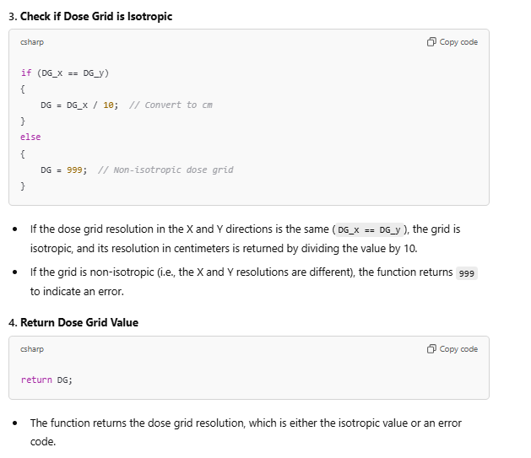
Note that the dose-grid is not checking if it isotropic in the z (sup-inf) direction. This is because the dose-grid resolution in the Z axis is limited by the CT slice spacing, so for simless and palliative plans where this is a large variable this test would return z axis values of 3 or sometimes even 5 mm; and will not report the dose-grid to be isotropic in that dimension. This function is designed to duplicate our current manual workflow – in which we check the setting in x and y dimensions. When it get called in the script, the dose-grid number set in the plan and returned by the function, will be compared to the desired dose-grid setting for the plan-check type (e.g. 0.2,0.125,0.1 for VMAT/SABR/SRS respectively). If the plan value is less than or equal to the desired value than this test will pass. E.g. a 0.1 cm dose-grid setting in the plan, will pass the VMAT checklist as it’s <= 0.2 cm required for the technique.
If there is an error in pulling the dose-grid, or it’s non-isotropic, it will give an error value of 999 or above. Such that the <= test will fail.

CheckingFunctions.GetHyperArcDoseGrid
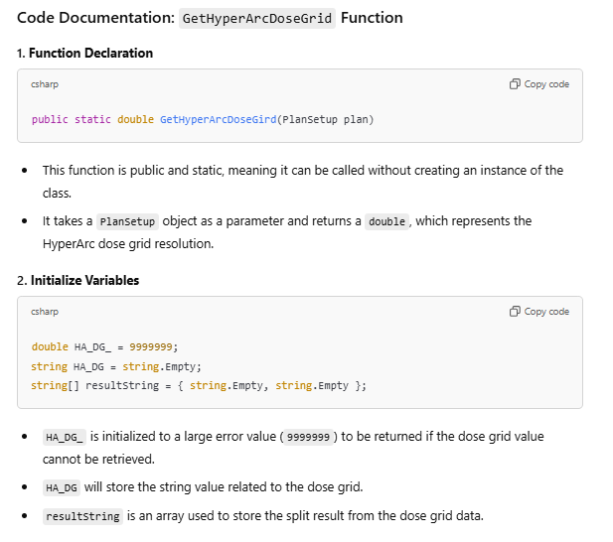
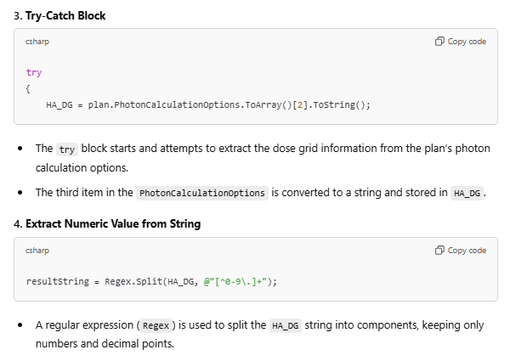
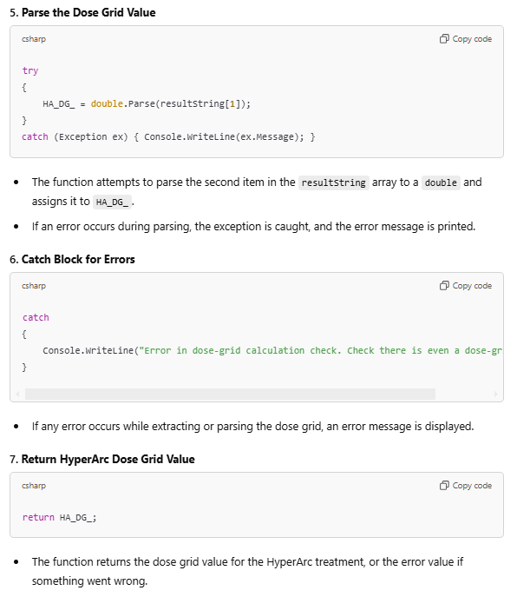
This is basically the same as the dose-grid function previously, but it pulls the HyperArc Dose-grid setting. It’s only compared and applicable for HyperArc plans.

CheckingFunctions.CheckDoseGirdSize
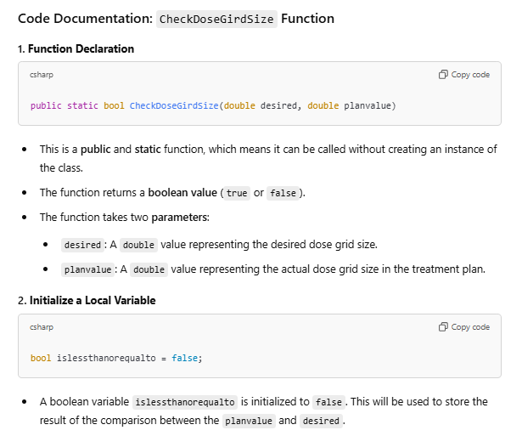

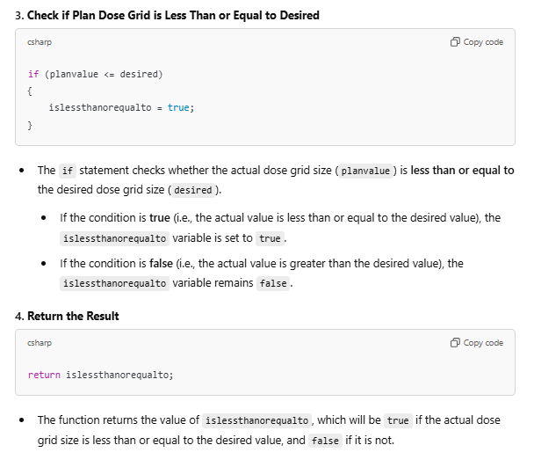

CheckingFunctions.GetVolDoseCalcAlgo
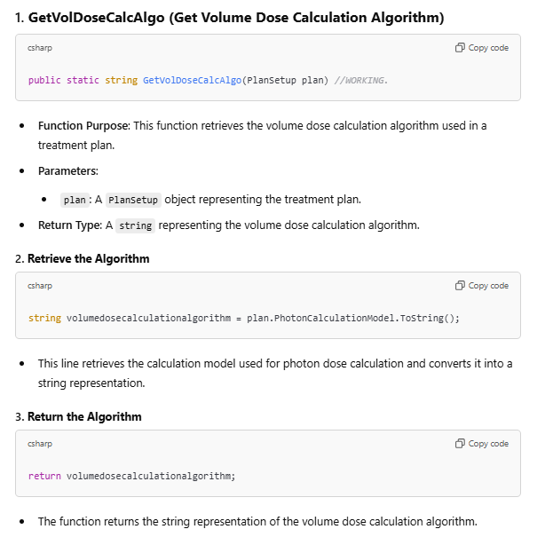

CheckingFunctions.GetOptimiserCalcAlgo
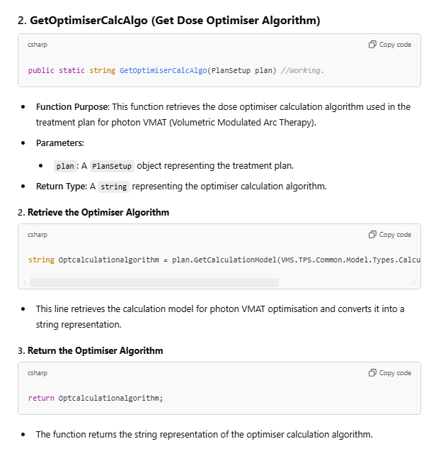

CheckingFunctions.GetHetreogeneity
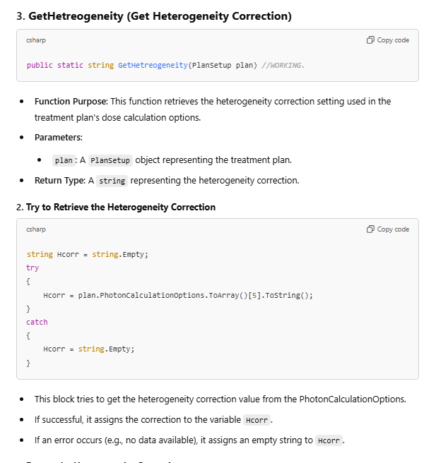
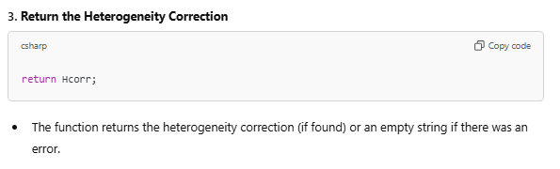

CheckingFunctions.GetAutoFeather
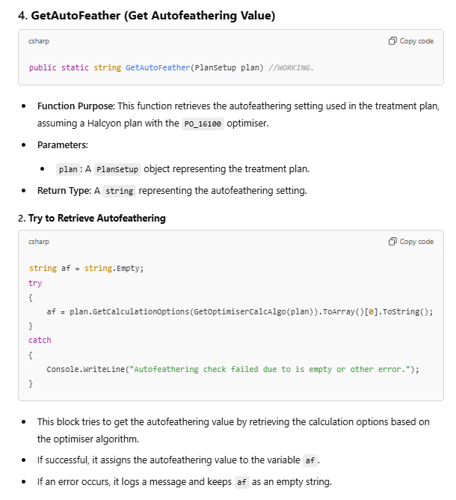
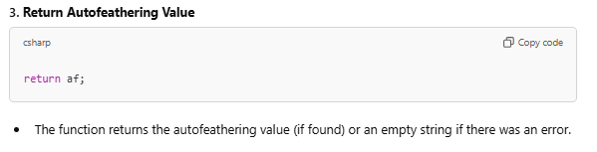

CheckingFunctions.GetBeamMU
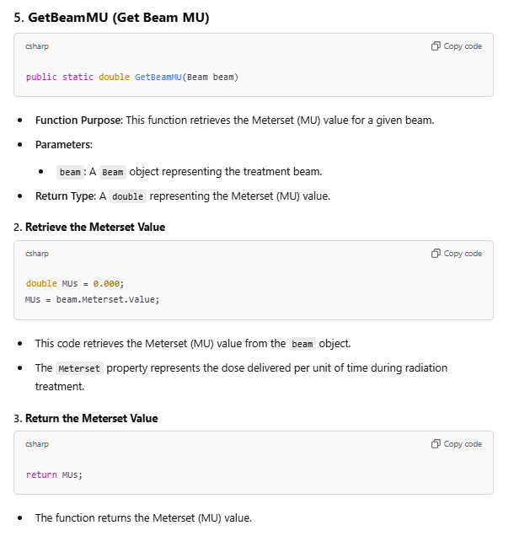
Returns to 3 decimal places. Is used for the LMC calculation test.

CheckingFunctions.GetBeamlogs
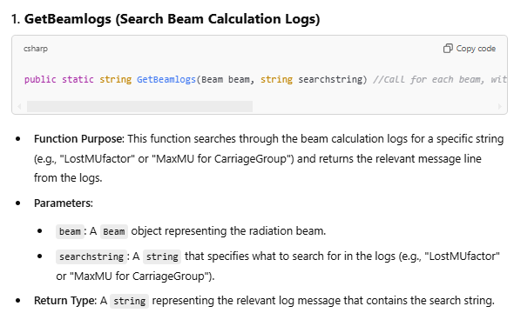

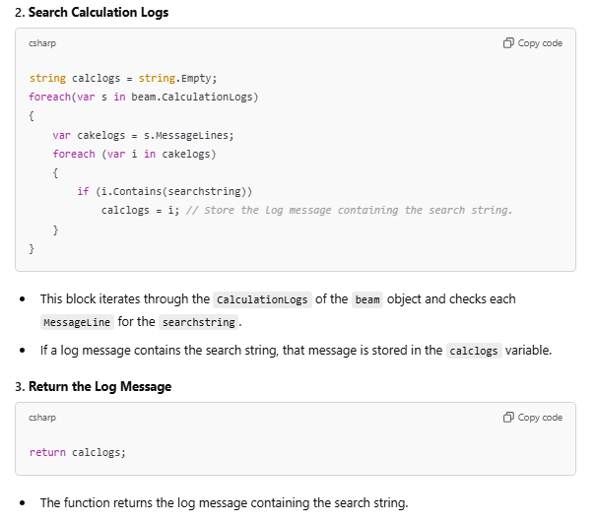

CheckingFunctions.beamAlign
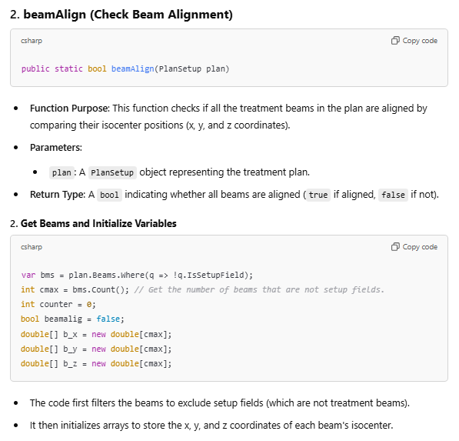
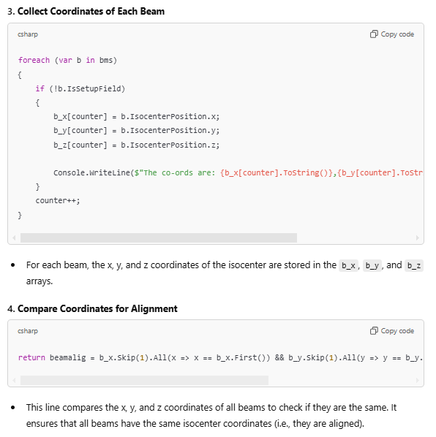
Note that this test will return true if all the beams have same iso co-ordinates, but is NOT checking if the isocentre is within the PTV (which is a test for SABR). So check the isocentre location is reasonable – but you can trust that the script has checked all the beams are at the same iso. Will return false for multi-isocentre plans, as expected.

CheckingFunctions.AllBeamsSameTmtMachine
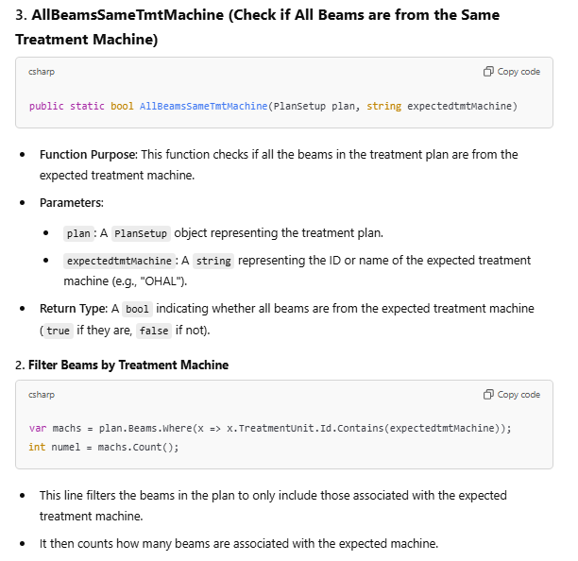
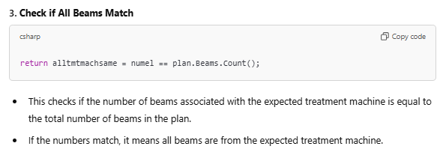
This test is run for Halcyon plans.

CheckingFunctions.AllBeamsDoseDynamicOrVMAT
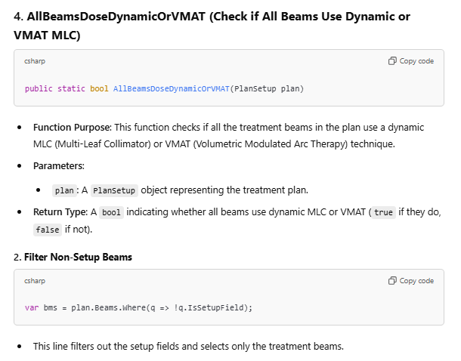
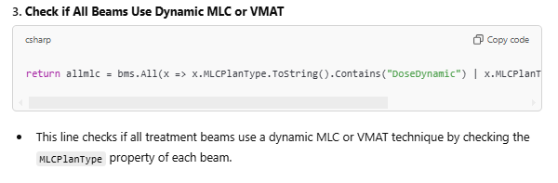
Run for Halcyon plan-checks.

CheckingFunctions.WriteToCellOnSheet
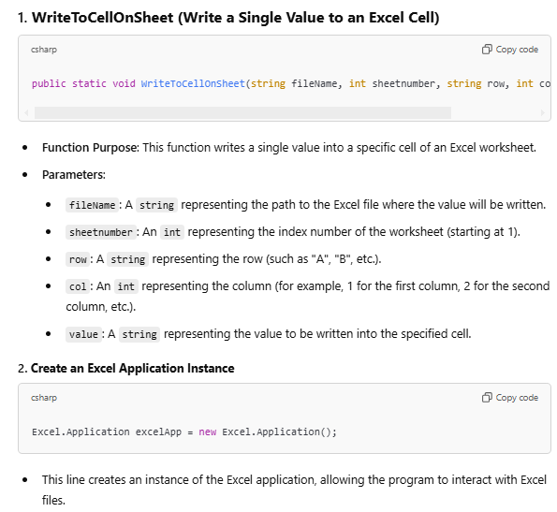
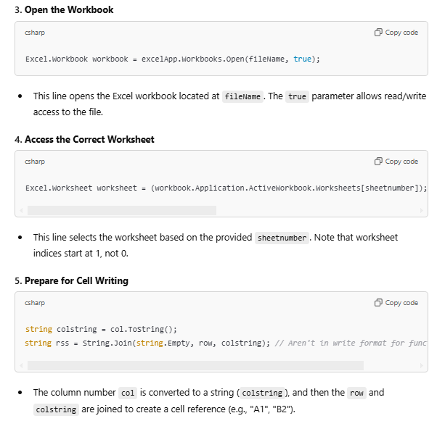
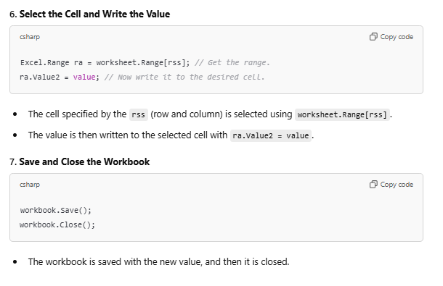

CheckingFunctions.WriteLotsOfValuesToCellsOnSheet
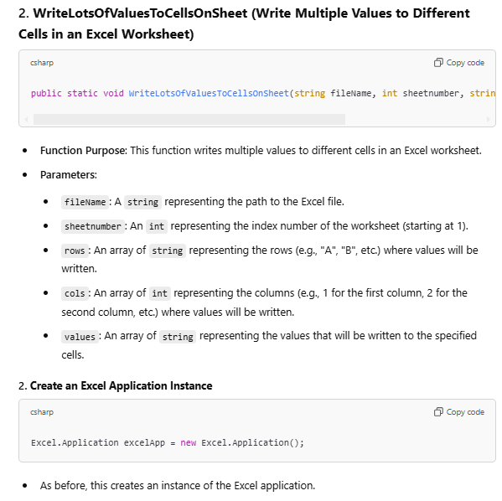
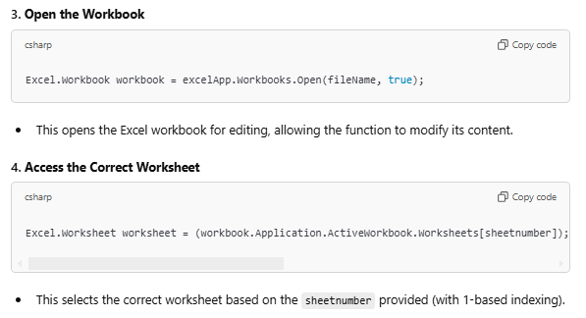
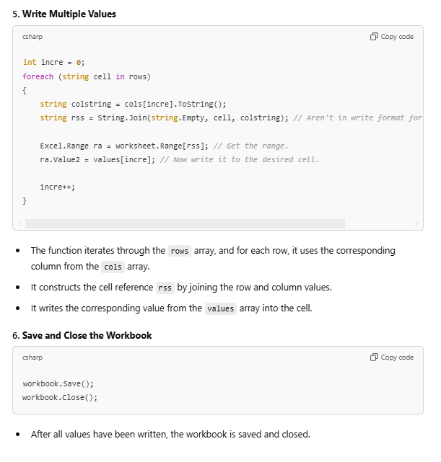

CheckingFunctions.GetEmptyCellRow

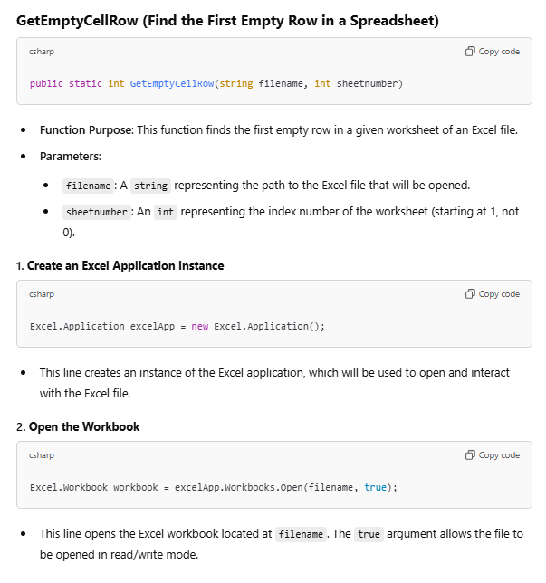
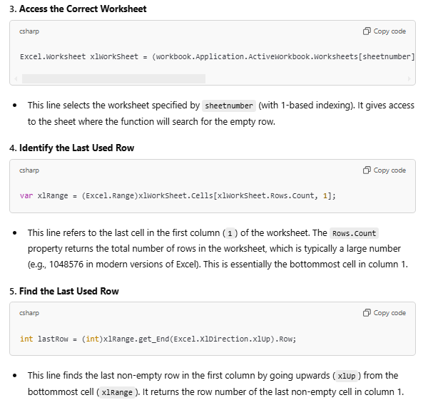
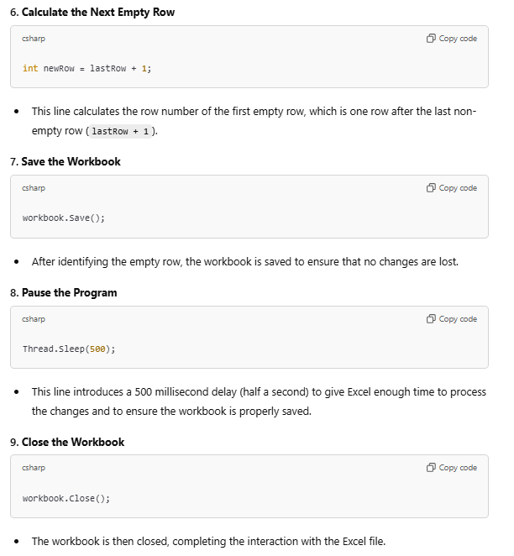
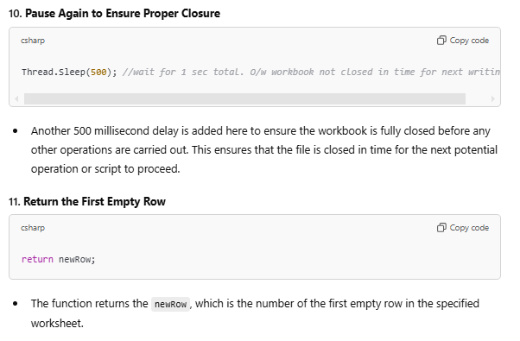
This function is run on the logging spreadsheet, to figure out from which row/col we may continue to log from.

Appendix – suggested improvements from chatGPT:
Okay, that's it - we've documented all the functions. Did you spot any errors or safety risks or other items that you'd like to discuss? From any of the code we've gone through?
ChatGPT said:
After reviewing the code you've provided and going through the documentation, there are a few observations and potential areas to discuss. These are not necessarily errors, but rather points for improvement in terms of robustness, safety, and performance.
1. Error Handling
- Missing Specific Exception Handling: Many of the functions use a generic catch block (catch { ... }). While this prevents the program from crashing, it doesn't provide any information about the error or allow the program to handle specific cases differently. It's often a better practice to catch specific exceptions, log them, or handle them appropriately.
Example:
csharp
Copy code
try
{
// Some code that may throw
}
catch (FileNotFoundException ex)
{
// Handle specific file-not-found error
}
catch (Exception ex)
{
// Handle other general exceptions
Console.WriteLine(ex.Message);
}
- Logging: Some functions, like GetBeamlogs and GetHetreogeneity, print errors directly to the console (Console.WriteLine). In production code, it's better to use a logging framework (such as NLog or log4net) for better traceability, logging to files, or remote systems.
2. Concurrency and Thread Safety
- Thread.Sleep in GetEmptyCellRow and other functions: Using Thread.Sleep introduces artificial delays, which can cause performance bottlenecks. These delays could be avoided unless absolutely necessary. If these delays are required to ensure that Excel has finished processing, it might be worth exploring other, more reliable synchronization methods, like waiting for a specific event or ensuring that the application is idle before proceeding.
- Excel Object Model: Interacting with Excel via COM objects (as seen in WriteToCellOnSheet, WriteLotsOfValuesToCellsOnSheet, and GetEmptyCellRow) can be prone to issues when multiple threads are involved. These functions are currently single-threaded, which is okay for most cases, but if you plan to scale the solution or use multi-threading, you will need to ensure thread safety when interacting with Excel.
3. Resource Management
- Excel Application Closing: You are opening an Excel instance (Excel.Application excelApp = new Excel.Application();) but not ensuring it's properly disposed of in case of an error. If Excel is not closed correctly, it can leave processes running in the background, consuming system resources.
To safely dispose of resources and avoid leaving Excel instances running, you could use a try/finally block or the using statement (if applicable). For example:
csharp
Copy code
try
{
Excel.Application excelApp = new Excel.Application();
Excel.Workbook workbook = excelApp.Workbooks.Open(fileName, true);
// Perform work with the workbook
}
finally
{
excelApp.Quit();
}
- Excel Object Cleanup: You might want to explicitly release COM objects (such as Excel.Application, Excel.Workbook, Excel.Worksheet) after use to avoid memory leaks:
csharp
Copy code
Marshal.ReleaseComObject(excelApp);
4. Performance Considerations
- Repeated Calls to Excel: For functions like WriteToCellOnSheet or WriteLotsOfValuesToCellsOnSheet, opening and closing the workbook every time data is written can be inefficient, especially if writing to multiple cells. A better approach would be to open the workbook once, perform all the necessary writes, and then close it at the end. This reduces the overhead of opening and closing the file multiple times.
Example of optimizing writing to Excel:
csharp
Copy code
Excel.Application excelApp = new Excel.Application();
Excel.Workbook workbook = excelApp.Workbooks.Open(fileName, true);
Excel.Worksheet worksheet = workbook.Worksheets[sheetnumber];

// Perform multiple writes here
worksheet.Cells[1, 1].Value = "New Value";
worksheet.Cells[2, 2].Value = "Another Value";

workbook.Save();
workbook.Close();
excelApp.Quit();
Marshal.ReleaseComObject(excelApp);
5. Security Concerns
- File Access: The WriteToCellOnSheet and WriteLotsOfValuesToCellsOnSheet functions open and modify Excel files without any user authentication or checks to ensure the file is valid or not corrupted. In real-world scenarios, you might want to add file validation before performing any operations to make sure that the file is accessible, isn't open elsewhere, and is not read-only.
- Permissions: These functions assume that the program has write access to the file. In some cases, a file might be locked, or the program might not have the necessary permissions to modify it. This could cause exceptions, so handling such cases would make the program more robust.
6. Null Checking
- In functions like GetBeamlogs, GetDoseGird, and others, it's assumed that certain objects (like beam.CalculationLogs or course.TreatmentPhases) are never null. In a production environment, it’s a good idea to add null checks to prevent NullReferenceExceptions.
Example:
csharp
Copy code
if (beam.CalculationLogs != null && beam.CalculationLogs.Any())
{
// Process logs
}
7. Magic Strings and Hardcoded Values
- The functions make extensive use of hardcoded strings (e.g., "Approved", "MaxMU for CarriageGroup"). While this works for small applications, it can be difficult to maintain as the codebase grows. A better approach would be to use constants or enumerations for these values.
8. Function Documentation and Comments
- The functions have some comments, but there are places where additional explanation would help. For example:
  - The exact role of some of the "magic numbers" (such as index positions in PhotonCalculationOptions.ToArray()[5]) could be clarified. These values should ideally be named constants or handled in a more self-explanatory manner.
  - Function names could be slightly more descriptive in some cases. For example, WriteToCellOnSheet could be renamed to something like WriteValueToCellOnWorksheet to better reflect its purpose.
JH note: PhotonCalculationOptions.ToArray()[5] is index position of Heterogeneity correction value. The function in which the magic number is called should be quite evident of what value is to be expected. If unsure, just use Console.WriteLine and a for loop to list all elements of the array.

Conclusion:
Overall, the code is functional, but there are several opportunities for improvement in terms of robustness, security, performance, and maintainability. By implementing the suggestions above, such as improving error handling, using thread-safe techniques for Excel interaction, and cleaning up resources properly, the code would be safer, more efficient, and easier to maintain.
If you'd like help with specific changes or refactorings, feel free to ask!
This documentation provides clear descriptions of the purpose and usage of each function within the radiotherapy plan-checking script. Each method is aimed at ensuring that radiotherapy plans conform to specific standards and parameters necessary for accurate treatment delivery.

Troubleshooting:
- Script failed to complete running, no new patient folder created. This is a known issue for patients with multiple plans (> 2) within the same course. Solution: Check if patient folder already exists for this plan-check type, with a sub-folder with the same course name. If so, try renaming the sub-folder to something different to the current course name. Then re-run the script.
- Script generated an excel sheet for an IMRT/Halcyon IMRT plan but failed to completely write all the values for the LMC lost-MU check. This means that LMC may not have been run. Solution: Manually check all fields that it did not run for. The script will fail to complete writing these if the calculation logs do not contain the maximum MUs, lost MUs, etc….; which does occur when the LMC has not been run. Note that sometimes these values or the jaw-tracking values are absent when a specific work-flow has occurred (e.g. it’s a copy of a plan).
As a general rule, if the script has failed to run completely – manual assessment of any failed tests is required.

