**iDroid**

**(An IOS App)**

CSE 3200: System Development Project



Presented By-

Shah Newaj Ibne Azad (1607035)

Md. Main Oddin Chisty (1607050)

Supervised by-

H. M. Abdul Fattah

Lecturer,

Department of Computer Science and Engineering,

Khulna University of Engineering & Technology

Khulna – 9203, Bangladesh

**iDroid**

**(An IOS App)**

CSE 3200: System Development Project



Presented By-

Shah Newaj Ibne Azad (1607035)

Md. Main Oddin Chisty (1607050)

Supervised by-

___________________

H. M. Abdul Fattah

Lecturer,

Department of Computer Science and Engineering,

Khulna University of Engineering & Technology,

Khulna – 9203, Bangladesh

# **Abstract**

The iPhone is a line of smartphones designed and marketed by Apple Inc. Apple Inc. has a cloud storage and cloud computing service for iPhone called iCloud. Whenever we turn on an iPhone, the user must provide his iCloud id and password. Security of iCloud is the highest. The password must contain at least one capital letter, one small letter, one numeric digit and the length must be at least 9. Because of this complexity with the password, sometimes users forget their password. The password of iCloud is not easily recoverable. The only way to recover this password is to contact and take help from Apple Office directly.

As we don’t have any Apple Offices in our country, in case an iPhone user ever loses his password, his/her iPhone becomes uninteractable. Most of the cases, the password is not recovered and the phone is thought as useless. Instead of throwing it away, user can do something meaningful with it which might make the iPhone valuable. That is what we are trying do in our app.

# **Acknowledgement**

The first thank is to the almighty creator who has permitted and blessed us to carry out this project and without whose instruction nothing was possible and it was a supreme favor of Allah.

# Here we want to express our sincere and core heart gratitude to our respectful teacher H. M. Abdul Fattah, Lecturer, Department of Computer Science & Engineering, Khulna University of Engineering & Technology (KUET) for his relentless patience, constant inspiration and friendly guidance during the progress of the work. Without his help and suggestion, it was not possible anyway to complete the work. We are also humbly grateful to all our reverent teachers of our department for their genial support.

Table of Contents

**1.** **Introduction** 6

**1.1 Background** 6

**1.2 Purpose** 6

**2.** **Objectives** 7

**3.** **Features** 8

**4.** **Implementation** 13

**4.1 Tools** 13

**4.2 Data Flow Diagram** 14

**5.** **Conclusion** 15

**5.1 Challenges** 15

**5.2 Future Scope** 15

**6.** **References** 16

# **Introduction**

## **1.1 Background**

iDroid is iOS platform based app that tries to help people with iCloud locked iPhone to do something good with it. If any iPhone user doesn’t want to go through all the trouble and unlock their iCloud locked iPhone, we give them the opportunity to sell their phone’s parts. There can be some iPhone users who are having problem with their smartphone parts e.g. display, speaker, battery etc. Also, whenever the battery health of an iPhone goes below 75%, Apple recommends to change it. These users have to replace the parts. Though thus can be done so in any mobile accessories market, there’s only a few them. iPhone users cannot go to those market just from anywhere. Besides, no online selling app covers smartphone parts dedicatedly. iDroid tries to solve this problem.

## **1.2 Purpose**

The iCloud locked iPhone still has parts that is good and can be used with another iPhone. The sole purpose of iDroid is to sell those parts to another iPhone user who is facing problem with one or more parts of the phone. iDroid lets the first user sell those parts and get some money in return instead of nothing. And also, the user who just needs a part can buy that part instead of replacing the smartphone. iDroid will work as a platform between these two types of users. Not only for iPhone, iDroid does the same for other smartphones.

# **Objectives**

1. To make a platform between smartphone users
2. To sell various parts of iCloud locked iPhones
3. To also sell parts of general smartphones
4. To make the communication between seller and buyer
5. To make smartphone parts more available
6. To make the app for IOS users

# **Features**

1. **Login:** An existing user will have to login first using his email and password to start using the app (Fig. 3.1). The email field is validated so user can’t enter anything other than the desired email format. If email or password is entered wrong, user will be notified of the error (Fig. 3.2).

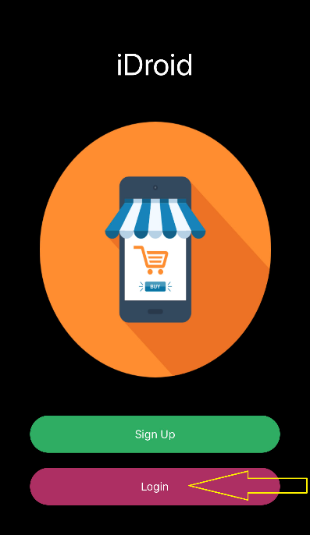 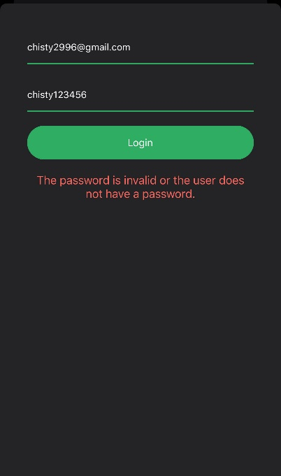

Fig. 3.1 Fig. 3.2

1. **Signup:** A new user will have to open an account first. To create an account, user will have to enter his first name, last name, email id and password. Password will have to be entered twice for confirmation. Password length has to be minimum 8 and must contain at least one letter, one digit and one special character. All the fields are validated to avoid having unwanted data in any particular field (Fig 3.3). If all the fields have proper information, then after pressing the signup button, account will be created and user will be taken to login page. If there’s any error, user will be notified about the error.

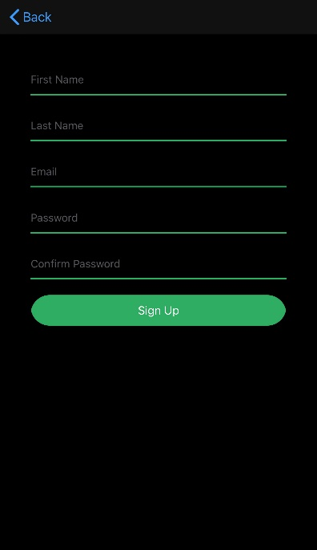

Fig. 3.3

1. **Post feed:** After the user has logged in successfully, this page will be shown first. It contains all the sell posts from the user. This page has a search option to search the products according to seller’s area (Fig 3.4).

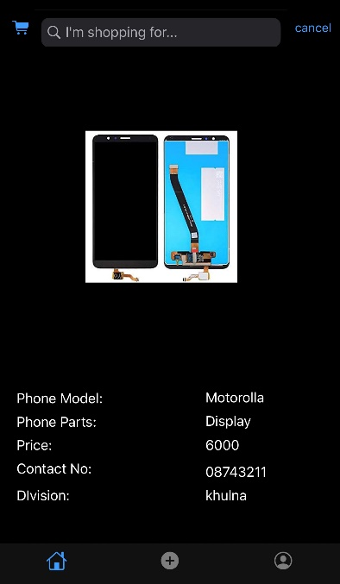

Fig. 3.4

1. **Add sell post:** User can submit a selling post from here about the part he wants to sell. The information seller must give is the smartphone model, the part to be sold, seller’s contact no., price of the part and seller’s area(division). Seller also has to upload a picture of the part he is selling. After all the information has been correctly provided, user can press the submit button and the post will be added to the home page. If after providing some certain data, user wants to cancel then he can press the cancel button (Fig 3.5).

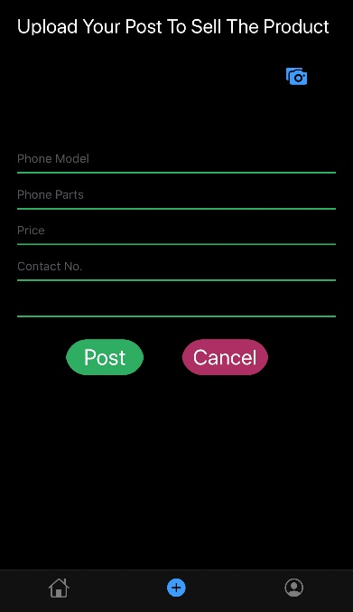

Fig. 3.5

1. **Profile:** All of the user’s information will be in this page. User will be able to change all of his information except email. User can also upload a picture to be used as the user’s profile picture (Fig 6).

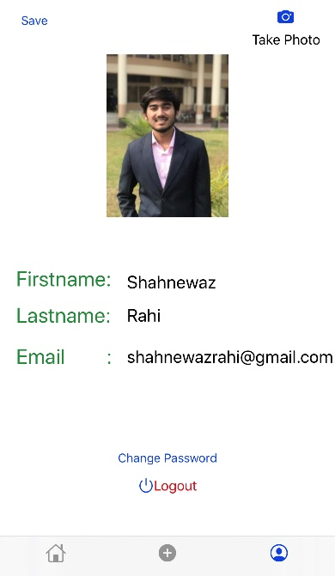

Fig. 3.6

# **Implementation**

## **4.1 Tools**

1. **MacBook Pro:** The MacBook Pro is a line of Macintosh portable computers by Apple Inc.
2. **Xcode:** Xcode is an integrated development environment (IDE) for macOS containing suite of software development tools developed by Apple for developing software for macOS, iOS, iPadOS, tvOS and watchOS. The latest stable release is version 11.3 and is available via the Mac App Store free of charge for macOS Catalina users.
3. **Swift Programming Language:** Swift is a general-purpose, multi-paradigm, compiled programming language developed by Apple Inc. for iOS, iPadOS, macOS, watchOS, tvOS, Linux, and z/OS.
4. **Firebase:** Firebase is a mobile and web application development platform developed by Firebase, Inc. in 2011, then acquired by Google in 2014. Firebase provides a real-time database and backend as a service. The service provides application developers an API that allows application data to be synchronized across clients and stored on Firebase's cloud.
5. **iPhone 7 Plus:** The iPhone 7 plus is a smartphone designed, developed and marketed by Apple Inc. They are the tenth generation of iPhone.

## **4.2 Data Flow Diagram**

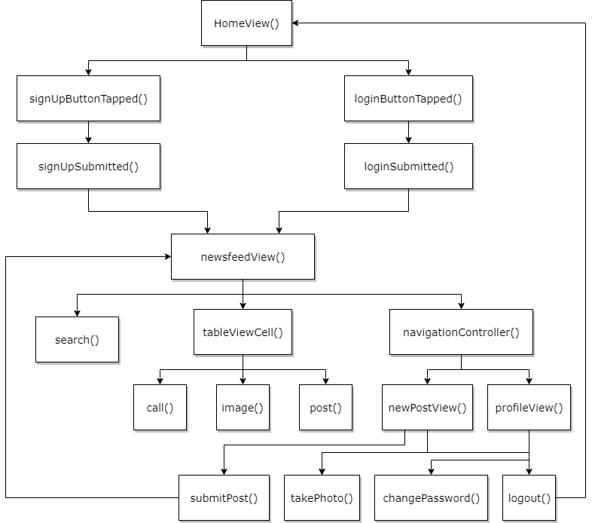

# **Conclusion**

## **5.1 Challenges**

* There’s not a lot of resources online to take help from which made it harder for us.
* After we’ve started working for the app, Apple has released 3 iOS updates, 1 big macOS update which also had updates for Xcode and Swift Programming Language. Moreover, recently firebase also released an update which changed some syntax. Because of all those updates, we had to change our code various times to get it working properly.
* There wasn’t a lot of articles or tutorials about the new changes and the documentation was a little obscure. As a result, we had to spend a lot of extra time adapting with those changes.

## **5.2 Future Scope**

* As currently there’s no online selling app in the market that is dedicated to smartphone parts, this app has huge opportunity to make an impact.
* Where most of the app developers tend to make app on android platform, this app is developed on iOS platform so that iOS users can use this app as their advantage.
* There can be a cart system for buyer to enlist the items he wants to buy or if he wants to keep track of some items.
* There will be a direct messaging system through the app so that the buyer can chat with the seller and negotiate.

# **References**

1. Firebase Authentication 2019 (Login for iOS)

<https://www.youtube.com/watch?v=1HN7usMROt8&t=2755s>

1. Xcode Documentation

<https://developer.apple.com/documentation>

1. Swift Documentation

<https://swift.org/documentation/>

1. Swift 5 Syntax Problems

<https://stackoverflow.com>

1. Firebase Documentation

https://firebase.com/documentation